|  |  |  |  |
| --- | --- | --- | --- |
|  | United Nations | ST/SG/AC.10/C.3/2018/34 | |
| _unlogo | **Secretariat** | | Distr.: General  4 April 2018  Original: English |

**Committee of Experts on the Transport of Dangerous Goods  
and on the Globally Harmonized System of Classification  
and Labelling of Chemicals**

**Sub-Committee of Experts on the Transport of Dangerous Goods**

**Fifty-third session**

Geneva, 25 June-4 July 2018  
Item 6 (b) of the provisional agenda  
**Miscellaneous proposals for amendments to the   
Model Regulations on the Transport of Dangerous Goods:   
packagings**

Minimum wall thickness for Metal IBCs[[1]](#footnote-2)\*

Transmitted by the Stainless Steel Container Association (SSCA)[[2]](#footnote-3)\*\*

Introduction

1. In the forty-fourth session (25 November-4 December 2013) SSCA presented the working document ST/SG/AC.10/C.3/2013/57 and the Sub-Committee has discussed the proposal deleting the minimum wall thickness requirements for metal IBCs.

2. At that time the majority of experts were against that proposal, although some said that they would accept the deletion of 6.5.5.1.6 provided that the wall thickness in mm continued to be required in the additional marking under 6.5.2.2. In their view, where metal IBCs were concerned, a minimum thickness was a safety measure, and it was necessary to be able to ascertain the degree of corrosion to the metal.

3. Moreover SSCA was requested to support its arguments by relevant data.

4. This document intends therefore (a) to remind to the arguments brought forward already with ST/SG/AC.10/C.3/2013/57 and (b) to deal with topic “minimum thickness as a safety measure in the context of corrosion”, to support SSCA arguments with relevant data and to provide a text proposal on the information on the wall thickness.

5. Chapter 6.5 of the United Nations Model Regulations on the Transport of Dangerous Goods describes the requirements for the construction and testing of Intermediate Bulk Containers (IBCs).

6. As defined in 6.5.1.3 there is a wide range of IBCs (categories) manufactured with different materials in accordance with table 6.5.1.4.1 (b). The general principle for the manufacturing of IBCs is that they have – if applicable – to pass the different design type tests as described for example in 6.5.6.4 (Bottom Lift test), 6.5.6.5 (Top Lift test), 6.5.6.6 (Stacking test), 6.5.6.7 (Leakproofness test), 6.5.6.8 (Hydraulic Pressure test), 6.5.6.9 (Drop test), and 6.5.6.12 (Vibration test). The criterion for passing the tests is the “performance”.

7. Except for metal IBCs, there are no requirements defined which relate to the design and extend beyond the performance criterion. It can therefore be assumed that all IBCs which pass the design type tests are safe for the transport of dangerous goods. Para. 6.6.6.1.1 describes the fundamental test requirements for IBCs: “Each IBC design type shall successfully pass the tests prescribed in this chapter before being used and being approved by the competent authority allowing the allocation of the mark. An IBC design type **is defined by** the design, size, material and **thickness**, manner of construction and means of filling and discharging but may include various surface treatments…”. But only for metal IBCs there is a “Minimum Wall Thickness” requirement in 6.5.5.1.6 (and in the table in 6.5.2.2.1).

8. SSCA thinks that this requirement is still a vestige / remnant from former times when metal IBCs were derived from tank containers (cubical tank containers). These regulations had made provisions regarding minimal wall thickness (former German “Technische Richtlinien für kubische Tankcontainer TRKTC 001”).

9. To treat all manufactures of IBCs in the same manner, SSCA proposes to delete the requirement “Minimum Wall Thickness” in 6.5.5.1.6 (and in the table in 6.5.2.2.1) **while retaining the information on the wall thickness**. The proposal is drafted below.

10. The deletion of the “minimum wall thickness” would lead to the effect that for manufacturers of metal IBCs the direct **access to innovation** and new developments is no longer blocked as it is today to a large extent.

11. The proposed revision would also help the manufacturers of metal IBCs to produce their metal IBCs in accordance with requirements coming from environmental legal regulations and customers’ demands. Examples regarding the environmental aspect are the European Packaging and Packaging waste Directive (the packaging must meet certain “Essential Requirements”) as well as the new ISO Standard series ISO 18601 (especially ISO 18602 “Packaging and the environment – Optimization of the packaging system”). The optimisation of the wall thickness – **while ensuring performance** – could contribute to the environment protection by the realisation of a lower packaging weight and the sustainable use of resources.

12. Regarding the topic “corrosion” the experts expressed their view that – where metal IBCs were concerned – a minimum thickness was a safety measure, and it was necessary to be able to ascertain the degree of corrosion to the metal. SSCA would like to explain that neither the prescribed thickness in 6.5.5.1.6 (a) nor the thickness calculated with the formula 6.5.5.1.6 (b) make able to ascertain the degree of corrosion to the metal. But anyway a corrosion allowance is not required on surfaces if they are adequately protected against corrosion or if the material as such is non-corrosive. That means the design, materials and construction should be selected to **minimise corrosion**.

13. (Metal) IBCs are “transport containers” that means they are periodically filled, emptied, cleaned and inspected and not foreseen to be used for storage. Therefore the cycles of filling and emptying are very short and corrosion – if despite selection of material at all possible – would be detected immediately and the **wall thickness can be measured at the periodic inspection**. This makes sure that the **extraordinary life time** of metal IBCs is remained and will not be affected.

14. Regarding the request to support arguments by relevant data SSCA has initiated a test. A protected metal IBC (31A) was successfully tested at TÜV Rheinland in Halle. The test report is attached in the **Annex**. We would like to summarise: As is evident from the test report, the wall thickness of the tested container is between 0.97 (top), 0.98 (body) and 1.42 (bottom). According to the 6.5.5.1.6 the wall thickness for metal IBC should in no case be less than 1.5 mm. In our view, the successful test illustrates, that this requirement is no longer appropriate.

15. SSCA would appreciate if this proposal would be considered by the Sub-Committee and if we were given the opportunity to introduce the paper.

Proposal

16. **Amend** the table in 6.5.2.2.1 by deleting “minimum” in the third row under “Additional marks”, as follows:

“Body material and its ~~minimum~~ thickness in mm”

17. **Delete** 6.5.5.1.6.

Annex

Test report “Design type test of an intermediate bulk container (IBC) for the transport of dangerous goods” / Code: UN 31A

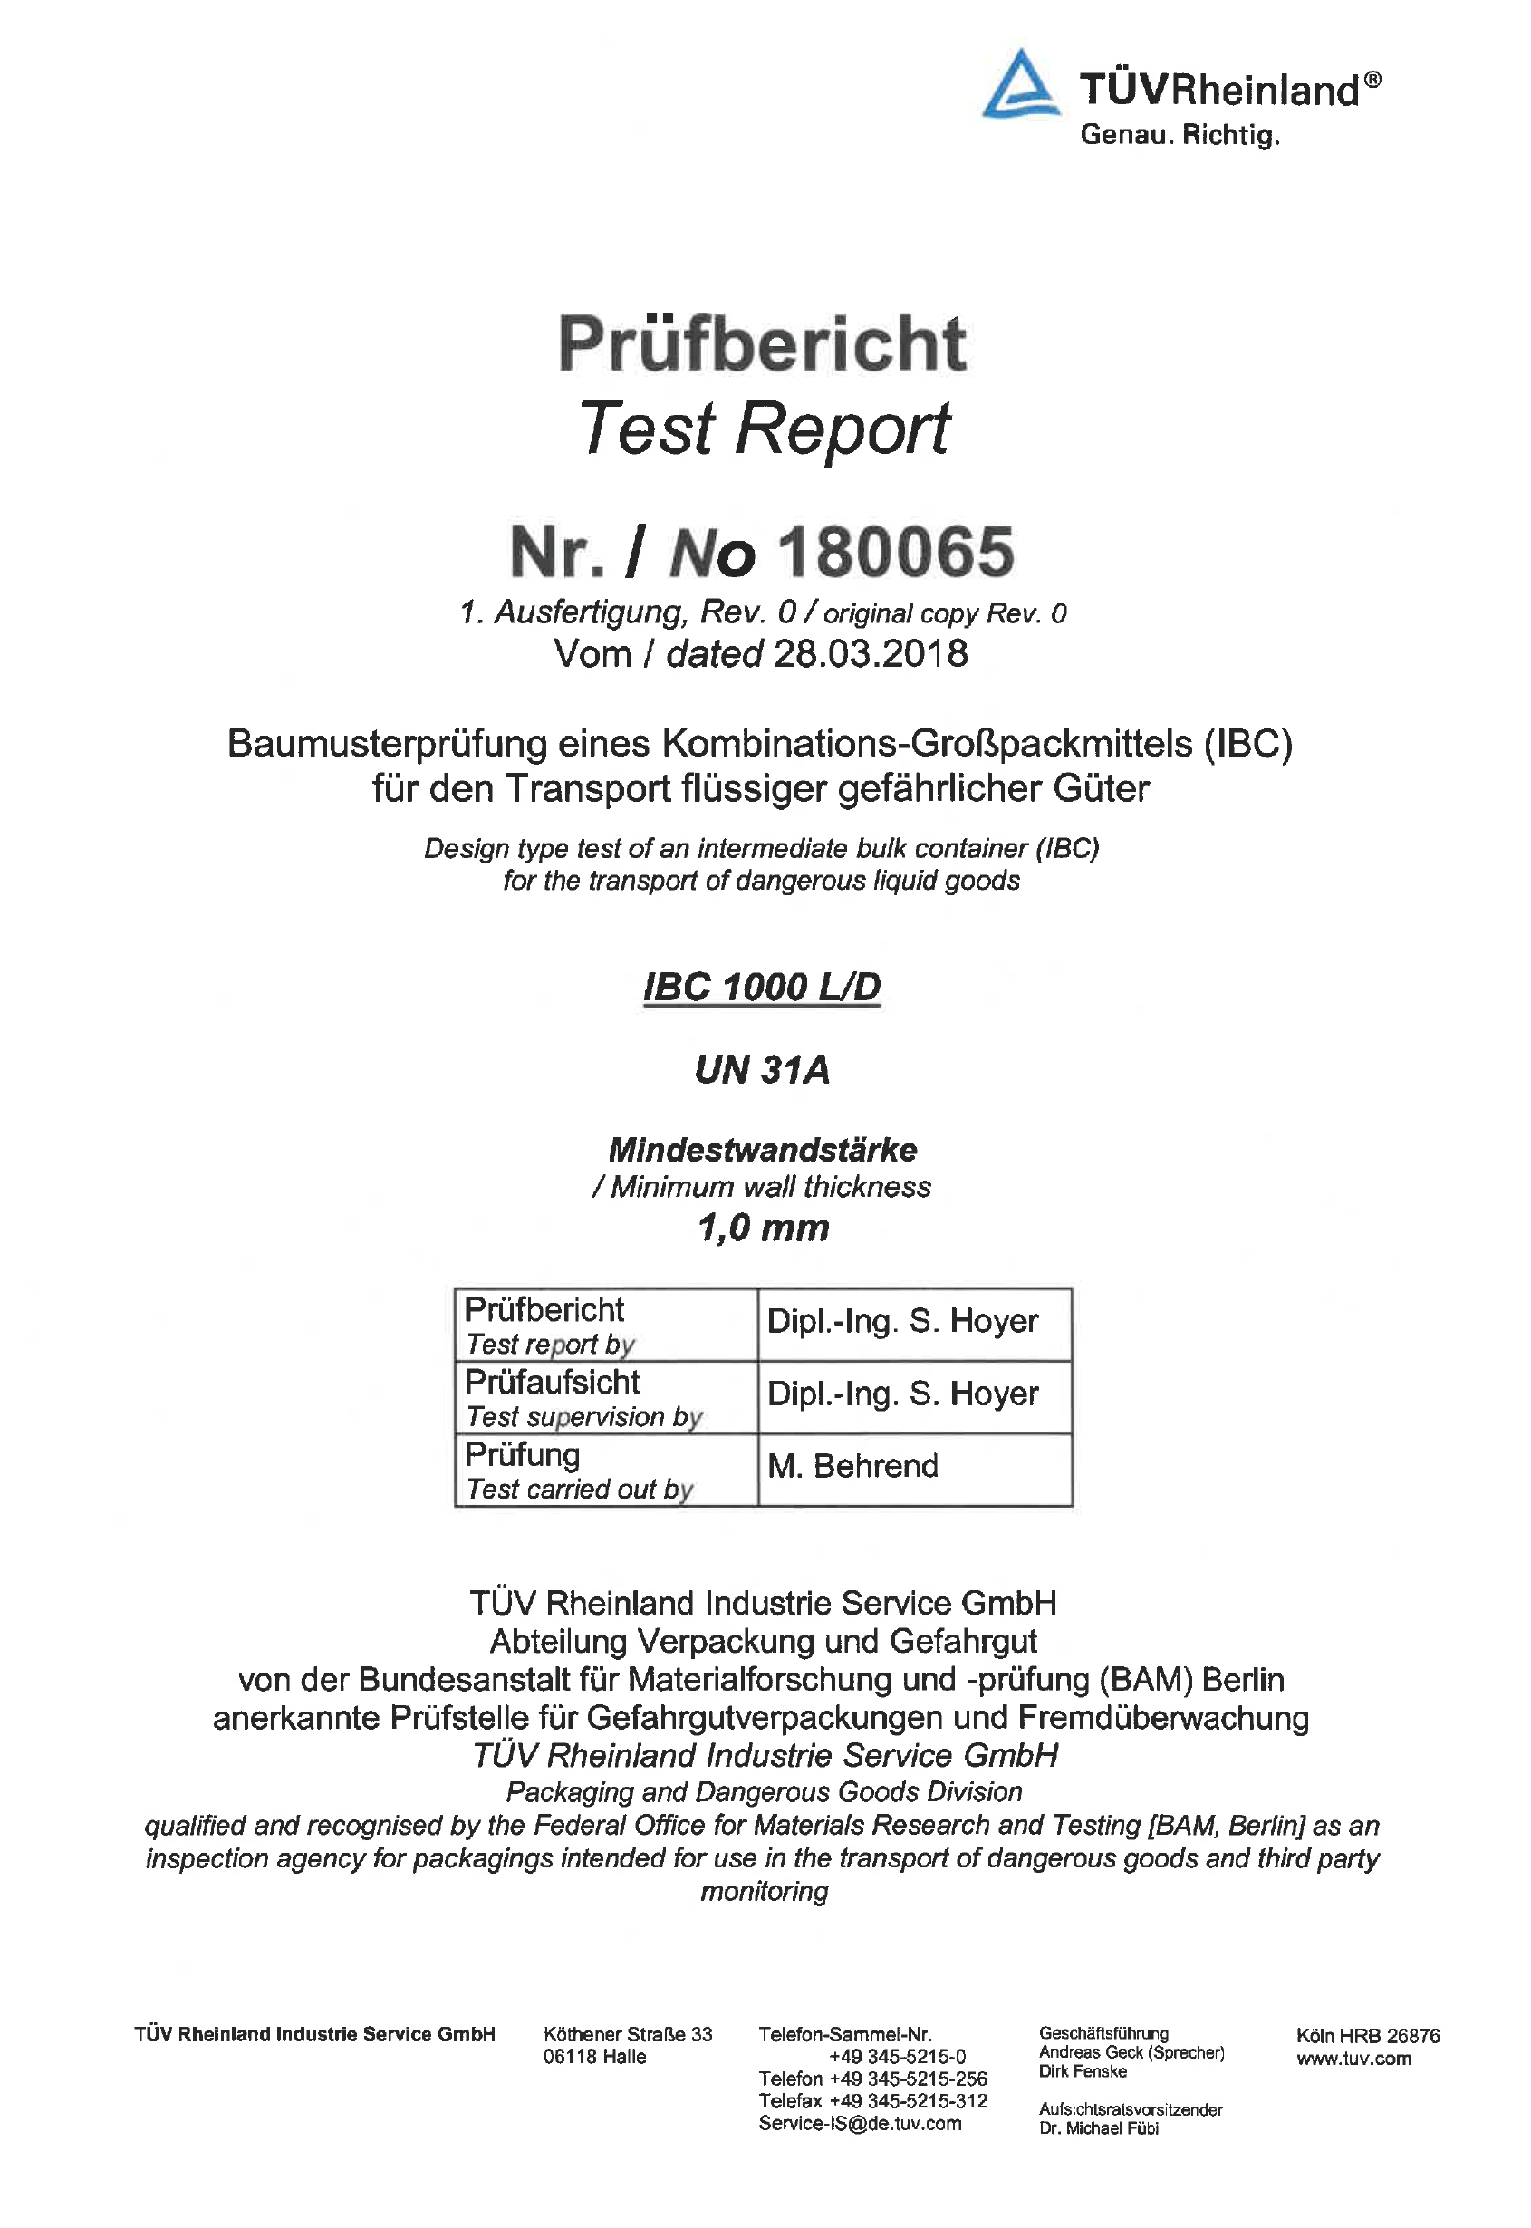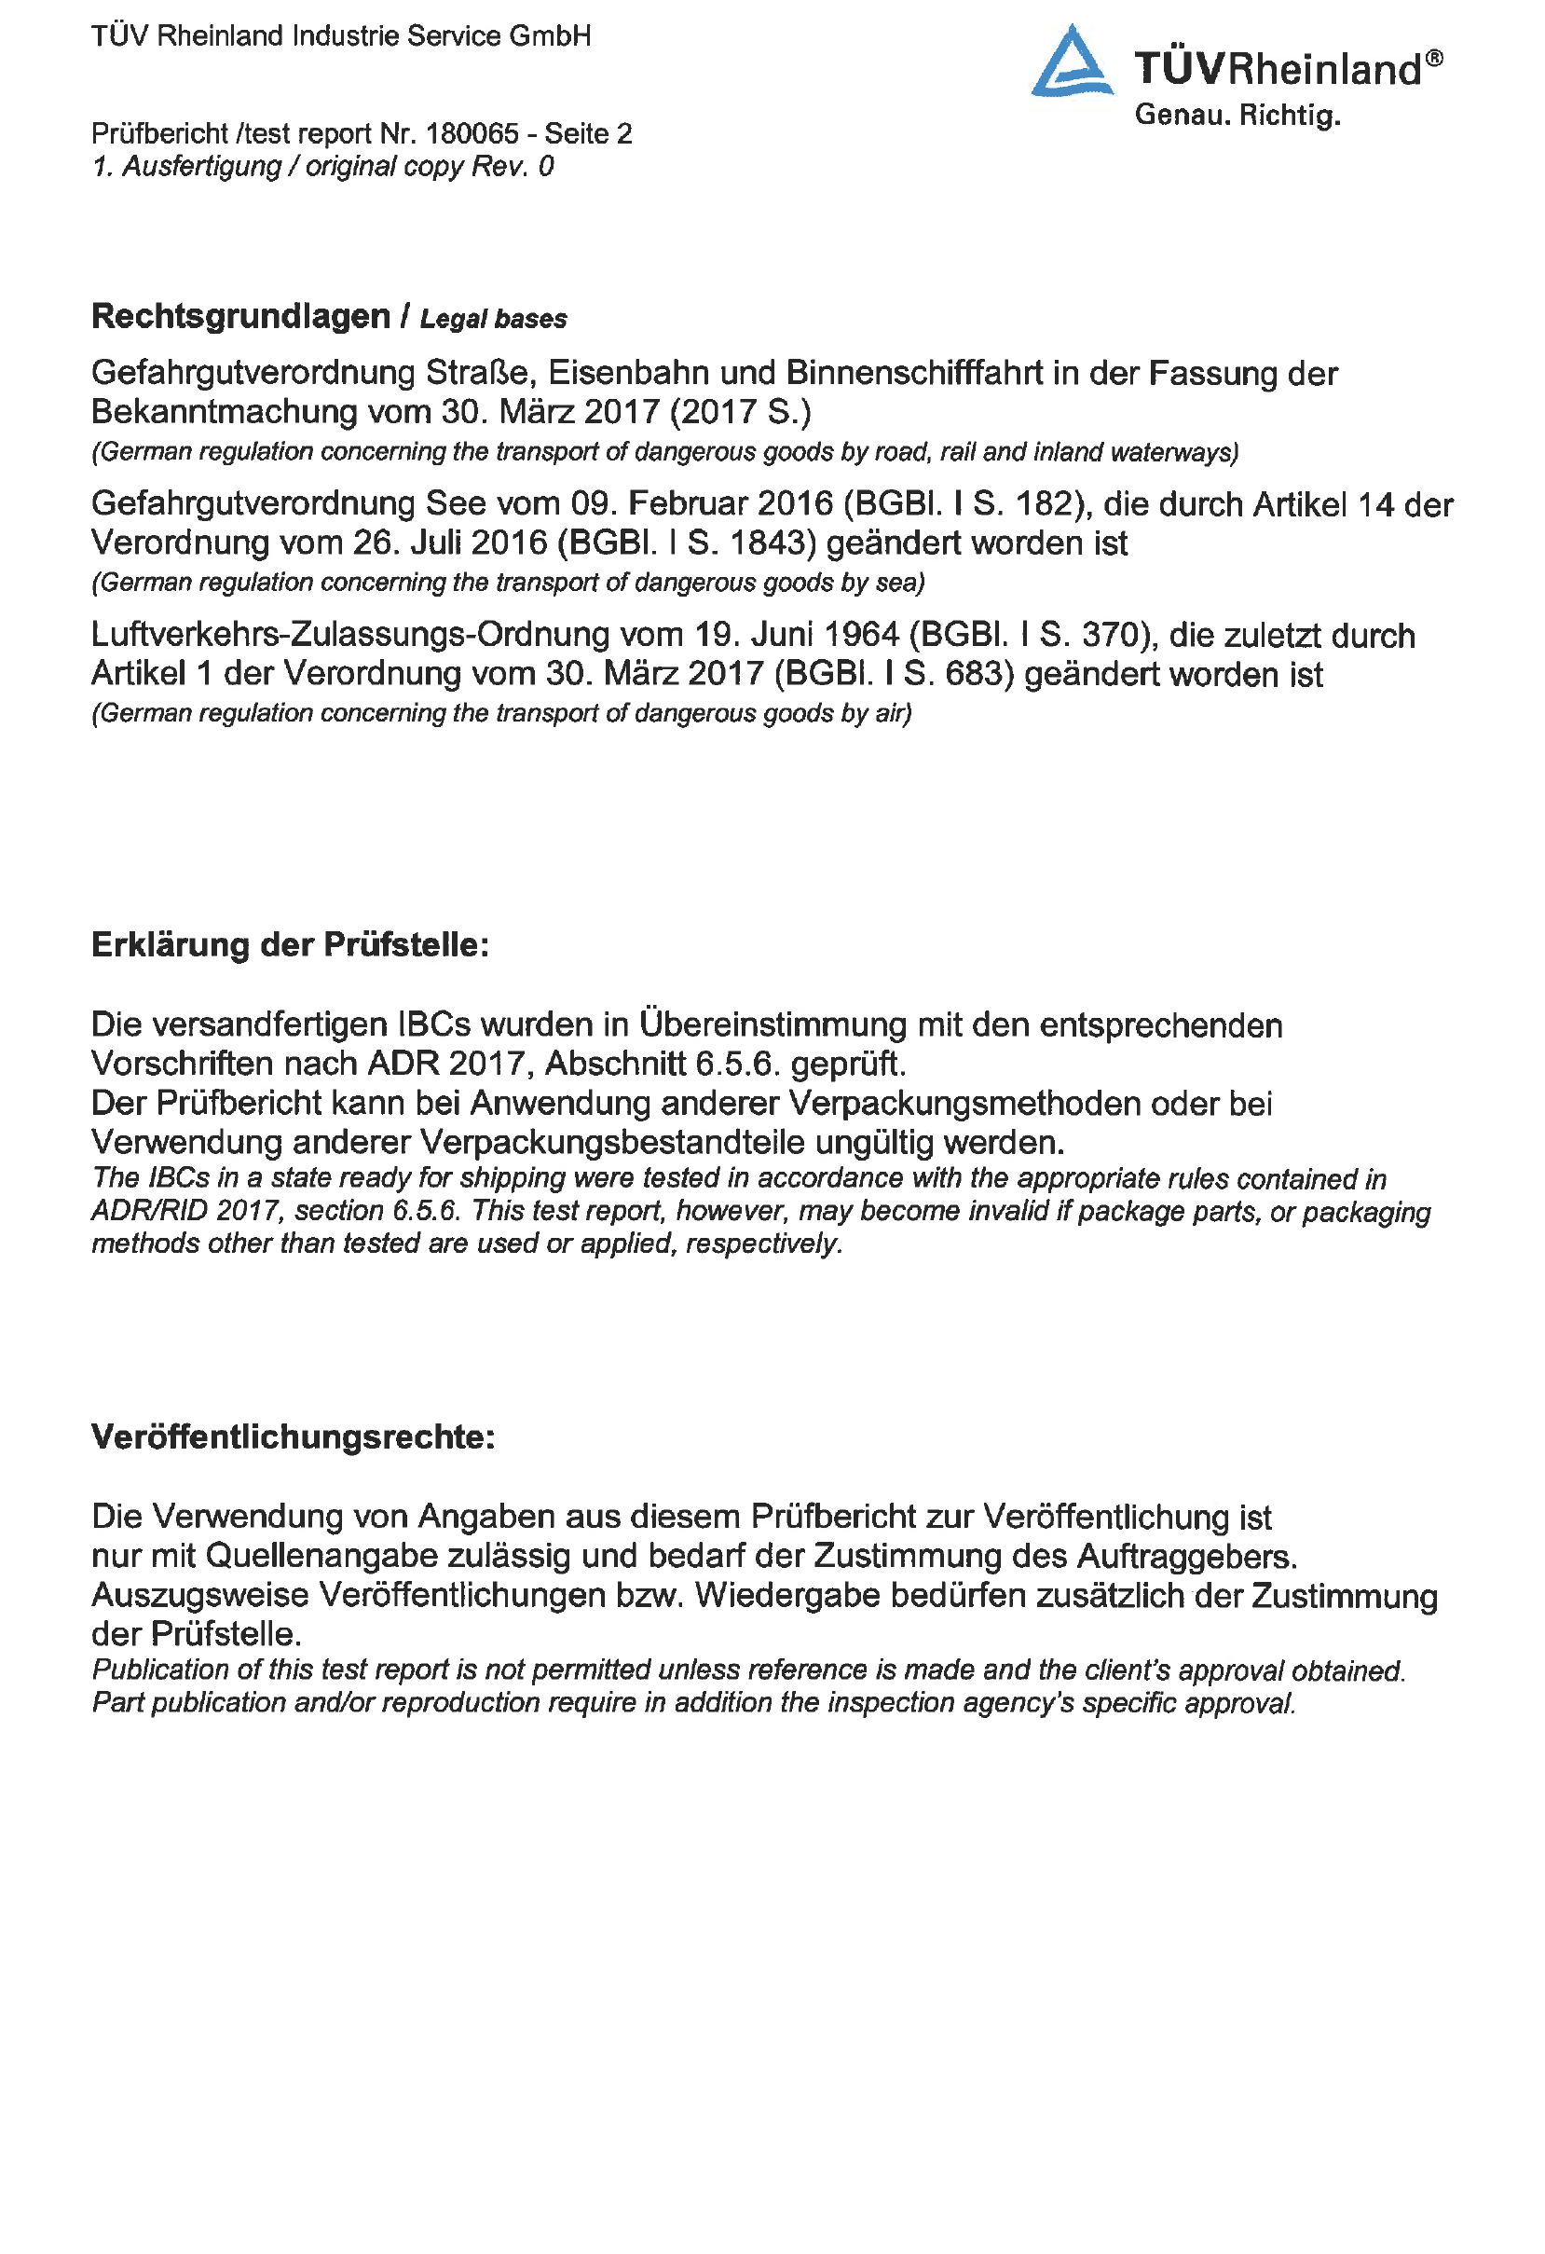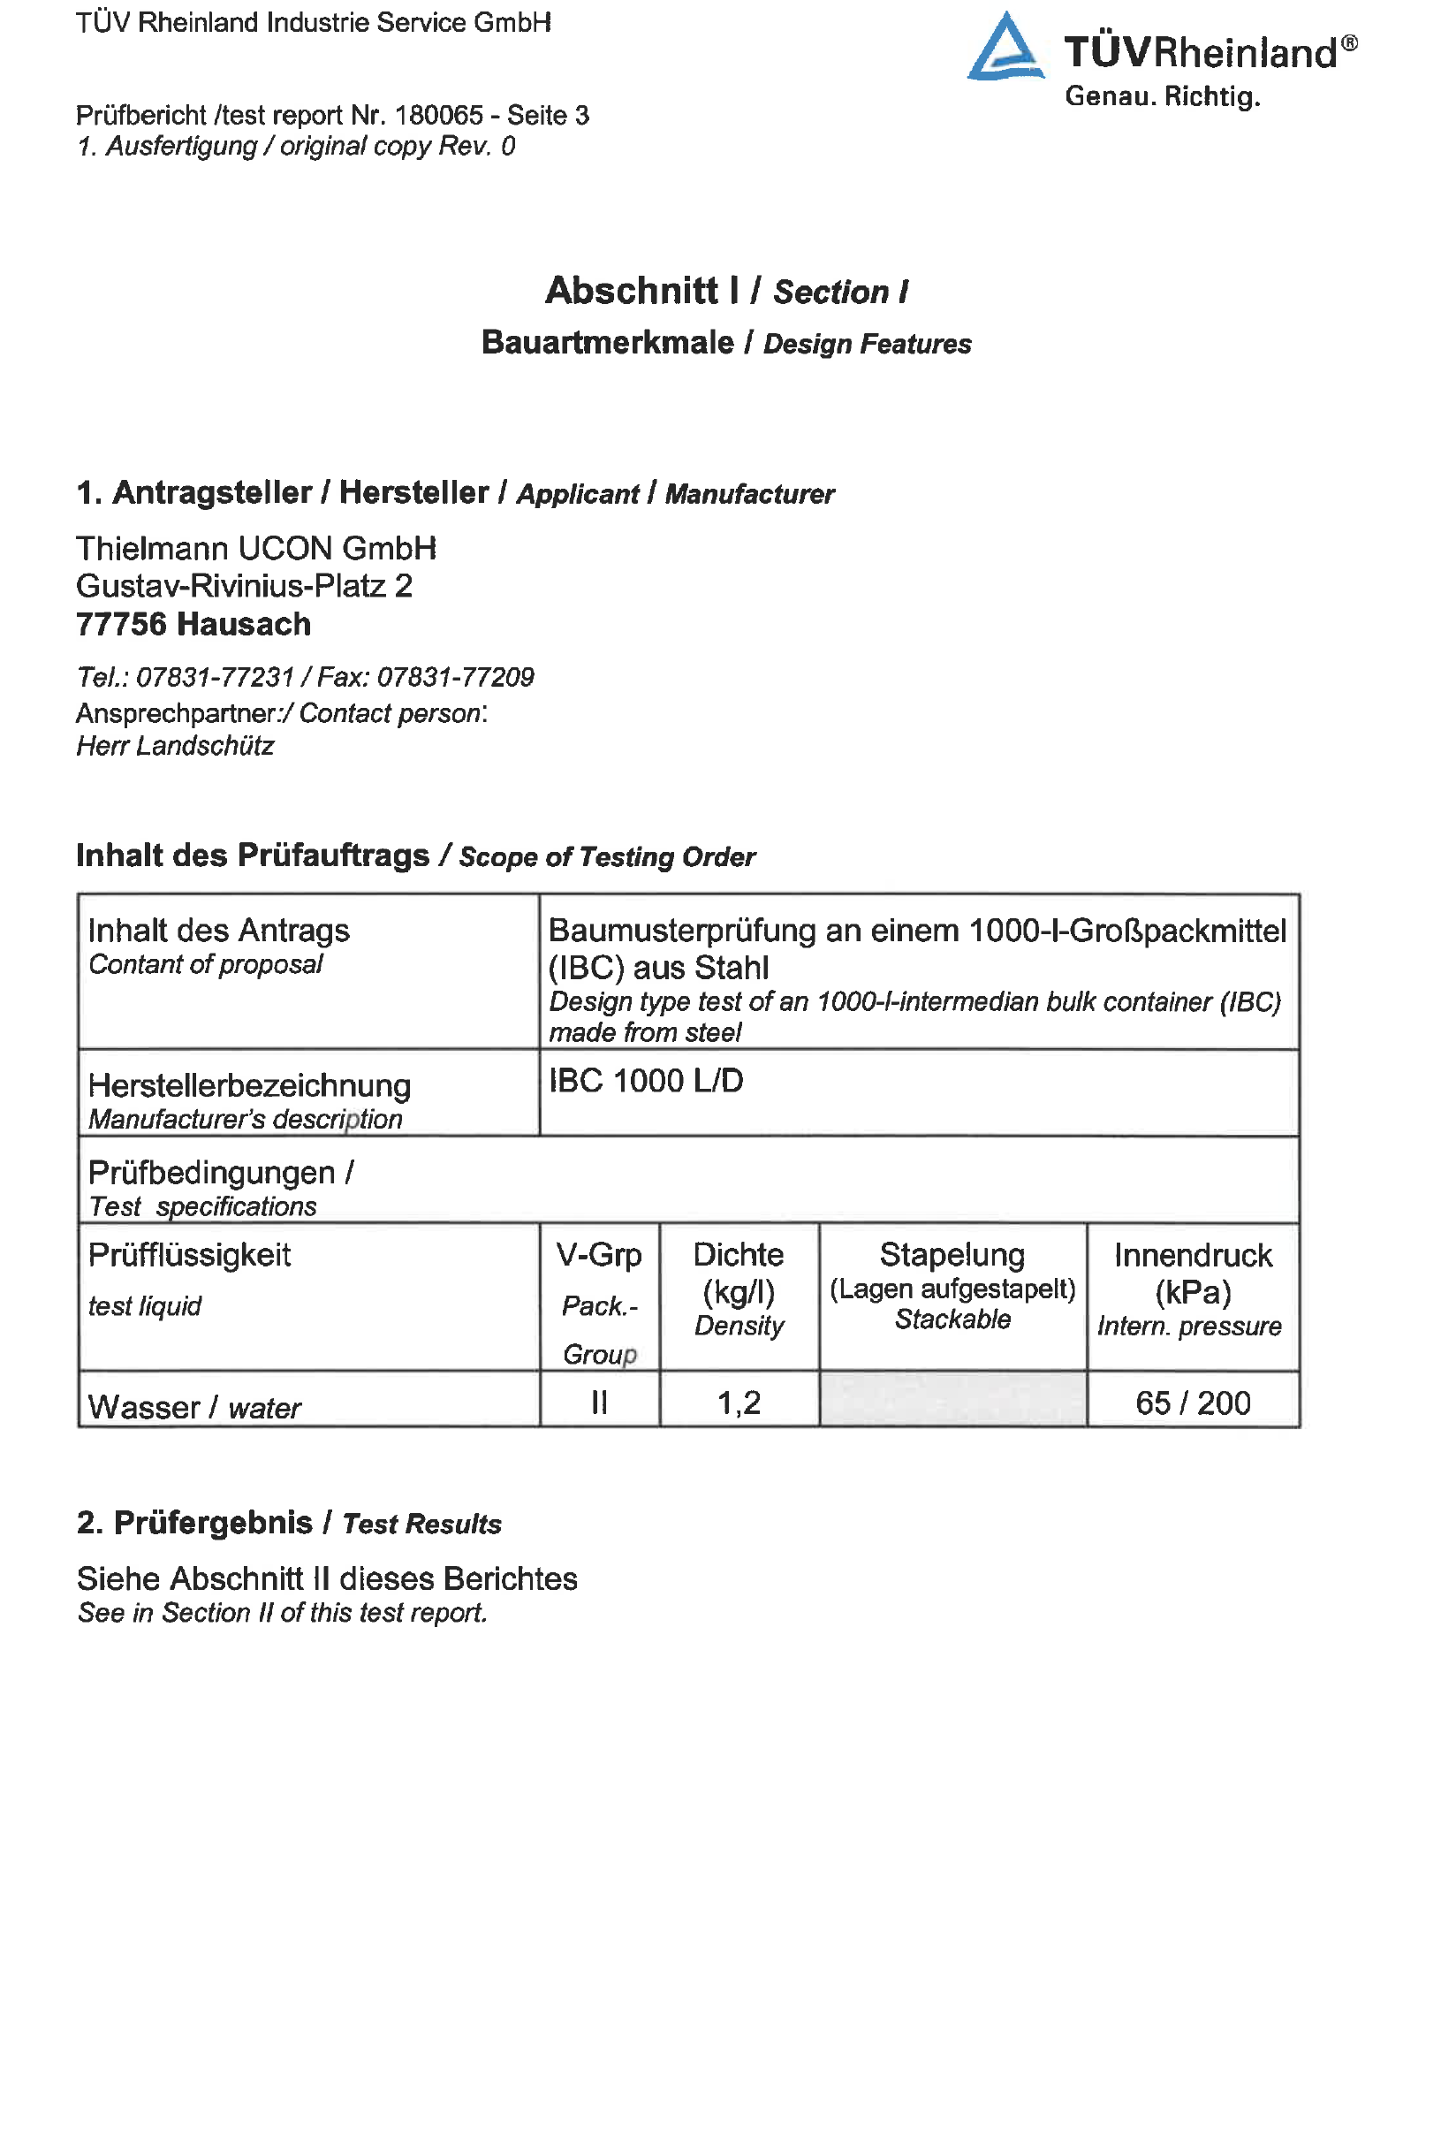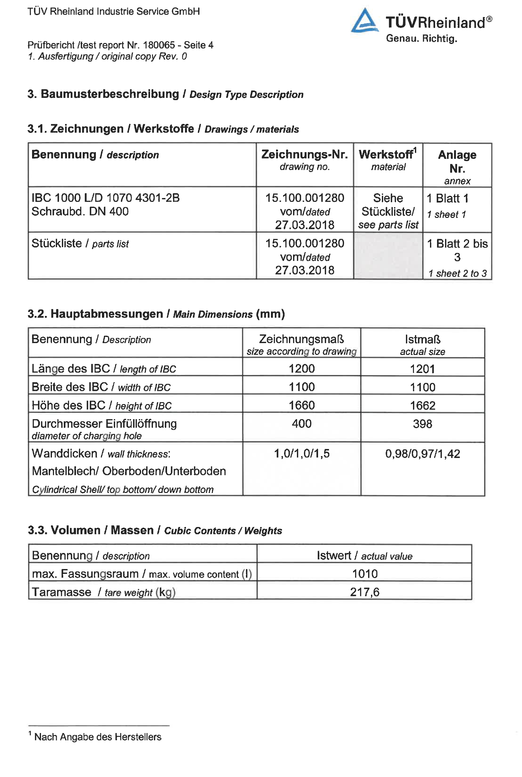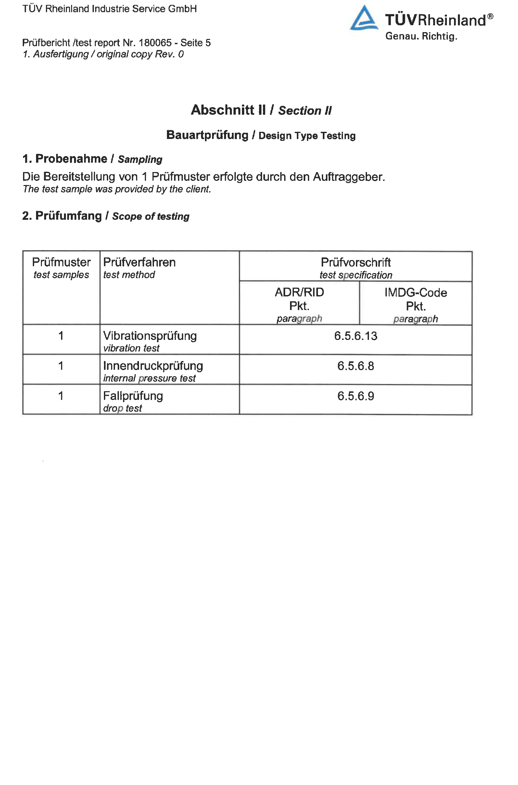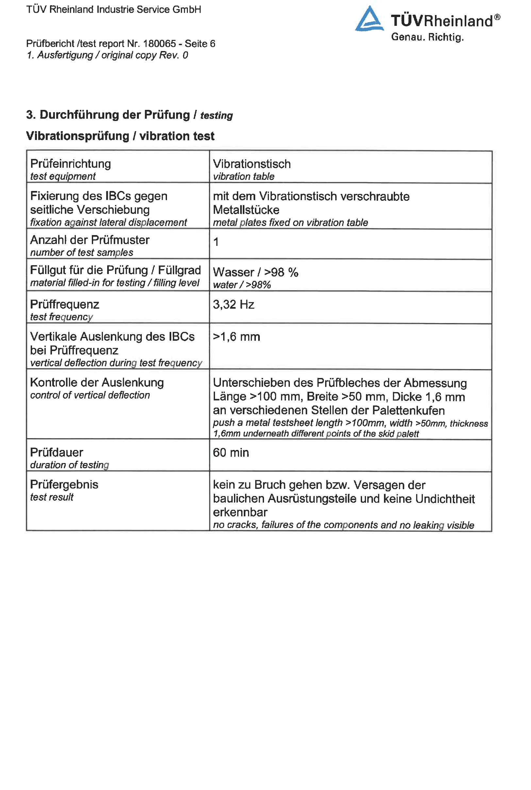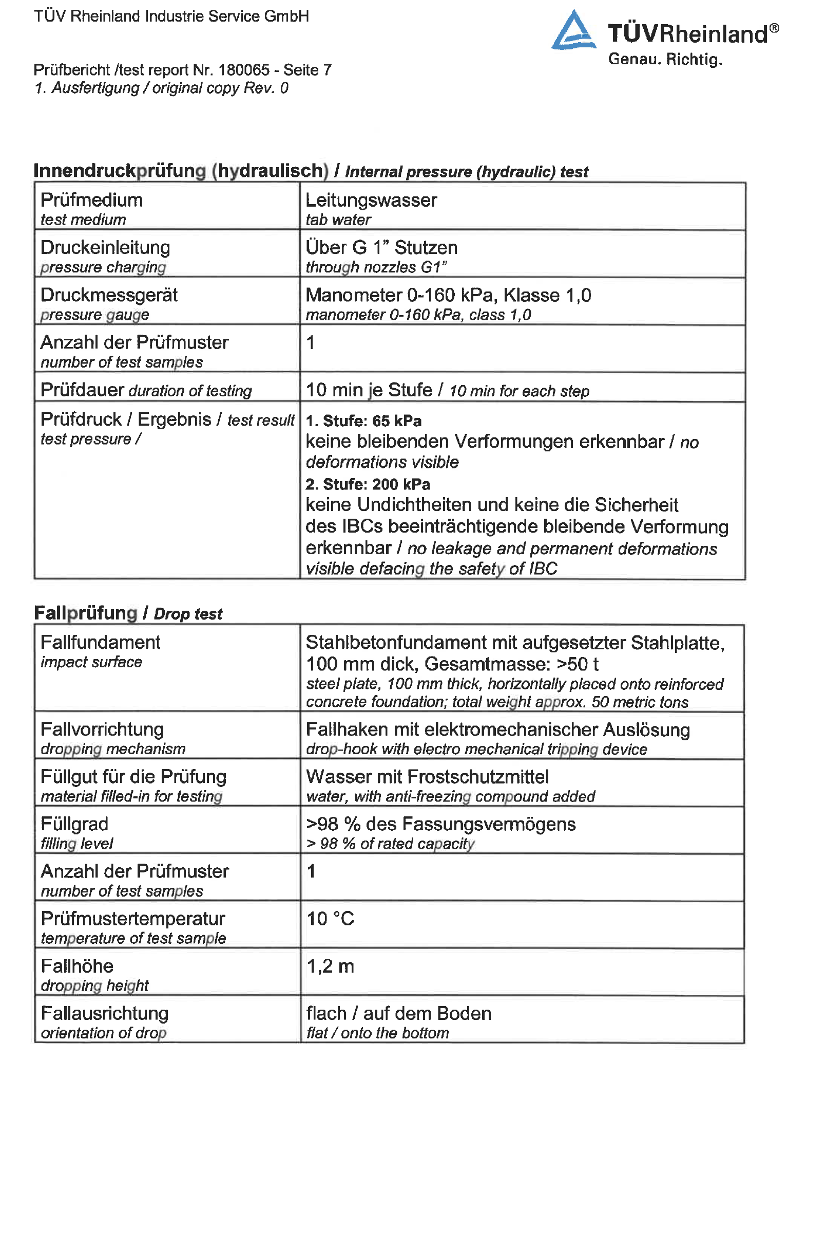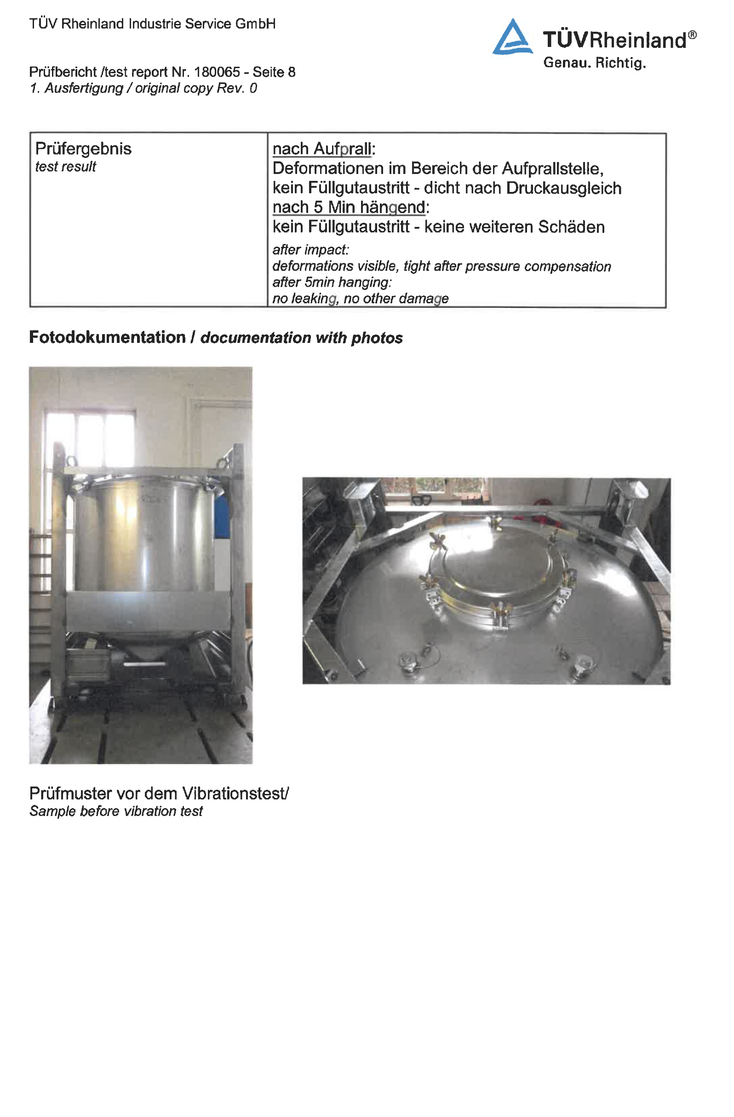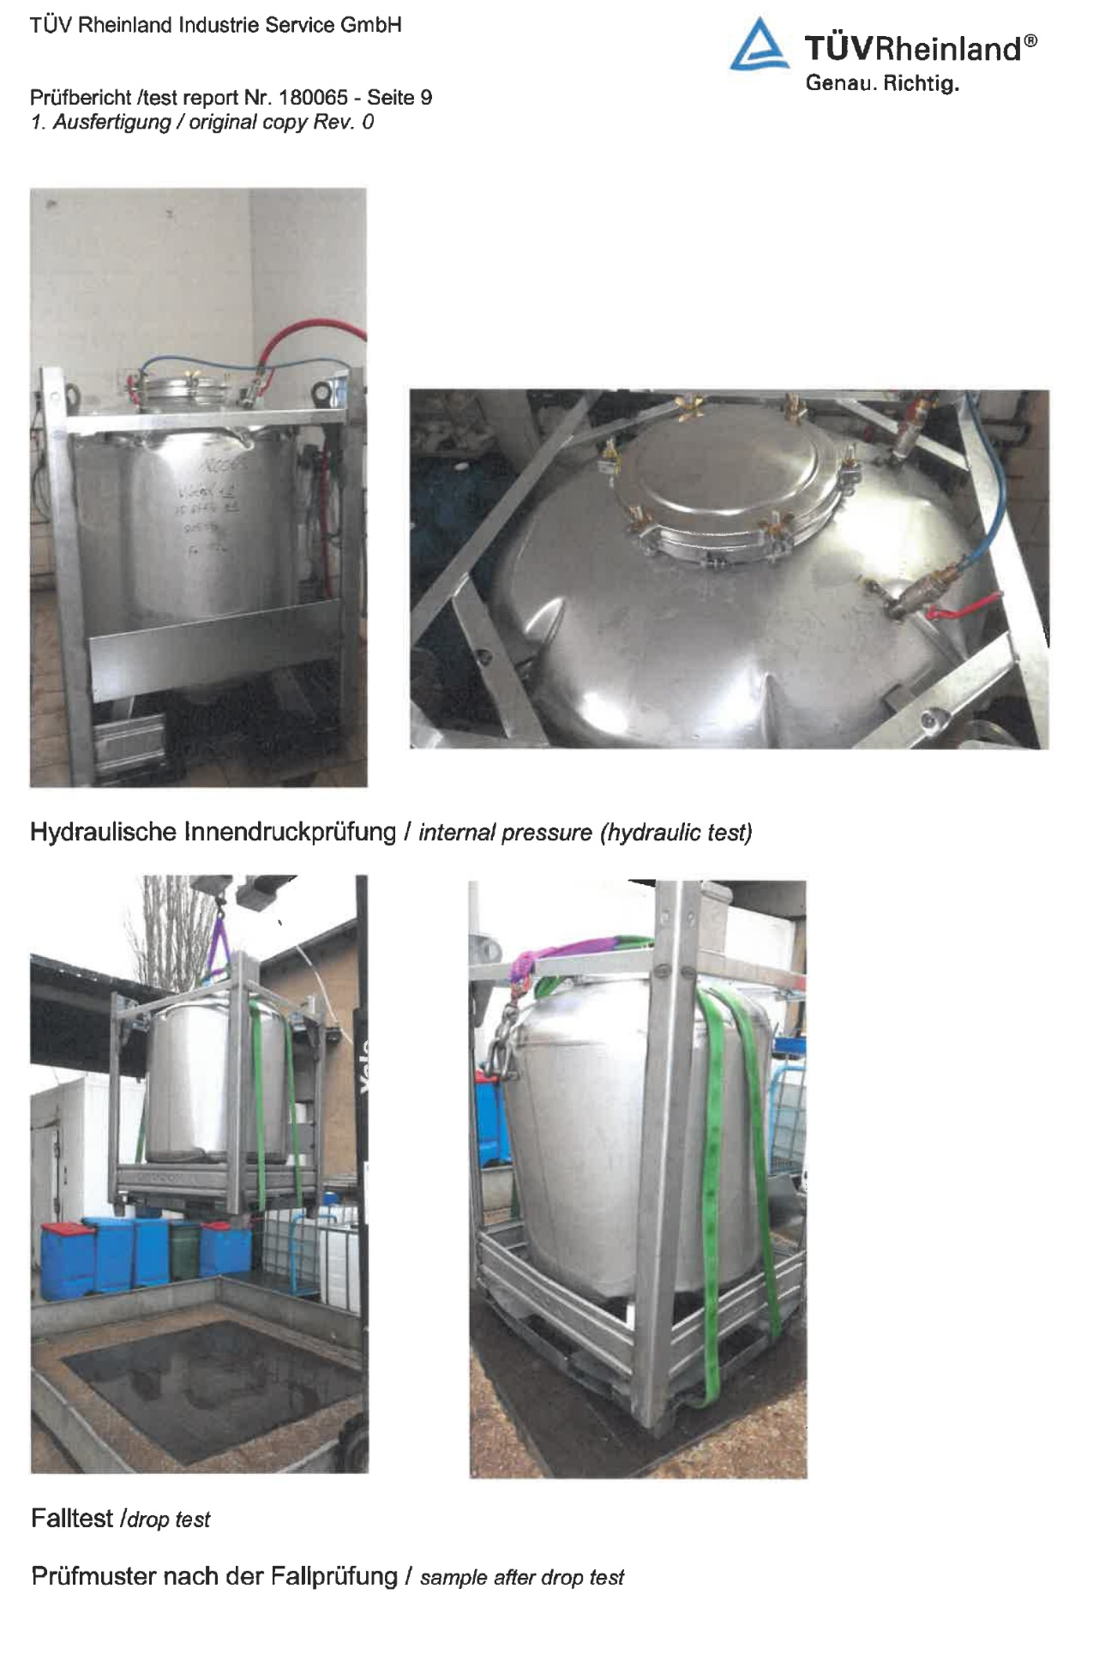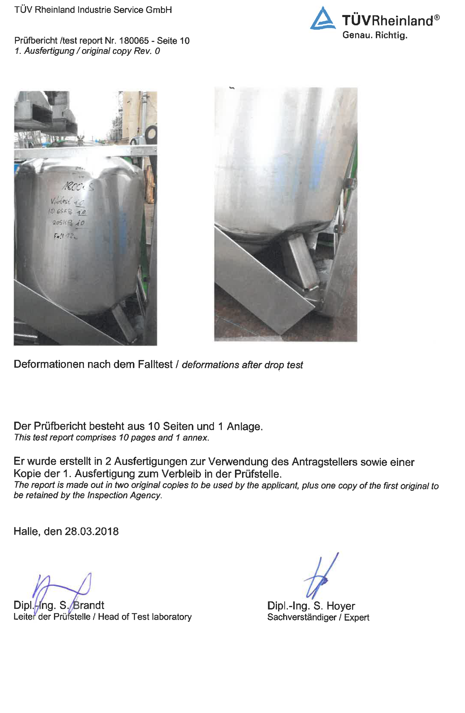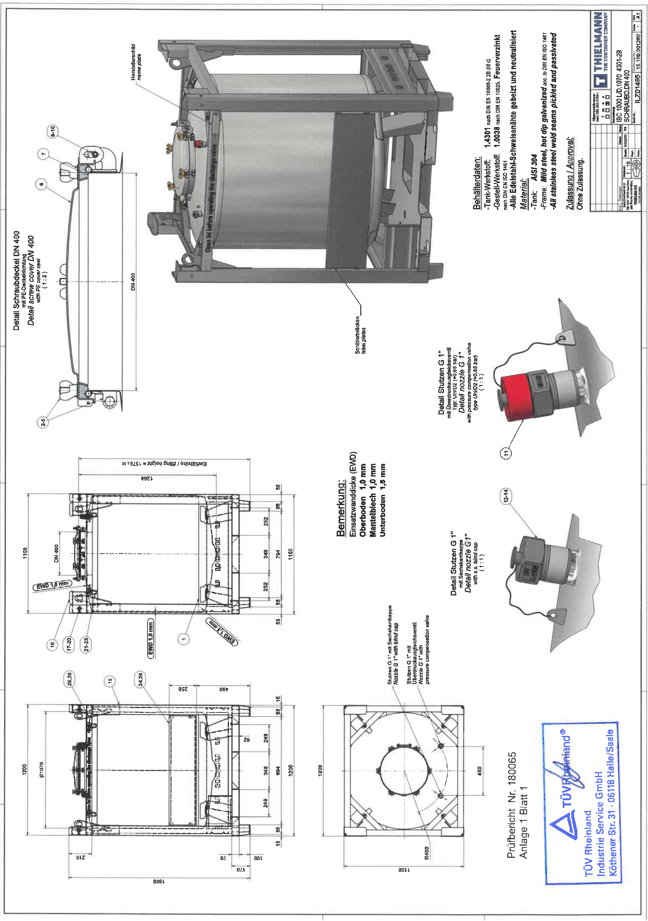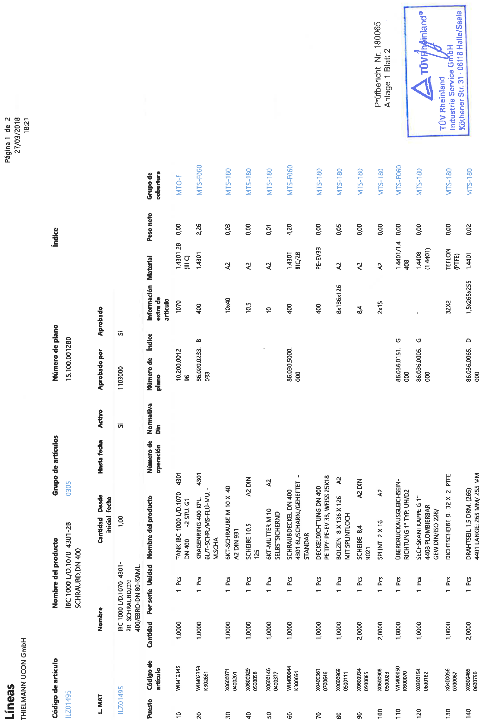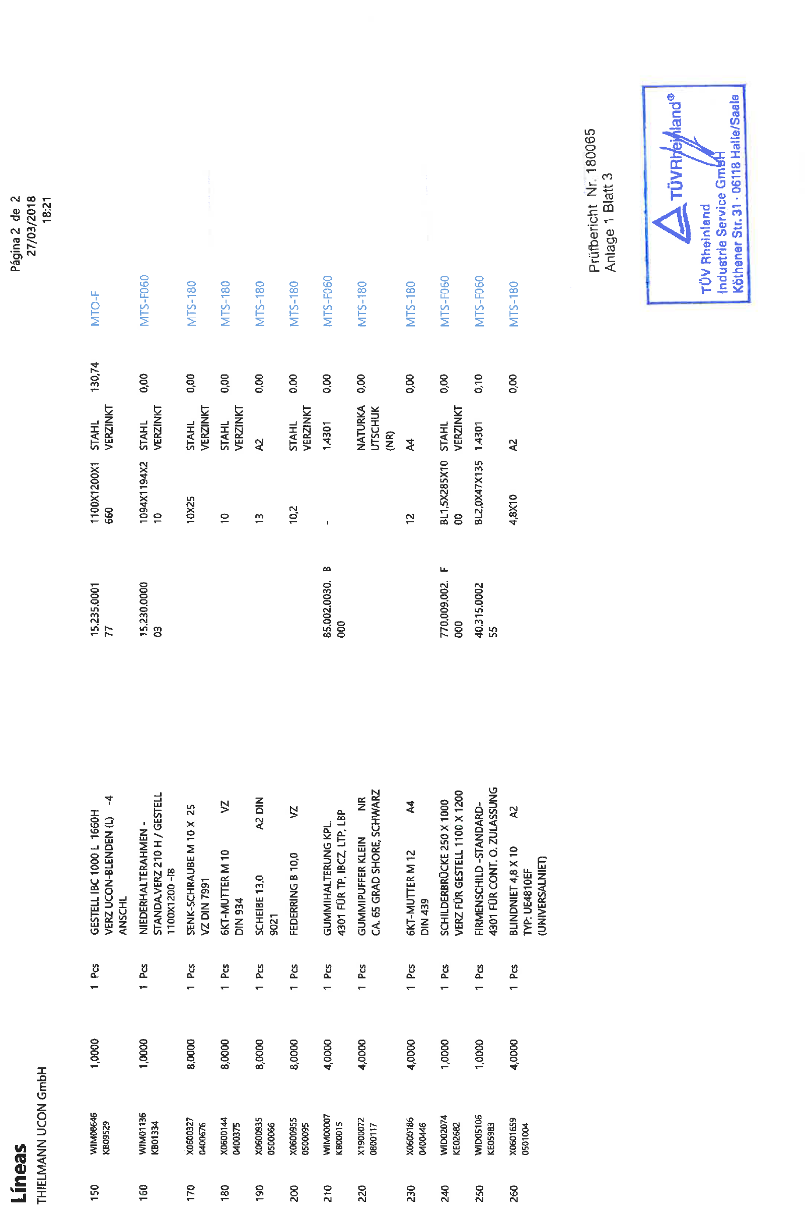

1. \* The annex is reproduced as received. [↑](#footnote-ref-2)
2. \*\* In accordance with the programme of work of the Sub-Committee for 2017–2018 approved by the Committee at its eighth session (see ST/SG/AC.10/C.3/100, paragraph 98 and ST/SG/AC.10/44, paragraph 14). [↑](#footnote-ref-3)