|  |  |  |  |
| --- | --- | --- | --- |
|  | United Nations | ECE/TRANS/2017/20 | |
| _unlogo | **Economic and Social Council** | | Distr.: General  12 December 2016  Original: English |

**Economic Commission for Europe**

Inland Transport Committee

**Seventy-ninth session**

Geneva, 21-24 February 2017  
Item 5 (g) of the provisional agenda  
**Strategic questions of a modal and thematic nature:  
Inland water transport**

Strategy of the Working Party on Inland Water Transport   
for 2016-2021

Note by the secretariat

|  |
| --- |
| *Summary* |
| This note presents the strategy for 2016-2021 adopted by the Working Party on Inland Water Transport (SC.3) on 4 November 2016 during its sixtieth session. This strategy aims to promote inland waterways development. It sets nine objectives and the necessary actions to reach them. |
| The Committee may wish to **take note** of this strategy and to **endorse** it. |
|  |

I. Introduction

1. This document presents the strategy to promote inland waterways development, as adopted by the Working Party on Inland Water Transport (SC.3) on 4 November 2016, during its sixtieth session (ECE/TRANS/SC.3/203, para. 29). The Inland Transport Committee (ITC) may wish to endorse this strategy.

2. The secretariat recalls that the strategy is limited to the period from 2016 until 2021. A longer-term strategy ‘IWT Vision 2030’ is expected to evolve from the strategic review of ITC in 2016-2017.

II. Inland Water Transport strategy 2016-2021

3. The activities of the Working Party are focused on a pan-European network of inland waterways of international importance with a sustainable and resilient infrastructure and services as an integrated part of inland transport networks and markets. The goal is to support economic development, with a focus on affordable and equitable access for all UNECE member States possessing navigable inland waterways. The activities encourage cost-efficient and safe services with a minimal impact on the environment, integrated with other transportation modes and focusing on the development of quality infrastructure that is resilient to climate change. It is important that national transport strategies support these aims and capitalise on the comparative advantages of Inland Water Transport (IWT). These key building blocks are set out in the figure below.

A. Integrated pan-European IWT infrastructure and services

Figure

**Key** **Building Blocks for the IWT strategy**

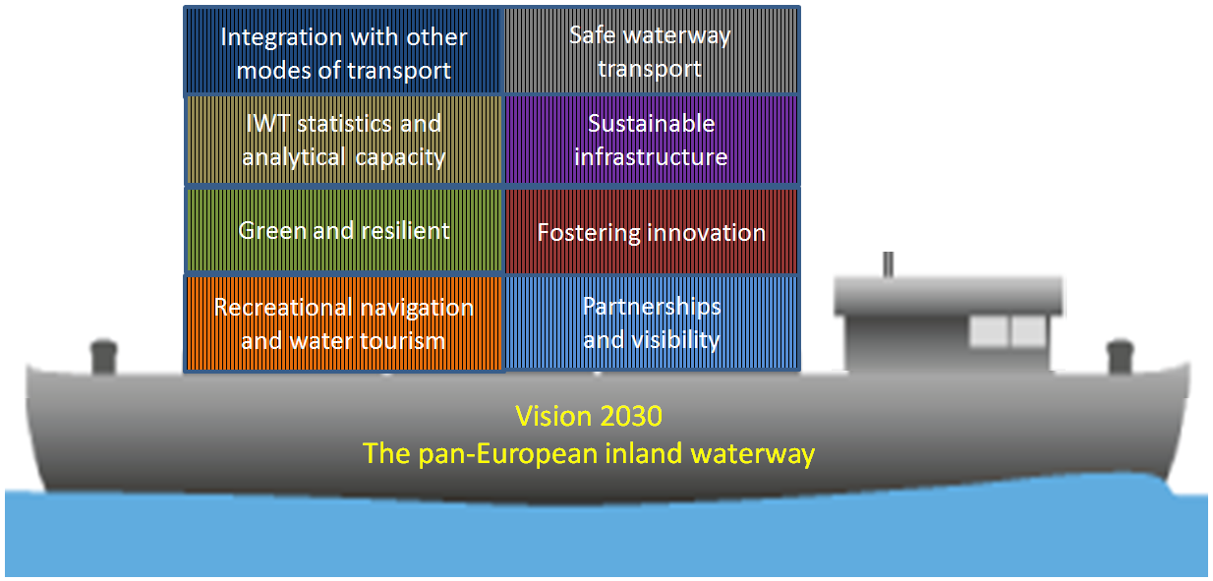

B. Overarching goals and objectives for 2016-2021

4. The overarching goal of the activities of the Working Party on Inland Water Transport is to support the development of resilient IWT infrastructure and services in a sustainable manner while fostering innovation. The period 2016-2021 would include the following objectives:

(a) consolidating efforts and involving all UNECE member States when addressing modern challenges and assisting the implementation of the Sustainable Development Goals where this is pertinent for the sector;

(b) supporting the development of IWT related statistics and analytical capacity aimed at providing much needed data for the sector;

(c) coordinating measures for further integration of IWT in multimodal transport chains;

(d) developing and maintaining efficient legal mechanisms aimed at ensuring equal and transparent conditions for all players;

(e) cooperation with new players on the European market as well as players from other regions of the world where they can benefit from the technical harmonization being developed by the Working Party;

(f) fostering innovations in the IWT sector;

(g) facilitate the development of synergic capabilities with maritime and land transport, on the one side, and water-related activities, on the other side;

(h) fostering RIS and other information and communication technologies (ICT) in inland navigation in all UNECE member States;

(i) developing partnerships and increasing the visibility of IWT.

C. Necessary actions to reach the above goals

5. The following actions are proposed to reach the above goals:

**1. Supporting the building of sustainable IWT infrastructure and services**

* Continue work on the pan-European and global policy dialogue on the IWT issues;
* Coordination of measures, policies and continuing the activities aimed at the development of an international platform for the promotion of IWT;
* Increasing the efficiency and effectiveness of international, legally binding, instruments and conventions;
* Further promotion of the European Agreement on Main Inland Waterways of International Importance (AGN), the Inventory of Main Standards and Parameters of the E-Waterway Network (Blue Book), in particular, infrastructure projects aimed at the implementation of AGN.

**2. Development of IWT related statistics and analytical capacity**

* Cooperation with the Working Party on Transport Statistics on IWT statistics and data collection and collection of inland water transport statistics of member States;
* Providing updated information and traffic development IWT related data also with the aim of supplementing the analysis undertaken by the ForFITS tool on assessing CO2 emission scenarios.

**3. Integration in multimodal transport chains**

* Detailed elaboration of coastal routes in AGN as well as hinterland connections of seaports;
* Further work on aligning the Protocol on Combined Transport on Inland Waterways to the European Agreement on Important International Combined Transport Lines and Related Installations (the AGTC Protocol) with AGN in cooperation with the Working Party on Intermodal Transport and Logistics; (WP.24)
* Contribution to the development of Euro-Asian Transport Links (EATL) in cooperation with the Working Party on Transport Trends and Economics (WP.5) and the Group of Experts on Euro-Asian Transport Links;
* Exchange of best practices across member States, international organizations and other stakeholders.

**4. Ensuring a safe mode of transport**

* Continue work on the European Code for Inland Waterways (CEVNI) provisions, waterway signs and marking, technical prescriptions for vessels taking into account recent developments of other international organizations in this field;
* Addressing professional requirements and recognition of certificates, monitoring the progress in this field.

**5. Prevention of environmental pollution and resilience of inland water transport**

* Continue discussion on the prevention of environmental pollution from vessels and waste management including revision of relevant SC.3 documents such as UNECE Resolutions Nos. 21 and 61;
* Detection of environmental hot spots coupled with planning measures aimed at minimizing their impact on inland navigation;
* Addressing inland waterways’ resilience to climate change via the follow-up of the activities of the Group of Experts on Climate Change Impacts and Adaptation for Transport Networks and Nodes and the Global Network of Basins Working on Climate Change Adaptation as applied to the E waterway network;
* Minimize the vulnerability of inland water transport infrastructure and continue exchange of best practices in this area.

**6. Fostering innovations**

* Promotion of RIS and other relevant information technology;
* Addressing new ship technologies, updating UNECE documents with due regard to new vessel types.

**7. Promotion of recreational navigation and water tourism**

* Assessment of options relating to the development of an international legal framework for recreational navigation and water tourism;
* Maintaining the database on models of the International Certificate for Operator of Pleasure Craft (ICC);
* Updating maps for recreational navigation;
* Ensure the availability of information on relevant UNECE documents.

**8. Developing partnerships and increasing the visibility of IWT**

* Cooperation and regular exchange of information with River Commissions, the European Commission (EU) and other stakeholders to avoid duplication of activities;
* Enhancing cooperation in specific topics with EU, River Commissions and other stakeholders to arrive at synergies;
* Increasing the visibility of IWT by means of international events, in particular, the international high-level conference to be held in 2017.