ECE/TRANS/WP.15/AC.1/HAR/2017/1/Rev.1
7 April 2017

Original: English

ECONOMIC COMMISSION FOR EUROPE

INLAND TRANSPORT COMMITTEE
Working Party on the Transport of Dangerous Goods

Joint Meeting of the RID Committee of Experts and the
Working Party on the Transport of Dangerous Goods

Ad hoc Working Group on the Harmonization of RID/ADR/ADN
with the UN Recommendations on the Transport of Dangerous Goods

Geneva, 25-27 April 2017
Harmonization with the United Nations Model Regulations on the Transport of Dangerous Goods
The UNECE secretariat has prepared a draft proposal of amendments to RID/ADR/ADN on the basis of the decisions taken by the UN Committee of Experts on the Transport of Dangerous Goods and on the Globally Harmonized System of Classification and Labelling of Chemicals at its December 2016 session.
The reference document is ST/SG/AC.10/44/Add.1.
Modifications to the above document are shown in track changes. Stricken out text means that the amendment does not seem relevant for RID/ADR/ADN. Text underlined means alternative wording proposed by the secretariat.
The amendments related to the use of the terms risk and hazard will be presented in document ECE/TRANS/WP.15/AC.1/HAR/2017/2.
This revised version contains additional consequential amendments in relation with new 2.1.5 and corrections and additional provisions for RID transmitted by the OTIF secretariat.

Chapter 1.1
[Consequential amendments should be added depending on the transport category assigned to the new entries in Table A.].
Chapter 1.2
1.2.1 In the definition of “Animal material”, replace “or animal foodstuffs” by “foodstuffs or feedstuffs derived from animals”.
1.2.1 In the definition of “GHS”, replace “sixth” by “seventh” and replace “ST/SG/AC.10/30/Rev.6” by “ST/SG/AC.10/30/Rev.7”.

1.2.1 In the definition of “Manual of Tests and Criteria”, after “ST/SG/AC.10/11/Rev.6”, insert “and Amend.1”.
Chapter 1.10
1.10.3 After the heading, insert the following note:
“NOTE: In addition to the security provisions of RID/ADR/ADN, competent authorities may implement further security provisions for reasons other than safety of dangerous goods during carriage. In order to not impede international and multimodal carriage by different explosives security markings, it is recommended that such markings be formatted consistent with an internationally harmonized standard (e.g. European Union Commission Directive 2008/43/EC).”.
[Note: The Working Groupe may wish to delete the first sentence bearing in mind ADR Article 4 § 1 and in Article 3 of Appendix C to COTIF]
Chapter 2.1
[Covered by 2.1.2.5]
2.1.4 Add the following new sub-section 2.1.4.3:
“2.1.4.3 Samples of energetic materials for testing purposes
2.1.4.3.1 Samples of organic substances carrying functional groups listed in tables A6.1 and/or A6.3 in Appendix 6 (Screening Procedures) of the Manual of Tests and Criteria may be carried under UN No. 3224 (self-reactive solid type C) or UN No. 3223 (self-reactive liquid type C), as applicable, of Class 4.1 provided that:
(a) The samples do not contain any:
- Known explosives;
- Substances showing explosive effects in testing;
- Compounds designed with the view of producing a practical explosive or pyrotechnic effect; or
- Components consisting of synthetic precursors of intentional explosives;
(b) For mixtures, complexes or salts of inorganic oxidizing substances of Class 5.1 with organic material(s), the concentration of the inorganic oxidizing substance is:
- Less than 15%, by mass, if assigned to packing group I (high hazard) or II (medium hazard); or
- Less than 30%, by mass, if assigned to packing group III (low hazard);
(c) Available data do not allow a more precise classification;
(d) The sample is not packed together with other goods; and
(e) The sample is packed in accordance with packing instruction P520 and special packing provisions PP94 or PP95 of 4.1.4.1, as applicable.”.
2.1.5 Add the following new section 2.1.5 and renumber existing 2.1.5 as 2.1.6:
“2.1.5 Classification of articles as articles containing dangerous goods, N.O.S.
NOTE: For articles which do not have an existing proper shipping name and which contain only dangerous goods within the permitted limited quantity amounts specified in Column 7a of the Dangerous Goods List, see UN No. 3363 and special provision 301 of Chapter 3.3.
2.1.5.1 Articles containing dangerous goods may be carried as otherwise provided by RID/ADR/ADN under the proper shipping name for the dangerous goods they contain or in accordance with this section. For the purposes of this section “article” means machinery, apparatus or other devices containing one or more dangerous goods (or residues thereof) that are an integral element of the article, necessary for its functioning and that cannot be removed for the purpose of carriage. An inner packaging shall not be an article.
2.1.5.2 Such articles may in addition contain batteries. Lithium batteries that are integral to the article shall be of a type proven to meet the testing requirements of the Manual of Tests and Criteria, part III, sub-section 38.3, except when otherwise specified by RID/ADR/ADN (e.g. for pre-production prototype articles containing lithium batteries or for a small production run, consisting of not more than 100 such articles).
2.1.5.3 This section does not apply to articles for which a more specific proper shipping name already exists in Table A of Chapter 3.2.
2.1.5.4 This section does not apply to dangerous goods of Class 1, Class 6.2, Class 7 or radioactive material contained in articles.
2.1.5.5 Articles containing dangerous goods shall be assigned to the appropriate Class determined by the hazards present using, where applicable, the table of precedence of hazard in 2.1.3.10 for each of the dangerous goods contained in the article. If dangerous goods classified as Class 9 are contained within the article, all other dangerous goods present in the article shall be considered to present a higher hazard.
2.1.5.6 Subsidiary hazards shall be representative of the primary hazard posed by the other dangerous goods contained within the article or they shall be the subsidiary hazard(s) identified by the subsidiary hazard label(s) in column (5) of Table A of Chapter 3.2 when only one item of dangerous good is present in the article. If the article contains more than one dangerous good and these could react dangerously with one another during carriage, each of the dangerous goods shall be enclosed separately (see 4.1.1.6).”.
Consequential amendments in the Table of Contents.
[Consequential amendments:
Delete 1.1.3.1 (b) and add “(b) Deleted.”.
Insert special provision 301 in Chapter 3.3:
“301 This entry only applies to machinery or apparatus containing dangerous goods as a residue or an integral element of the machinery or apparatus. It shall not be used for machinery or apparatus for which a proper shipping name already exists in the Dangerous Goods List of Chapter 3.2. Machinery and apparatus transported under this entry shall only contain dangerous goods which are authorized to be transported in accordance with the provisions of Chapter 3.4 (Limited quantities). The quantity of dangerous goods in machinery or apparatus shall not exceed the quantity specified in Column 7a of the Dangerous Goods List of Chapter 3.2 for each item of dangerous goods contained. If the machinery or apparatus contains more than one item of dangerous goods, the individual dangerous goods shall be enclosed to prevent them reacting dangerously with one another during transport (see 4.1.1.6). When it is required to ensure liquid dangerous goods remain in their intended orientation, package orientation labels meeting the specifications of ISO 780:1997 shall be affixed on at least two opposite vertical sides with the arrows pointing in the correct direction.
The competent authority may exempt from regulation machinery or apparatus which would otherwise be transported under this entry.”.
In Table A, replace the row for UN No 3363 by the following:
(1) | (2) | (3a) | (3b) | (4) | (5) | (6) | (7a) | (7b) | (8) | (9a) | (9b) | (10) | (11) | (12) – (20)
3363 | DANGEROUS GOODS IN MACHINERY or DANGEROUS GOODS IN APPARATUS | 9 | M11 | - | 9 |  | 0 | E0 | P907
2.2.9.3 For M11, insert
“3363 DANGEROUS GOODS IN MACHINERY or
3363 DANGEROUS GOODS IN APPARATUS”
4.1.4.1 Insert the following P907:
P907 | PACKING INSTRUCTION | P907
If the machinery or apparatus is constructed and designed so that the receptacles containing the dangerous goods are afforded adequate protection, an outer packaging is not required. Dangerous goods in machinery or apparatus shall otherwise be packed in outer packagings constructed of suitable material, and of adequate strength and design in relation to the packaging capacity and its intended use, and meeting the applicable requirements of 4.1.1.1.
Receptacles containing dangerous goods shall conform to the general provisions in 4.1.1, except that 4.1.1.3, 4.1.1.4, 4.1.1.12 and 4.1.1.14 do not apply. For Division 2.2 gases, the inner cylinder or receptacle, its contents and filling density shall be to the satisfaction of the competent authority of the country in which the cylinder or receptacle is filled.
In addition, the manner in which receptacles are contained within the machinery or apparatus, shall be such that under normal conditions of transport, damage to receptacles containing the dangerous goods is unlikely; and in the event of damage to receptacles containing solid or liquid dangerous goods, no leakage of the dangerous goods from the machinery or apparatus is possible (a leakproof liner may be used to satisfy this requirement). Receptacles containing dangerous goods shall be so installed, secured or cushioned as to prevent their breakage or leakage and so as to control their movement within the machinery or apparatus during normal conditions of transport. Cushioning material shall not react dangerously with the content of the receptacles. Any leakage of the contents shall not substantially impair the protective properties of the cushioning material.
]
Chapter 2.2
2.2.1.1.1 (c) Replace “practical effect by explosion or a pyrotechnic effect” by “practical explosive or pyrotechnic effect”.
2.2.1.1.7.1 (a) Replace “giving a positive result when tested in one of the HSL Flash composition tests in Appendix 7 of the Manual of Tests and Criteria” by “containing flash composition (see Note 2 of 2.2.1.1.7.5)”.
2.2.1.1.7.5 Amend Note 2 to read as follows:
“NOTE 2: “Flash composition” in this table refers to pyrotechnic substances in powder form or as pyrotechnic units as presented in the firework that are used in waterfalls, or to produce an aural effect or used as a bursting charge, or propellant charge unless:
(a) The time taken for the pressure rise in the HSL Flash Composition Test in Appendix 7 of the Manual of Tests and Criteria is demonstrated to be more than 6 ms for 0.5 g of pyrotechnic substance; or
(b) The pyrotechnic substance gives a negative “-” result in the US Flash Composition Test in Appendix 7 of the Manual of Tests and Criteria.”.
2.2.1.1.7.5 In the table, amend the entry for “waterfall” as follows: For classification 1.1G, amend the entry under “Specification” to read: “containing flash composition regardless of the results of Test Series 6 (see 2.2.1.1.7.1 (a))”. For classification 1.3G, amend the entry under “Specification” to read: “not containing flash composition”.

2.2.41.4 At the end of the first paragraph, add a new sentence to read as follows: “The formulations listed in packing instruction IBC520 of 4.1.4.2 and in portable tank instruction T23 of 4.2.5.2.6 may also be carried packed in accordance with packing method OP8 of packing instruction P520 of 4.1.4.1 <(ADR only:), with the same control and emergency temperatures, if applicable>.”.
2.2.41.4 In the table, insert a new entry to read as follows:
SELF-REACTIVE SUBSTANCE | Concentration (%) | Packing  method | (ADR only:)  Control  tempe-rature  (°C) | (ADR only:)  Emergency temperature  (°C) | UN generic entry | Remarks
Phosphorothioic acid, O-[(cyanophenyl methylene) azanyl] O,O-diethyl ester | 82-91  (Z isomer) | OP8 |  |  | 3227 | (10)
2.2.41.4 After the table, add a new remark (10) to read as follows:
“(10) This entry applies to the technical mixture in n-butanol within the specified concentration limits of the (Z) isomer.”.

(ADR only:) 2.2.41.1.21 Add the following Note at the end:
“NOTE: Substances meeting the criteria of a polymerizing substance and also for inclusion in Classes 1 to 8 are subject to the requirements of special provision 386 of Chapter 3.3.”.

Insert a new 2.2.51.1.7 to read as follows and renumber subsequent paragraphs accordingly:
“2.5.2.1.2 By exception, solid ammonium nitrate based fertilizers shall be classified in accordance with the procedure as set out in the Manual of Tests and Criteria, Part III, Section 39.”.
Consequential amendment:
2.2.51.1.3 and 2.2.51.1.5 Replace “2.2.51.1.9” by “2.2.51.1.10”
2.2.52.4 At the end of the first paragraph, add a new sentence to read as follows: “The formulations listed in packing instruction IBC520 of 4.1.4.2 and in portable tank instruction T23 of 4.2.5.2.6 may also be carried packed in accordance with packing method OP8 of packing instruction P520 of 4.1.4.1 <(ADR only:), with the same control and emergency temperatures, if applicable>.”.
2.2.52.4 In the table, insert the following new entries:
Organic peroxide | (2) | (3) | (4) | (5) | (6) | (7) | (8) | (9) | (10) | (11)
Diisobutyryl peroxide | ≤ 42 (as a stable dispersion in water) |  |  |  |  | OP8 | (ADR only:)-20 | (ADR only:)-10 | 3119 | (RID only:) prohibited
Di-(4-tert-butylcyclohexyl) peroxydicarbonate | ≤ 42 (as a paste) |  |  |  |  | OP7 | (ADR only:)35 | (ADR only:)40 | 3116 | (RID only:) prohibited
1-phenylethyl hydroperoxide | ≤ 38 |  | ≥ 62 |  |  | OP8 |  |  | 3109

2.2.62.1.3 In the definition of “Patient specimens”, after “Patient specimens are” replace “human or animal materials,” by “those”.
2.2.62.1.12.2 Delete the existing paragraph and add “2.2.62.1.12.2 Deleted”.

Amend Section 2.2.8 to read as follows:
“
2.2.8 CLASS 8 CORROSIVE SUBSTANCES
2.2.8.1 Definition and general provisions
2.2.8.1.1 Corrosive substances are substances which, by chemical action, will cause irreversible damage to the skin, or, in the case of leakage, will materially damage, or even destroy, other goods or the means of carriage.
2.2.8.1.2 For substances and mixtures that are corrosive to skin, general classification provisions are provided in sub-section 2.2.8.2. Skin corrosion refers to the production of irreversible damage to the skin, namely, visible necrosis through the epidermis and into the dermis occurring after exposure to a substance or mixture.
2.2.8.1.3 Liquids and solids which may become liquid during carriage, which are judged not to be skin corrosive shall still be considered for their potential to cause corrosion to certain metal surfaces in accordance with the criteria in 2.2.8.3.3 (c) (ii).
2.2.8.1.4 General classification provisions
Insert existing 2.2.8.1.2 (Class 8 subdivisions) renumbered as 2.2.8.1.4.1
2.2.8.1.4.2 Substances and mixtures of Class 8 are divided among the three packing groups according to their degree of danger in carriage:
(a) Packing group I: very dangerous substances and mixtures;
(b) Packing group II: substances and mixtures presenting medium danger;
(c) Packing group III: substances and mixtures that present minor danger.
2.2.8.1.4.3 Allocation of substances listed in Table A of Chapter 3.2 to the packing groups in Class 8 has been made on the basis of experience taking into account such additional factors as inhalation risk (see 2.2.8.1.4.5) and reactivity with water (including the formation of dangerous decomposition products).
2.2.8.1.4.4 New substances and mixtures can be assigned to packing groups on the basis of the length of time of contact necessary to produce irreversible damage of intact skin tissue in accordance with the criteria in 2.2.8.1.5. Alternatively, for mixtures, the criteria in 2.2.8.1.6 can be used.
2.2.8.1.4.5 A substance or mixture meeting the criteria of Class 8 having an inhalation toxicity of dusts and mists (LC₅₀) in the range of packing group I, but toxicity through oral ingestion or dermal contact only in the range of packing group III or less, shall be allocated to Class 8 (see 2.2.61.1.7.2).
2.2.8.1.5 Packing group assignment for substances and mixtures
2.2.8.1.5.1 Existing human and animal data including information from single or repeated exposure shall be the first line of evaluation, as they give information directly relevant to effects on the skin.
2.2.8.1.5.2 In assigning the packing group in accordance with 2.2.8.1.4.4, account shall be taken of human experience in instances of accidental exposure. In the absence of human experience the grouping shall be based on data obtained from experiments in accordance with OECD Test Guideline 404 or 435. A substance or mixture which is determined not to be corrosive in accordance with OECD Test Guideline 430 or 431 may be considered not to be corrosive to skin for the purposes of RID/ADR/ADN without further testing.
2.2.8.1.5.3 Packing groups are assigned to corrosive substances in accordance with the following criteria (see table 2.2.8.1.5.3):
(a) Packing group I is assigned to substances that cause irreversible damage of intact skin tissue within an observation period up to 60 minutes starting after the exposure time of three minutes or less;
(b) Packing group II is assigned to substances that cause irreversible damage of intact skin tissue within an observation period up to 14 days starting after the exposure time of more than three minutes but not more than 60 minutes;
(c) Packing group III is assigned to substances that:
(i) Cause irreversible damage of intact skin tissue within an observation period up to 14 days starting after the exposure time of more than 60 minutes but not more than 4 hours; or
(ii) Are judged not to cause irreversible damage of intact skin tissue but which exhibit a corrosion rate on either steel or aluminium surfaces exceeding 6.25 mm a year at a test temperature of 55 °C when tested on both materials. For the purposes of testing steel, type S235JR+CR (1.0037 resp. St 37-2), S275J2G3+CR (1.0144 resp. St 44-3), ISO 3574 or Unified Numbering System (UNS) G10200 or a similar type or SAE 1020, and for testing aluminium, non-clad, types 7075–T6 or AZ5GU-T6 shall be used. An acceptable test is prescribed in the Manual of Tests and Criteria, Part III, Section 37.
NOTE: Where an initial test on either steel or aluminium indicates the substance being tested is corrosive the follow up test on the other metal is not required.
Table 32.2.8.1.5.3: Table summarizing the criteria in 2.2.8.1.5.3
Packing Group | Exposure  Time | Observation Period | Effect
I | ≤ 3 min | ≤ 60 min | Irreversible damage of intact skin
II | > 3 min ≤ 1 h | ≤ 14 d | Irreversible damage of intact skin
III | > 1 h ≤ 4 h | ≤ 14 d | Irreversible damage of intact skin
III | - | - | Corrosion rate on either steel or aluminium surfaces exceeding 6.25 mm a year at a test temperature of 55 ºC when tested on both materials
2.2.8.1.6 Alternative packing group assignment methods for mixtures: Step-wise approach
2.2.8.1.6.1 General provisions
For mixtures it is necessary to obtain or derive information that allows the criteria to be applied to the mixture for the purpose of classification and assignment of packing groups. The approach to classification and assignment of packing groups is tiered, and is dependent upon the amount of information available for the mixture itself, for similar mixtures and/or for its ingredients. The flow chart of Figure 2.2.8.1.6.1 below outlines the process to be followed:
Figure 2.2.8.1.6.1: Step-wise approach to classify and assign
packing group of corrosive mixtures
[Amend cross-references in this Figure]
2.2.8.1.6.2 Bridging principles
Where a mixture has not been tested to determine its skin corrosion potential, but there are sufficient data on both the individual ingredients and similar tested mixtures to adequately classify and assign a packing group for the mixture, these data will be used in accordance with the following bridging principles. This ensures that the classification process uses the available data to the greatest extent possible in characterizing the hazards of the mixture.
(a) Dilution: If a tested mixture is diluted with a diluent which does not meet the criteria for Class 8 and does not affect the packing group of other ingredients, then the new diluted mixture may be assigned to the same packing group as the original tested mixture.
NOTE: In certain cases, diluting a mixture or substance may lead to an increase in the corrosive properties. If this is the case, this bridging principle cannot be used.
(b) Batching: The skin corrosion potential of a tested production batch of a mixture can be assumed to be substantially equivalent to that of another untested production batch of the same commercial product when produced by or under the control of the same manufacturer, unless there is reason to believe there is significant variation such that the skin corrosion potential of the untested batch has changed. If the latter occurs, a new classification is necessary.
(c) Concentration of mixtures of packing group I: If a tested mixture meeting the criteria for inclusion in packing group I is concentrated, the more concentrated untested mixture may be assigned to packing group I without additional testing.
(d) Interpolation within one packing group: For three mixtures (A, B and C) with identical ingredients, where mixtures A and B have been tested and are in the same skin corrosion packing group, and where untested mixture C has the same Class 8 ingredients as mixtures A and B but has concentrations of Class 8 ingredients intermediate to the concentrations in mixtures A and B, then mixture C is assumed to be in the same skin corrosion packing group as A and B.
(e) Substantially similar mixtures: Given the following:
(i) Two mixtures: (A+B) and (C+B);
(ii) The concentration of ingredient B is the same in both mixtures;
(iii) The concentration of ingredient A in mixture (A+B) equals the concentration of ingredient C in mixture (C+B);
(iv) Data on skin corrosion for ingredients A and C are available and substantially equivalent, i.e. they are the same skin corrosion packing group and do not affect the skin corrosion potential of B.
If mixture (A+B) or (C+B) is already classified based on test data, then the other mixture may be assigned to the same packing group.
2.2.8.1.6.3 Calculation method based on the classification of the substances
2.2.8.1.6.3.1 Where a mixture has not been tested to determine its skin corrosion potential, nor is sufficient data available on similar mixtures, the corrosive properties of the substances in the mixture shall be considered to classify and assign a packing group.
Applying the calculation method is only allowed if there are no synergistic effects that make the mixture more corrosive than the sum of its substances. This restriction applies only if packing group II or III would be assigned to the mixture.
2.2.8.1.6.3.2 When using the calculation method, all Class 8 ingredients present at a concentration of ≥ 1% shall be taken into account, or < 1% if these ingredients are still relevant for classifying the mixture to be corrosive to skin.
2.2.8.1.6.3.3 To determine whether a mixture containing corrosive substances shall be considered a corrosive mixture and to assign a packing group, the calculation method in the flow chart in Figure 2.2.8.1.6.3 shall be applied.
2.2.8.1.6.3.4 When a specific concentration limit (SCL) is assigned to a substance following its entry in Table A of Chapter 3.2 or in a special provision, this limit shall be used instead of the generic concentration limits (GCL). This appears where 1% is used in the first step for the assessment of the packing group I substances, and where 5% is used for the other steps respectively in Figure 2.2.8.1.6.3.
2.2.8.1.6.3.5 For this purpose, the summation formula for each step of the calculation method shall be adapted. This means that, where applicable, the generic concentration limit shall be substituted by the specific concentration limit assigned to the substance(s) (SCLi), and the adapted formula is a weighted average of the different concentration limits assigned to the different substances in the mixture:
$$\frac{PGx1}{GCL}+\frac{PGx2}{SCL2}+…+ \frac{PGxi}{SCLi} ≥1$$
Where:
PG xi = concentration of substance 1, 2 …i in the mixture, assigned to packing group x (I, II or III)
GCL = generic concentration limit
SCLi = specific concentration limit assigned to substance i
The criterion for a packing group is fulfilled when the result of the calculation is ≥ 1. The generic concentration limits to be used for the evaluation in each step of the calculation method are those found in Figure 2.2.8.1.6.3.
Examples for the application of the above formula can be found in the note below.
NOTE: Examples for the application of the above formula
Example 1: A mixture contains one corrosive substance in a concentration of 5% assigned to packing group I without a specific concentration limit:
Calculation for packing group I: $\frac{5}{5 (GCL)}=1$ assign to class 8, packing group I:
Example 2: A mixture contains three substances corrosive to skin; two of them (A and B) have specific concentration limits; for the third one (C) the generic concentration limits applies. The rest of the mixture needs not to be taken into consideration:
Substance X in the mixture and its packing group assignment within Class 8 | Concentration (conc)in the mixture in % | Specific concentration limit (SCL)for packing group I | Specific concentration limit (SCL) for packing group II | Specific concentration limit (SCL) for packing group III
A, assigned to packing group I | 3 | 30% | none | none
B, assigned to packing group I | 2 | 20% | 10% | none
C, assigned to packing group III | 10 | none | none | none
Calculation for packing group I: $\frac{3 (conc A)}{30 (SCL PGI)} + \frac{2 (conc B) }{20 (SCL PGI)}=0,2<1$
The criterion for packing group I is not fulfilled.
Calculation for packing group II: $\frac{3 (conc A)}{5 (GCL PG II)} + \frac{2 (conc B) }{10 (SCL PG II)}=0,8<1$
The criterion for packing group II is not fulfilled.
Calculation for packing group III: $\frac{3 (conc A)}{5 (GCL PGIII)} + \frac{2 (conc B) }{5 (GCL PG III)} + \frac{10 (conc C) }{5 GCL PG III)}=3 ≥ 1$
The criterion for packing group III is fulfilled, the mixture shall be assigned to class 8, packing group III.

Figure2.2.8.1.6.3: Calculation method
2.2.8.2 Substances not accepted for carriage

[2.2.8.2.1 and 2.2.8.2.2 remain unchanged]
[2.2.8.3 Remain unchanged.]”.
[Note: Current 2.2.8.1.9 is not reflected in this text. The Working Group may wish to consider if this requirement is still necessary.]
Consequential amendment:
2.2.61.1.7.2 Replace "(see 2.2.8.1.5)" by "(see 2.2.8.1.4.5)".

2.2.9.3 For “Lithium batteries M4”, add the following new entry:
“3536 LITHIUM BATTERIES INSTALLED IN CARGO TRANSPORT UNIT”.

2.2.9.3 For “Other substances or articles presenting a danger during carriage, but not meeting the definitions of another class M11” add the following new entry:
“3548 ARTICLES CONTAINING MISCELLANEOUS DANGEROUS GOODS N.O.S.”.
and at the top of the list of entries, delete “No collective entry available.”.
2.2.9.1.10.4.6.5 At the end, delete “with the additional statement that: "x percent of the mixture consists of ingredients(s) of unknown hazards to the aquatic environment"”.
2.2.9.1.7 Add the following new sub-paragraphs (f) and (g):
“(f) Lithium batteries, containing both primary lithium metal cells and rechargeable lithium ion cells, that are not designed to be externally charged (see special provision 387 of Chapter 3.3) shall meet the following conditions:
(i) The rechargeable lithium ion cells can only be charged from the primary lithium metal cells;
(ii) Overcharge of the rechargeable lithium ion cells is precluded by design;
(iii) The battery has been tested as a lithium primary battery;
(iv) Component cells of the battery shall be of a type proved to meet the respective testing requirements of the Manual of Tests and Criteria, part III, sub-section 38.3.
(g) Manufacturers and subsequent distributors of cells or batteries shall make available the test summary as specified in the Manual of Tests and Criteria, Part III, sub-section 38.3, paragraph 38.3.5.”.
2.2.9.1.14 After "Vehicles, engines and machinery, internal combustion)", insert: "Articles containing miscellaneous dangerous goods".

Chapter 3.1
3.1.2.2 Amend the first sentence to read as follows: “When a combination of several distinct proper shipping names are listed under a single UN number, and these are separated by “and” or ”or” in lower case or are punctuated by commas, only the most appropriate shall be shown in the transport document and package marks.”. Delete the second sentence.
3.1.2.6 Sub-paragraph (b) becomes sub-paragraph (c). Add the following new sub-paragraph (b):
(RID:)
"(b) (Reserved)".
(ADR:)
“(b) Unless it is already included in capital letters in the name indicated in the Dangerous Goods List, the words “TEMPERATURE CONTROLLED” shall be added as part of the proper shipping name.”.
3.1.2.8.1.2 Amend the first sentence to read as follows: When a mixture of dangerous goods or articles containing dangerous goods are described by one of the “N.O.S.” or “generic” entries to which special provision 274 has been allocated in Column (6) of Table A in Chapter 3.2, not more than the two constituents which most predominantly contribute to the hazard or hazards of the mixture or of the articles need to be shown, excluding controlled substances when their disclosure is prohibited by national law or international convention.”.
3.1.2.8.1.3 Add the following new example at the end:
“UN 3540 ARTICLES CONTAINING FLAMMABLE LIQUID N.O.S. (pyrrolidine)”.
Chapter 3.2, Table A

For UN Nos. 0349, 0367, 0384 and 0481, insert “347” in column (6).
For UN Nos. 1011, 1049, 1075, 1954, 1965, 1969, 1971, 1978, insert “392” and delete “660” in column (6).
For UN Nos. 1363, 1386, 1398, 1435, 2217 and 2793, in column (10), insert “BK2”

For UN Nos. 2067, in column (6) delete “186”.
For UN Nos. 3090, 3091, 3480 and 3481, in column (6) insert “387”.
For UN 3166, delete “312” and “385” in column (6).
For UN Nos. 3166 and 3171, insert “388” in column (6).
Consequential amendment: In special provision 666, replace “special provisions 240, 312 and 385” by “special provision 388”. In 1.6.1.43, replace "240, 385 and 669" by "388 and 669".
For UN 3171, delete “240” in column (6).
For UN Nos. 3223 and 3224, in column (9a), add “PP94 PP95”.
For UN 3302 in column (2) add at the end of the designation “, STABILIZED” and in column (6), add “386”. Insert “V8” in column (16). Insert “S4” in column (19).
For UN 3316, delete the second entry corresponding to packing group III. In the remaining entry, in column (5), delete “II”.
Consequential amendment: 1.1.3.6.3, in the table, for transport category 2, for Class 9, insert “, 3316”.
Add the following new entries:

3a Class
3b Classification code
9b Mixed packing provisions
10/11 Portable tank
12/13 ADR tank
14 Vehicle for tank carriage
15 Transport category/Tunnel restriction code
16 Special provisions for carriage in packages
17 Special provisions for carriage in bulk
18 Special provisions for loading, unloading and handling
19 Special provisions for operation
20 Hazard identification number

Note: For articles, the classification codes have been assigned taking into account only the main hazard. The Working Group may recommend a different approach.

(1) | (2) | (3a) | (3b) | (4) | (5) | (6) | (7a) | (7b) | (8) | (9a) | (9b) | (10) | (11) | (12) | (13) | (ADR only:)  (14) | (15) | (16) | (17) | (18) | (19) | (20)
3535 | TOXIC SOLID, FLAMMABLE, INORGANIC, N.O.S. | 6.1 | TF3 | I | 6.1  +4.1 | 274 | 0 | E5 | P002  IBC99 |  | MP18 | T6 | TP33 |  |  | AT | 1  (ADR only:)  (C/E) | W10/  V10 |  | CW13  CW28  CW31/  CV1  CV13  CV28 | (ADR only:)  S9 S14 | 664
3535 | TOXIC SOLID, FLAMMABLE, INORGANIC, N.O.S. | 6.1 | TF3 | II | 6.1  +4.1 | 274 | 500 g | E4 | P002  IBC08 | B4 | MP10 | T3 | TP33 | SGAH  L4BH | TU15 (ADR only:) TE19 | AT | 2  (ADR only:) (D/E) | W11/  V11 |  | CW13  CW28  CW31/  CV13  CV28 | CE9/  S9 S19 | 64
3536 | LITHIUM BATTERIES INSTALLED IN CARGO TRANSPORT UNIT lithium ion batteries or lithium metal batteries | 9 | M4 |  | 9A | 389 | 0 | E0 |  |  |  |  |  |  |  |  | 2  (ADR only:) (E) |  |  |  |  | (RID only:) 90
3537 | ARTICLES CONTAINING FLAMMABLE GAS, N.O.S. | 2 | [6F] |  | See  2.1.5.6 | 274  391 | 0 | E0 | P006  LP03 |  |  |  |  |  |  |  | [2  (ADR only:) (D) |  |  | CW9  CW12/  CV9  CV12 | CE3/ S2 | (RID only:) 23]
3538 | ARTICLES CONTAINING NON-FLAMMABLE, NON TOXIC GAS, N.O.S. | 2 | [6A] |  | See  2.1.5.6 | 274  391 | 0 | E0 | P006  LP03 |  |  |  |  |  |  |  | [3  (ADR only:) (E) |  |  | CW9/  CV9 | (RID only:)  CE2 | (RID only:) 20]
3539 | ARTICLES CONTAINING TOXIC GAS, N.O.S. | 2 | [6T] |  | See  2.1.5.6 | 274  391 | 0 | E0 |  |  |  |  |  |  |  |  | [1  (ADR only:) (D) |  |  | CW9  CW36/  CV9  CV36 | CE2/  S14 | (RID only:) 20]
3540 | ARTICLES CONTAINING FLAMMABLE LIQUID, N.O.S. | 3 | [F3] |  | See  2.1.5.6 | 274  391 | 0 | E0 | P006  LP03 |  |  |  |  |  |  |  | [3  (ADR only:) (E) |  |  |  | CE3/ S2 | (RID only:) 30]
3541 | ARTICLES CONTAINING FLAMMABLE SOLID, N.O.S. | 4.1 | [F4] |  | See  2.1.5.6 | 274  391 | 0 | E0 | P006  LP03 |  |  |  |  |  |  |  | [2  (ADR only:) (E) |  |  |  | (RID only:)  CE10 | (RID only:) 40]
3542 | ARTICLES CONTAINING A SUBSTANCE LIABLE TO SPONTANEOUS COMBUSTION, N.O.S. | 4.2 | [S6] |  | See  2.1.5.6 | 274  391 | 0 | E0 |  |  |  |  |  |  |  |  | [?] |  |  |  |  | (RID only:) 40]
3543 | ARTICLES CONTAINING A SUBSTANCE WHICH EMITS FLAMMABLE GAS IN CONTACT WITH WATER, N.O.S. | 4.3 | [W3] |  | See  2.1.5.6 | 274  391 | 0 | E0 |  |  |  |  |  |  |  |  | [2  (ADR only:) (E) | W1/ V1 |  | CW23/ CV23 | (RID only:) CE2 | (RID only:) 423]
3544 | ARTICLES CONTAINING OXIDIZING SUBSTANCE, N.O.S. | 5.1 | [O3] |  | See  2.1.5.6 | 274  391 | 0 | E0 |  |  |  |  |  |  |  |  | [2  (ADR only:) (E) |  |  | CW24/  CV24 |  | (RID only:) 50]
3545 | ARTICLES CONTAINING ORGANIC PEROXIDE, N.O.S. | 5.2 | [?] |  | See  2.1.5.6 | 274  391 | 0 | E0 |  |  |  |  |  |  |  |  | [?] |  |  |  |  | (RID only:) 539
3546 | ARTICLES CONTAINING TOXIC SUBSTANCE, N.O.S. | 6.1 | [T10] |  | See  2.1.5.6 | 274  391 | 0 | E0 | P006  LP03 |  | [?] |  |  |  |  |  | [?] |  |  |  |  | (RID only:) 60
3547 | ARTICLES CONTAINING CORROSIVE SUBSTANCE, N.O.S. | 8 | [C11] |  | See  2.1.5.6 | 274  391 | 0 | E0 | P006  LP03 |  | [?] |  |  |  |  |  | [?] |  |  |  |  | (RID only:) 80]
3548 | ARTICLES CONTAINING MISCELLANEOUS DANGEROUS GOODS, N.O.S. | 9 | [M11?] |  | See  2.1.5.6 | 274  391 | 0 | E0 | P006  LP03 |  | [?] |  |  |  |  |  | [?]

Consequential amendments:
2.2.2.3 In the table for “Other articles containing gas under pressure”, for “6A”, add “3538 ARTICLES CONTAINING NON-FLAMMABLE, NON TOXIC GAS, N.O.S.”.
2.2.2.3 In the table for “Other articles containing gas under pressure”, for “6F”, add “3537 ARTICLES CONTAINING FLAMMABLE GAS, N.O.S.”.
2.2.2.3 In the table for “Other articles containing gas under pressure”, add a new row as follows:
6T | 3539 | ARTICLES CONTAINING TOXIC GAS, N.O.S.

2.2.3.3 In the List of collective entries, for “Flammable liquids and articles containing such substances”, for F3, add “3540 ARTICLES CONTAINING FLAMMABLE LIQUID, N.O.S.”.
2.2.41.3 In the List of collective entries, for “Flammable solids”, for F4, add “3541 ARTICLES CONTAINING FLAMMABLE SOLID, N.O.S.”.
2.2.42.1.2 For “Substances liable to spontaneous combustion, without subsidiary hazard”, insert the following new entry: “S6 Articles”.
2.2.42.3 For “Substances liable to spontaneous combustion, without subsidiary hazard”, insert the following new row:
Articles | S6 | 3542 | ARTICLES CONTAINING A SUBSTANCE LIABLE TO SPONTANEOUS COMBUSTION, N.O.S.

2.2.43.3 For “Substances which, in contact with water, emit flammable gases, without subsidiary hazard”, for “articles W3”, add the following new entry:
“3543 ARTICLES CONTAINING A SUBSTANCE WHICH EMITS FLAMMABLE GAS IN CONTACT WITH WATER, N.O.S.”.
2.2.51.3 For “Oxidizing substances and articles containing such substances, without subsidiary hazard”, for “articles O3”, add the following new entry:
“3544 ARTICLES CONTAINING OXIDIZING SUBSTANCE, N.O.S.”.
2.2.61.1.2 For “Toxic substances without subsidiary hazard” add the following new subdivision:
“T10 Articles”.
2.2.61.3 In the List of collective entries, for “Toxic substances without subsidiary hazard”, add the following new row:
Articles | T10 | 3546 | ARTICLES CONTAINING TOXIC SUBSTANCE, N.O.S.

2.2.61.3 In the List of collective entries, for “Toxic substances with subsidiary hazard(s)”, for TF3, add “3535 TOXIC SOLID, FLAMMABLE, INORGANIC, N.O.S.”.
2.2.8.3 In the List of collective entries, for “Articles C11” add “3547 ARTICLES CONTAINING CORROSIVE SUBSTANCE, N.O.S.”.
2.2.9.3 In the List of entries, for “Lithium batteries, M4”, add “3536 LITHIUM BATTERIES INSTALLED IN CARGO TRANSPORT UNIT lithium ion batteries or lithium metal batteries”.
2.2.9.3 Add a new entry for UN No. 3548 where appropriate (M11 or new code).
[In 2.2.X.1.2, other consequential amendments to the designations of the subdivisions may be added depending on the classification codes assigned to articles.]

Alphabetical Index
In column “Name and description” of the Alphabetical Index of Substances and Articles for the entry “2-DIMETHYLAMINOETHYL ACRYLATE” add at the end “, STABILIZED”.
Add the following new entries in alphabetical order:
ARTICLES CONTAINING FLAMMABLE GAS, N.O.S. | 2.1 | 3537
ARTICLES CONTAINING NON-FLAMMABLE, NON TOXIC GAS, N.O.S. | 2.2 | 3538
ARTICLES CONTAINING TOXIC GAS, N.O.S. | 2.3 | 3539
ARTICLES CONTAINING FLAMMABLE LIQUID, N.O.S. | 3 | 3540
ARTICLES CONTAINING FLAMMABLE SOLID, N.O.S. | 4.1 | 3541
ARTICLES CONTAINING A SUBSTANCE LIABLE TO SPONTANEOUS COMBUSTION, N.O.S. | 4.2 | 3542
ARTICLES CONTAINING A SUBSTANCE WHICH EMITS FLAMMABLE GAS IN CONTACT WITH WATER, N.O.S. | 4.3 | 3543
ARTICLES CONTAINING OXIDIZING SUBSTANCE, N.O.S. | 5.1 | 3544
ARTICLES CONTAINING ORGANIC PEROXIDE, N.O.S. | 5.2 | 3545
ARTICLES CONTAINING TOXIC SUBSTANCE, N.O.S. | 6.1 | 3546
ARTICLES CONTAINING CORROSIVE SUBSTANCE, N.O.S. | 8 | 3547
ARTICLES CONTAINING MISCELLANEOUS DANGEROUS GOODS, N.O.S. | 9 | 3548
LITHIUM BATTERIES INSTALLED IN CARGO TRANSPORT UNIT lithium ion batteries or lithium metal batteries | 9 | 3536
TOXIC SOLID, FLAMMABLE, INORGANIC, N.O.S. | 6.1 | 3535
Chapter 3.3
3.3.1 In the third sentence, replace “such as “Damaged Lithium Batteries”” by “such as “LITHIUM BATTERIES FOR DISPOSAL””.
Delete special provision 186 and add: “186 (Deleted)”.
Special provision 188 (d) Replace “protection against contact with conductive materials” by “protection against contact with electrically conductive material”.
Special provision 188 (f) At the end, add the following two new sentences: “When packages are placed in an overpack, the lithium battery mark shall either be clearly visible or be reproduced on the outside of the overpack and the overpack shall be marked with the word “OVERPACK”. The lettering of the “OVERPACK” mark shall be at least 12 mm high.”.
Add the following new Note:
“NOTE: Packages containing lithium batteries packed in conformity with the provisions of Part 4, Chapter 11, packing instructions 965 or 968, Section IB of the ICAO Technical Instructions for the Safe Transport of Dangerous Goods by Air that bear the mark as shown in 5.2.1.9 (lithium battery mark) and the label shown in 5.2.2.2.2, Model No. 9A shall be deemed to meet the provisions of this special provision.”.
Special provision 188, in the first paragraph after (h) Add the following sentence at the end: “As used in this special provision “equipment” means apparatus for which the lithium cells or batteries will provide electrical power for its operation.”.

Delete special provision 240 and add: “240 (Deleted)”.
Special provision 251 In the first paragraph, replace the last sentence by:
“Such kits shall only contain dangerous goods that are permitted as:
(a) Excepted quantities not exceeding the quantity indicated by the code in column (7b) of Table A of Chapter 3.2, provided that the net quantity per inner packaging and net quantity per package are as prescribed in 3.5.1.2 and 3.5.1.3; or;
(b) Limited quantities as indicated in column (7a) of Table A of Chapter 3.2, provided that the net quantity per inner packaging does not exceed 250 ml or 250 g.”.
In the second paragraph, delete the last sentence.
In the third paragraph, insert a new first sentence to read as follows: “For the purposes of completion of the dangerous goods transport document as set out in 5.4.1.1.1, the packing group shown on the document shall be the most stringent packing group assigned to any individual substance in the kit.”.
Special provision 293 (b) After “Safety matches are”, replace “matches which” by “matches that”.

Special provision 307 Amend to read as follows:
“307 This entry may only be used for ammonium nitrate based fertilizers. They shall be classified in accordance with the procedure as set out in the Manual of Tests and Criteria, Part III, Section 39.”.

Special provision 310 In the first paragraph, replace “cells and batteries” by “cells or batteries”, twice, and add “or LP905 of 4.1.4.3, as applicable” at the end.
Delete special provision 312 and add: “312 (Deleted)”.
Special provision 363 Add the following new introductory sentence: “This entry may only be used when the conditions of this special provision are met. No other requirements of RID/ADR/ADN apply.”.
Special provision 363 (f) Replace the last sentence by the following text:

[It is proposed to keep the reference special provision 667 which is more detailed for damaged or defective vehicles.]
Special provision 363 Delete the first sub-paragraph under (g). Renumber existing (i) to (vi) under current (g) as (g) to (l). Add a new sub-paragraph (m) to read as follows:
“(m) The requirements specified in packing instruction P005 of 4.1.4.1 shall be met.”.
Special provision 376 Amend the text after the third paragraph to read as follows:
“Cells and batteries shall be packed in accordance with packing instructions P908 of 4.1.4.1 or LP904 of 4.1.4.3, as applicable.
Cells and batteries identified as damaged or defective and liable to rapidly disassemble, dangerously react, produce a flame or a dangerous evolution of heat or a dangerous emission of toxic, corrosive or flammable gases or vapours under normal conditions of carriage shall be packed and carried in accordance with packing instruction P911 of 4.1.4.1 or LP906 of 4.1.4.3, as applicable. Alternative packing and/or carriage conditions may be authorized by the competent authority.

The transport document shall include the following statement “Transport in accordance with special provision 376”.
If applicable, a copy of the competent authority approval shall accompany the carriage.”.
Delete special provision 385 and add:

“385 (Deleted)”
3.3.1 Add the following new special provisions:
“387 Lithium batteries in conformity with 2.2.9.1.7 (f) containing both primary lithium metal cells and rechargeable lithium ion cells shall be assigned to UN Nos. 3090 or 3091 as appropriate. When such batteries are carried in accordance with special provision 188, the total lithium content of all lithium metal cells contained in the battery shall not exceed 1.5 g and the total capacity of all lithium ion cells contained in the battery shall not exceed 10 Wh.”.
“388 UN No. 3166 entries apply to vehicles powered by flammable liquid or gas internal combustion engines or fuel cells.
Vehicles powered by a fuel cell engine shall be consigned under the entries UN 3166 VEHICLE, FUEL CELL, FLAMMABLE GAS POWERED or UN 3166 VEHICLE, FUEL CELL, FLAMMABLE LIQUID POWERED, as appropriate. These entries include hybrid electric vehicles powered by both a fuel cell and an internal combustion engine with wet batteries, sodium batteries, lithium metal batteries or lithium ion batteries, carried with the battery(ies) installed.
Other vehicles which contain an internal combustion engine shall be consigned under the entries UN 3166 VEHICLE, FLAMMABLE GAS POWERED or UN 3166 VEHICLE, FLAMMABLE LIQUID POWERED, as appropriate. These entries include hybrid electric vehicles powered by both an internal combustion engine and wet batteries, sodium batteries, lithium metal batteries or lithium ion batteries, carried with the battery(ies) installed.
If a vehicle is powered by a flammable liquid and a flammable gas internal combustion engine, it shall be assigned to UN 3166 VEHICLE, FLAMMABLE GAS POWERED.
Entry UN 3171 only applies to vehicles powered by wet batteries, sodium batteries, lithium metal batteries or lithium ion batteries and equipment powered by wet batteries or sodium batteries carried with these batteries installed.
For the purpose of this special provision, vehicles are self-propelled apparatus designed to carry one or more persons or goods. Examples of such vehicles are cars, motorcycles, scooters, three- and four-wheeled vehicles or motorcycles, trucks, locomotives, bicycles (pedal cycles with a motor) and other vehicles of this type (e.g. self-balancing vehicles or vehicles not equipped with at least one seating position), wheelchairs, lawn tractors, self-propelled farming and construction equipment, boats and aircraft. This includes vehicles carried in a packaging. In this case some parts of the vehicle may be detached from its frame to fit into the packaging.
Examples of equipment are lawnmowers, cleaning machines or model boats and model aircraft. Equipment powered by lithium metal batteries or lithium ion batteries shall be consigned under the entries UN 3091 LITHIUM METAL BATTERIES CONTAINED IN EQUIPMENT or UN 3091 LITHIUM METAL BATTERIES PACKED WITH EQUIPMENT or UN 3481 LITHIUM ION BATTERIES CONTAINED IN EQUIPMENT or UN 3481 LITHIUM ION BATTERIES PACKED WITH EQUIPMENT, as appropriate.
Dangerous goods, such as batteries, airbags, fire extinguishers, compressed gas accumulators, safety devices and other integral components of the vehicle that are necessary for the operation of the vehicle or for the safety of its operator or passengers, shall be securely installed in the vehicle and are not otherwise subject to RID/ADR/ADN. However, lithium batteries shall meet the provisions of 2.2.9.1.7, except as otherwise provided for in special provision 667.
Where a lithium battery installed in a vehicle or equipment is damaged or defective, the vehicle or equipment shall be carried as defined by the competent authority.”.
“389 This entry only applies to lithium ion batteries or lithium metal batteries installed in a cargo transport unit and designed only to provide power external to the cargo transport unit. The lithium batteries shall meet the requirements of 2.2.9.1.7 (a) to (e) and contain the necessary systems to prevent overcharge and over discharge between the batteries.
The batteries shall be securely attached to the interior structure of the cargo transport unit (e.g., by means of placement in racks, cabinets, etc.) in such a manner as to prevent short circuits, accidental operation, and significant movement relative to the cargo transport unit under the shocks, loadings and vibrations normally incident to carriage. Dangerous goods necessary for the safe and proper operation of the cargo transport unit (e.g., fire extinguishing systems and air conditioning systems), shall be properly secured to or installed in the cargo transport unit and are not otherwise subject to RID/ADR/ADN. Dangerous goods not necessary for the safe and proper operation of the cargo transport unit shall not be carried within the cargo transport unit.
The batteries inside the cargo transport unit are not subject to marking or labelling requirements. The cargo transport unit shall bear orange-coloured plates in accordance with 5.3.2.2 and placards in accordance with 5.3.1.1 on two opposing sides.”.
“391 Articles containing dangerous goods of group T, TF, TC, TO, TFC or TOC of Class 2, or classes 4.2, 4.3, 5.1 or 5.2 or Class 6.1 for substances of inhalation toxicity requiring packing group I and articles containing more than one of the hazards listed in 2.1.3.5.3 (c), (d), or (e) shall be carried under conditions approved by the competent authority.”.
“392 For the carriage of fuel gas containment systems designed and approved to be fitted in motor vehicles containing this gas the provisions of sub-section 4.1.4.1 and Chapter 6.2 of RID/ADR need not be applied when carried for disposal, recycling, repair, inspection, maintenance or from where they are manufactured to a vehicle assembly plant, provided the following conditions are met:
(a) The fuel gas containment systems shall meet the requirements of the standards or regulations for fuel tanks for vehicles, as applicable. Examples of applicable standards and regulations are:
LPG tanks
ECE Regulation No. 67 Revision 2 | Uniform provisions concerning: I. Approval of specific equipment of vehicles of category M and N using liquefied petroleum gases in their propulsion system; II. Approval of vehicles of category M and N fitted with specific equipment for the use of liquefied petroleum gases in their propulsion system with regard to the installation of such equipment
ECE Regulation No. 115 | Uniform provisions concerning the approval of: I. Specific LPG (liquefied petroleum gases) retrofit systems to be installed in motor vehicles for the use of LPG in their propulsion systems; II Specific CNG (compressed natural gas) retrofit systems to be installed in motor vehicles for the use of CNG in their propulsion system
CNG tanks
ECE Regulation No. 110 | Uniform provisions concerning: I. Specific components of motor vehicles using compressed natural gas (CNG) in their propulsion system; II. Vehicles with regard to the installation of specific components of an approved type for the use of compressed natural gas (CNG) in their propulsion system
ECE Regulation No. 115 | (Uniform provisions concerning the approval of: I. Specific LPG (liquefied petroleum gases) retrofit systems to be installed in motor vehicles for the use of LPG in their propulsion systems; II Specific CNG (compressed natural gas) retrofit systems to be installed in motor vehicles for the use of CNG in their propulsion system)
ISO 11439:2013 | Gas cylinders — High pressure cylinders for the on-board storage of natural gas as a fuel for automotive vehicles
ISO 15500-Series | ISO 15500: Road vehicles -- Compressed natural gas (CNG) fuel system components – several parts as applicable
ANSI NGV 2 | Compressed natural gas vehicle fuel containers
CSA B51 Part 2: 2014 | Boiler, pressure vessel, and pressure piping code Part 2 Requirements for high-pressure cylinders for on-board storage of fuels for automotive vehicles
Hydrogen pressure tanks
Global Technical Regulation (GTR) No. 13 | Global technical regulation on hydrogen and fuel cell vehicles (ECE/TRANS/180/Add.13).
ISO/TS 15869:2009 | Gaseous hydrogen and hydrogen blends - Land vehicle fuel tanks
Regulation (EC) No.79/2009 | Regulation (EC) No. 79/2009 of the European Parliament and of the Council of 14 January 2009 on type approval of hydrogen-powered motor vehicles, and amending Directive 2007/46/EC
Regulation (EU) No. 406/2010 | Commission Regulation (EU) No 406/2010 of 26 April 2010 implementing Regulation (EC) No 79/2009 of the European Parliament and of the Council on type-approval of hydrogen-powered motor vehicles.
ECE Regulation No. 134 | Hydrogen and fuel cell vehicles (HFCV)
CSA B51 Part 2: 2014 | Boiler, pressure vessel, and pressure piping code Part 2 Requirements for high-pressure cylinders for on-board storage of fuels for automotive vehicles
Gas tanks designed and constructed in accordance with previous versions of relevant standards or regulations for gas tanks for motor vehicles, which were applicable at the time of the certification of the vehicles for which the gas tanks were designed and constructed may continue to be carried;
(b) The fuel gas containment systems shall be leakproof and shall not exhibit any signs of external damage which may affect their safety;
NOTE 1: Criteria may be found in standard ISO 11623:2015 Transportable gas cylinders – Periodic inspection and testing of composite gas cylinders (or ISO 19078:2013 Gas cylinders – Inspection of the cylinder installation, and requalification of high pressure cylinders for the on-board storage of natural gas as a fuel for automotive vehicles).
NOTE 2: If the fuel gas containment systems are not leakproof or are overfilled or if they exhibit damage that could affect their safety (e.g. in case of a safety related recall), they shall only be carried in salvage pressure receptacles in conformity with RID/ADR/ADN.
(c) If a fuel gas containment system is equipped with two valves or more integrated in line, the two valves shall be closed as to be gastight under normal conditions of carriage. If only one valve exists or only one valve works all openings with the exception of the opening of the pressure relief device, it shall be closed as to be gastight under normal conditions of carriage;
(d) Fuel gas containment systems shall be carried in such a way as to prevent obstruction of the pressure relief device or any damage to the valves and any other pressurised part of the fuel gas containment systems and unintentional release of the gas under normal conditions of carriage. The fuel gas containment system shall be secured in order to prevent slipping, rolling or vertical movement;
(e) Valves shall be protected by one of the methods described in 4.1.6.8 (a) to (e);
(f) Except for the case of fuel gas containment systems removed for disposal, recycling, repair, inspection or maintenance, they shall be filled with not more than 20% of their nominal filling ratio or nominal working pressure, as applicable;
(g) Notwithstanding the provisions of Chapter 5.2, when fuel gas containment systems are consigned in a handling device, markings and labels may be affixed to the handling device; and
(h) Notwithstanding the provisions of 5.4.1.1.1 (f) the information on the total quantity of dangerous goods may be replaced by the following information:
(i) The number of fuel gas containment systems; and
(ii) In the case of liquefied gases the total net mass (kg) of gas of each fuel gas containment system and, in the case of compressed gases, the total water capacity (l) of each fuel gas containment system followed by the nominal working pressure.
Examples for information in the transport document:
Example 1: “UN 1971 natural gas, compressed, 2.1, 1 fuel gas containment system of 50 l in total, 200 bar”.
Example 2: “UN 1965 hydrocarbon gas mixture, liquefied, n.o.s., 2.1, 3 fuel gas containment systems, each of 15 kg net mass of gas”.”.
[Consequential amendment: Delete special provision 660 and add “660 Deleted.”.]

Chapter 4.1

4.1.4.1, packing instruction P001 Under “Composite packagings”, in the first line, replace “with outer steel or aluminium drum” by “with outer steel, aluminium or plastics drum” and add “, 6HH1” after “6HB1”.
4.1.4.1, packing instruction, P001 Under “Composite packagings”, in the second line, delete “, plastics” after “fibre”. Delete “6HH1,” after “6HG1”.

4.1.4.1, packing instruction P206 (3) Amend as follows:
In the second paragraph, replace “the liquid” by “the liquefied gas”.
In subparagraph (a), replace “liquid” by “liquefied gas”.
In subparagraph (d), replace “liquid” by “liquefied gas”.
In subparagraph (e), replace “liquid” by “liquefied gas”.

4.1.4.1, packing instruction P520 Add the following new special packing provisions PP94 and PP95:
“PP94 Very small amounts of energetic samples of section 2.1.4.3may be carried under UN No. 3223 or UN No. 3224, as appropriate, provided that:
1. Only combination packaging with outer packaging comprising boxes (4A, 4B, 4N, 4C1, 4C2, 4D, 4F, 4G, 4H1 and 4H2) are used;
2. The samples are carried in microtiter plates or multi-titer plates made of plastics, glass, porcelain or stoneware as inner packaging;
3. The maximum amount per individual inner cavity does not exceed 0.01 g for solids or 0.01 ml for liquids;
4. The maximum net quantity per outer packaging is 20 g for solids or 20 ml for liquids, or in the case of mixed packing the sum of grammes and millilitres does not exceed 20; and
5. When dry ice or liquid nitrogen is optionally used as a coolant for quality control measures, the requirements of 5.5.3 are complied with. Interior supports shall be provided to secure the inner packagings in their original position. The inner and outer packagings shall maintain their integrity at the temperature of the refrigerant used as well as the temperatures and the pressures which could result if refrigeration were lost.
PP95 Small amounts of energetic samples of section 2.1.4.3 may be carried under UN No. 3223 or UN No. 3224, as appropriate, provided that:
1. The outer packaging consist only of corrugated fibreboard of type 4G having minimum dimensions of 60 cm (length) by 40.5 cm (width) by 30 cm (height) and minimum wall thickness of 1.3 cm;
2. The individual substance is contained in an inner packaging of glass or plastics of maximum capacity 30 ml placed in an expandable polyethylene foam matrix of at least 130 mm thickness having a density of 18 ± 1 g/l;
3. Within the foam carrier, inner packagings are segregated from each other by a minimum distance of 40 mm and from the wall of the outer packaging by a minimum distance of 70 mm. The package may contain up to two layers of such foam matrices, each carrying up to 28 inner packagings;
4. The maximum content of each inner packaging does not exceed 1 g for solids or 1 ml for liquids;
5. The maximum net quantity per outer packaging is 56 g for solids or 56 ml for liquids, or in the case of mixed packing the sum of grammes and millilitres does not exceed 56; and
6. When dry ice or liquid nitrogen is optionally used as a coolant for quality control measures, the requirements of 5.5.3 are complied with. Interior supports shall be provided to secure the inner packagings in their original position. The inner and outer packagings shall maintain their integrity at the temperature of the refrigerant used as well as the temperatures and the pressures which could result if refrigeration were lost.”.
4.1.4.1, packing instruction P620 In additional requirement 3., at the end, delete “and temperatures in the range -40°C to +55°C” and add the following new sentence: “This primary receptacle or secondary packaging shall also be capable of withstanding temperatures in the range -40 °C to +55 °C.”.
4.1.4.1, packing instruction P801, additional requirement 2 Replace “non conductive” by “electrically non-conductive”.
4.1.4.1, packing instruction P901 Under “Additional requirements”, delete “not exceed either 250 ml or 250 g and shall”.
4.1.4.1, packing instruction P902 In the paragraph under “Unpackaged articles:”, amend the end of the sentence to read: “when moved to, from, or between where they are manufactured and an assembly plant including intermediate handling locations.”.
4.1.4.1, packing instruction P903 Before the introductory sentence that starts “The following packagings…”, insert a new sentence to read as follows: “For the purpose of this packing instruction, “equipment” means apparatus for which the lithium cells or batteries will provide electrical power for its operation.”.
4.1.4.1, packing instruction P903 (3) Delete the last sentence.

4.1.4.1, packing instruction P908 In paragraphs 2 and 4, replace “non-conductive” by “electrically non-conductive”.
4.1.4.1 , packing instruction P909 In paragraphs 1 (c) and 2 (b), in the fourth indent of additional requirement 2 and in additional requirement 3, replace “non-conductive” by “electrically non-conductive”.
4.1.4.1, packing instruction P910 In the introductory sentence, replace “cells and batteries” by “cells or batteries”, twice.
4.1.4.1 , packing instruction P910 In paragraphs (1) (c), (1) (d), (2) (c), and fourth indent of the additional requirements, replace “non-conductive” by “electrically non-conductive”.
4.1.4.1 Add the following new packing instruction P006:
P006 | PACKING INSTRUCTION | P006
This instruction applies to UN Nos. 3537, 3538, 3540, 3541, 3546, 3547 and 3548.
(1) The following packagings are authorized, provided that the general provisions of 4.1.1 and 4.1.3 are met:
Drums (1A2, 1B2, 1N2, 1H2, 1D, 1G);
Boxes (4A, 4B, 4N, 4C1, 4C2, 4D, 4F, 4G, 4H1, 4H2);
Jerricans (3A2, 3B2, 3H2)
Packagings shall conform to the packing group II performance level.
(2) In addition, for robust articles the following packagings are authorized:
Strong outer packagings constructed of suitable material and of adequate strength and design in relation to the packaging capacity and its intended use. The packagings shall meet the provisions of 4.1.1.1, 4.1.1.2, 4.1.1.8 and 4.1.3 in order to achieve a level of protection that is at least equivalent to that provided by Chapter 6.1. Articles may be carried unpackaged or on pallets when the dangerous goods are afforded equivalent protection by the article in which they are contained.
(3) Additionally, the following conditions shall be met:
(a) Receptacles within articles containing liquids or solids shall be constructed of suitable materials and secured in the article in such a way that, under normal conditions of carriage, they cannot break, be punctured or leak their contents into the article itself or the outer packaging;
(b) Receptacles containing liquids with closures shall be packed with their closures correctly oriented. The receptacles shall in addition conform to the internal pressure test provisions of 6.1.5.5;
(c) Receptacles that are liable to break or be punctured easily, such as those made of glass, porcelain or stoneware or of certain plastics materials shall be properly secured. Any leakage of the contents shall not substantially impair the protective properties of the article or of the outer packaging;
(d) Receptacles within articles containing gases shall meet the requirements of Section 4.1.6 and Chapter 6.2 as appropriate or be capable of providing an equivalent level of protection as packing instructions P200 or P208;
(e) Where there is no receptacle within the article, the article shall fully enclose the dangerous substances and prevent their release under normal conditions of carriage.
(4) Articles shall be packed to prevent movement and inadvertent operation during normal conditions of carriage.
4.1.4.1 Add the following new packing instruction P911:
P911 | PACKING INSTRUCTION | P911
This instruction applies to damaged or defective cells and batteries of UN Nos. 3090, 3091, 3480 and 3481 liable to rapidly disassemble, dangerously react, produce a flame or a dangerous evolution of heat or a dangerous emission of toxic, corrosive or flammable gases or vapours under normal conditions of carriage.
The following packagings are authorized, provided that the general provisions of 4.1.1 and 4.1.3 are met:
For cells and batteries and equipment containing cells and batteries:
Drums (1A2, 1B2, 1N2, 1H2, 1D, 1G);
Boxes (4A, 4B, 4N, 4C1, 4C2, 4D, 4F, 4G, 4H1, 4H2);
Jerricans (3A2, 3B2, 3H2)
The packagings shall conform to the packing group I performance level.
(1) The packaging has to be capable of meeting the following additional performance requirements in case of rapid disassembly, dangerous reaction, production of a flame or a dangerous evolution of heat or a dangerous emission of toxic, corrosive or flammable gases or vapours of the cells or batteries:
(a) The outside surface temperature of the completed package shall not have a temperature of more than 100°C. A momentary spike in temperature up to 200°C is acceptable;
(b) No flame will occur outside the package;
(c) No projectiles will exit the package;
(d) The structural integrity of the package shall be maintained
(e) The packagings shall have a gas management system (e.g. filter system, air circulation, containment for gas, gas tight packaging etc.), as appropriate.
(2) The additional packaging performance requirements shall be verified by a test as specified by the competent authorityª.
A verification report shall be available on request. As a minimum requirement, the cell or battery name, the cell or battery number, the mass, type, energy content of the cells or batteries, the packaging identification and the test data according to the verification method as specified by the competent authority shall be listed in the verification report.
(3) When dry ice or liquid nitrogen is used as a coolant, the requirements of section 5.5.3 shall apply. The inner packaging and outer packaging shall maintain their integrity at the temperature of the refrigerant used as well as the temperatures and the pressures which could result if refrigeration were lost.
Additional requirement:
Cells or batteries shall be protected against short circuit.
ª The following criteria, as relevant, may be considered to assess the performance of the packaging:
(a) The assessment shall be done under a quality management system (as described e.g. in section 2.2.9.1.7 (e)) allowing for the traceability of tests results, reference data and characterization models used;
(b) The list of hazards expected in case of thermal runaway for the cell or battery type, in the condition it is carried (e.g. usage of an inner packaging, state of charge (SOC), use of sufficient non-combustible, electrically non-conductive and absorbent cushioning material etc.), shall be clearly identified and quantified; the reference list of possible hazards for lithium cells or batteries (rapidly disassemble, dangerously react, produce a flame or a dangerous evolution of heat or a dangerous emission of toxic, corrosive or flammable gases or vapours) can be used for this purpose. The quantification of this hazards shall rely on available scientific literature;
(c) The mitigations effects of the packaging shall be identified and characterized, based on the nature of the protections provided and the construction material properties. A list of technical characteristics and drawings shall be used to support this assessment (Density [kg·m⁻³], specific heat capacity [J·kg⁻¹·K⁻¹], heating value [kJ·kg⁻¹], thermal conductivity [W·m⁻¹·K⁻¹], melting temperature and flammability temperature [K], heat transfer coefficient of the outer packaging [W·m⁻²·K⁻¹], …);
(d) The test and any supporting calculations shall assess the result of a thermal run-away of the cell or battery inside the packaging in the normal conditions of carriage;
(e) In case the SOC of the cell or battery is not known, the assessment used, shall be done with the higher possible SOC corresponding to the cell or battery use conditions;
(f) The surrounding conditions in which the packaging may be used and carried shall be described (including for possible consequences of gas or smoke emissions on the environment, such as ventilation or other methods) according to the gas management system of the packaging;
(g) The tests or the model calculation shall consider the worst case scenario for the thermal runaway triggering and propagation inside the cell or battery: this scenario includes the worst possible failure in the normal carriage condition, the maximum heat and flame emissions for the possible propagation of the reaction;
(h) The scenario consequences shall be assessed over a period covering all possible consequences (i.e. a period of 24 hours).
4.1.4.2, packing instruction IBC520 In the second line, after “4.1.7.2.”, insert a new sentence to read as follows: “The formulations listed below may also be carried packed in accordance with packing method OP8 of packing instruction P520 of 4.1.4.1, with the same control and emergency temperatures, if applicable.”.
4.1.4.2, packing instruction IBC520 For UN No. 3109, under the entry «tert-Butyl hydroperoxide, not more than 72% solution with water», add a new line to read:
Type of IBC | Maximum quantity (litres) | (ADR only:)  Control temperature | (ADR only:)  Emergency Temperature
31HA1 | 1 000
4.1.4.2, packing instruction IBC 520 Add the following new entries:
UN No. | Organic peroxide | Type of IBC | Maximum quantity (litres) | (ADR only:)  Control temperature | (ADR only:)  Emergency Temperature
3109 | 2,5-Dimethyl-2,5-di(tert-butylperoxy)hexane,  not more than 52% in diluent type A | 31HA1 | 1000
3109 | 3,6,9-Triethyl-3,6,9-trimethyl-1,4,7-triperoxonane  not more than 27% in diluent type A | 31HA1 | 1000
(ADR only:)  3119 | tert-Amyl peroxy-2-ethylhexanoate,  not more than 62% in diluent type A | 31HA1 | 1000 | +15 °C | +20 °C
4.1.4.3, packing instruction LP902 Under “Packaged articles”, replace “Packagings conforming to the packing group III performance level.” by:
“Rigid large packagings conforming to the packing group III performance level, made of:
steel (50A);
aluminium (50B);
metal other than steel or aluminium (50N);
rigid plastics (50H);
natural wood (50C);
plywood (50D);
reconstituted wood (50F);
rigid fibreboard (50G).”.
4.1.4.3, packing instruction LP902 In the paragraph under “Unpackaged articles:”, amend the end of the sentence to read: “when moved to, from, or between where they are manufactured and an assembly plant including intermediate handling locations.”.
4.1.4.3, packing instruction LP903 In the second sentence, replace “, including for a battery contained in equipment” by “and for batteries contained in a single item of equipment,”. Amend the last sentence before the additional requirements to read as follows: “The battery or the equipment shall be packed so that the battery or the equipment is protected against damage that may be caused by its movement or placement within the large packaging.”
4.1.4.3, packing instruction LP904 Amend as follows:
In the first sentence, after “or defective batteries”, add “and to damaged or defective cells and batteries contained in a single item of equipment”. At the end of the first sentence, delete “, including those contained in equipment”.
Amend the second sentence to read as follows: “The following large packagings are authorized for a single damaged or defective battery and for damaged or defective cells and batteries contained in a single item of equipment, provided the general provisions of 4.1.1 and 4.1.3 are met.”.
In the third sentence, replace “containing batteries” by “containing cells and batteries”.
Before “steel (50A)”, insert the following new line:
“Rigid large packagings conforming to the packing group II performance level, made of:”.
After “plywood (50D)”, delete “Packagings shall conform to the packing group II performance level.”.
In 1., amend the beginning of the first sentence to read as follows: “The damaged or defective battery or equipment containing such cells or batteries shall be ...”.
In 2., amend the beginning of the sentence to read “The inner packaging”. Replace “non-conductive” by “electrically non-conductive”.
In 4., after “movement of the battery” add “or the equipment”. Replace “non-conductive” by “electrically non-conductive”.
In the last sentence, replace “For leaking batteries” by “For leaking cells and batteries”.
In the additional requirements, replace “Batteries” by “Cells and batteries”.
4.1.4.3 Add the following new packing instruction LP03:
LP03 | PACKING INSTRUCTION | LP03
This instruction applies to UN Nos. 3537, 3538, 3540, 3541, 3546, 3547 and 3548.
(1) The following large packagings are authorized, provided that the general provisions of 4.1.1 and 4.1.3 are met:
Rigid large packagings conforming to the packing group II performance level made of:
steel (50A);
aluminium (50B);
metal other than steel or aluminium (50N);
rigid plastics (50H);
natural wood (50C);
plywood (50D);
reconstituted wood (50F);
rigid fibreboard (50G).
(2) Additionally, the following conditions shall be met:
(a) Receptacles within articles containing liquids or solids shall be constructed of suitable materials and secured in the article in such a way that, under normal conditions of carriage, they cannot break, be punctured or leak their contents into the article itself or the outer packaging;
(b) Receptacles containing liquids with closures shall be packed with their closures correctly oriented. The receptacles shall in addition conform to the internal pressure test provisions of 6.1.5.5;
(c) Receptacles that are liable to break or be punctured easily, such as those made of glass, porcelain or stoneware or of certain plastics materials shall be properly secured. Any leakage of the contents shall not substantially impair the protective properties of the article or of the outer packaging;
(d) Receptacles within articles containing gases shall meet the requirements of Section 4.1.6 and Chapter 6.2 as appropriate or be capable of providing an equivalent level of protection as packing instructions P200 or P208; and
(e) Where there is no receptacle within the article, the article shall fully enclose the dangerous substances and prevent their release under normal conditions of carriage.
(3) Articles shall be packed to prevent movement and inadvertent operation during normal conditions of carriage.
4.1.4.3 Add the new following packing instruction LP905:
LP905 | PACKING INSTRUCTION | LP905
This instruction applies to UN Nos. 3090, 3091, 3480 and 3481 production runs consisting of not more than 100 cells and batteries and to pre-production prototypes of cells and batteries when these prototypes are carried for testing.
The following large packagings are authorized for a single battery and for cells and batteries contained in a single item of equipment, provided that the general provisions of 4.1.1 and 4.1.3 are met:
(1) For a single battery:
Rigid large packagings conforming to the packing group II performance level, made of:
steel (50A);
aluminium (50B);
metal other than steel or aluminium (50N);
rigid plastics (50H);
natural wood (50C);
plywood (50D);
reconstituted wood (50F);
rigid fibreboard (50G).
Large packagings shall also meet the following requirements:
(a) A battery of different size, shape or mass may be packed in an outer packaging of a tested design type listed above provided the total gross mass of the package does not exceed the gross mass for which the design type has been tested;
(b) The battery shall be packed in an inner packaging and placed inside the outer packaging;
(c) The inner packaging shall be completely surrounded by sufficient non-combustible and electrically non-conductive thermal insulation material to protect against a dangerous evolution of heat;
(d) Appropriate measures shall be taken to minimize the effects of vibration and shocks and prevent movement of the battery within the package that may lead to damage and a dangerous condition during carriage. When cushioning material is used to meet this requirement it shall be non-combustible and electrically non-conductive; and
(e) Non-combustibility shall be assessed according to a standard recognized in the country where the large packaging is designed or manufactured.
(2) For cells or batteries contained in a single item of equipment:
Rigid large packagings conforming to the packing group II performance level, made of:
Steel (50A);
Aluminium (50B);
Metal other than steel or aluminium (50N);
Rigid plastics (50H);
Natural wood (50C);
Plywood (50D);
Reconstituted wood (50F);
Rigid fibreboard (50G).
Large packagings shall also meet the following requirements:
(a) A single item of equipment of different size, shape or mass may be packed in an outer packaging of a tested design type listed above provided the total gross mass of the package does not exceed the gross mass for which the design type has been tested;
(b) The equipment shall be constructed or packed in such a manner as to prevent accidental operation during carriage;
(c) Appropriate measures shall be taken to minimize the effects of vibration and shocks and prevent movement of the equipment within the package that may lead to damage and a dangerous condition during carriage. When cushioning material is used to meet this requirement, it shall be non-combustible and electrically non-conductive; and
(d) Non-combustibility shall be assessed according to a standard recognized in the country where the large packaging is designed or manufactured.
Additional requirement:
Cells and batteries shall be protected against short circuit.
4.1.4.3 Add the following new packing instruction LP906:
LP906 | PACKING INSTRUCTION | LP906
This instruction applies to single damaged or defective batteries of UN Nos. 3090, 3091, 3480 and 3481 liable to rapidly disassemble, dangerously react, produce a flame or a dangerous evolution of heat or a dangerous emission of toxic, corrosive or flammable gases or vapours under normal conditions of carriage.
The following large packagings are authorized, provided that the general provisions of 4.1.1 and 4.1.3 are met:
For a single battery and batteries contained in a single item of equipment:
Rigid large packagings conforming to the packing group I performance level, made of:
steel (50A);
aluminium (50B);
metal other than steel or aluminium (50N);
rigid plastics (50H);
plywood (50D);
rigid fibreboard (50G)
(1) The large packaging has to be capable of meeting the following additional performance requirements in case of rapid disassembly, dangerous reaction, production of a flame or a dangerous evolution of heat or a dangerous emission of toxic, corrosive or flammable gases or vapours of the battery:
(a) The outside surface temperature of the completed package shall not have a temperature of more than 100 °C. A momentary spike in temperature up to 200 °C is acceptable;
(b) No flame shall occur outside the package;
(c) No projectiles shall exit the package;
(d) The structural integrity of the package shall be maintained; and
(e) The large packagings shall have a gas management system (e.g. filter system, air circulation, containment for gas, gas tight packaging etc.), as appropriate.
(2) The additional large packaging performance requirements shall be verified by a test as specified by the competent authority ª.
A verification report shall be available on request. As a minimum requirement, the battery name, the battery number, the mass, type, energy content of the batteries, the large packaging identification and the test data according to the verification method as specified by the competent authority shall be listed in the verification report.
(3) When dry ice or liquid nitrogen is used as a coolant, the requirements of section 5.5.3 shall apply. The inner packaging and outer packaging shall maintain their integrity at the temperature of the refrigerant used as well as the temperatures and the pressures which could result if refrigeration were lost.
Additional requirement:
Batteries shall be protected against short circuit.
ª The following criteria, as relevant, may be considered to assess the performance of the large packaging:
(a) The assessment shall be done under a quality management system (as described e.g. in section 2.2.9.1.7 (e)) allowing for the traceability of tests results, reference data and characterization models used;
(b) The list of hazards expected in case of thermal runaway for the battery type, in the condition it is carried (e.g. usage of an inner packaging, state of charge (SOC), use of sufficient non-combustible, electrically non-conductive and absorbent cushioning material etc.), shall be clearly identified and quantified; the reference list of possible hazards for lithium batteries (rapidly disassemble, dangerously react, produce a flame or a dangerous evolution of heat or a dangerous emission of toxic, corrosive or flammable gases or vapours) can be used for this purpose. The quantification of this hazards shall rely on available scientific literature;
(c) The mitigations effects of the large packaging shall be identified and characterized, based on the nature of the protections provided and the construction material properties. A list of technical characteristics and drawings shall be used to support this assessment (Density [kg·m⁻³], specific heat capacity [J·kg⁻¹·K⁻¹], heating value [kJ·kg⁻¹], thermal conductivity [W·m⁻¹·K⁻¹], melting temperature and flammability temperature [K], heat transfer coefficient of the outer packaging [W·m⁻²·K⁻¹], …);
(d) The test and any supporting calculations shall assess the result of a thermal run-away of the battery inside the large packaging in the normal conditions of carriage;
(e) In case the SOC of the battery is not known, the assessment used, shall be done with the higher possible SOC corresponding to the battery use conditions;
(f) The surrounding conditions in which the large packaging may be used and carried shall be described (including for possible consequences of gas or smoke emissions on the environment, such as ventilation or other methods) according to the gas management system of the large packaging;
(g) The tests or the model calculation shall consider the worst case scenario for the thermal runaway triggering and propagation inside the battery: this scenario includes the worst possible failure in the normal carriage condition, the maximum heat and flame emissions for the possible propagation of the reaction;
(h) The scenario consequences shall be assessed over a period covering all possible consequences (i.e. a period of 24 hours).

Chapter 4.2
4.2.5.2.6, portable tank instruction T23 In the first line after the title, at the end, add a new sentence to read as follows: “The formulations listed below may also be carried packed in accordance with packing method OP8 of packing instruction P520 of 4.1.4.1<(ADR only:), with the same control and emergency temperatures, if applicable>.”.
4.2.5.3, portable tank special provision TP10 Add the following new sentence at the end: “A portable tank may be offered for carriage after the date of expiry of the last lining inspection for a period not to exceed three months beyond the date of expiry of the last testing, after emptying but before cleaning, for purposes of performing the next required test or inspection prior to refilling.”.
Chapter 5.1
5.1.1 At the end, add the following Note:
“NOTE: In accordance with the GHS, a GHS pictogram not required by RID/ADR/ADN should only appear in carriage as part of a complete GHS label and not independently (see GHS 1.4.10.4.4).”.
[This new Note could be placed as a new Note under 5.2.1.]
Chapter 5.2
5.2.1.3 After “Salvage packagings” add “including large salvage packagings”.
Add the following new sub-section 5.2.2.1.12:
“5.2.2.1.12 Labels for articles containing dangerous goods carried as UN Nos. 3537, 3538, 3539, 3540, 3541, 3542, 3543, 3544, 3545, 3546, 3547 and 3548
5.2.2.1.12.1 Packages containing dangerous goods in articles and dangerous goods in articles carried unpackaged shall bear labels according to 5.2.2.1 reflecting the hazards established according to 2.1.5. If the article contains one or more lithium batteries with, for lithium metal batteries, an aggregate lithium content of 2 g or less, and for lithium ion batteries, a Watt-hour rating of 100 Wh or less, the lithium battery mark (Figure 5.2.1.9.2) shall be affixed to the package or unpackaged article. If the article contains one or more lithium batteries with, for lithium metal batteries, an aggregate lithium content of more than 2 g and for lithium ion batteries, a Watt-hour rating of more than 100 Wh, the lithium battery label (label model No. 9A in 5.2.2.2.2) shall be affixed to the package or unpackaged article.
5.2.2.1.12.2 When it is required to ensure articles containing liquid dangerous goods remain in their intended orientation, orientation marks meeting 5.2.1.10.1 shall be affixed and visible on at least two opposite vertical sides of the package or of the unpackaged article where possible, with the arrows pointing in the correct upright direction.”.
5.2.2.2.1.1.3 In the first sentence, after “the dimensions may be reduced” add “proportionally”. Delete the second and third sentences (“The line inside the edge shall remain 5 mm to the edge of the label. The minimum width of the line inside the edge shall remain 2 mm.”).

5.2.2.2.2 Amend to read as follows:
“5.2.2.2.2 Specimen labels

Label model No. | Division or Category | Symbol and symbol colour | Background | Figure in bottom corner (and figure colour) | Specimen labels | Note
Class 1: Explosive substances or articles
1 | Divisions 1.1, 1.2, 1.3 | Exploding bomb: black | Orange | 1  (black) | 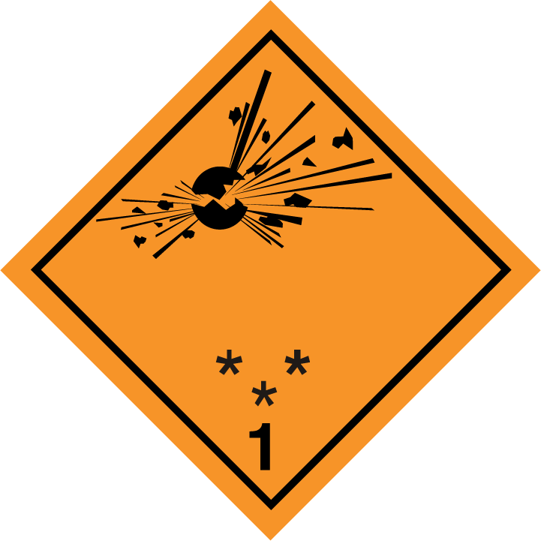 | - Place for division – to be left blank if explosive is the subsidiary hazard  - Place for compatibility group – to be left blank if explosive is the subsidiary hazard
1.4 | Division 1.4 | 1.4: black  Numerals shall be about 30 mm in height and be about 5 mm thick (for a label measuring 100 mm × 100 mm) | Orange | 1  (black) |  | Place for compatibility group
1.5 | Division 1.5 | 1.5: black  Numerals shall be about 30 mm in height and be about 5 mm thick (for a label measuring 100 mm × 100 mm) | Orange | 1  (black) |  | Place for compatibility group
1.6 | Division 1.6 | 1.6: black  Numerals shall be about 30 mm in height and be about 5 mm thick (for a label measuring 100 mm × 100 mm) | Orange | 1  (black) |  | Place for compatibility group

Label model No. | Division or Category | Symbol and symbol colour | Background | Figure in bottom corner (and figure colour) | Specimen labels |  | Note
Class 2: Gases
2.1 | Flammable gases (except as provided for in 5.2.2.2.1.6 d)) | Flame: black or white | Red | 2  (black or white) | 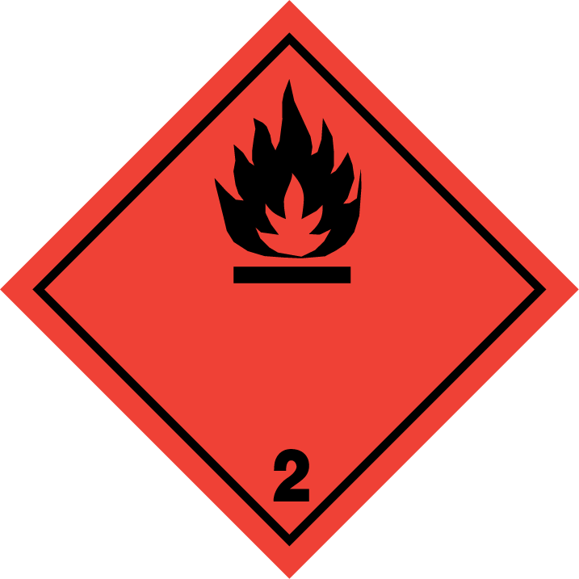 | 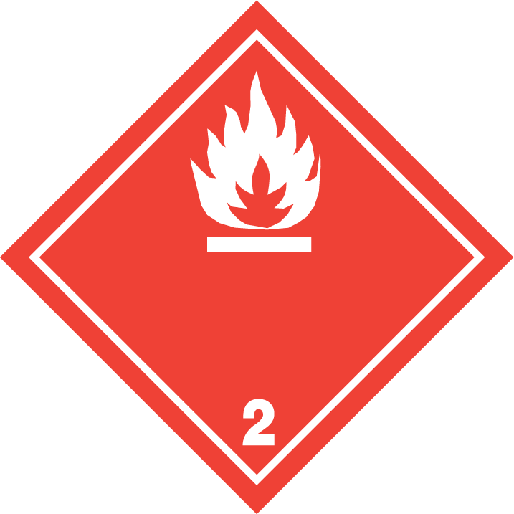 | -
2.2 | Non-flammable, non-toxic gases | Gas cylinder: black or white | Green | 2  (black or white) |  |  | -
2.3 | Toxic gases | Skull and crossbones: black | White | 2  (black) |  |  | -
Label model No. | Division or Category | Symbol and symbol colour | Background | Figure in bottom corner (and figure colour) | Specimen labels |  | Note
Class 3: Flammable liquids
UN/SCETDG/47/INF.19

3 | - | Flame: black or white | Red | 3  (black or white) | 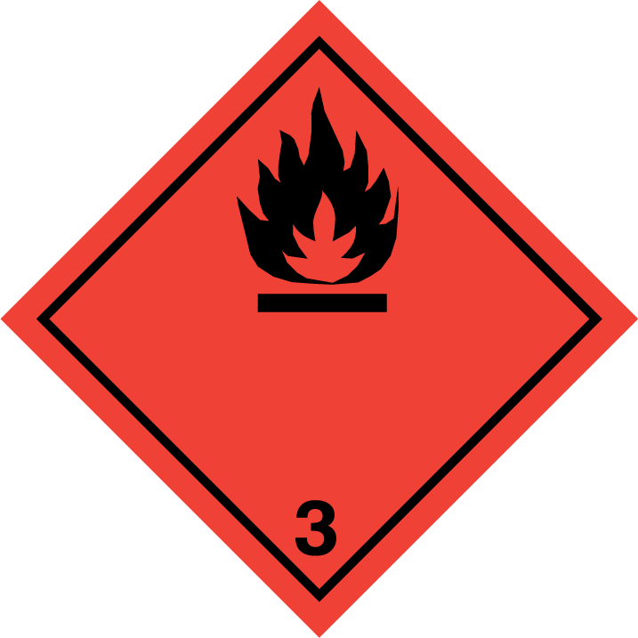 |  | -
Class 4.1: Flammable solids, self-reactive substances, solid desensitized explosives and polymerizing substances

4.1 | - | Flame: black | White with 7 vertical red stripes | 4  (black) |  |  | -
Class 4.2: Substances liable to spontaneous combustion
4.2 | - | Flame: black | Upper half white, lower half red | 4  (black) |  |  | -
Class 4.3: Substances which, in contact with water emit flammable gases
4.3 | - | Flame: black or white | Blue | 4  (black or white) |  |  | -
Label model No. | Division or Category | Symbol and symbol colour | Background | Figure in bottom corner (and figure colour) | Specimen labels |  | Note
Class 5.1: Oxidizing substances
5.1 | - | Flame over circle: black | Yellow | 5.1  (black) |  |  | -
Class 5.2: Organic peroxides
5.2 | - | Flame: black or white | Upper half red, lower half yellow | 5.2  (black) | 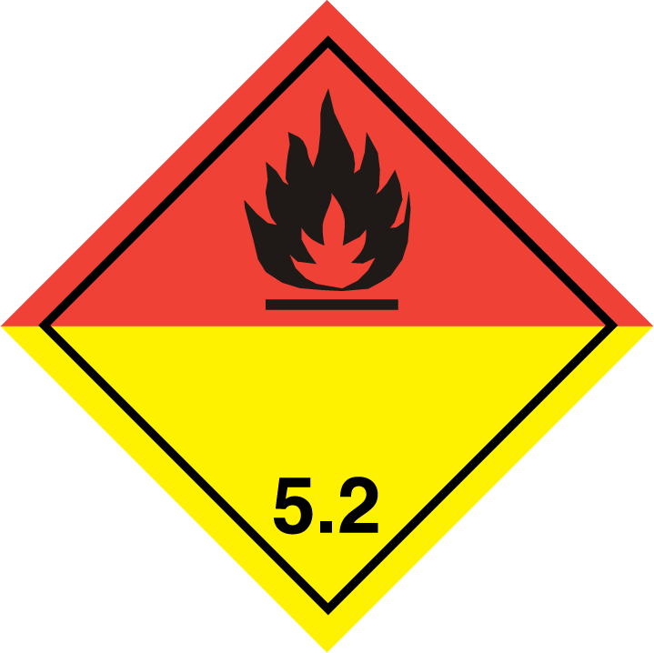 |  | -
Class 6.1: Toxic substances
6.1 | - | Skull and crossbones: black | White | 6  (black) |  |  | -
Class 6.2: Infectious substances
6.2 | - | Three crescents superimposed on a circle: black | White | 6  (black) |  |  | The lower half of the label may bear the inscriptions: “INFECTIOUS SUBSTANCE” and  “In the case of damage or leakage immediately notify Public Health Authority” in black colour

Label model No. | Division or Category | Symbol and symbol colour | Background | Figure in bottom corner (and figure colour) | Specimen labels | Note
Class 7: Radioactive material
7A | Category I | Trefoil: black | White | 7  (black) |  | Text (mandatory), black in lower half of label:  “RADIOACTIVE”  “CONTENTS ...”  “ACTIVITY ...”  One red vertical bar shall follow the word: “RADIOACTIVE”
7B | Category II | Trefoil: black | Upper half yellow with white border, lower half white | 7  (black) | 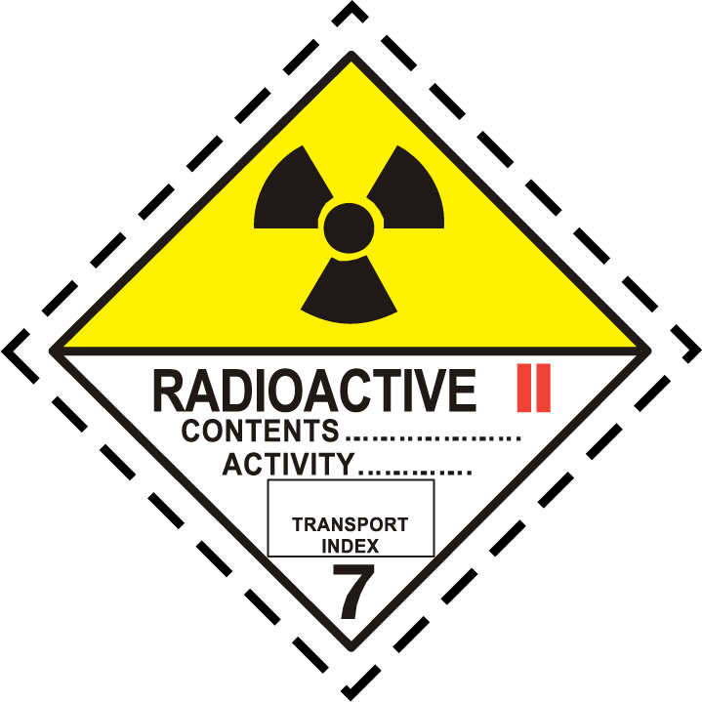 | Text (mandatory), black in lower half of label:  “RADIOACTIVE”  “CONTENTS ...”  “ACTIVITY ...”  In a black outlined box:  “TRANSPORT INDEX”;  Two red vertical bars shall follow the word: “RADIOACTIVE”
7C | Category III | Trefoil: black | Upper half yellow with white border, lower half white | 7  (black) | 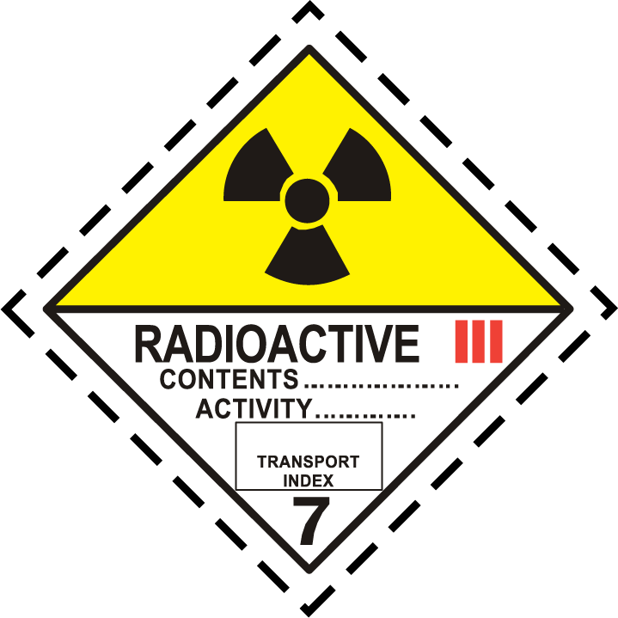 | Text (mandatory), black in lower half of label:  “RADIOACTIVE”  “CONTENTS ...”  “ACTIVITY ...”  In a black outlined box:  “TRANSPORT INDEX”.  Three red vertical bars shall follow the word: “RADIOACTIVE”
7E | Fissile material | - | White | 7  (black) | 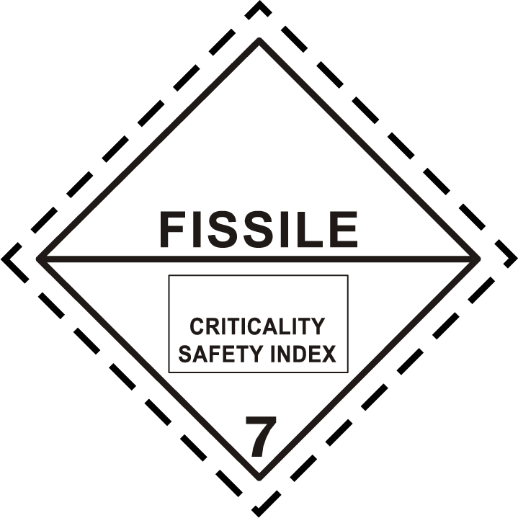 | Text (mandatory): black in upper half of label: “FISSILE”;  In a black outlined box in the lower half of label: “CRITICALITY SAFETY INDEX”

Label model No. | Division or Category | Symbol and symbol colour | Background | Figure in bottom corner (and figure colour) | Specimen labels | Note
Class 8: Corrosive substances
8 | - | Liquids, spilling from two glass vessels and attacking a hand and a metal: black | Upper half white, lower half black with white border | 8  (white) |  | -
Class 9: Miscellaneous dangerous substances and articles, including environmentally hazardous substances
9 | - | 7 vertical stripes in upper half: black | White | 9 underlined  (black) |  | -
9A | - | 7 vertical stripes in upper half:  black;  battery group, one broken and emitting flame in lower half:  black | White | 9 underlined  (black) |  | -

”.

Chapter 5.3

(ADR only:) In the title of Chapter 5.3, after “CONTAINERS”, insert “, BULK CONTAINERS”.
5.3.1.1.1 In the first sentence, after “large containers/containers”, insert “, bulk containers”. In the second sentence, after “large container/container”, insert “, bulk container”.
5.3.1.2 In the title, after “large containers/containers”, insert “, bulk containers”. In the paragraph after the Note, at the end, add “and to two opposites sides of the bulk container”.
5.3.1.3 In the title, after “large containers/containers”, insert “, bulk containers”. In the paragraph after the Note, after “large containers/containers”, insert “, bulk containers”.
(ADR only:) 5.3.2.1.4 In the first sentence, replace “and containers” by “, containers and bulk containers” and replace “or container” by “, container or bulk container”. In the second sentence, replace “or in the container” by “, in the container or in the bulk container” (twice).
5.3.2.1.5 After “containers”, insert “, bulk containers”.
5.3.6.1 and 5.3.6.2 After “large containers/containers”, insert “, bulk containers”.
Chapter 5.4
5.4.1.1.5 In the heading and the following sentence, after “salvage packagings” add “including large salvage packagings”.

Chapter 6.1

6.1.5.8.1 Under item 8, add the following sentence at the end: “For plastics packagings subject to the internal pressure test in 6.1.5.5, the temperature of the water used.”.
Chapter 6.2
6.2.1.6.1 Replace the existing Note 2 with the following:
“NOTE 2: For seamless steel cylinders and tubes the check of 6.2.1.6.1 (b) and hydraulic pressure test of 6.2.1.6.1 (d) may be replaced by a procedure conforming to ISO 16148:2016 ‘Gas cylinders – Refillable seamless steel gas cylinders and tubes – Acoustic emission examination (AT) and follow-up ultrasonic examination (UT) for periodic inspection and testing”.
6.2.1.6.1 In Note 3, replace “The hydraulic pressure test may be replaced” by “The check of 6.2.1.6.1 (b) and the hydraulic pressure test of 6.2.1.6.1 (d) may be replaced”.
6.2.2.1.1 In the table, for “ISO 11118:1999”, in the column “Applicable for manufacture”, replace “Until further notice” by “Until 31 December 2020”.
6.2.2.1.1 In the table, after “ISO 11118:1999”, insert a new line to read as follows:
ISO 11118:2015 | Gas cylinders – Non-refillable metallic gas cylinders – Specification and test methods | Until further notice
6.2.2.1.2 In the table, for “ISO 11120:1999”, in the column “Applicable for manufacture”, replace “Until further notice” by “Until 31 December 2022”.
6.2.2.1.2 In the table, after “ISO 11120:1999”, insert a new line to read as follows:
ISO 11120:2015 | Gas cylinders – Refillable seamless steel tubes of water capacity between 150 l and 3 000 l – Design, construction and testing | Until further notice
6.2.2.1 Insert a new paragraph 6.2.2.1.8 to read as follows.
“6.2.2.1.8 The following standards apply for the design, construction and initial inspection and test of UN pressure drums, except that inspection requirements related to the conformity assessment system and approval shall be in accordance with 6.2.2.5:
Reference | Title | Applicable for Manufacture
ISO 21172-1:2015 | Gas cylinders – Welded steel pressure drums up to 3 000 litres capacity for the transport of gases – Design and construction – Part 1: Capacities up to 1 000 litres  NOTE: Irrespective section 6.3.3.4 of this standard, welded steel gas pressure drums with dished ends convex to pressure may be used for the carriage of corrosive substances provided all applicable requirements of RID/ADR are met. | Until further notice
ISO 4706: 2008 | Gas cylinders – Refillable welded steel cylinders – Test pressure 60 bar and below | Until further notice
ISO 18172-1:2007 | Gas cylinders – Refillable welded stainless steel cylinders – Part 1: Test pressure 6 MPa and below | Until further notice
6.2.2.3 In the first table, for “ISO 13340:2001”, in the column “Applicable for manufacture”, replace “Until further notice” by “Until 31 December 2020”.
6.2.2.3 In the first table, insert the following rows at the end:
ISO 14246:2014 | Gas cylinders – Cylinder valves – Manufacturing tests and examination | Until further notice
ISO 17871:2015 | Gas cylinders – Quick-release cylinders valves- Specification and type testing | Until further notice
6.2.2.4 Amend the end of the introductory sentence to read: “…testing of UN cylinders and their closures:”. Move the last row of the table into a new table, after the existing one, with the same headings and a new introductory sentence to read: “The following standard applies to the periodic inspection and testing of UN metal hydride storage systems:”.
6.2.2.4 In the table, for “ISO 11623:2002”, in column “Applicable”, replace “Until further notice” by “Until 31 December 2020”. After the row for “ISO 11623:2002” insert the following new row:
ISO 11623:2015 | Gas cylinders – Composite construction – Periodic inspection and testing | Until further notice
6.2.2.4 At the end of the first table, insert the following row:
ISO 22434:2006 | Transportable gas cylinders – Inspection and maintenance of cylinder valves  NOTE: These requirements may be met at times other than at the periodic inspection and test of UN cylinders | Until further notice

6.2.2.7.4 Under subparagraph (m), insert a new Note to read as follows:
“NOTE: Information on marks that may be used for identifying threads for cylinders is given in ISO/TR 11364, Gas cylinders – Compilation of national and international valve stem/gas cylinder neck threads and their identification and marking system.”.

Chapter 6.5

6.5.6.9.3 Amend the last paragraph to read as follows:
“The same IBC or a different IBC of the same design may be used for each drop.”
6.5.6.14.1 Under item 8, add the following sentence: “For rigid plastics and composite IBCs subject to the hydraulic pressure test in 6.5.6.8, the temperature of the water used.”.

Chapter 6.7
6.7.2.2.16 The amendment does not apply to the English version. (Remplacer «des risques inhérents aux matières transportées» par «des risques inhérents au transport des matières concernées».)

Chapter 7.1 [Not for RID]
[Amend the heading to read “GENERAL PROVISIONS AND SPECIAL PROVISIONS FOR TEMPERATURE CONTROL”.]
Add the following new [7.1.7]:
[Note: Text added in square brackets corresponds to existing text of V8 and S4 not used in the Model Regulations. The Working Group may decide to delete this text to fully align on the Model Regulations.]
“7.1.7 Special provisions applicable to the carriage of self-reactive substances of Class 4.1, organic peroxides of Class 5.2 and substances stabilized by temperature control (other than self-reactive substances and organic peroxides)
7.1.7.1 All self-reactive substances, organic peroxides and polymerizing substances shall be protected from direct sunlight and all sources of heat, and placed in adequately ventilated areas.

7.1.7.2 Where a number of packages are assembled in a container or closed vehicle, the total quantity of substance, the type and number of packages and the stacking arrangement shall not create an explosion hazard.
7.1.7.3 Temperature control provisions
7.1.7.3.1 These provisions apply to certain self-reactive substances when required by 2.2.41.1.17, and certain organic peroxides when required by 2.2.52.1.15 and certain polymerizing substances when required by 2.2.41.1.21 or special provision 386 of Chapter 3.3 which may only be carried under conditions where the temperature is controlled.
7.1.7.3.2 These provisions also apply to the carriage of substances for which:
(a) The proper shipping name as indicated in column 2 of Table A of Chapter 3.2 or according to 3.1.2.6 contains the word “STABILIZED”; and
(b) The SADT or SAPT determined for the substance (with or without chemical stabilization) as offered for carriage is:
(i) 50 °C or less for single packagings and IBCs; or
(ii) 45 °C or less for tanks.
When chemical inhibition is not used to stabilize a reactive substance which may generate dangerous amounts of heat and gas, or vapour, under normal carriage conditions, these substances need to be carried under temperature control. These provisions do not apply to substances which are stabilized by the addition of chemical inhibitors such that the SADT or the SAPT is greater than that prescribed in (b) (i) or (ii), above.
7.1.7.3.3 In addition, if a self-reactive substance or organic peroxide or a substance the proper shipping name of which contains the word “STABILIZED” and which is not normally required to be carried under temperature control is carried under conditions where the temperature may exceed 55 °C, it may require temperature control.
7.1.7.3.4 The “control temperature” is the maximum temperature at which the substance can be safely carried. It is assumed that during carriage the temperature of the immediate surroundings of the package does not exceed 55 °C and attains this value for a relatively short time only during each period of 24 hours. In the event of loss of temperature control, it may be necessary to implement emergency procedures. The “emergency temperature” is the temperature at which such procedures shall be implemented.
7.1.7.3.5 Derivation of control and emergency temperatures
Type of receptacle | SADTª /SAPTª | Control temperature | Emergency temperature
Single packagings and IBCs | 20 °C or less  over 20 °C to 35 °C  over 35 °C | 20 °C below SADT/SAPT  15 °C below SADT/SAPT  10 °C below SADT/SAPT | 10 °C below SADT/SAPT  10 °C below SADT/SAPT  5 °C below SADT/SAPT
Tanks | < 50 °C | 10 °C below SADT/SAPT | 5 °C below SADT/SAPT
ª i.e. the SADT/SAPT of the substance as packed for carriage.
7.1.7.3.6 The control and emergency temperatures are derived using the table in 7.1.7.3.5 from the SADT or from the SAPT which are defined as the lowest temperatures at which self-accelerating decomposition or self-accelerating polymerization may occur with a substance in the packaging, IBC or tank as used in carriage. An SADT or SAPT shall be determined in order to decide if a substance shall be subjected to temperature control during carriage. Provisions for the determination of the SADT and SAPT are given in 2.2.41.1.17, 2.2.52.1.15 and 2.2.41.1.21 for self-reactive substances, organic peroxides and polymerizing substances and mixtures, respectively.
7.1.7.3.7 Control and emergency temperatures, where appropriate, are provided for currently assigned self-reactive substances in 2.2.41.4 and for currently assigned organic peroxide formulations in 2.2.52.4.
7.1.7.3.8 The actual carriage temperature may be lower than the control temperature but shall be selected so as to avoid dangerous separation of phases.
7.1.7.4 Carriage under temperature control

7.1.7.4 .1 Maintenance of the prescribed temperature is an essential feature of the safe carriage of substances stabilized by temperature control. In general, there shall be:
(a) Thorough inspection of the cargo transport unit prior to loading;
(b) Instructions to the carrier about the operation of the refrigeration system [including a list of the suppliers of coolant available en route];
(c) Procedures to be followed in the event of loss of control;
(d) Regular monitoring of operating temperatures; and
(e) Provision of a back-up refrigeration system or spare parts.
7.1.7.4 .2 Any control and temperature sensing devices in the refrigeration system shall be readily accessible and all electrical connections weather-proof. The temperature of air space within the cargo transport unit shall be measured by two independent sensors and the output shall be recorded so that temperature changes are readily detectable. The temperature shall be checked every four to six hours and logged. When substances having a control temperature of less than +25 °C are carried, the cargo transport unit shall be equipped with visible and audible alarms, powered independently of the refrigeration system, set to operate at or below the control temperature.
7.1.7.4 .3 If during carriage the control temperature is exceeded, an alert procedure shall be initiated involving any necessary repairs to the refrigeration equipment or an increase in the cooling capacity (e.g. by adding liquid or solid refrigerants). The temperature shall also be checked frequently and preparations made for implementation of the emergency procedures. If the emergency temperature is reached, the emergency procedures shall be initiated.
7.1.7.4.4 The suitability of a particular means of temperature control for carriage depends on a number of factors. Factors to be considered include:
(a) The control temperature(s) of the substance(s) to be carried;
(b) The difference between the control temperature and the anticipated ambient temperature conditions;
(c) The effectiveness of the thermal insulation;
(d) The duration of carriage; and
(e) Allowance of a safety margin for delays.
7.1.7.4 .5 Suitable methods for preventing the control temperature being exceeded are, in order of increasing control capability:
(a) Thermal insulation; provided that the initial temperature of the substance(s) to be carried is sufficiently below the control temperature;
(b) Thermal insulation with coolant system; provided that:
(i) An adequate quantity of [non-flammable] coolant (e.g. liquid nitrogen or solid carbon dioxide), allowing a reasonable margin for [possible] delay, is carried [or a means of replenishment is assured];
(ii) Liquid oxygen or air is not used as coolant;
(iii) There is a uniform cooling effect even when most of the coolant has been consumed; and
(iv) The need to ventilate the transport unit before entering is clearly indicated by a warning on the door(s) of the transport unit;
(c) [Thermal insulation and] Single mechanical refrigeration; provided that for substance(s) to be carried with a flash point lower than the sum of the emergency temperature plus 5 °C explosion-proof electrical fittings [, EEx IIB T3] are used within the cooling compartment to prevent ignition of flammable vapours [from the substances];
(d) [Thermal insulation and] Combined mechanical refrigeration system with coolant system; provided that:
(i) The two systems are independent of one another;
(ii) The provisions in (b) and (c) are complied with;
(e) [Thermal insulation and] Dual mechanical refrigeration system; provided that:
(i) Apart from the integral power supply unit, the two systems are independent of one another;
(ii) Each system alone is capable of maintaining adequate temperature control; and
(iii) For substance(s) to be carried with a flash point lower than the sum of the emergency temperature plus 5 °C explosion-proof electrical fittings [, EEx IIB T3] are used within the cooling compartment to prevent ignition of flammable vapours [from the substances].
7.1.7.4.6 to 7.1.7.4.8 Insert the following new paragraphs with the text of V8 (4) to (6):
“7.1.7.4.6 The methods described in 7.1.7.4.5 (d) and (e) may be used for all organic peroxides and self-reactive substances and polymerizing substances.
The method described in 7.1.7.4.5 (c) may be used for organic peroxides and self-reactive substances of Types C, D, E and F and, when the maximum ambient temperature to be expected during carriage does not exceed the control temperature by more than 10 °C, for organic peroxides and self-reactive substances of Type B and polymerizing substances.
The method described in 7.1.7.4.5 (b) may be used for organic peroxides and self-reactive substances of Types C, D, E and F and polymerizing substances when the maximum ambient temperature to be expected during carriage does not exceed the control temperature by more than 30 °C.
The method described in 7.1.7.4.5 (a) may be used for organic peroxides and self-reactive substances of Types C, D, E and F and polymerizing substances when the maximum ambient temperature to be expected during carriage is at least 10 °C below the control temperature.
7.1.7.4.7 Where substances are required to be carried in insulated, refrigerated or mechanically-refrigerated vehicles or containers, these vehicles or containers shall satisfy the requirements of Chapter 9.6.
7.1.7.4.8 If substances are contained in protective packagings filled with a coolant, they shall be loaded in closed or sheeted vehicles or closed or sheeted containers. If the vehicles or containers used are closed they shall be adequately ventilated. Sheeted vehicles and containers shall be fitted with sideboards and a tailboard. The sheets of these vehicles and containers shall be of an impermeable and non-combustible material.
”.
Consequential amendments:
1.2.1 In the definition of "control temperature", replace "or the self-reactive substance" by ", the self-reactive substance or the polymerizing substance".
2.2.41.1.17 Amend to read as follows:
“2.2.41.1.17 Self-reactive substances with an SADT not greater than 55 °C shall be subject to temperature control during carriage. See Section 7.1.7.”.
2.2.41.1.21 At the end, add the following new text: “See Section 7.1.7.”.
2.2.41.4 After the table, in remarks (1), (4), (6) after the table, replace “2.2.41.1.17” by “7.1.7.3.1 to 7.1.7.3.6”.
2.2.52.1.15 to 2.2.52.1.17 Amend as follows:
Delete 2.2.52.1.15 and 2.2.52.1.16. Renumber 2.2.52.1.17 as 2.2.52.1.15 and add the following new text after the Note: “See Section 7.1.7.”.
Renumber 2.2.52.1.18 as 2.2.52.1.16.
In 2.2.52.1.7, third indent, replace “2.2.52.1.15 to 2.2.52.1.18” by “2.2.52.1.15 and 2.2.52.1.16”.
In 2.2.52.1.7, at the end, replace “2.2.52.1.16” by “7.1.7.3.6”.
3.1.2.6 (a) After “Chapter 3.3,” insert “Section 7.1.7,”.
Special provision 386 In the first sentence, after “2.2.41.1.17,”, insert “Section 7.1.7,”.
5.4.1.1.15 Replace “2.2.41.1.17” by “Section 7.1.7”.
5.4.1.2.3.1 Replace “2.2.52.1.15 to 2.2.52.1.17” by “2.2.52.1.15”.
7.2.4, V8 Amend to read as follows:
“V8 See Section 7.1.7.
NOTE: This special provision V8 does not apply to substances referred to in 3.1.2.6 when substances are stabilized by the addition of chemical inhibitors such that the SADT is greater than 50 °C. In this latter case, temperature control may be required under conditions of carriage where the temperature may exceed 55 °C.”.
8.5, S4 Amend to read as follows:
“S4 See Section 7.1.7.
NOTE: This special provision S4 does not apply to substances referred to in 3.1.2.6 when substances are stabilized by the addition of chemical inhibitors such that the SADT is greater than 50 °C. In this latter case, temperature control may be required under conditions of carriage where the temperature may exceed 55 °C.”.
9.6.1 (a) Replace “2.2.52.1.16” by “2.2.52.1.15”.

OECD Guideline for the testing of chemicals No. 404 "Acute Dermal Irritation/Corrosion" 2015
OECD Guideline for the testing of chemicals No. 435 "In Vitro Membrane Barrier Test Method for Skin Corrosion” 2015
OECD Guideline for the testing of chemicals No. 430 "In Vitro Skin Corrosion: Transcutaneous Electrical Resistance Test (TER)” 2015
OECD Guideline for the testing of chemicals No. 431 "In Vitro Skin Corrosion: Human Skin Model Test" 2015

