|  |  |  |  |
| --- | --- | --- | --- |
|  | United Nations | ST/SG/AC.10/C.3/2017/38 | |
| _unlogo | **Secretariat** | | Distr.: General  31 August 2017  Original: English |

**Committee of Experts on the Transport of Dangerous Goods  
and on the Globally Harmonized System of Classification  
and Labelling of Chemicals**

Sub-Committee of Experts on the Transport of Dangerous Goods

**Fifty-second session**

Geneva, 27 November -6 December 2017  
Item 3 of the provisional agenda  
**Listing, classification and packing**

New entry for UN 1390 ALKALI METAL AMIDES, packing group I

Transmitted by the expert from Germany[[1]](#footnote-2)

Introduction

1. For UN 1390 ALKALI METAL AMIDES, there is only an entry for packing group II in the Model Regulations. In accordance with special provision 182, sodium amide would have to be assigned to that entry.

2. In connection with the request of a company, the German occupational accident insurance fund for raw materials and the chemical industry (Berufsgenossenschaft Rohstoffe und chemische Industrie) carried out investigations (N.5 test). The findings of these investigations showed that the criteria for assignment to Class 4.3, packing group I, are met.

3. Based on these findings, the Federal Institute for Materials Research and Testing (BAM) then tested sodium amide by means of the N.5 test. In this test, gas evolution rates between 126 l/(kg.min) and 239 l/(kg.min) were measured. The test report is enclosed as an annex.

4. Against this background, the German expert believes that the substance must be assigned to packing group I.

Proposal

5. It is therefore proposed to add the following row for UN 1390 ALKALI METAL AMIDES packing group I to the table of dangerous goods:

|  |  |  |  |  |  |  |  |  |  |  |  |
| --- | --- | --- | --- | --- | --- | --- | --- | --- | --- | --- | --- |
| **UN**  **No.** | **Name and description** | **Class**  **or division** | **Subsidiary risk** | **UN packing group** | **Special provisions** | **Limited and excepted quantities** | | **Packagings and IBCs** | | **Portable tanks and bulk containers** | |
|  |  |  |  |  |  |  |  | **Packing instruction** | **Special provisions** | **Instruction** | **Special provisions** |
| **(1)** | **(2)** | **(3)** | **(4)** | **(5)** | **(6)** | **(7a)** | **(7b)** | **(8)** | **(9)** | **(10)** | **(11)** |
| 1390 | ALKALI METAL AMIDES | 4.3 |  | I | 182 | 0 | E0 | P403  IBC04 | B1 | T9 | TP 7 TP 33 |

Annex [English only]

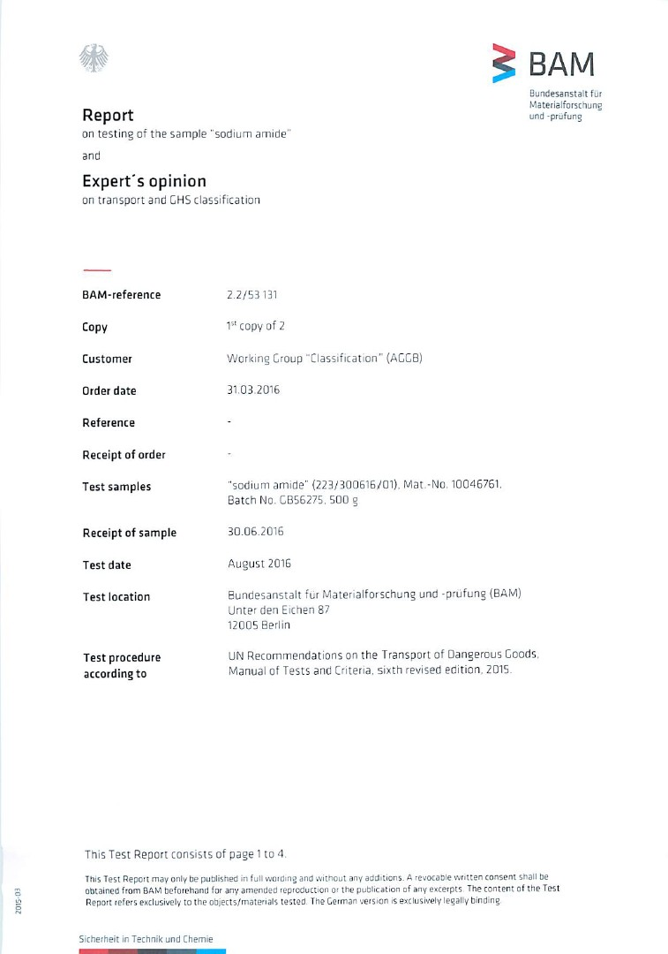

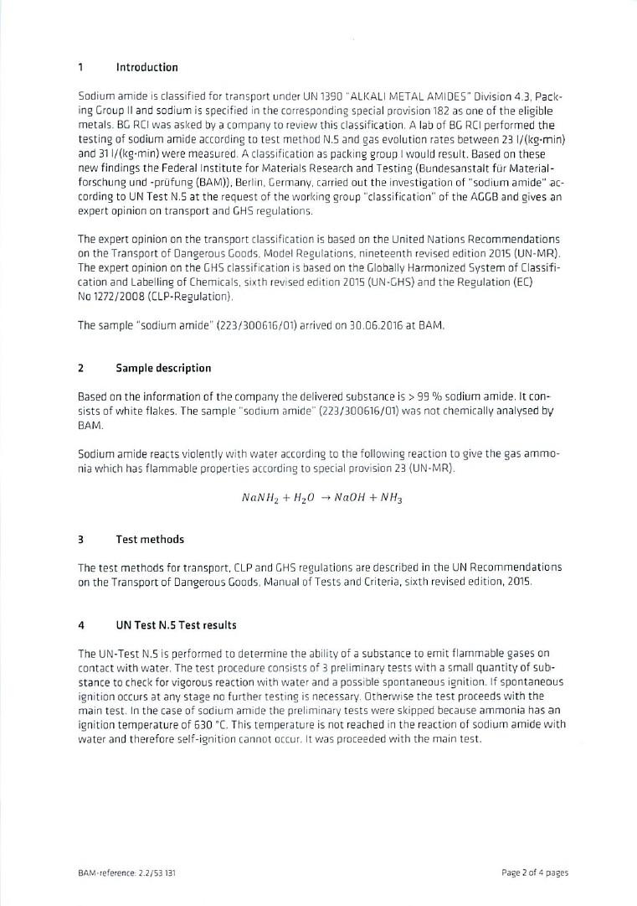

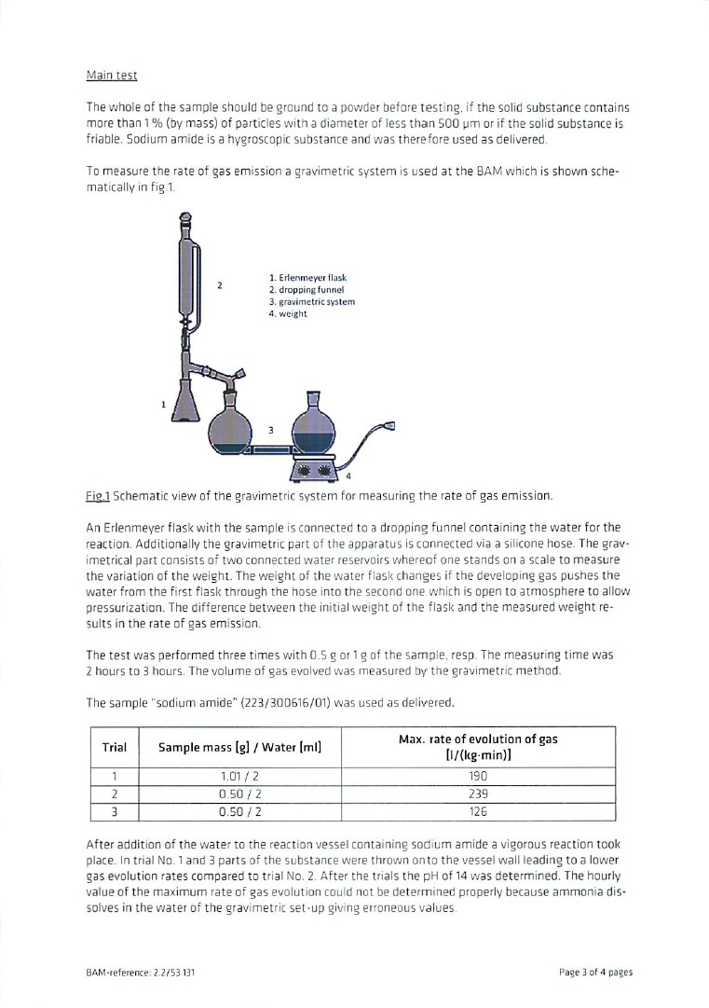

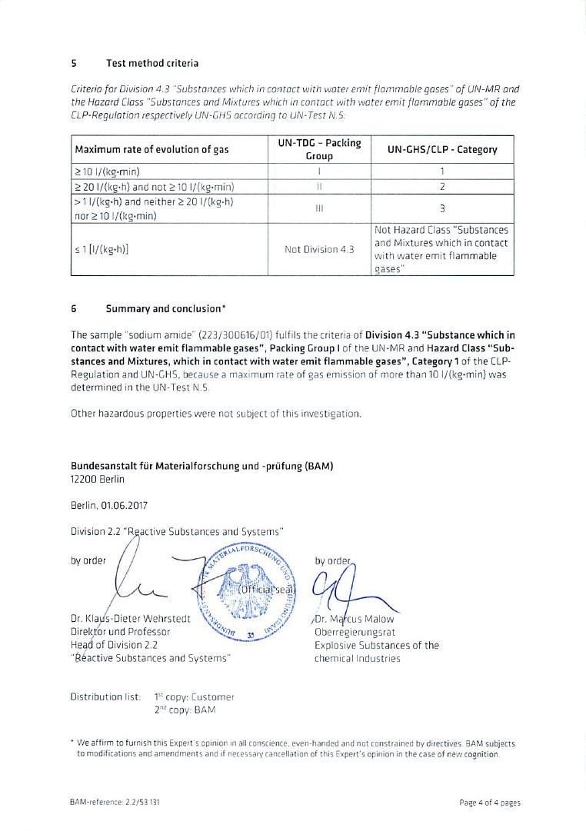

\_\_\_\_\_\_\_\_\_\_\_\_\_\_

1. In accordance with the programme of work of the Sub-Committee for 2017–2018 approved by the Committee at its eighth session (see ST/SG/AC.10/C.3/100, paragraph 98 and ST/SG/AC.10/44, paragraph 14). [↑](#footnote-ref-2)