|  |  |  |  |
| --- | --- | --- | --- |
|  | United Nations | ECE/TRANS/WP.29/GRE/2016/29 | |
| Description: _unlogo | **Economic and Social Council** | | Distr.: General  11 August 2016  Original: English |

**Economic Commission for Europe**

Inland Transport Committee

**World Forum for Harmonization of Vehicle Regulations**

**Working Party on Lighting and Light-Signalling**

**Seventy-sixth session**

Geneva, 25–28 October 2016

Item 7 (h) of the provisional agenda  
**Other Regulations:   
Regulation No. 123 (Adaptive front-lighting systems (AFS))**

Proposal for Supplement 8 to the 01 series of amendments to Regulation No. 123 (Adaptive front lighting systems (AFS))

Submitted by the expert from the International Automotive Lighting and Light Signalling Expert Group (GTB)[[1]](#footnote-2)\*

The text reproduced below was prepared by the expert from GTB to correct inconsistencies and to introduce provisions to allow for the adaptation to foggy weather conditions. The modifications to the existing text of the Regulation are marked in bold for new or strikethrough for deleted characters.

I. Proposal

*Paragraph 5.7.3.,* amend to read:

"5.7.3. In the case of failure it must be possible to obtain automatically a passing beam or a state with respect to the photometric conditions which yields values not exceeding 1,300 cd in the zone III b as defined in Annex 3 to this Regulation and at least 3,400 cd in a point of "segment ~~Emax~~ **Imax** ", by such means as e.g. switching off, dimming, aiming downwards, and/or functional substitution;

When performing the tests to verify compliance with these requirements, the Technical Service responsible for approval tests shall refer to the instructions supplied by the applicant."

*Paragraph 6.2.4.,* amend to read:

"6.2.4. When emitting a specified mode of the passing beam, the system shall meet the requirements in the respective section (C, V, E, W) of part A of Table 1 (photometric values) and in Table 2 ~~Emax~~ **Imax** and "cut-off" positions) of Annex 3 to this Regulation, as well as section 1 ("cut-off" requirements) of Annex 8 to this Regulation."

*Paragraph 6.2.5.4.,* amend to read:

"6.2.5.4. If approval is sought for a category 1 bending mode, the system is designed so that, in the case of a failure affecting the lateral movement or modification of the illumination, it must be possible to obtain automatically either photometric conditions corresponding to paragraph 6.2.4. above or a state with respect to the photometric conditions which yields values not exceeding 1,300 cd in the zone IIIb, as defined in Annex 3 to this Regulation, and at least 3,400 cd in a point of "segment ~~Emax~~ **Imax** ";"

*Annex 3, Figure 1,* amend to show (change Imax is highlighted yellow):

**"Figure 1**

# **Angular positions of passing beam photometric requirements (indicated for right-hand traffic)**

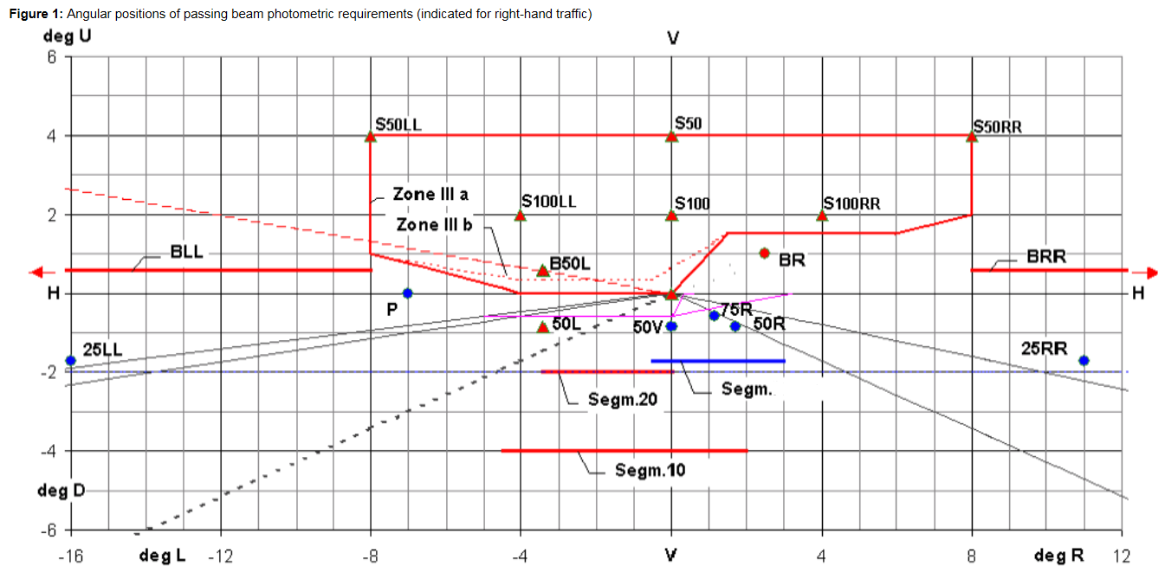"

**Imax**

*Table 1, Part A, line 18,* replace "Emax" with "**Imax**".

*Table 1, Part B, line 18,* replace "Emax" with "**Imax**".

*Table 1, footnote 3,* amend to read:

"3 ~~Position~~ **R**equirements according to the provisions of Table 2 below ("Segment ~~E~~~~max~~ **Imax**") apply in addition.

*Table 2*, amend to read:

Table 2

"**Passing beam elements angular position/extend, additional requirements**

|  |  |  |  |  |  |  |  |  |  |  |  |  |
| --- | --- | --- | --- | --- | --- | --- | --- | --- | --- | --- | --- | --- |
|  | *Angular position / extend in deg  for segment Imax* | *Class C passing-beam* | | *Class V passing-beam* | | | *Class E passing-beam* | | | *Class W passing-beam* | | |
| *No* | *beam part designation and requirement* | *horizontal* | *vertical* | *horizontal* | *vertical* | | *horizontal* | | *vertical* | *horizontal* | | *vertical* |
| 2.1. | The maximum luminous intensity in "Segment Imax" as indicated in this table shall be within the limits as prescribed in Table 1 , Line No. 18. | 0.5L  to 3R | 0.3D  to 1.72D |  | 0.3D  to 1.72D | | 0.5L  to 3R | | 0.1D  to 1.72D | 0.5L  to 3R | | 0.3D  to 1.72D |
| 2.2. | The "cut-off" and part(s) of shall:  (a) comply with the requirements of paragraph 1. of Annex 8 to this Regulation and | | | | | | | | | | | |
|  | (b) be positioned with its "flat horizontal part" |  | at V = 0.57 D  not above 0.57D  not below 1.0D |  | | not above 0.57D not below 1.3D | |  | not above 0.23D8 not below 0.57D |  | not above 0.23D  not below 0.57D | |
| 8 | Requirements according to the provisions indicated in Table 6 below apply in addition. | | | | | | | | | | | |

"

*Annex 4,*

*Introductory part,* amend to read:

"Annex 4

Tests for stability of photometric performance of systems in operation – Tests on complete systems

Tests on complete systems

Once the photometric values have been measured according to the prescriptions of this Regulation, in the point of ~~Emax~~ **Imax** for driving beam and in points HV, 50V and B50L (or R), whichever applies for passing beam, a complete system sample shall be tested for stability of photometric performance in operation.

…

(remainder of the text is unchanged)"

*Paragraph 1.2.1.5.,* amend to read:

"1.2.1.5. Application of the test mixture to the test sample

The test mixture shall be uniformly applied to the entire light‑emitting surface(s) of the test sample and then left to dry. This procedure shall be repeated until the illuminating value has dropped to 15-20 per cent of the values measured for each following point under the conditions described in this annex:

point ~~Emax~~ **Imax** in driving beam, under neutral state conditions,

50V for aclass C passing beam, and each specified passing beam mode."

*Annex 5, paragraph 2.4.,* amend to read:

"2.4. Measured and recorded photometric characteristics

The sampled headlamps shall be subjected to photometric measurements at the points provided for in the Regulation, the reading being limited:

To points ~~Emax~~ **Imax**, HV1, HL and HR2 in the case of a driving beam;

To points B50L, HV if applicable, 50V, 75R if applicable, and 25LL in the case of the passing beam(s) (see Figure 1 in Annex 3)."

*Annex 6, paragraph 2.1.2.1.,* amend to read:

"2.1.2.1. Method

Photometric measurements shall be carried out on the samples before and after the test.

These measurements shall be made according to Annex 9 to this Regulation, at the following points:

B50L and 50V for the class Cpassing beam lighting;

~~Emax~~ **Imax** for the driving beam of a system."

II. Justification

1. When the 01 series of amendments to Regulation No. 123 was introduced to convert the photometric requirements from illuminance E (lux) to luminous intensities I (cd), some changes from Emax to Imax were overlooked. This amendment introduces the necessary corrections.

2. Additionally, Annex 3, Table 2 is amended to allow sub-classes of Class C to lower the cut-off position to give the opportunity to adapt to foggy weather conditions and, thus, to avoid glare and to increase safety.

1. \* In accordance with the programme of work of the Inland Transport Committee for 2014–2018 (ECE/TRANS/240, para. 105 and ECE/TRANS/2014/26, programme activity 02.4), the World Forum will develop, harmonize and update Regulations in order to enhance the performance of vehicles. The present document is submitted in conformity with that mandate. [↑](#footnote-ref-2)