|  |  |  |  |
| --- | --- | --- | --- |
|  | United Nations | ST/SG/AC.10/C.3/2016/68 | |
| _unlogo | **Secretariat** | | Distr.: General 9 September 2016  Original: English |

**Committee of Experts on the Transport of Dangerous Goods  
and on the Globally Harmonized System of Classification  
and Labelling of Chemicals**

**Sub-Committee of Experts on the Transport of Dangerous Goods**

**Fiftieth session**

Geneva, 28 November-6 December 2016

Item 2 (d) of the provisional agenda

**Recommendations made by the Sub-Committee   
on its forty-seventh, forty-eighth   
and forty-ninth sessions and pending issues:   
electric storage systems**

Harmonization of rechargeable lithium metal polymer batteries

Transmitted by the European Association for Advanced Rechargeable Batteries (RECHARGE) and the Rechargeable Battery Association (PRBA)[[1]](#footnote-2)

Introduction

1. This document is proposing 2 options to allow for a relevant classification of rechargeable lithium metal polymer (RLMP) in the Model Regulations. Following the forty-eighth and forty-ninth sessions discussions, it is presenting new complementary information to clarify the purpose, the definition of the product, and complementary safety information.

2. The document ST/SG/AC.10/C.3/2016/33 and informal document INF.10 (forty-eight session) have presented the rationale for the harmonization of the energy rating for rechargeable lithium metal polymer (RLMP) and lithium-ion batteries: primary lithium batteries are transported undischarged when they are new, it is therefore appropriate to represent the characteristics of the battery by its lithium metal content. For example, according to SP188, for lithium metal batteries (UN3090), exempted cells and batteries must contain less than 1 g lithium for lithium metal or lithium alloy per cell or less than 2 g lithium per battery. On the other hand, rechargeable lithium-ion batteries (UN3480) are characterized by their total energy content in Wh when fully charged. According to SP188, for lithium-ion rechargeable batteries, exempted cells and batteries must contain less than 20Wh per cell or less than 100 Wh per battery.

3. The purpose of the proposal is to allow for the same transport regulations and applicable exemptions for RLMP and Li-ion batteries. It is important to allow for the development of this new technology in fair competitive conditions, fitting the use and safety characteristics presented:

* The new technology is used as the Li-ion technology for IT applications, where the product size is described by the Wh content. A different condition for the limit of exemption for small cells and batteries according to SP188 would generate a significant gap for the transport conditions of these small products, when using the new RLMP technology instead of Li-ion technology.
* This gap is not justified by safety properties, as supported by the tests results presented in the following points.

An harmonization of the marking in Wh and of the exemption limit in SP 188 would close this gap.

4. In the informal document INF.13/Rev.1 (forty-seventh session) and working document ST/SG/AC.10/C.3/2016/33, was introduced the description of the RLMP, rechargeable lithium battery based on a lithium metal anode associated with a polymer electrolyte. An illustration of an RMLP is proposed in Annex I, as well as the key features of this technology. Although based on the usage of lithium, the RLMP technology is clearly identified as a new battery technology, characterized by 2 specific components in the product definition:

(a) The lithium metal anode is treated to allow for the usage in rechargeable cells or batteries (i.e. carbon nanoparticles or polymer-seramic coating).

(b) The electrolyte is a solid polymer electrolyte, used without flammable solvent.

Both of these technologies were not available when the first known technologies of Lithium metal (3090) and Li-ion (3480) where placed on the market. Even the Li-ion polymer, later introduced, contains a liquid solvent in addition to the polymer, contrary to the RLMP. It is proposed to use these two specific components to define and identify the RLMP, and differentiate from the other lithium technologies.

5. Following the introduction of ST/SG/AC.10/C.3/2016/33, new safety data have been obtained, in order to answer the concerns expressed about the batteries behaviour in case of fire, particularly for the air transport mode. The earlier presented results of the comparative tests campaigns were describing the safe behaviour of the RLMP in the destructive tests of the Manual of Tests and Criteria, Chapter 38.3 (test T6-crushing, test T8-overdischarge). In addition, tests showing the safe behaviour in case of thermal abuse, as developed for the air transport packaging standard, thanks to the stable electrolyte, were presented in the forty-ninth session in informal document INF 32. New results are being prepared, showing the cell behaviour measured in an Accelerated Rate Calorimeter (ARC) when submitting the RLMP to unlimited temperature increase until combustion, and measuring the energy and gas emitted.

6. A table with a summary of the key tests results is presented below, comparing the RLMP to the other technologies. The description of the cells tested and the tests process is provided in annex II.

|  |  |  |  |  |
| --- | --- | --- | --- | --- |
|  |  | Results observed | | |
| Type of test | Test description | Lithium metal cells | Lithium ion cells | Rechargeable Lithium metal Polymer cells |
|  |  |  | Pouch cell Li-ion 6,5 Wh | Pouch cell RLMP 6,5 Wh |
| Destructive | Test T.6 (crush) of UN MT&C, 38.3 | / | Pass ( 25°C) | Pass (25°C) |
| Destructive | Test T.8 (cell reversal) of UN MT&C, 38.3 | / | Pass (51°C) | Pass (42°C) |
|  |  | Li-SOCl2 primary bobbin cell ( 7,5Wh) | Li-ion pouch cell (7 Wh) | RLMP pouch cell ( 9 Wh) |
| Destructive | Nail penetration test | Pass: no flame, no peak temperature | Pass: no flame, temperature 70°C | Pass: no flame, no peak temperature |
|  |  |  |  |  |
| Component stability | Thermal stability of the electrolyte (TGA) | Weight Loss at 200°C : 44% | Weight Loss at 200°C : 64% | Weight Loss at 200°C : 11% |
|  |  | Pouch cell | Pouch cell | Pouch cell |
| Abusive | Oven test at 200°C | Thermal run away 700°C peak | Thermal runaway 600°C peak | No Thermal runaway: stable at 200°C |
| Abusive | Accelerated Rating Calorimetry (ARC) |  | To be presented in INF paper | To be presented in INF paper |

Based on the results obtained, it is proven that the RLMP cells are equivalent to Li-ion cells, or more robust. In all cases, the total heat generated of similar order of magnitude. As the hazards are similar, the recommended fire containment are similar. Extinguishing methods for fire fighters are the same in all cases, large amount of water is recommended.

7. In conclusion, the safety characteristics of the RLMPs are equivalent or better than those of the Lithium-Ion battery technology, particularly thanks to the use of the polymer electrolyte without flammable solvent.

8. Earlier comments at the forty-ninth session were suggesting that the way the introduction of the new entry as presented in ST/SG/AC.10/C.3/2016/33 was not suitable. Other suggested that a modification of the SP188 would be sufficient. Both options are presented in this document, allowing for the Sub-Committee to decide about the preferred option. In addition, a definition has been added to clearly identify the scope of the new entry.

9. Both solutions are allowing for a suitable treatment of the RLMP classification, until a broader revision of the Li batteries classification and safety management during transport is developed in the next biennium.

Proposal

Option 1: modification of the SP188

10. Modify the text of SP 188 (a) and (b) as indicated below, and add a note at the end of (b):

*(a) For a lithium metal or lithium alloy cell, the lithium content is not more than 1 g, and for a lithium ion cell,* or a rechargeable lithium metal polymer cell *the Watt-hour rating is not more than 20 Wh;*

*(b) For a lithium metal or lithium alloy battery the aggregate lithium content is not more than 2 g, and for a lithium ion battery,* or a rechargeable lithium metal polymer battery *the Watt-hour rating is not more than 100 Wh. Lithium ion batteries and* rechargeable lithium metal polymer battery *subject to this provision shall be marked with the Watt-hour rating on the outside case, except those manufactured before 1 January2009;*

***NOTE***: For the purpose of this special provision, a Rechargeable Lithium Metal Polymer (RLMP) is a lithium metal cell or battery (UN 3090) designed to be rechargeable and characterized by the use of a solid polymer electrolyte, without flammable solvent.

Option 2: new UN numbers for the RLMP cells and batteries, and the RLMP cells and batteries in equipment.

11. It is proposed to introduce a new UN number 35XX for RLMP cells and batteries, and 35XY for RLMP batteries in equipment, and add the new UN numbers and proper shipping names where appropriate, for identification of the transport conditions applicable to RLMP.

**Dangerous Goods List (Model Regulations ninth revised edition)**

|  |  |  |  |  |  |  |  |  |
| --- | --- | --- | --- | --- | --- | --- | --- | --- |
| *UN No.* | *Name and description* | *Class* | *Sub*  *sidiary*  *risk* | *UN*  *packing*  *group* | *Special*  *provisions* | *Limited and excepted quantities* | | *Packing instruction* |
| *(1)* | *(2)* | *(3)* | *(4)* | *(5)* | *(6)* | *(7a)* | *(7b)* | *(8)* |
| 35XX | RECHARGEABLE LITHIUM METAL POLYMER BATTERIES | 9 | - | - | YYY,188,230,  310, 348, 376,  377, 384 | 0 | E0 | P903  P908  P909  P910  LP903  LP904 |
| 35XY | RECHARGEABLE LITHIUM METAL POLYMER BATTERIES, CONTAINED IN EQUIPMENT or RECHARGEABLE LITHIUM METAL POLYMER BATTERIES PACKED WITH EQUIPMENT | 9 | - | - | YYY, 188, 230,310, 348  360, 376,  377, 384 | 0 | E0 | P903  P908  P909  P910  LP903  LP904 |

12. Modify paragraph 2.9.4 to add the new UN numbers

Cells and batteries, cells and batteries contained in equipment, or cells and batteries packed with equipment, containing lithium in any form shall be assigned to UN Nos. 3090, 3091, 3480, 3481, 35XX and 35XY as appropriate.

13. Modify SP188 paragraphs (a) and (b) to add the new proper shipping name, as follows:

(a) For a lithium metal or lithium alloy cell, the lithium content is not more than 1 g, and for a lithium ion cell, or a rechargeable lithium metal polymer cell the Watt-hour rating is not more than 20 Wh;

(b) For a lithium metal or lithium alloy battery the aggregate lithium content is not more than 2 g, and for a lithium ion battery, or a rechargeable lithium metal polymer battery the Watt-hour rating is not more than 100 Wh. Lithium ion batteries and rechargeable lithium metal polymer battery subject to this provision shall be marked with the Watt-hour rating on the outside case, except those manufactured before 1 January 2009;

14. Modify SP240 to add the new UN numbers and proper shipping names:

240. This entry only applies to vehicles powered by wet batteries, sodium batteries, lithiummetal batteries ~~or~~ lithium ion batteries or rechargeable lithium metal polymer batteries, and equipment powered by wet batteries or sodium batteries transported with these batteries installed. For the purpose of this special provision, vehicles are self-propelled apparatus designed to carry one or more persons or goods. Examples of such vehicles are electrically-powered cars, motorcycles, scooters, three- and four-wheeled vehicles or motorcycles, e-bikes, wheel-chairs, lawn tractors, boats and aircraft. Examples of equipment are lawnmowers, cleaning machines or model boats and model aircraft. Equipment powered by lithium metal batteries or lithium ion batteries shall be consigned under the entries UN 3091 LITHIUM METAL BATTERIES CONTAINED INEQUIPMENT or UN 3091 LITHIUM METAL BATTERIES PACKED WITH EQUIPMENT or UN 3481 LITHIUM ION BATTERIES CONTAINED IN EQUIPMENT or UN 3481 LITHIUM ION BATTERIES PACKED WITH EQUIPMENT, or UN 35XY RECHARGEABLE LITHIUM METAL POLYMER CONTAINED INEQUIPMENT, or 35XY RECHARGEABLE LITHIUM METAL POLYMER PACKED WITH EQUIPMENT as appropriate.

15. Modify SP360 to add the new proper shipping names

360 Vehicles only powered by lithium metal batteries, ~~or~~ lithium ion batteries or rechargeable lithium metal polymer batteries shall be consigned under the entry UN 3171 BATTERY-POWERED VEHICLE.

16. Modify SP376 to add the new UN number and proper shipping names:

376. Lithium ion cells or batteries, lithium metal cells or batteries and rechargeable lithium metal polymer cells or batteries identified as being damaged or defective such that they do not conform to the type tested according to the applicable provisions of the Manual of Tests and Criteria shall comply with the requirements of this special provision.

For the purposes of this special provision, these may include, but are not limited to:

- Cells or batteries identified as being defective for safety reasons; - Cells or batteries that have leaked or vented; - Cells or batteries that cannot be diagnosed prior to transport; or - Cells or batteries that have sustained physical or mechanical damage

**NOTE**: In assessing a battery as damaged or defective, the type of battery and its previous use and misuse shall be taken into account.

Cells and batteries shall be transported according to the provisions applicable to UN 3090, UN 3091, UN 3480 ~~and~~, UN 3481, UN 35XX and UN 35XY, except Special Provision 230 and as otherwise stated in this special provision.

Packages shall be marked “Damaged/Defective Lithium-ion Batteries” or “Damaged/Defective Lithium Metal Batteries”, as applicable.

Cells and batteries shall be packed in accordance with packing instructions P908 of 4.1.4.1 or LP904 of 4.1.4.3, as applicable.

Cells and batteries liable to rapidly disassemble, dangerously react, produce a flame or a dangerous evolution of heat or a dangerous emission of toxic, corrosive or flammable gases or vapours under normal conditions of transport shall not be transported except under conditions specified by the competent authority.

17. Modify SP377 to add the new UN numbers

377. Lithium ion, ~~and~~ lithium metal cells and batteries and rechargeable lithium metal polymer cells and batteries, and equipment containing such cells and batteries transported for disposal or recycling, …. [following text unchanged].

18. Modify le packing instruction to add the new UN numbers

Replace the list ~~UN Nos. 3090, 3091, 3480 and 3481~~ with the list UN Nos 3090, 3091, 3480, 3481, 35XX and 35XY in the packing instructions P903, P908, P909, P910, LP 903 and LP904

19. Modify the Manual of Tests and Criteria, paragraph 38.3.1 to refer to the new UN numbers

38.3.1 Purpose

This section presents the procedures to be followed for the classification of lithium metal, ~~and~~ lithium ion cells and batteries and rechargeable lithium metal polymer cells and batteries (see UN Nos. 3090, 3091, 3480, ~~and~~ 3481, 35XX and 35XY) and the applicable special provisions of Chapter 3.3 of the Model Regulations.

20. Add the definition of rechargeable lithium metal polymer in the Manual of Tests and Criteria, paragraph 38.3.2.3

Rechargeable Lithium Metal Polymer (RLMP) cell or battery means a cell or battery in which the negative electrodes is a lithium metal electrode, which has been designed to be rechargeable and uses a solid polymer electrolyte, without flammable solvent.

Conclusion

21. The Sub-Committee is invited to consider the above proposal for the creation of a new Special Provision and/or new UN numbers for the RLMP.

Annex I

Definition of a RLMP

A RLMP is a rechargeable electrochemical device in which the anode is based on Li metal, and characterized by

(i) a specific treatment of the anode surface avoiding the Lithium dendrites growth during the charging of the cells or batteries.

(ii) a polymer electrolyte, which is designed to be non-flammable and endurable against long -term operations.

A description and comparison to Li-ion battery is proposed in figures 1, 2 and 3 below. Examples of specific aspect of the RLMP design are provided in annex II.

**Fig.1 Operating principle of lithium metal and lithium ion cells**

**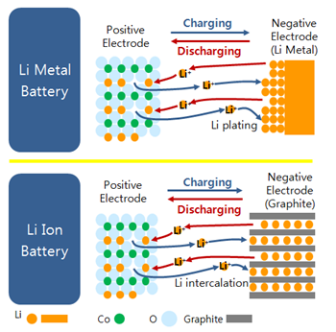**

**Fig.2 Constituent of a rechargeable lithium metal cell where the two active materials are exposed to non-flammable, solid electrolyte**

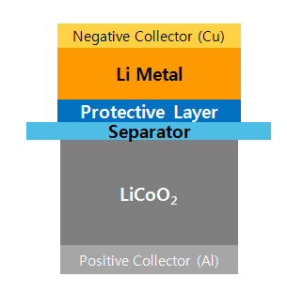

**Fig.3 Schematic diagrams of different lithium anode structures. a, A thin film of SEI layer forms quickly on the surface of deposited lithium (blue). Volumetric changes during the lithium deposition process can easily break the SEI layer, especially at high current rates. This behavior leads to ramified growth of lithium dendrites and rapid consumption of the electrolytes. b, Modifying the Cu substrate with a hollow carbon nanosphere layer creates a scaffold for stabilizing the SEI layer. The volumetric change of the lithium deposition process is accommodated by the flexible hollow-carbon-nanosphere coating**

**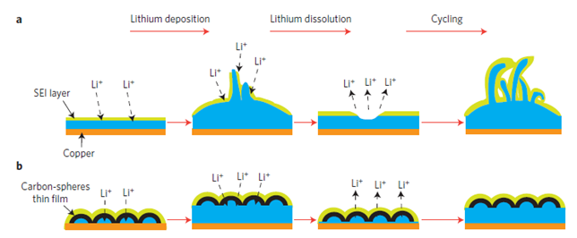**

Constituent of a RLMP and operating principle

A RLMP cell is comprised of a negative electrode, positive electrode, separator and electrolyte. (Fig.2) A RLMP is a rechargeable lithium metal battery which can store the electrical energy by plating and stripping lithium ions at the negative electrode, and by intercalating and deintercalating lithium ions at the positive electrode in the case of oxides (Fig.3), or alloying and dealloying lithium ions in the case of sulfur composites.

As for a RLMP, the anode electrode is comprised of lithium metal and a protective layer, in place of graphite as typically found in lithium ions batteries. In the case of graphite, its principle is based on the intercalating and deintercalation chemistry. On the other hand, in the case of lithium metal, the principle is based on the plating and stripping chemistry. Unlike graphite, no housing for lithium ions exists in lithium metal. Therefore, electricity is stored at the negative electrode by lithium plating. Since there is no boundary for the plating, non-uniform growth of lithium ions (i.e., dendrites) could appear at the negative electrode, which could cause safety concerns. (Fig.3) For this reason, the protective layer, an ultra thin polymer matrix including various additives like salts, carbon nanopowders and other proprietary materials, is needed.

Features of RLMPs (comparison with lithium ions batteries)

A RLMP has the following features compared to lithium ion batteries:

(a) The chemistry of lithium metal is plating and stripping whereas that of graphite it is intercalating and deintercalating.

(b) The gravimetric charge density of lithium metal is 10.4 times higher than that of graphite: Lithium 3,862mAh/g vs*.* Graphite 372 mAh/g.

(c) The volumetric charge density of lithium metal is about 2.4 times higher than that of graphite: Lithium 2,047 mAh/cm3 vs. 837mAh/cm3.

(d) The potential of lithium metal vs. lithium is zero whereas that of graphite it is 0.05V. This difference can be transferred to an increase in capacity.

(e) A large volumetric change appears from lithium metal, compared to that of graphite.

(f) Because lithium metal can be more reactive than lithiated graphite, these safety concerns must be addressed through proper cell and battery design and testing.

Annex II

Safety performance of RLMP (comparison with lithium ions batteries)

|  |  |  |  |
| --- | --- | --- | --- |
| Manual of Tests and Criteria  UN38.3 | | T6  (Crush) | T8  (Forced Discharge, 1C) |
| Test  Conditions | Cycle | 1 | 1 |
| SOC | 50 | 0 |
| Test | Yes | Yes |
| Criteria | cell/battery temperature does not exceed 170°C.no disassembly, no rupture, no fire | no disassembly,  no fire within seven days of the test |
| Test Results\*\* | Lithium Ion Cell  (1750mAh, Polymer) | PASS  (25 °C) | PASS  (51.0 °C) |
| Lithium Metal Polymer Cell\*  (1750mAh, Polymer) | PASS  (25 °C) | PASS  (42.5 °C) |

\* Partially solid electrolyte is involved for required Li ion conductivity.

\*\* Lithium Ion Battery (LIB) was tested at SDI, whereas Rechargeable Lithium Metal Polymer Battery (RLMP) at TÜV Süd Korea.

**Fig.2 Thermal behaviour of Li-ion and RLMP during the tests 38.3 T6 and T8**

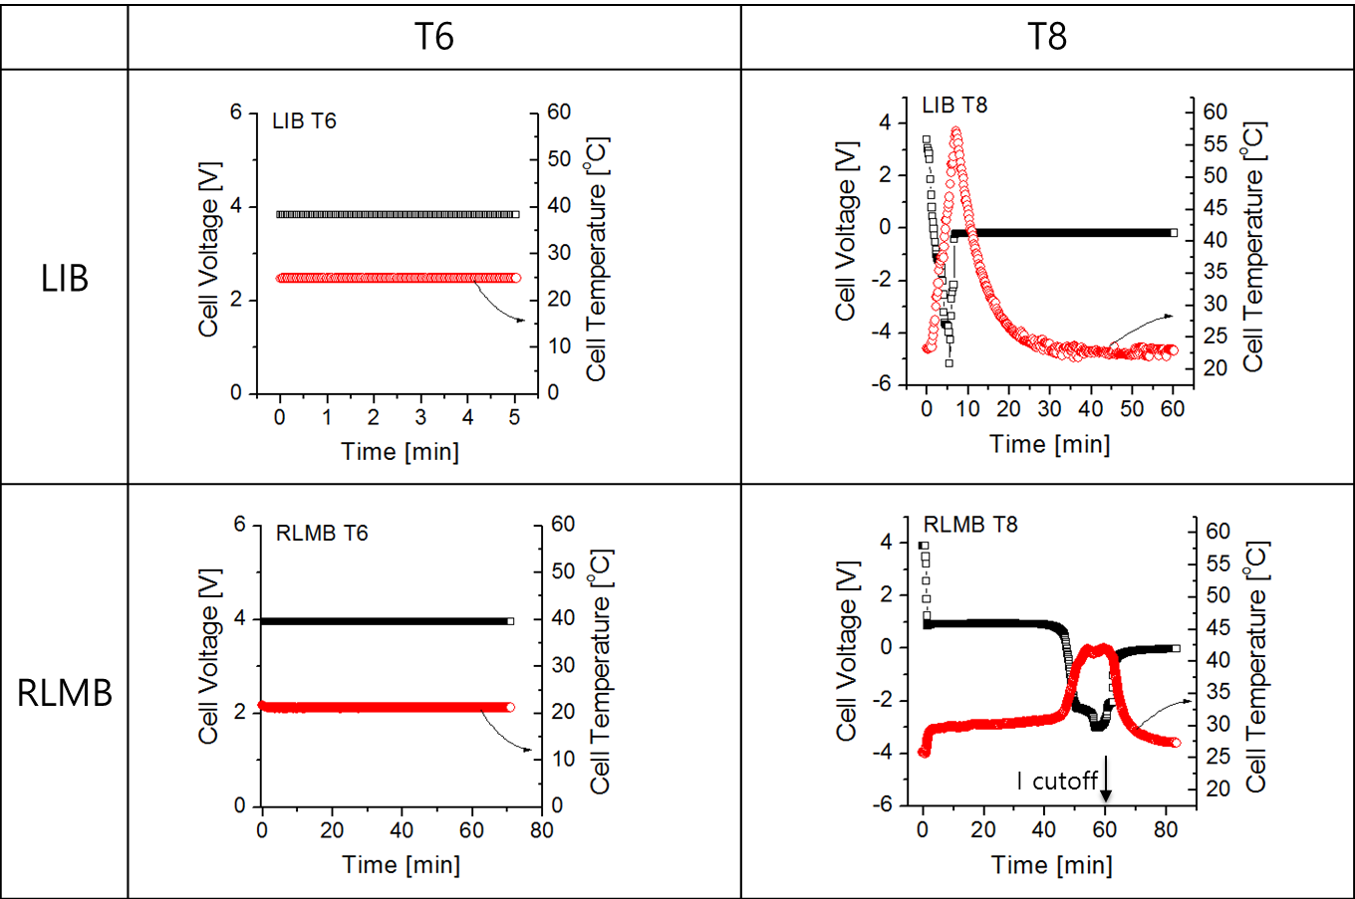

**Fig.3 Physical aspect of Li-ion and RLMP after the tests 38.3 T6 and T8**

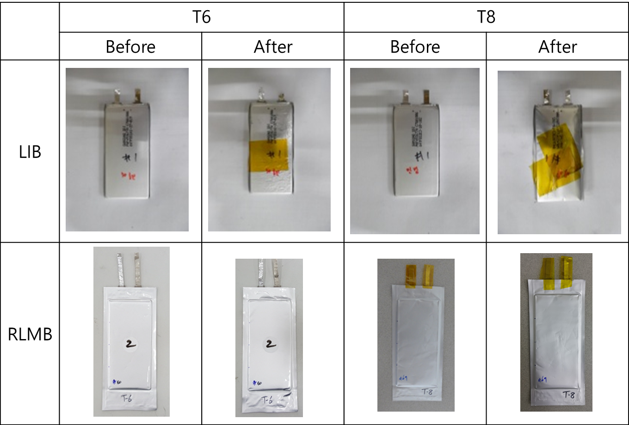

Nail Penetration test results

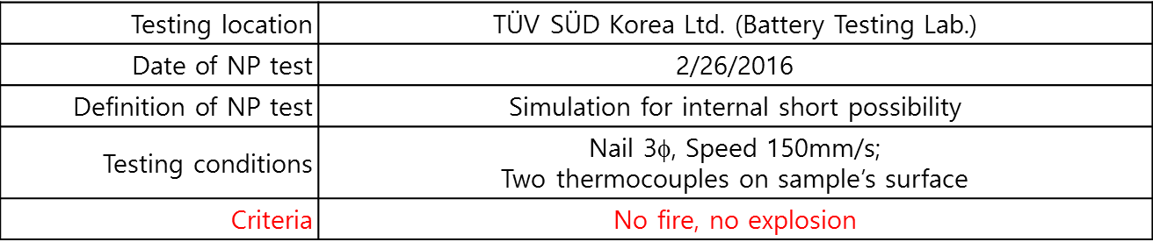

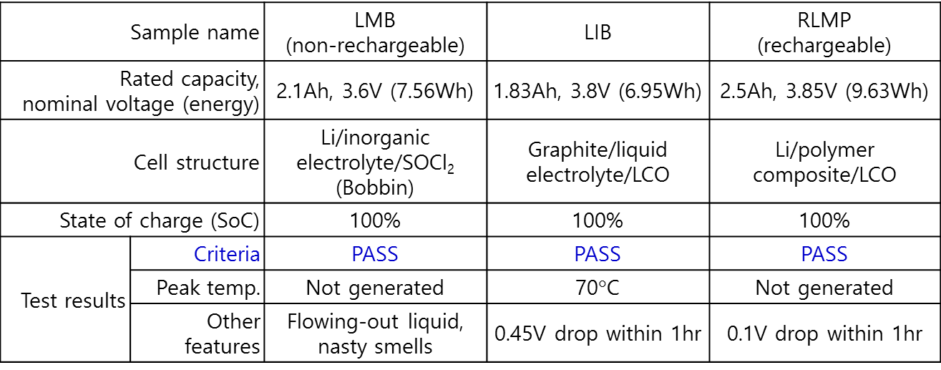

\* LMB: Primary lithium metal battery; LIB: Lithium ion battery; RLMP: Rechargeable lithium metal polymer

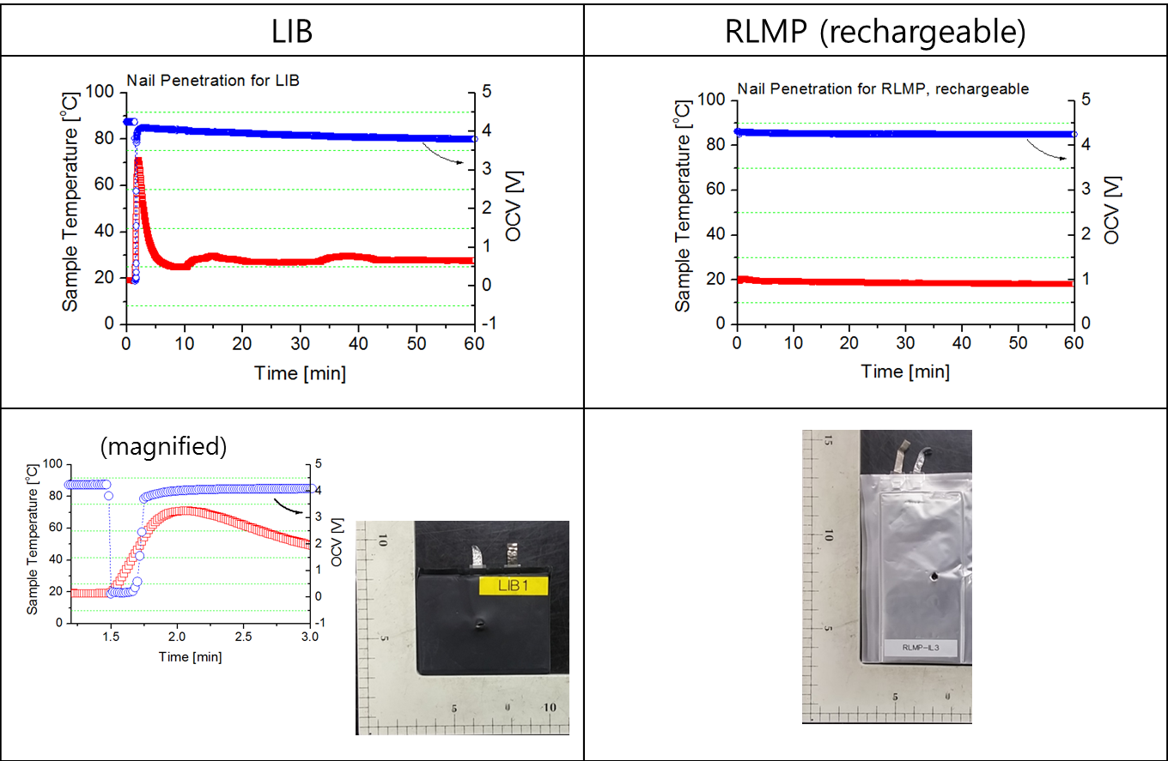



ARC test results to be presented in a separate INF paper.

1. In accordance with the programme of work of the Sub-Committee for 2015–2016 approved by the Committee at its seventh session (see ST/SG/AC.10/C.3/92, paragraph 95 and ST/SG/AC.10/42, para. 15). [↑](#footnote-ref-2)