|  |  |  |  |
| --- | --- | --- | --- |
|  | United Nations | ST/SG/AC.10/C.3/2016/61 | |
| _unlogo | **Secretariat** | | Distr.: General  2 September 2016  Original: English |

**Committee of Experts on the Transport of Dangerous Goods  
and on the Globally Harmonized System of Classification  
and Labelling of Chemicals**

Sub-Committee of Experts on the Transport of Dangerous Goods

**Fiftieth session**

Geneva, 28 November-6 December 2016  
Item 2 (b) of the provisional agenda  
**Recommendations made by the Sub-Committee  
on its forty-seventh, forty-eighth and   
forty-ninth sessions and pending issues:   
explosives and related matters**

Transport of energetic samples for further testing

Transmitted by the European Chemical Industry Council (CEFIC)[[1]](#footnote-2)

Introduction

1. Research and development in industry, public institutes and universities frequently have the need to transport substances for the purpose of testing, i.e. the determination of physical, chemical, biological, toxicological or ecotoxicological properties and behavior, fitness for use or application.
2. The substances usually consist of organic molecules which are active ingredients, building blocks or intermediates for pharmaceutical or agricultural chemicals.
3. Generally, the amounts per substance are small (frequently milligram or lower gram scale), and reliable information about the proper classification is not available due to the lack of test data.
4. In many cases, the molecules of the substances carry functional groups listed in tables A6.1 and/or A6.2 in Annex 6 (Screening Procedures) of the Manual of Tests and Criteria, thus indicating explosive or self-reactive properties; however, they are not designed to be explosives of Class 1.
5. Whereas the transport of samples of self-reactive substances and organic peroxides is permitted under the provisions of 2.4.2.3.2.4 (b) and 2.5.3.2.5.1, respectively, substances considered to meet the criteria for Class 1 are prohibited for transport by 2.0.4.2 (b).
6. However, at this early stage of development, test data are not available to distinguish candidates for Class 1 and self-reactive substance of Division 4.1. Thus, there is a need to find a proper solution for the transport of energetic samples for the purpose of testing in small amounts, to define appropriate criteria for classification in cases of limited test data, and to specify the required packaging.
7. For practical purposes, industry has decided to focus on a solution for very small samples (milligrams to a few grams) in the first phase, and to develop solutions for medium size (up to about 100 grams) and finally lower kilogram scale samples (to cover the amounts required for test series 1 and 2 of the Manual of Tests and Criteria) in the next biennia.
8. During the current biennium, CEFIC had submitted informal document INF.29 (47th session) as a thought starter, suggesting developing a safe packaging specification and an entry in Division 4.1 as self-reactive substance for these energetic samples.
9. Encouraged by the Sub-Committee to proceed in the suggested direction, industry performed testing at the German Federal Institute for Materials Research and Testing (BAM) in close cooperation with the German authorities. The results were presented in informal paper INF.20 (49th session) and give clear evidence that a safe package design has been found.
10. The concept developed in the informal paper received principal support along with the task to define more precisely the scope of applicable substances. Building on discussions with experts in the Working Group on Explosives, a revised scope has been developed (see section “proposal” below) with the following key elements:

* The scope is limited to **organic** substances;
* **Known** and **intentional explosives** are excluded as well as their **synthetic precursors**;
* For samples **containing oxidizers**, section 3.3 (d) of Appendix 6 of the Manual of Tests and Criteria was applied. Whereas the Manual mentions only **mixtures**, the scope in this proposal has been extended to **complexes and salts**.

1. It is not necessary to exclude diazonium salts from the scope since one of the smallest diazonium compounds available (Azodicarbonamide) was included in the tests performed (see below). Aromatic diazonium compound have a higher molar mass and thus are less energetic. Aliphatic diazonium salts are unstable and decompose immediately so there is no need of mentioning them. Further, by using 1 g of TNT equivalent for initiation in the tests performed, substances far more energetic than diazonium compounds are covered.

Discussion

Sample size and packaging

1. In a first stage of research, pharmaceutical companies frequently ship complete substance libraries for activity screenings to specialized institutes. For this purpose, substances may be arranged in so-called multi-titer plates (i.e. array of several dozens or hundreds of samples) as primary packagings with about 1-10 mg of individual sample.

Figure 1: 96 and 384 type multi-titer plate

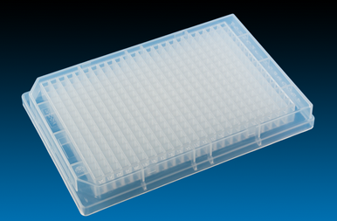

1. Substances may be dissolved in an inert solvent before transport if so required by the test institute. The number of samples in this screening phase is quite large and may reach a magnitude of 10,000 to 100,000 per year and company.
2. The multi-titer plates are frequently placed in dry ice (see figure 2) for quality reasons. For transport at ambient temperature, the usual cushioning material (i.e. bubble wrap, plastic chips, foam pads, etc.) is used.

Figure 2: Multi-titer plates transported on dry ice

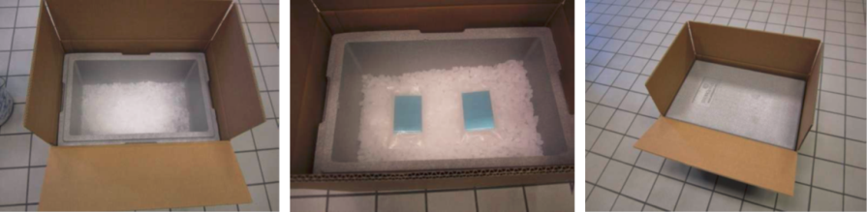

1. At a later stage (lower gram scale), samples may be put into individual glass bottles or plastic containers as primary packagings (see figure 3).

Figure 3: Plastic vessels for individual substances

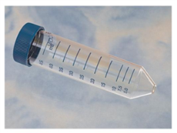

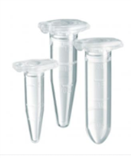

Sample characteristics

1. Since this paper focuses on energetic samples, only substances with functional groups listed in tables A6.1 and/or A6.2 in Annex 6 (Screening Procedures) of the Manual of Tests and Criteria are considered, thus indicating explosive or self-reactive properties; however, the substances are not designed to be explosives of Class 1.
2. The energy content of the samples was determined by screening DSC (heating rate 3 K/min, closed crucible) for a representative set of such substances in research (see diagram 1). Nearly all substances exhibit a decomposition energy of less than 3000 J/g, corresponding to the range of typical self-reactive substances and peroxides and clearly below the range of typical intentional explosives.

**Diagram 1: Distribution of energy content (369 substances)**

1. However, individual outliers do exist. Upon discussion with several authorities, CEFIC decided to take a conservative approach for further testing (see annex).
2. Another issue to be discussed is the decomposition onset: The investigation of a representative set of substances shows a distribution of the onset over a wide temperature range (see diagram 2) (DSC at 3 K/min, closed crucible).

**Diagram 2 Distribution of decomposition onset (372 substances)**

1. This diagram allows some important conclusions: The onset as determined by a screening DSC gives only very rough estimates of thermal stability. Substances with an onset above 200 °C are stable and formally candidates for Class 1. The candidates for self-reactive substances should primarily be found for substances with an onset below 200 °C, whereas a small fraction (decomposition onset <100 °C) might even require temperature control.
2. At this stage, however, neither can the SADT (test series H) be determined nor can test series 1 or 2 of the Class 1 Acceptance Procedure be performed, and a decision about a correct classification is simply not possible.
3. Experience from later stages of development has shown that only a very small fraction of the substances (estimated << 0.1 %) gives a positive result in the Class 1 Acceptance Procedure according to Test Series 2, whereas about 5 to 10 % turn out to be self-reactives.

Testing

1. Tests were performed on highly energetic model substances at the German Federal Institute for Materials Research and Testing with different sample receptacles, amounts and packing arrangements. The essential findings are given in the annex of this paper.
2. Due to the energy content of the samples, tests were performed

* To assess the effects of a possible thermal decomposition, and
* To investigate the initiation of a detonation and its propagation.

Further, the mechanical stability of the package was tested.

1. As a result, a safe package design was found.

Proposal

1. Create a new section 2.0.4.3 to read

“2.0.4.3 **Samples of energetic materials**

2.0.4.3.1 Samples of organic substances carrying functional groups listed in tables A6.1 and/or A6.2 in Annex 6 (Screening Procedures) of the Manual of Tests and Criteria may be transported under UN 3224 (solid self-reactive substances) or UN 3223 (liquid self-reactive substances), as applicable, of Division 4.1 provided that:

1. The samples do not contain any known explosives or compounds designed with the view of producing a practical explosive or pyrotechnic effect. This restriction also applies to samples consisting of synthetic precursors of intentional explosives;
2. For mixtures, complexes or salts of inorganic oxidizing substances of Division 5.1 with organic material(s), the concentration of the inorganic oxidizing substance is:
   * + Less than 15%, by mass, if assigned to packing group I (high hazard) or II (medium hazard);
     + Less than 30%, by mass, if assigned to packing group III (low hazard);
3. Available data do not allow a more precise classification; and
4. The sample is not packed together with other goods.

If solids and liquids are contained within one package, UN 3223 shall be used.”

1. In the Dangerous Goods List, add PP94 and PP95 in column 9 for UN No. 3223 and 3224 to read

|  |  |  |  |  |  |  |  |  |  |  |  |
| --- | --- | --- | --- | --- | --- | --- | --- | --- | --- | --- | --- |
| UN No. | Name and description | Class or divi-sion | Subsi-diary risk | UN packing group | Special provi-sions | Limited and excepted quantities | | Packagings and IBCs | | Portable tanks and bulk containers | |
| Packing instruct-tion | Special packing provi-sions | Instruc-tions | Special provisions |
| (1) | (2) | (3) | (4) | (5) | (6) | (7a) | (7b) | (8) | (9) | (10) | (11) |
| 3223 | SELF-REACTIVE LIQUID TYPE C | 4.1 |  |  | 274 | 25 ml | E0 | P520 | PP21  PP94  PP95 |  |  |
| 3224 | SELF-REACTIVE SOLID TYPE C | 4.1 |  |  | 274 | 100 g | E0 | P520 | PP21  PP94  PP95 |  |  |

1. In packing instruction P520, add a new special packing provision PP94 as follows:

“PP94 Very small amounts of energetic samples of section 2.0.4.3 may be carried under UN 3223 or 3224, as appropriate, provided that:

1. Only combination packagings with outer packagings comprising boxes (4A, 4B, 4N, 4C1, 4C2, 4D, 4F, 4G, 4H1 and 4H2) are used;

2. The samples are carried in microtiter plates or multi-titer plates made of plastic, glass, porcelain or stoneware as inner packagings;

3. The maximum amount per individual inner cavity does not exceed 0.01 g for solids or 0.01 ml for liquids;

4. The maximum net quantity per outer packaging is 20 grams for solids or 20 ml for liquids, or sum of grams and ml in the case of mixed packing;

5. Packing method OP2 is applied; and

6. When dry ice or liquid nitrogen is optionally used as a coolant for quality control measures, the requirements of 5.5.3 are complied with. Interior supports shall be provided to secure the secondary packagings in the original position. The primary receptacle and the secondary packaging shall maintain their integrity at the temperature of the refrigerant used as well as the temperatures and the pressures which could result if refrigeration were lost.”

1. In packing instruction P520, add a new special packing provision PP95 as follows:

“PP95 Small amounts of energetic samples of section 2.0.4.3 may be carried under UN 3223 or 3224, as applicable, provided that:

1. Outer packagings comprise only type 4G having dimensions of ( wx hy dz);

2. The individual substance is contained in an inner packaging of glass or plastic of maximum capacity 30 ml placed in a foam matrix having a density of (xx) g/mm³;

3. Samples are segregated from each other by a foam layer of (xx) mm thickness and from the wall of the outer package by a foam layer of (yy) mm thickness;

4. The maximum content of each inner receptacle does not exceed 1 g for solids or 1 ml for liquids;

5. The maximum net quantity per outer packaging is 20 grams for solids or 20 ml for liquids, or sum of grams and ml in the case of mixed packing;

6. Packing method OP2 is applied; and

7. When dry ice or liquid nitrogen is optionally used as a coolant for quality control measures, the requirements of 5.5.3 are complied with. Interior supports shall be provided to secure the secondary packagings in the original position. The primary receptacle and the secondary packaging shall maintain their integrity at the temperature of the refrigerant used as well as the temperatures and the pressures which could result if refrigeration were lost.”

1. The dimensions of the outer packaging and the details about the foam layout as tested (see annex, initiation of detonation and its propagation) will be detailed in a supplementary informal paper as soon as the test program has been completed.

Justification

(a) Multi-titer plates

1. Since the critical detonation diameter for a sensitive commercial explosive is about 1 mm, and since even commercial explosives are difficult to initiate in small amounts without confinement, it can be concluded that even in a worst case scenario the initiation of a detonation or its propagation in a multi-titer plate is not possible.
2. Further, a thermal decomposition would have no effect outside the package (see test results below). Due to the small amounts, any other hazardous effects can be excluded.

(b) Other samples in small amounts

1. The tests performed have shown that for the chosen packaging design

(a) A mass explosion or dangerous projection hazard can be excluded;

(b) Violent burning or strong heat radiation will not occur due to the design of the package and the large volume and mass of the packaging material compared to the sample;

(c) Fire fighting in the immediate vicinity is not hindered;

(d) There are no hazardous effects outside the package.

1. The substances are not manufactured with the view of producing a practical explosive or pyrotechnic effect. Therefore, according to the Procedure for assignment to a division of Class 1 (Section 10.4 of the Manual of Tests and Criteria) and the flowchart in figure 10.3, the result is “Not Class 1”.
2. Given the properties of the substances as described in the introduction of this paper, the classification as self-reactive substances of Division 4.1 seems to be the most appropriate entry.

Annex

Test results

Thermal decomposition

1. Test were performed on azodicarbonamide (solid, 1400 J/g) and a liquid organic peroxide (1900 J/g decomposition energy).
2. 5 g of the solid substance in a 50 ml glass bottle was put into a plastic bag which was placed into a 1.5 l HDPE bottle along with foam flakes. This bottle was put into a cardboard box filled with foam flakes (see figure 4); a similar arrangement was used for liquids.

Figure 4: Packaging of solid sample for testing

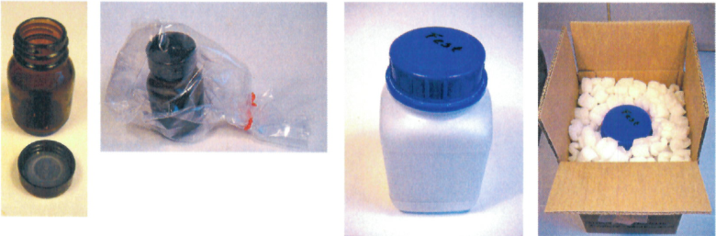

1. The initiation of decomposition by a heating coil or a hot plate resulted only in minor damage (i.e., broken or melted lid); see figure 5 for results of liquid material.

Figure 5: Result of thermal decomposition test

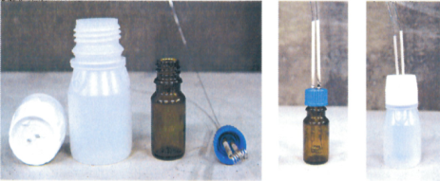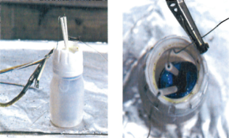

Before test

After test

1. From these results it can be concluded that thermal decomposition does not cause any severe effects for small amounts of energetic samples provided that proper packaging is applied; thus, temperature control for the purpose of safety is not necessary in these cases.

Initiation of detonation and its propagation

1. Tests were performed with two goals:

(a) To minimize hazardous effects outside the package, and

(b) To find a package design to prohibit propagation of detonation from one sample to the other.

Figure 6: Metal-free detonative initiator

1. 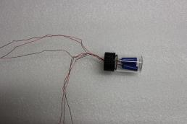A major difficulty was to find an appropriate detonator. The commercial standard detonators proved to be unsuitable due to the metallic fragments which distorted the assessment of the experiments. Finally, a non-metallic pyrotechnic initiator with a detonative output was found. This initiator (see figure 6) with the energy equivalent of 1 g TNT was used throughout the detonation tests.
2. A fibreboard box (4G) of dimensions 60 cm (length) by 41 cm (width) by 28 cm (height) and a wall thickness of 1,3 cm was used. A foam matrix was manufactured with recesses for the sample bottles in defined distances from each other and from the package wall (figure 7).

Figure 7: Foam matrix for sample containers

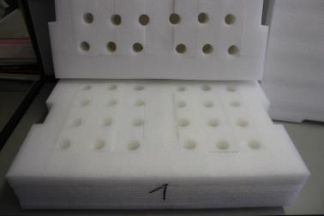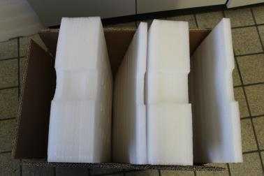

Figure 8: Propagation of detonation at different distances

1. 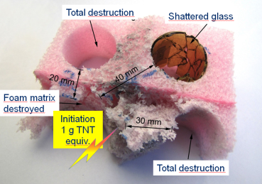In order to determine safe distances to prevent a propagation of detonation from one sample to another, a pilot test was performed with an initiator (1 g TNT equivalent; see above) and sample bottles in defined distances.
2. Whereas total destruction was observed up to a distance of 30 mm, the foam matrix remained intact and the glass bottle was only shattered at 40 mm distance (see figure 8).
3. Finally, the package specified above was tested with sample containers placed in the foam matrix. In order to obtain a worst case scenario, the initiator was placed in the corner at a distance of 7 cm to each wall. The results are shown in figure 9:

Figure 9: Effects on package (inside and outside)

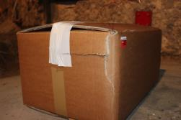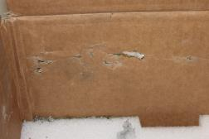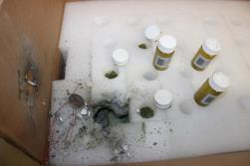

1. Evidently, apart from a superficial crack in the wall of the cardboard box, all effects are limited to the inside of the package. No material was able to penetrate the walls of the box or escape to the outside. The immediately adjacent glass bottles were broken but their lower part was mostly intact. The glass bottles farther away remained fully intact.
2. A second test of the same arrangement with samples of dry picric acid placed around the initiator delivered the same result. A propagation of detonation did not occur.
3. An external fire test (test series 6, type 6 (c)) was not performed since the sample mass is small compared to the packaging material, and a safety relevant effect is not to be expected.

Mechanical stability

1. A drop test (1.8 m, different orientations) resulted only in a slight deformation of the corner of the cardboard box while the inner receptacles remained completely undamaged.

1. In accordance with the programme of work of the Sub-Committee for 2015–2016 approved by the Committee at its seventh session (see ST/SG/AC.10/C.3/92, paragraph 95 and ST/SG/AC.10/42, para. 15). [↑](#footnote-ref-2)