|  |  |  |  |
| --- | --- | --- | --- |
|  | United Nations | ST/SG/AC.10/C.3/2016/43 | |
| _unlogo | **Secretariat** | | Distr.: General  12 April 2016  Original: English |

**Committee of Experts on the Transport of Dangerous Goods  
and on the Globally Harmonized System of Classification  
and Labelling of Chemicals**

**Sub-Committee of Experts on the Transport of Dangerous Goods**

**Forty ninth session**

Geneva, 27 June – 6th July 2016

Item 4 (d) of the provisional agenda

**Electric storage systems: miscellaneous**

Clarification for shipping lithium batteries shipments prepared for transport according to ICAO packing Instruction 965 or 968 Section IB

Transmitted by the Rechargeable Battery Association (PRBA)[[1]](#footnote-2)

Introduction

1. PRBA members have experienced problems with shipments offered for transport by road and sea when offered to carriers due to the fact that packages prepared according to packing instruction 965 or 968 Section IB in the International Civil Aviation Organization (ICAO) Technical Instructions on the Safe Transport of Dangerous Goods by Air bear both the Class 9 label and lithium battery mark.

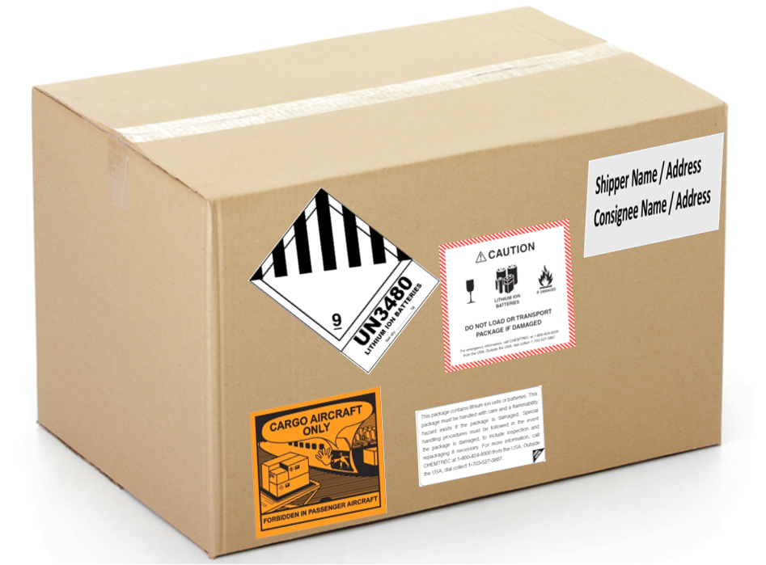

2. On 1 April 2016 amendments adopted by the ICAO came into force and as a result many companies who previously shipped small lithium batteries without Class 9 labels could no longer do so because of limits on the quantity of excepted packages per consignment. These shipments meet the conditions for excepted batteries under SP 188.

3. Many Section IB packages are transported by ground and sea prior to or after being offered for air transport. Unfortunately, since these have a Class 9 hazard label on the package, ground and sea carriers are treating them as if they are fully regulated packages adding further cost and regulatory burden on lithium battery shippers. In many cases carrier personnel use the hazard label on a package as a trigger to indicate that the package is fully regulated and require a dangerous goods transport document.

4. PRBA members cannot in many instances remove or cover labels following an air transport segment or offer the freight as a fully regulated shipment with a dangerous goods transport document. Downstream shippers may not have appropriate training because they only ship excepted lithium batteries and are normally just required to receive adequate instruction relative to offering excepted batteries for transport by sea or road.

5. Based on the confusion experienced to date with Section IB shipments transported by sea and ground it may be necessary to include clarifying language in the Model Regulations to alleviate future confusion. It is noted that the Model Regulations were amended not so long ago to revise paragraph 3.4.10 to clarify that limited quantity packages offered for air transport can be shipped under the ground exceptions applicable to limited quantity shipments. A similar regulatory amendment may be necessary to clarify shipments conforming with the provisions of ICAO PI 965 and 968 Section IB may be transported according to exceptions applicable to small lithium batteries offered for transport by ground and sea.

Proposal

6. The Sub-Committee is invited to consider amending SP 188(f) by adding an additional note as follows:

Renumber the current Note and Note 1. Add a new Note 2 as follows:

*NOTE 2: Packages containing lithium batteries packed in conformity with the provisions of Part 4, Chapter 11, Packing Instructions 965 or 968, Section IB of the ICAO Technical Instructions for the Safe Transport of Dangerous Goods by Air that bear the mark as shown in 5.2.1.9 (lithium battery mark) and the label shown in 5.2.2.2.2, Model No.9A shall be deemed to meet the provisions of this special provision.*

1. In accordance with the programme of work of the Sub-Committee for 2015–2016 approved by the Committee at its seventh session (see ST/SG/AC.10/C.3/92, paragraph 95 and ST/SG/AC.10/42, para. 15). [↑](#footnote-ref-2)