|  |  |  |  |
| --- | --- | --- | --- |
|  | United Nations | ST/SG/AC.10/C.3/2016/10 | |
| _unlogo | **Secretariat** | | Distr.: General  29 March 2016  Original: English |

**Committee of Experts on the Transport of Dangerous Goods  
and on the Globally Harmonized System of Classification  
and Labelling of Chemicals**

Sub-Committee of Experts on the Transport of Dangerous Goods

**Forty-ninth session**

Geneva, 27 June – 6 July 2016  
Item 2 (c) of the provisional agenda  
**Explosives and related matters:   
review of tests in parts I and II of the Manual of Tests and Criteria**

Supporting material for the new design proposal for the standard detonator in the Manual of Tests and Criteria

Transmitted by the expert from Germany[[1]](#footnote-2)

Introduction

1. During the forty-seventh session of the Sub-Committee an amendment to the design for the standard detonator (European type) has been proposed in document ST/SG/AC.10/C.3/2015/26. While there was much general support for an update of the standard detonator specification, discussions in the explosives working group (EWG) led to the result, that further experimental evidence would be desirable to demonstrate, that the amended design performs equally to the previous design.

2. Part of such evidence was given in informal document INF.37 (47th session), where test results from the Trauzl-test showed that the obtained volumes would be the same, for the previous and for the new standard detonator design.

3. Another possibility to compare the detonator’s performance was discussed during the 47th session of the Working Group on Explosives, which is to consider data from the so called underwater-test. This test measures the shock energy of a detonator by recording the maximum peak pressure and the time for the collapse of the gas bubble generated, when a detonator is fired under water.

4. A number of tests have been performed in accordance with EN 13763 “Explosives for civil uses – Detonators and relays”, part 15 “Determination of equivalent initiating capability”. The European standard covers this test with many technical details. Relevant experimental parameter are: a water tank with 500 litre volume is used, and that the pressure gauge is placed at a distance of 400 mm from the detonator. Distance of both shall be at least 200 mm to the walls of the tank and 400 mm under the water surface. Test results for each two detonators of the previous and of the new design are reproduced in the annex to this document.

Proposal

5. It is proposed that, on the basis of experimental evidence given in this and previous papers, the specification of the standard detonator, is amended. The amended design shall be based on the proposal in ST/SG/AC.10/C.3/2015/26, taking into account the comments given in the report of the Working Group on Explosives (Informal document INF.53, 47th session).

Annex

Under water tests results with the standard detonator

1. The following graphs show pressure traces recorded at BAM (Federal Institute for Materials Research and Testing, Germany). The tests are referenced by their original numbering as V20 and V21 for the original detonator design (0.6 g PETN main charge, Copper shell, produced by dyniTEC in Germany). For comparison a detonator with 0.6 g PETN main charge and a Copper shell produced by Austin Detonator, Czech Republic, which contains all elements of the new standard detonator design, was also subjected twice to the underwater test numbered V15 and V16. A table summarizes the values taken from the original data.

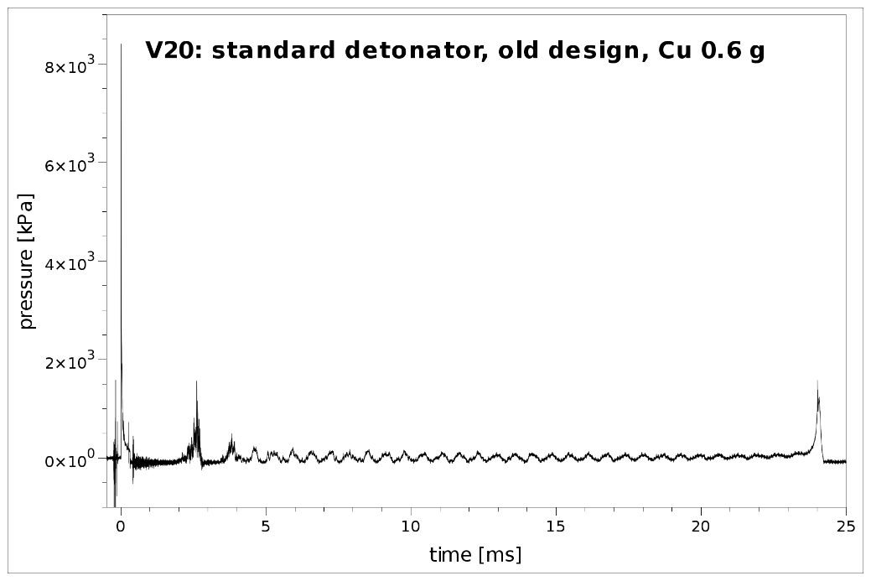

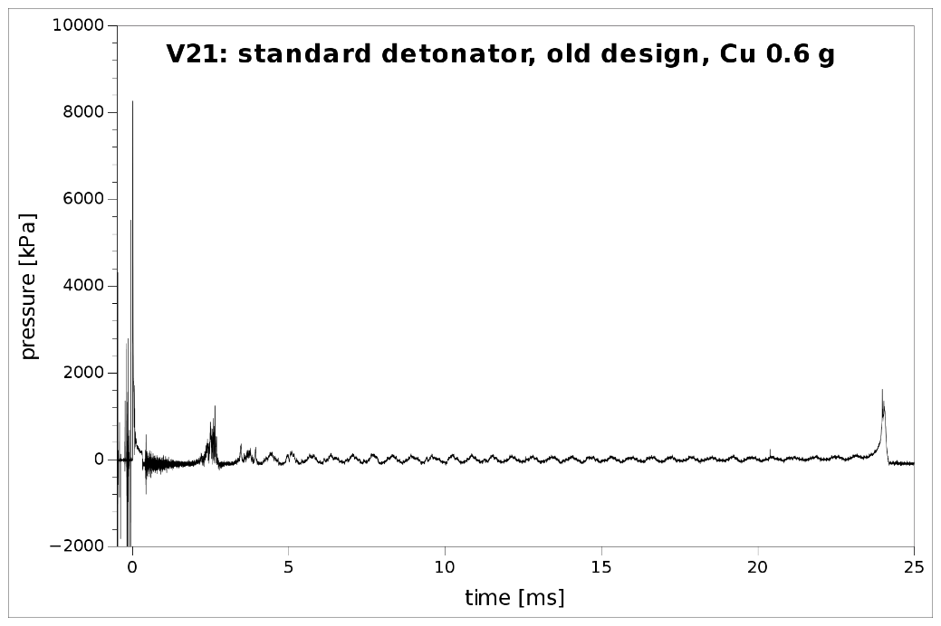

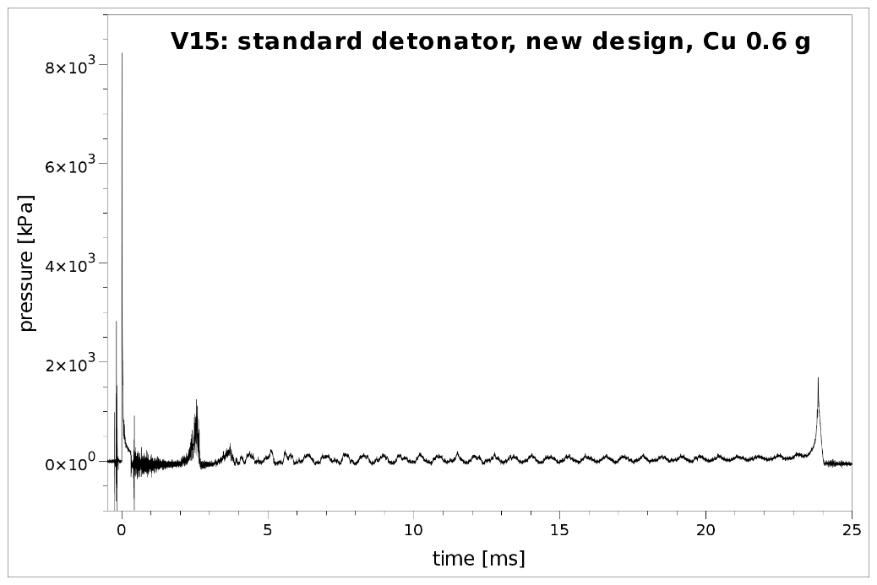

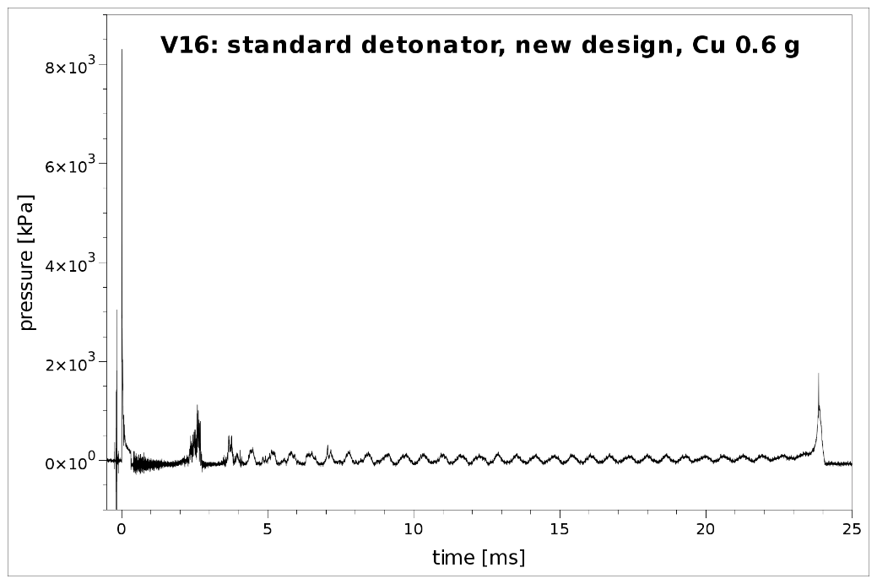

|  |  |  |  |  |
| --- | --- | --- | --- | --- |
| **Date** | **Test no.** | **Detonator design** | **Peak pressure [MPa]** | **Time till collapse [ms]** |
| 2015-09-02 | V20 | Old | 8.41 | 24.04 |
| 2015-09-02 | V21 | Old | 8.26 | 24.02 |
| 2015-09-02 | V15 | New | 8.23 | 23.83 |
| 2015-09-02 | V16 | New | 8.30 | 23.88 |

1. In accordance with the programme of work of the Sub-Committee for 2015–2016 approved by the Committee at its seventh session (see ST/SG/AC.10/C.3/92, paragraph 95 and ST/SG/AC.10/42, para. 15). [↑](#footnote-ref-2)