In confirmation of our attitude towards the proposed amendment to document ECE/TRANS/WP.29/GRSP/2012/19, we would like to present the vehicles that are beyond the scope of UN ECE Regulation No 29 with 03 series of amendments as currently amended and included in document ECE/TRANS/WP.29/GRSP/2013/9, submitted by Sweden:

PAZ-32053-20 (passenger and goods vehicle) | Vario Mercedes-Benz
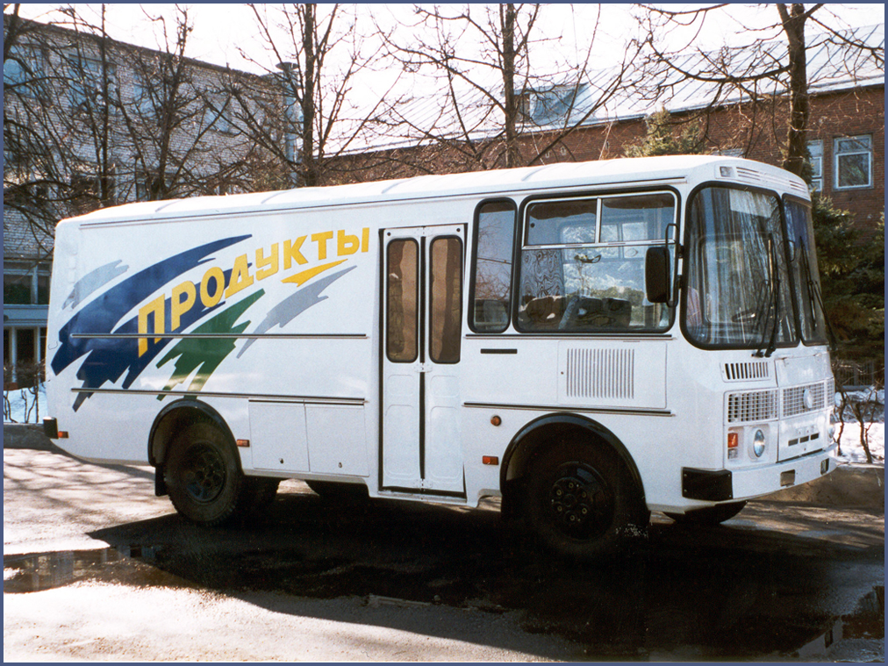 | 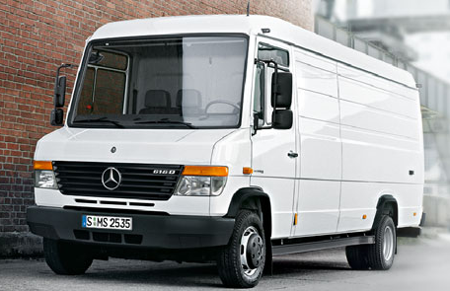
With Gross Vehicle Mass 7 740 ÷ 8 305 kg | With Gross Vehicle Mass 5 990÷ 7 490 kg

Those GVM data for the Vario Mercedes-Benz were taken from the specifications provided by the manufacturer. In case the GVM is increased by 20 kg, that vehicle will fall beoynd the scope of UN Regulation No. 29. Therefore, the RF proposes that the scope of UN Regulation No. 29 with 03 series of amendments should include all vehicles of Category N.

