 | United Nations | ST/SG/AC.10/C.3/2012/70
 | Secretariat |  | Distr.: General  11 September 2012  Original: English
Committee of Experts on the Transport of Dangerous Goods
and on the Globally Harmonized System of Classification
and Labelling of Chemicals
Sub-Committee of Experts on the Transport of Dangerous Goods
Forty-second session
Geneva, 3 – 11 December 2012
Item 7 of the provisional agenda
New proposals for amendments to the Model Regulations
on the Transport of Dangerous Goods
Proposal for further amendment to the descriptions of labels, placards, symbols, markings and marks
Transmitted by the International Paint & Printing Ink Council (IPPIC)
Introduction and discussion
1. IPPIC welcomes the proposals for standardisation of marks/labels/placards made by the United Kingdom in document ST/SG/AC.10/C.3/2012/32, all but one of which were adopted with modifications at the forty-first session of the Sub-Committee. The adopted amendments to the Model Regulations, as documented in Annex II of the report of the session (ST/SG/AC.10/C.3/82/Add.1), will help to improve clarity and remove uncertainty both for consignors and for designers/producers of labels.
2. In recent years IPPIC has noted an issue with the practical implementation and enforcement of reduced size labels and markings. This specific issue was however not addressed or affected by the amendments mentioned in paragraph 1, therefore IPPIC wishes to propose some additional changes to the descriptions of marks and labels.
3. The descriptions of the limited quantities marks in sections 3.4.7 and 3.4.8, the environmentally hazardous substance mark in 5.2.1.6.3 and labels in 5.2.2.2.1 all provide for a reduction in the dimensions of the mark or label (below the normal minimum 100 mm x 100 mm) where this is necessitated by the size of the package. The same provisions appear in the corresponding sections of the modal regulations for transport of dangerous goods by land, sea and air.
4. IPPIC has become aware from member companies that some national competent authorities interpret the reduced size provision very literally, requiring that a 100 mm x 100 mm label or mark be displayed if this can physically be accommodated by the size of the package. This applies even if the label/mark occupies a large proportion of the available surface area, and takes no account of other obligatory elements which must also be accommodated on the package, such as a second transport label or mark (e.g. the environmentally hazardous substance mark in addition to a label for Classes 1-9) and/or hazard labelling for supply and use, as well as essential product information such as identifiers and instructions for use. For some single packagings it is necessary to reduce the size of transport markings in order to fit all required information legibly or securely onto the package, so application of the strict interpretation mentioned above creates difficulties for companies in the design and application of their product labelling.
5. Some genuine examples of labelled packagings illustrating the issue described in paragraph 4 are presented in the Annex to this document.
6. IPPIC proposes to amend the descriptions of the aforementioned labels and marks to clarify that their dimensions may be reduced when necessitated not solely by the physical size of the packaging, but also the other obligatory labelling elements which must be displayed thereon. The following proposals use as their starting point the adopted texts included in Annex II to ST/SG/AC.10/C.3/82/Add.1.
Proposal 1: Limited quantity marking
7. Amend paragraphs 3.4.7.2 and 3.4.8.2 to read as follows:
“3.4.7.2 If the size of the package, taking into account other obligatory marks or labels, so requires, the minimum outer dimensions shown in Figure 3.4.1 may be reduced to be not less than 50 mm x 50 mm provided the marking remains clearly visible. The minimum width of the line forming the diamond may be reduced to a minimum of 1 mm.”.
“3.4.8.2 If the size of the package, taking into account other obligatory marks or labels, so requires, the minimum outer dimensions shown in Figure 3.4.2 may be reduced to be not less than 50 mm x 50 mm provided the marking remains clearly visible. The minimum width of the line forming the diamond may be reduced to a minimum of 1 mm. The symbol "Y" shall remain in approximate proportion to that shown in Figure 3.4.2.”.
Proposal 2: Environmentally hazardous substance mark
8. Amend section 5.2.1.6.3 and figure 5.2.2 to read as follows:
“5.2.1.6.3 The environmentally hazardous substance mark shall be as shown in
Figure 5.2.2.
Figure 5.2.2
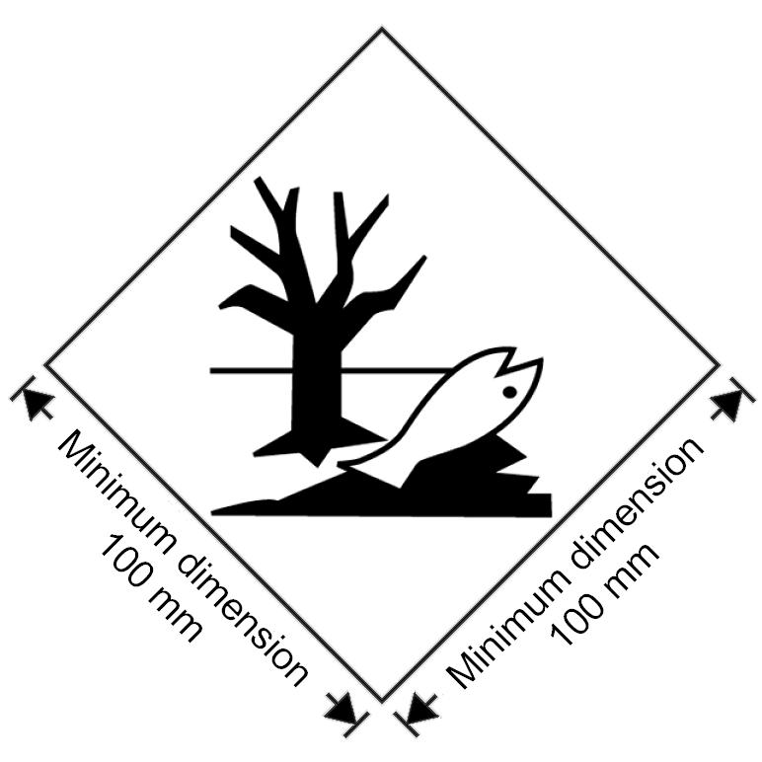
Environmentally hazardous substance mark
The marking shall be in the form of a square set at an angle of 45 degrees (diamond-shaped). The symbol (fish and tree) shall be black on white or suitable contrasting background. The minimum dimensions shall be 100 mm x 100 mm and the minimum width of line forming the diamond shall be 2 mm. If the size of the package, taking into account other obligatory marks or labels, so requires, the dimensions/line thickness may be reduced, provided the marking remains clearly visible. Where dimensions are not specified, all features shall be in approximate proportion to those shown.
NOTE: The labelling provisions of 5.2.2 apply in addition to any requirement for packages to bear the environmentally hazardous substance mark.”.
Proposal 3: Class/division labels
9. Amend paragraph 5.2.2.2.1.1.3 to read as follows:
“5.2.2.2.1.1.3 If the size of the package, taking into account other obligatory marks or labels, so requires the dimensions may be reduced, provided the symbols and other elements of the label remain clearly visible. The line inside the edge shall remain 5 mm to the edge of the label. The minimum width of the line inside the edge shall remain 2 mm. Dimensions for cylinders shall comply with 5.2.2.2.1.2.”.
Annex
Examples of single packagings showing difficulties in properly accommodating 100 mm x 100 mm transport labels
Example 1: 5 litre pail
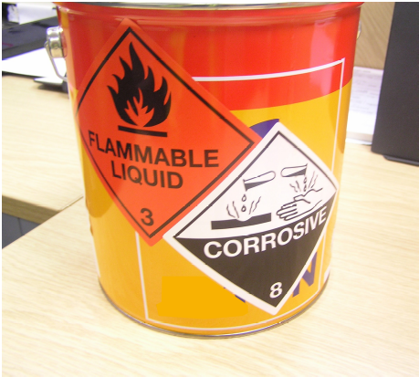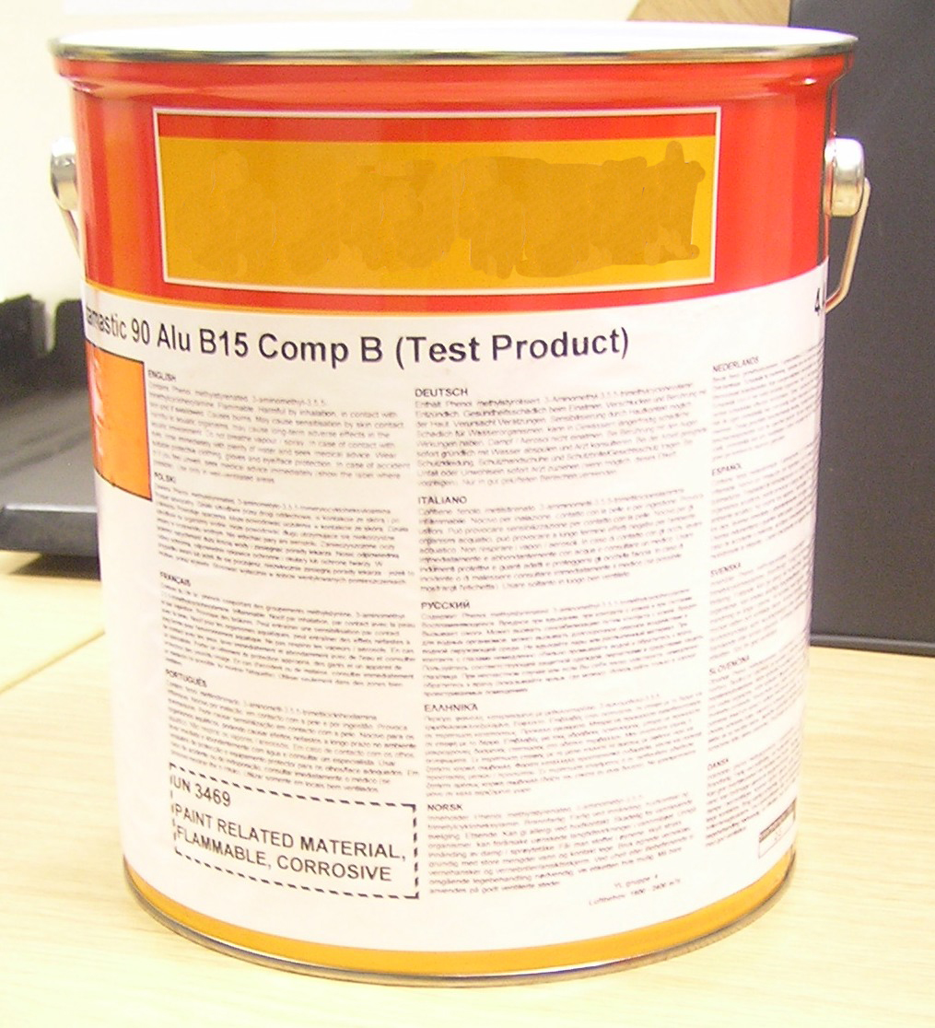
This packaging contains a product classified as UN 3469 PAINT RELATED MATERIAL, flammable, corrosive. Two transport labels, Class 3 and Class 8, are therefore required to be displayed on the packaging. (The product is also classified as an environmentally hazardous substance, but the corresponding mark is not required on packages of 5 litres maximum).
It is only just possible to affix two transport labels of 100 mm x 100 mm on the pail without partially covering the obligatory supply label. The transport labels must adjoin one another along one edge in order to fit onto the pail; even so, one label overlaps onto the top flange of the pail, which is not ideal as the label is less securely affixed and thus more likely to peel away.
A small reduction in the size of the transport labels, e.g. by 20%, would enable two labels to be accommodated comfortably and securely on the pail, without prejudicing safety since such labels would still be clearly visible and legible.
Example 2: 3 litre pail
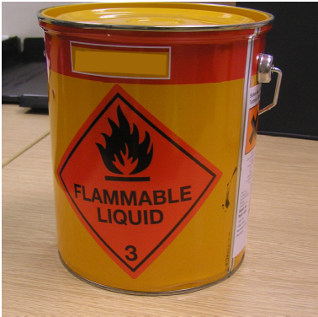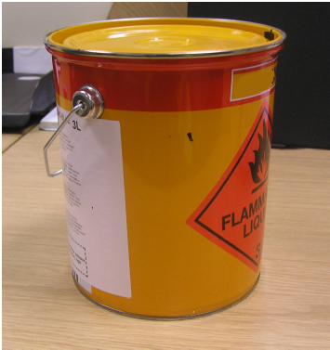

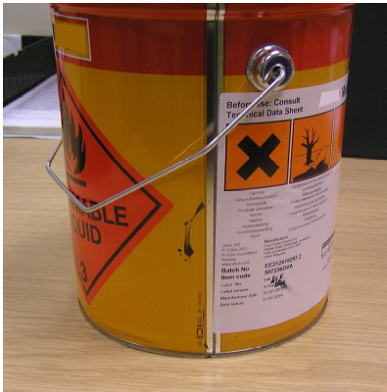
This packaging contains a flammable product classified as UN 1263 PAINT RELATED MATERIAL. Besides the obligatory supply label, the pail is able to accommodate one transport label of 100 x 100 mm, which for this product is feasible since only the Class 3 label is required. (The product is also classified as environmentally hazardous, but the mark is not required since the package does not exceed 5 litres.)
For a product requiring a second transport label, such as UN 3469 in Example 1, it is not possible to affix this to a 3 litre pail without obscuring either the supply label or the first transport label. Nonetheless some companies have been told by national authorities that, since a package of this size can physically accommodate a label of 100 mm x 100 mm, the size of the transport labels may not be reduced. This interpretation of the labelling provisions creates a problem for consignors which has no solution.
Example 3: 2.5 litre pail
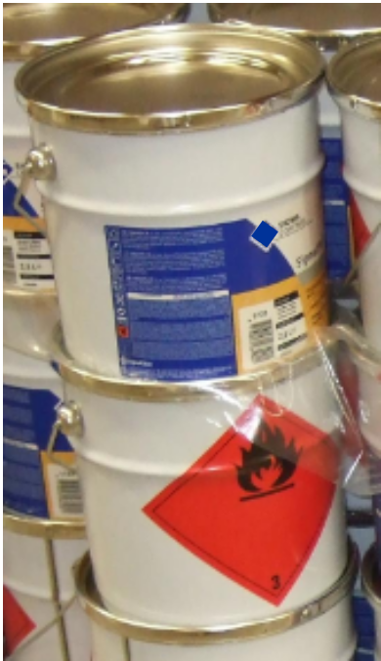
This packaging contains a flammable product, UN 1263 PAINT. Only one 100 mm x 100 mm transport label can fit on the pail alongside the supply label. Since this overlaps the strengthening bead in the pail wall, it is necessary for the Class 3 label to be pre-printed onto the pail during manufacture to prevent problems with label adhesion or distortion. This increases costs for the consignor and reduces flexibility in packaging stock allocation, without any obvious safety benefit: a label reduced in size, such that it just fits below the bead, would still be clearly visible and legible on the pail.
As in Example 2, it is impossible to accommodate a second transport label on this packaging unless the consignor would be permitted to reduce the size of both.

? In accordance with the programme of work of the Sub-Committee for 2011-2012 approved by the Committee at its fifth session (refer to ST/SG/AC.10/C.3/76, para. 116 and ST/SG/AC.10/38, para. 16).

