Particle Number Counter Calibration/Validation Procedures


Report to the Department for Transport

Restricted Commercial
ED47382004/PNC
Issue Number Draft Revision 4
August 2007

Title | Particle Number Counter Calibration/Validation Procedures

Customer | Department for Transport

Customer reference | Contract No. PRO 4/9/4

Confidentiality, copyright and reproduction | This report is the Copyright of Department of Transport and has been prepared by AEA Technology plc under contract to Department for Transport dated 7 August 2006. The contents of this report may not be reproduced in whole or in part, nor passed to any organisation or person without the specific prior written permission of Department for Transport. AEA Technology plc accepts no liability whatsoever to any third party for any loss or damage arising from any interpretation or use of the information contained in this report, or reliance on any views expressed therein

Reference number | ED47382004/PNC- DRAFT

AEA Energy & Environment
Building 551.11
Harwell International Business Centre
Didcot
OX11 0QJ

t: 0870 190 6526
f: 0870 190 6608

AEA Energy & Environment is a business name of
AEA Technology plc

AEA Energy & Environment is certificated to ISO9001
and ISO14001

Author | Name | Ian Marshall

Approved by | Name | Emma Sandbach

Signature

 | Date | August 2007

Table of contents
1 Introduction 1
2 Principle of Operation 2
3 Draft Regulation No. 83 Requirements 3
3.1 PNC 3
3.2 PNC Validation 3
4 Calibration/Validation Methods 4
4.1 Primary Method 5
4.2 Secondary Method 11
4.3 Lower Cut-Off Diameter Performance Check 15
4.4 Equipment Summary 16
5 References 18
6 Annex 1 20
6.1 Emery Oil Specification 20
7 Annex 2 21
7.1 Secondary Validation Method Example 21

Introduction
Condensation of supersaturated vapors has been used for more than a century to grow small aerosol particles to sizes that can be detected optically. Instruments that use condensation to detect particles can be divided into two categories:

- Expansion-type instruments (including the “Aitken” dust counters and the “Pollak” photoelectric nucleus counters).
- Steady-flow condensation particle number counters (PNC).

The second category of instruments can be further subdivided according to the approach used to produce the saturated vapour:

- Forced convection heat transfer
- Mixing warm and cool vapour streams, or mixing two vapours that subsequently undergo multi-component condensation
- Segmented thermal diffusion

The majority of modern condensation PNCs are of the forced convection heat transfer type and only this type of PNC will be considered here. Further information on the historical development and performance of all types of condensation PNC can be found in the review produced by McMurry (2000)¹.

Principle of Operation
On entering the condensation PNC, particles pass through a saturator where the working fluid evaporates into the gas stream. The flow becomes saturated with vapour of the working fluid before passing into a condenser where supersaturation of the vapour occurs. Under this condition the vapour condenses onto the particles to form droplets larger in diameter than the original particles. The droplets pass through a laser on leaving the condenser, and light scattered by the droplets is collected and focused onto a photodetector. The photodetector converts the light signal to an electrical pulse that is recorded as a particle count.

The optimal working fluid for an instrument of this type requires a vapour pressure at typical ambient temperature (25 – 30°C) that is large enough to grow particles in the condenser to a size that can easily be detected optically (0.5 – 15 µm), yet not so large that particles would be lost by sedimentation or impaction. Vapour diffusivity, which determines the rate of vapour depletion to the condenser walls, is also an important consideration. It is desirable to choose a working fluid having a small diffusivity in air, thereby ensuring that particles are exposed to elevated supersaturation as long as possible during flow through the condenser.

The first commercially produced forced convection heat transfer PNC was developed by Agarwal and Sem (1980)². This instrument operated in two modes: single-particle counting mode for concentrations below ~1000 cm⁻³ and “photometric” mode for concentrations higher than this. The single particle counting mode involved the detection of forward-scattered white light from a halogen lamp. The photometric mode involved measurement of the d.c. level of light scattered by the aerosol cloud at the exit of the condenser. While the single-particle count mode was considered to provide an absolute measurement of concentration, the photometric mode required an empirical calibration. Butanol was selected as the working fluid because it was found to absorb water more slowly than isopropanol, which was used initially. Absorbed water led to a decrease in the amount of alcohol vapor added to the aerosol, and therefore affected the instrument response.

A number of refinements in the design of continuous flow condensation PNCs have been reported since (e.g. Wilson et al. (1983a³, 1983b⁴), Stolzenburg and McMurry (1991)⁵).

Draft Regulation No. 83 Requirements

PNC
The specific requirements for the particle number measurement device (PNC) are listed in Section 1.3.4 of ‘Proposal for draft supplement 7 to the 05 series of amendments to Regulation No.83’⁶(this was further amended in document No. GRPE-54-10⁷), and are reproduced here:

The relevant paragraphs from amended Reg. 83 will be inserted here

PNC Validation
The specific requirements for the validation of the particle number measurement device (PNC) are listed in Section 2.1 of ‘Proposal for draft supplement 7 to the 05 series of amendments to Regulation No.83’⁶(this was further amended in document No. GRPE-54-10⁷), and are reproduced here:

The relevant paragraphs from amended Reg. 83 will be inserted here

Calibration/Validation Methods
The following general points are brought to the attention of the reader:

- Both the primary and secondary methods described here are intended as methods to validate PNC performance in the context of draft Regulation No. 83 requirements. However, any PNC used as the reference PNC in the secondary method will have been calibrated by the primary method, i.e. a calibration factor will have been derived from the aerosol electrometer comparison and applied to subsequent data measured by the transfer PNC. No such factor is derived and applied to PNCs that have been validated by either the primary or secondary method and are subsequently used for measurements required by draft Regulation No. 83.

- Principles of good laboratory practice should be adopted when using any of the methods described below. In particular, users should ensure that any piece of ancillary equipment that is critical to the validation is itself appropriately calibrated before use.

The calibration of the electrostatic classifier and the aerosol electrometer are of particular relevance to these methods. Electrostatic classifier calibration is specified in the forthcoming international standard “Determination of particle size distribution — differential electrical mobility analysis for aerosol particles”. This document, ISO/CD15900⁸, has been approved for registration as a Draft International Standard with a target publication date of August 2008. Aerosol electrometer calibration is also partially covered within this document under an Informative Annex: “Particle detectors”. However, a new ISO work item “Validation and Calibration of Aerosol Particle Number Counters” is underway which will separately specify calibration requirements for aerosol particle number counters (see Section 4.1.3). In the absence of either of these documents being formally available, the approach adopted by Liu et al. (2005)⁹ provides an excellent model to follow.

- The methods rely upon comparing the response of two pieces of aerosol measurement instrumentation to a common test aerosol. One piece of equipment acts as the reference, while the other is the instrument under calibration/validation. The user must ensure that the test aerosol pathway to each instrument is configured so that any particle deposition that may occur between particle source and instrument is comparable for both instruments. This is usually achieved by ensuring residence time is comparable in both pathways. Residence time must be adjusted by varying the length rather than diameter of the pathway, as diffusional deposition is independent of tube diameter for a given volumetric flow rate. The equivalence of both pathways should be checked when using PNCs of equivalent inlet flow rate by exchanging the pathways between the PNCs while sampling a stable aerosol source of concentration in excess of 1,000 cm⁻³. The pathways are considered equivalent if the change in measured concentration is ≤ ?? %. (TBC)

- Particle deposition can be minimised by utilizing conductive tubing and installing a flow splitter where the test aerosol is divided for delivery to each instrument

- The PMP specification for the particle number counter excludes those with automatic data manipulation functions. However, “coincidence correction” is required and should be applied to all PNC-measured data using the formula specified by the PNC manufacturer, subject to a maximum permissible correction of 10% (TBC).

- References to particle diameters throughout the remainder of the document are electrical mobility diameters unless otherwise stated.

Primary Method

Background
The current calibration/validation method for condensation PNCs is based on the method developed by Liu and Pui (1974)⁸. An electrostatic classifier is used to deliver singly charged, monodisperse test aerosols of known size and composition. An aerosol electrometer and the PNC under test sample this aerosol in parallel downstream of the classifier. The concentration is obtained from the aerosol electrometer current.

This approach has been adopted as standard in many laboratories (e.g. Liu et al. (1975)¹¹, Liu and Kim (1977)¹², Agarwal and Sem (1980)², Marshall and Dickens (2000)¹³) and in numerous intercomparison workshops (e.g., Liu et al. (1982)¹⁴, Bartz et al. (1985)¹⁵, Wiedensohler et al. (1997)¹⁶).

This is the method used by most condensation PNC manufacturers to determine PNC performance, including lower size detection limit, counting efficiency and linearity of response.

Two potential complications with this method have been mooted:

- multiply charged particles having the same mobility as the desired singly charged particles may be included within the aerosol leaving the electrostatic classifier, leading to a more complicated relationship between current and concentration, and

- the detection limit of the aerosol electrometer limits the concentrations at which the validation can be performed to those greater than ~10³ particles cm⁻³.

These issues have been addressed by Liu et al. (2005)⁹. They generated a quasi-monodisperse test aerosol by electrospraying emery oil and measured the size distribution after electrostatic classification to confirm the absence of any larger multiply charged particles. Emery oil (Emery 3004 or PAO 4 cSt) is a highly branched isoparaffinic polyalphaolefin (1-decene (tetramer) mixed with 1-decene (trimer), hydrogenated), see Annex 1. It provides a source of quasi-monodisperse spherical particles of chemical composition representative of synthetic lube oil particles. Thereafter they compared four TSI Model 3010 PNCs against a reference aerosol electrometer over a concentration range from 2,000 to 11,000 particles cm⁻³. A further data point was recorded for each comparison at a particle concentration of zero. Excellent agreement was achieved between concentrations measured by the PNCs and the aerosol electrometer, with correlation plots yielding gradients in the range from 0.953 to 0.973 and correlation coefficients greater than 0.998. Figure 1 is an example of such a correlation plot. Thus, with correlation plot gradients close to unity, correlation coefficients greater than 0.998 and good agreement at zero particle concentration, it is unnecessary to undertake comparison measurements at particle concentrations less than ~1,000 particle cm⁻³, below the detection limit of the reference aerosol electrometer. There is no plausible reason why PNC performance should be any different between zero and ~ 1,000 cm⁻³ than it is above 1,000 cm⁻³. Liu et al. also undertook an analysis of the traceability of critical parameters affecting the performance of the reference aerosol electrometer, viz. flow rate, charge per particle and electrometer current. Osmondson and Liu (2005)¹⁷ have also demonstrated that the collection efficiency of the filter within the aerosol electrometer is greater than 99.999% for 50 nm particles.

Sakurai et al. (2005)¹⁸ describe the adoption of a very similar method using a reference aerosol electrometer as the national Japanese standard against which PNCs are compared.

Figure 1 Example of Reference Aerosol Electrometer and CPC Concentration Correlation (from Reference 15)

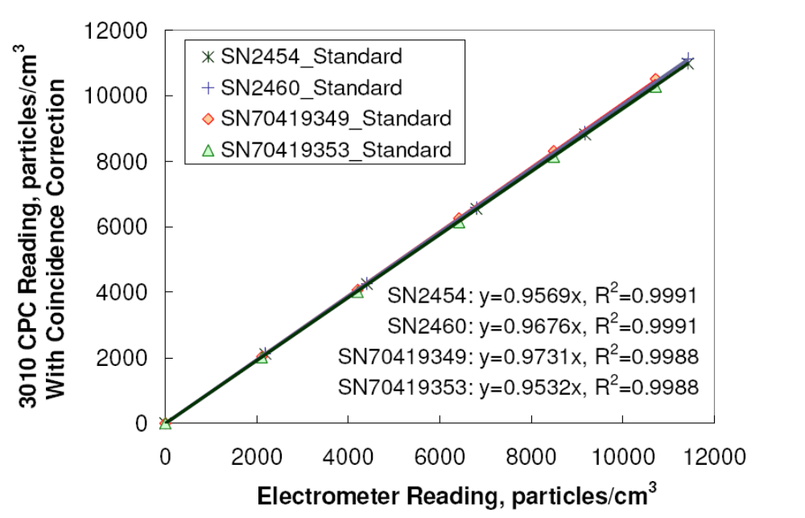

Test Aerosol
The composition and absolute size of the test particles are not critical (within limits), providing they meet the following criteria:

- Modal diameter in the range from 50 to 100 nm
- Monodispersity: GSD ≤ 1.2

The test aerosol will subsequently be electrostatically classified to provide a source of monodisperse particles each carrying a single elementary charge unit. The size distribution of the particles leaving the electrostatic classifier should be measured to confirm the absence of any larger particles carrying multiple charges which have the same electrical mobility as the monodisperse singly charges particles.

- Concentration: a minimum concentration of [SPCM]_{max} cm⁻³ after electrostatic classification (where [SPCM]_{max} is the maximum single particle count mode concentration of the PNC under validation).

Procedure
The procedure for performing a PNC validation against an aerosol electrometer according to the primary validation method is described below.

Prepare the PNCs for use:
- Position the PNC as illustrated in Figure 2, but do not connect it to the remainder of the apparatus
- Switch on, fill with working fluid to the specified level (observe manufacturer’s precautions regarding moving the unit when full) and allow the saturator and condenser to reach their specified temperatures
- Apply an external vacuum source if the PNC is not fitted with an internal pump
- Do not proceed unless all indicators show correct instrument status (e.g. temperature, liquid level, temperature, laser intensity etc.).
- Check the inlet flow rate with an appropriate calibrated flow meter (low pressure drop variety recommended, e.g. bubble flow meter). The measured flow should be within ± 5 % of the nominal value for the model of PNC under test.
- Check that zero concentration is reported when a HEPA filter is attached to the inlet. If concentrations higher than 0.5cm⁻³ are reported check for, and correct, any leaks in the connection between the HEPA filter and PNC. The PNC requires attention from the manufacturer if concentrations greater than 0.5 cm⁻³ are reported after any leaks are eliminated.

Prepare the aerosol electrometer for use:
- Position the aerosol electrometer as illustrated in Figure 2, but do not connect to the remainder of the apparatus
- Switch on and allow to warm up for the period recommended by the manufacturer
- Apply an external vacuum source if the aerosol electrometer is not fitted with an internal pump
- Configure the aerosol electrometer as appropriate (e.g. set inlet flow rate, average charge per particle and data average time)
- Check the inlet flow rate with an appropriate calibrated flow meter (low pressure drop variety recommended, e.g. bubble flow meter). The measured flow should be within ± 5 % of the nominal value for the model of PNC under test
- Reset zero offset (background current) with a HEPA filter connected to the inlet

Figure 2 Primary Method

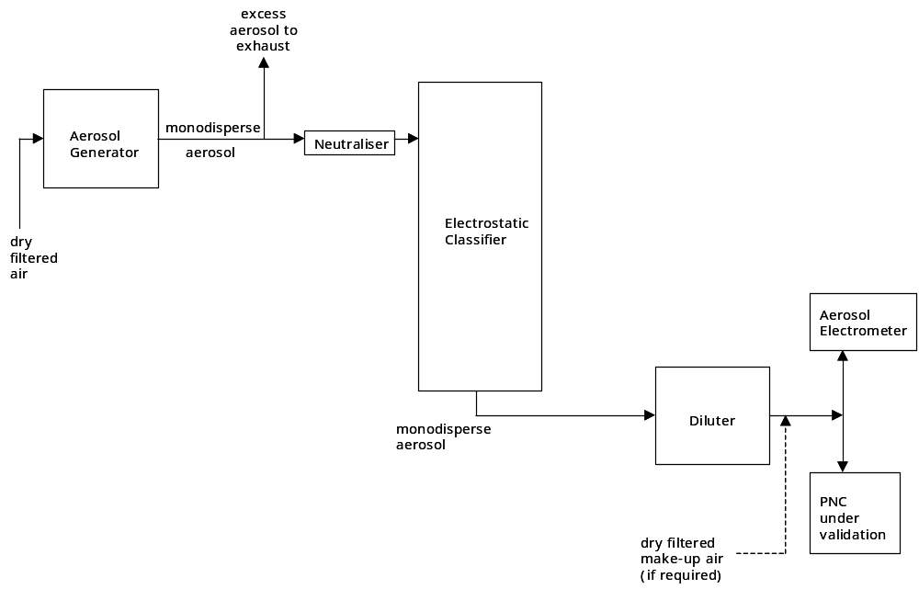

Set up the aerosol generator and electrostatic classifier.

- Set the electrostatic classifier flows such that the monodisperse aerosol flow leaving the classifier is sufficient for the total inlet flow of both the PNC and the aerosol electrometer. (Provide additional particle-free flow after the classifier if necessary).
- Select a voltage on the electrostatic classifier that corresponds to a particle diameter larger than the D₉₀ of the PNC under validation (50 nm suggested).
- Operate the aerosol generator and measure the size distribution of the particles leaving the electrostatic classifier to confirm the absence of larger multiply charged particles.

Connect the PNC and the aerosol electrometer to the remainder of the apparatus (Figure 2):

- Ensure that the particle residence time in the pipe work from the electrostatic classifier to both the PNC and aerosol electrometer is identical (see Section 3.2). Take into account the inlet flow to the PNC and the aerosol electrometer, and the internal diameter and length of the interconnecting pipe work. Take particular care if the inlet flows into the PNC ad aerosol electrometer are different.

Make arrangements to log data from both the PNC and the aerosol electrometer simultaneously at the same sampling rate.

Set the electrostatic classifier voltage to zero volts and begin logging data. Both the PNC and aerosol electrometer should report “zero” particle concentrations (< 0.5 cm⁻³), having already been checked with a HEPA-filtered inlet. If either the PNC or aerosol electrometer reports a non-zero concentration, check the apparatus for leaks. It is important that leaks are eliminated. Any particles leaking into the system downstream of the classifier may be of a size smaller than the D₉₀ of the PNC under validation, which will invalidate the comparison.

Generate the test aerosol and select the voltage on the electrostatic classifier corresponding to the particle diameter of interest, ensuring that it is larger than the D₉₀ of the PNC under validation (50 nm suggested). Continue logging data and ensure that the PNC is not reporting a concentration above its maximum single particle count mode concentration limit. Otherwise adjust the diluter until the reported concentration is below the maximum concentration limit. Thereafter, adjust the diluter to vary the concentration delivered to the PNC and aerosol electrometer. Five approximately equally spaced concentrations between 2,000 and [SPCM]_{max} cm⁻³ are suggested (where [SPCM]_{max} is the maximum single particle count mode concentration of the PNC under validation). Allow the reported concentration to stabilise at each dilution setting. Repeat the procedure at electrostatic classifier voltages corresponding to other diameters of interest if necessary.

Analyse the resulting data, including the zero concentration point in the dataset, in terms of the correlation between the log of the reported concentrations from the PNC (y axis) and the aerosol electrometer (x axis) to establish the gradient and the linearity (R² coefficient).

The linearity of response in terms of the R² coefficient must be greater than 0.97, else the PNC under validation does not respond linearly over the measured concentration range. The gradient of the correlation plot must be within the range from 0.90 to 1.10 (unity signifies complete agreement between the PNC and the aerosol electrometer).

Proposed ISO Method
ISO Technical Committee 24 Sub-Committee 4 has recently proposed a new work item: “Validation and Calibration of Aerosol Particle Number Counters”. This will provide a procedure for the derivation and quantification of measurement uncertainty with the aim of realizing internationally recognized primary particle counters. The accompanying calibration procedure will specify the comparison of a particle counter with a particle counter that is traceable to a primary particle counter.

The primary particle counter concept was proposed because different counting methods are used to measure number concentrations (e.g. aerosol electrometer, condensation particle counter, optical particle counter). The results of the counting methods should agree within the specified uncertainties of the measurements by each method. Each counting method is best suited to specific particle characteristics as different methods have smaller uncertainties for different particle characteristics. Each method has its advantages but no single method can be designated as superior. All the methods must be validated to be established as primary methods in metrological terms. By comparing each with the other, their uncertainties can be justified and each method can be acknowledged as a primary method.

The concept is illustrated in Figure 3.

Figure 3 Concept of Particle Number Concentration Standard

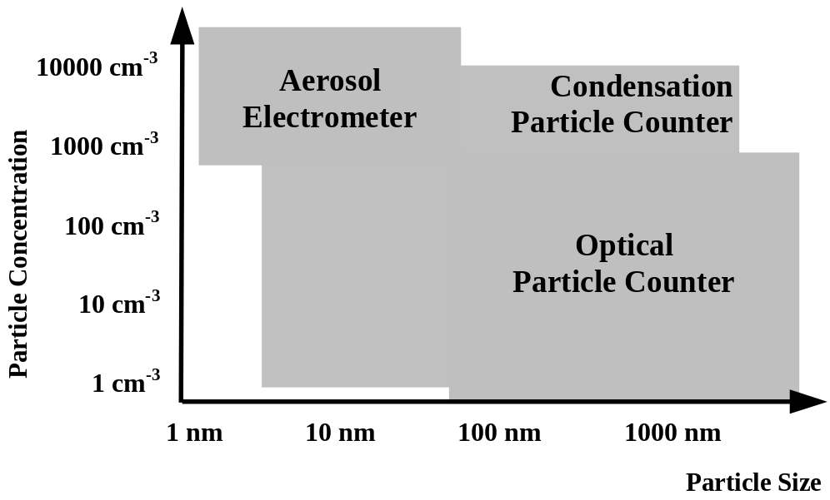

Taking the condensation particle number counter as an example, validation at modest concentrations is achieved by comparison with the aerosol electrometer, whereas validation at low concentrations is achieved by comparison with the optical particle counter using larger particles. Validation is achieved across the whole concentration range by utilizing the method with the better measurement uncertainty in combination with appropriately sized calibration particles.

At the time of writing, ISO members have adopted the proposal as a New Work Item “Validation and calibration of aerosol particle number counters” and work is scheduled to begin on the document in the Autumn of 2007.

Secondary Method
Any PNC calibrated by the primary method described in Section 4.1 can be utilised as a reference against which the performance of other PNCs can be compared. It is recommended that the transfer standard PNC should be of the same make and model as the PNC under validation. However, any PNC can be used as long as due regard is given to the D₅₀ and D₉₀ diameters of the respective models (D_{x} is the diameter at which the PNC detection efficiency is x %) and to any differences in maximum single particle count mode concentrations of the respective models. The reference PNC must have demonstrated a counting accuracy of ± 5 % across the concentration range 1,000 cm⁻³ to the maximum concentration of its single particle count mode from its primary calibration.

This approach has been adopted to validate the Golden PNC used in the PMP Light-Duty Interlaboratory Comparison Exercise. A TSI Model 3010 PNC (S/N: 2005) calibrated by TSI according to the primary method was used as the reference PNC. This has been included by way of an example in Annex 2.

Test Aerosol
There are a number of aerosol generation techniques that are capable of producing solid particles in the size range between 50 and 100nm diameter including condensation generators, combustion aerosol generators, electrosprays, nebulisation and hot wires. Any of these methods are suitable for producing test aerosols for this procedure. The size distribution required depends on which of the secondary methods is employed:

Method A
a size distribution in the diameter range from 50 to 100 nm from which monodisperse fractions having concentrations from 100 to [SPCM]_{max} cm⁻³ can be delivered after electrostatic classification (where [SPCM]_{max} is the maximum single particle count mode concentration of the PNC under validation)

Method B
a size distribution from which a monodisperse 50 nm fraction having a minimum concentration of [SPCM]_{max} cm⁻³ can be delivered after electrostatic classification (where [SPCM]_{max} is the maximum single particle count mode concentration of the PNC under validation).

Procedure
The procedure for performing a PNC validation against a reference PNC according to the secondary validation method is described below.

Prepare both PNCs for use:
- Position the PNCs as illustrated in Figure 4, but do not connect them to the electrostatic classifier.
- Switch on, fill with working fluid to the specified level (observe manufacturer’s precautions regarding moving the unit when full) and allow the saturator and condenser to reach their specified temperatures
- Apply an external vacuum source if the PNC is not fitted with an internal pump
- Do not proceed unless all indicators show correct instrument status (e.g. temperature, liquid level, temperature, laser intensity etc.).
- Check the inlet flow rate with an appropriate calibrated flow meter (low pressure drop variety recommended, e.g. bubble flow meter). The measured flow should be within ± 5 % of the nominal value for the model of PNC under test.
- Check that zero concentration is reported when a HEPA filter is attached to the inlet. If concentrations higher than 0.5cm⁻³ are reported check for, and correct, any leaks in the connection between the HEPA filter and PNC. The PNC requires attention from the manufacturer if concentrations greater than 0.5 cm⁻³ are reported after any leaks are eliminated.

Figure 4 Secondary Method

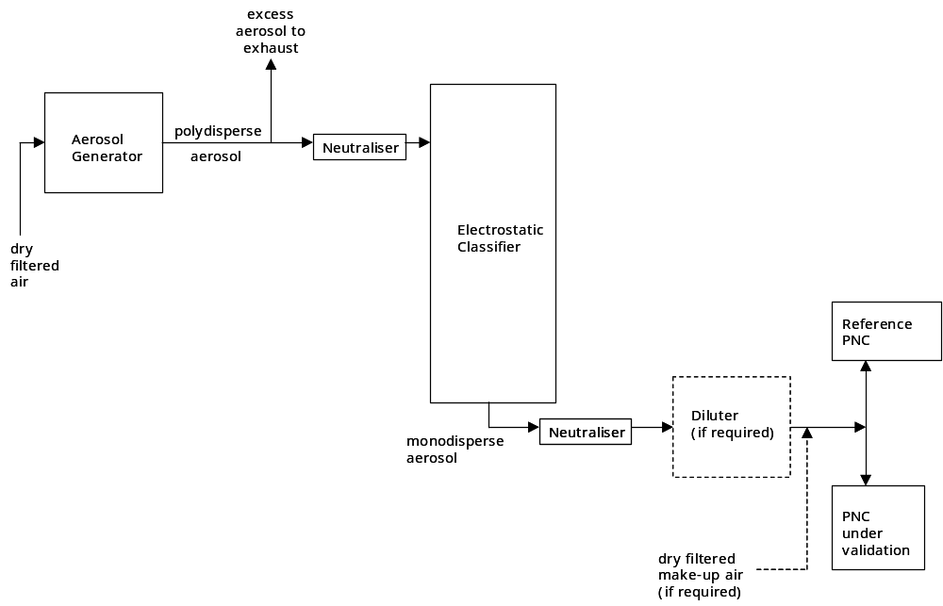

Connect the PNCs to the remainder of the apparatus (Figure 4):

- Ensure that the particle residence time in the pipe work from the electrostatic classifier to both PNCs is identical (see Section 3.2). Take into account the inlet flow to each PNC and the internal diameter and length of the interconnecting pipe work. Take particular care if the inlet flows into each PNC are different.
- Set the electrostatic classifier flows such that the monodisperse aerosol flow leaving the classifier is sufficient for the total inlet flow of both PNCs. (Provide additional particle-free flow after the classifier if necessary).

Make arrangements to log data from both PNCs simultaneously at the same sampling rate.

Set the electrostatic classifier voltage to zero volts and begin logging PNC data. Both PNCs should report “zero” particle concentration (< 0.5 cm⁻³), having already been checked with a HEPA-filtered inlet. If either PNC reports non-zero concentrations, check the apparatus for leaks. It is important that leaks are eliminated. Any particles leaking into the system downstream of the classifier may be of a size smaller than the D₉₀ of the PNC under validation, which will invalidate the comparison.

Either:
Secondary Method (A)
Generate the test aerosol and select a voltage on the electrostatic classifier corresponding to a particle diameter larger than the D₉₀ of either PNC (50 nm suggested). Continue logging PNC data and ensure that neither PNC is reporting a concentration above its maximum concentration limit. If not, adjust the electrostatic classifier voltage until the reported concentration is below the maximum concentration limit. Thereafter, gradually adjust the electrostatic classifier voltage to vary the concentration delivered to the PNCs without exceeding the classifier voltage corresponding to the maximum particle diameter (100 nm suggested). Allow the PNC reported concentration to stabilise at each electrostatic classifier voltage to allow for possible differences in response time between the two PNCs.

Or:
Secondary Method (B)
Generate the test aerosol and select the voltage on the electrostatic classifier corresponding to the particle diameter of interest, ensuring that it is larger than the D₉₀ of either PNC (50 nm suggested). Continue logging PNC data and ensure that neither PNC is reporting a concentration above its maximum concentration limit. If not, adjust the diluter until the reported concentration is below the maximum concentration limit. Thereafter, adjust the diluter to vary the concentration delivered to the PNCs. Allow the PNC reported concentration to stabilise at each dilution setting to allow for possible differences in response time between the two PNCs. Repeat the procedure at electrostatic classifier voltages corresponding to other diameters of interest if necessary.

Analyse the resulting data, including the zero concentration point in the dataset, in terms of the correlation between the reported concentrations from both PNCs with the reference PNC on the x axis and the PNC under validation on the y axis, to establish the gradient and the linearity (R² coefficient).

The linearity of response in terms of the R² coefficient must be greater than 0.97, else the PNC under validation does not respond linearly over the measured concentration range. The gradient of the correlation plot must be within the range from 0.90 to 1.10 (unity signifies complete agreement between the two PNCs).

Lower Cut-Off Diameter Performance Check
The PNC is required to detect 23 nm particles with an efficiency of 50 ± 12 % (see Section 3.1 and References 6 &7). This performance is achieved in the majority of PNCs by controlling the respective temperatures of the saturator and condenser. The secondary validation method should be used to check its detection efficiency at 23 nm. The procedure is identical to that described in Section 4.2.1 except that only a single concentration and diameter are required. This is achieved by setting the electrostatic classifier voltage to the value corresponding to a diameter of 23 nm. The aerosol used must be of the same material used by the manufacturers for determining the cut-off characteristics of both test and reference PNCs. PNC detection efficiency is calculated by comparing the concentrations reported by each of the PNCs taking due regard of the detection efficiency of the transfer standard PNC at 23 nm diameter:

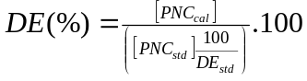

where DE is the detection efficiency of the PNC under test (%), [PNC_{cal}] is the particle concentration measured by the PNC under test (cm⁻³), [PNC_{std}] is the particle concentration measured by the transfer standard PNC (cm⁻³) and DE_{std} is the detection efficiency of the transfer standard PNC at 23 nm diameter (%).

The DE of the PNC under test must lie within the range 38-62%.

Equipment Summary
The following equipment is required to validate a PNC using the primary method.

Table 1: Equipment required to validate the PNC (primary method)
Equipment | Purpose
Flow meter, low pressure drop, calibrated (e.g. bubble flow meter) | Measurement of inlet flow
HEPA filter (at least 99.99% efficiency) | Zero concentration checks
Aerosol generator | Production of test particles
Electrostatic Classifier, calibrated | Selection of monodisperse particle fraction from aerosol generator output
Neutraliser | Electrostatic equilibration of particles before electrostatic classifier
SMPS | Check size distribution of test particles leaving the electrostatic classifier
Source of compressed air, dry, filtered | To supply the;  - Aerosol generator  - Diluter  - Make up air (optional)
Diluter | Vary concentration of test aerosol
Reference aerosol electrometer | Comparison of measured concentrations

The following equipment is required to validate a PNC using the secondary method.

Table 2: Equipment required to validate the PNC (secondary method)
Equipment | Purpose
Flow meter, low pressure drop, calibrated (e.g. bubble flow meter) | Measurement of PNC inlet flow
HEPA filter (at least 99.99% efficiency) | Zero concentration checks of PNC
Aerosol generator | Production of test particles
Electrostatic Classifier, calibrated | Selection of monodisperse particle fraction from aerosol generator output
2 Neutralisers | Electrostatic equilibration of particles before and after electrostatic classifier
Source of compressed air, dry, filtered | To supply the;  - Aerosol generator  - Diluter (optional)  - Make up air (optional)
Diluter (optional) | Vary concentration of test aerosol
Reference PNC calibrated by primary method | Comparison of measured concentrations

References
1 .McMurry, P. H. (2000). The History of Condensation Nucleus Counters, Aerosol Sci. Technol., 33, 297.

2. Agarwal, J. K., and Sem, G. J. (1980). Continuous Flow, Single-Particle-Counting Condensation Nucleus Counter, J. Aerosol Sci., 11, 343.

3. Wilson, J. C., Blackshear, E. D., and Hyun, J. H. (1983a). An Improved Continuous-Flow Condensation Nucleus Counter for Use in the Stratosphere, J. Aerosol Sci., 14, 387.

4. Wilson, J. C., Hyun, J. H., and Blackshear, E. D. (1983b). The Function and Response of an Improved Stratospheric Condensation Nucleus Counter, Journal of Geophysical Research, 88, 6781.

5. Stolzenburg, M. R., and McMurry, P. H. (1991). An Ultrafine Aerosol Condensation Nucleus Counter, Aerosol Sci. Technol., 14, 48.

6. Amendments to UNECE Regulations, Regulation No. 83, Proposal for draft supplement 7 to the 05 series of amendments to Regulation No.83, ECE/TRANS/WP.29/GRPE/2007/8

7. Document no. GRPE-54-10. Reg 83 amendment.

8. ISO/CD15900 (2007) “Determination of particle size distribution — differential electrical mobility analysis for aerosol particles”.

9. Liu, W., Osmondson, B. L., Bischof, O. F. and Sem, G. J. (2005). Calibration of Condensation Particle Counters, Paper No. 2005-01-0189, Emissions Measurement and Testing 2005, Society of Automotive Engineers (SAE) Book No. SP-1941.

10. Liu, B. Y. H., and Pui, D. Y. H. (1974). A Submicron Aerosol Standard and the Primary, Absolute Calibration of the Condensation Nuclei Counter, J. Colloid Interface Sci., 47, 155.

11. Liu, B. Y. H., Pui, D. Y. H., Hogan, A. W., and Rich, T. A. (1975). Calibration of the Pollak Counter with Monodisperse Aerosols, Journal of Applied Meteorology, 14, 46.

12. Liu, B. Y. H., and Kim, C. S. (1977). On the Counting Efficiency of Condensation Nuclei Counters, Atmospheric Environment, 11, 1097.

13. Marshall, I. A. and Dickens, C. J. (2000). Calibration Service for Ultrafine Particle Counters, AEA Technology Report AEAT/R/ENV/0391 for the UK Department of Trade and Industry Valid Analytical Measurement Programme.

14. Liu, B.Y. H., Pui, D.Y. H.,McKenzie, R. L., Agarwal, J. K., Jaenicke, R., Pohl, F. G., Preining, O., Reischl, G., Szymanski, W., and Wagner, P. E. (1982). Intercomparison, of Different “Absolute” Instruments for Measurement of Aerosol Number Concentration, J. Aerosol Sci., 13, 429.

15. Bartz, H., Fissan, H., Helsper, C., Kousaka, Y., Okuyama, K., Fukushima, N., Keady, P., Fruin, S., McMurry, P. H., Pui, D. Y. H., and Stolzenburg, M. R. (1985). Response Characteristics for Four Condensation Nucleus Counters to Particles in 3 to 50 nm Diameter Range, J. Aerosol Sci., 16, 443.

16. Wiedensohler, A., Orsini, D., Covert, D. S., Coffmann, D., Cantrell, W., Havlicek, M., Brechtel, F. J., Russell, L. M., Weber, R. J., Gras, J., Hudson, J. G., and Litchy, M. (1997). Intercomparison Study of the Size-Dependent Counting Efficiency of 26 Condensation Particle Counters, Aerosol Sci. Technol., 27, 224.

17. Osmondson, B. L. and Liu, W. (2005). Awaiting confirmation.

18. Sakurai, H., Ehara, E., Tajima, N. and Fukushima, N. (2005). Development of a Primary Calibration Standard for Aerosol Particle Number Concentration Using the Electrometer Method, Proc. 9th ETH Conference on Combustion Generated Nanoparticles, Swiss Federal Institute of Technology, Zürich.

Annex 1

Emery Oil Specification

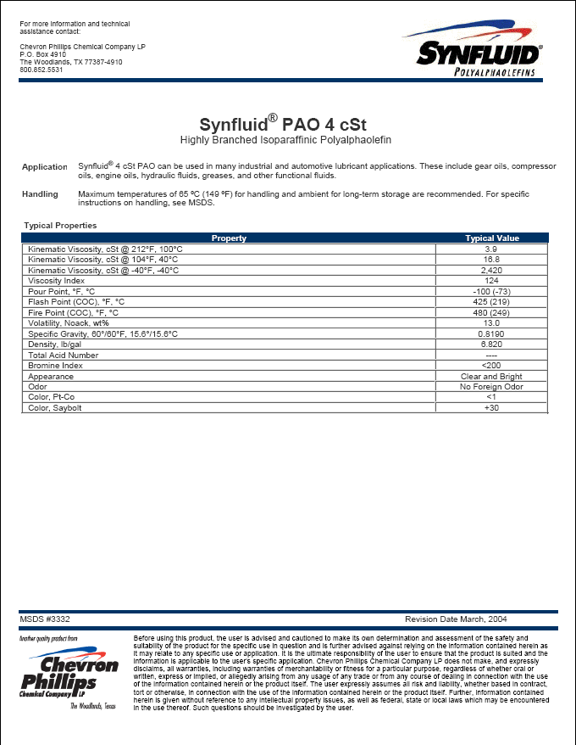

Annex 2

Secondary Validation Method Example
Any PNC calibrated by the primary method described in Section 4.1 can be utilised as a reference against which the performance of other PNCs can be compared. This approach has been adopted to validate the Golden PNC used in the PMP Light Duty Interlaboratory Comparison Exercise and is described here as an example of using the secondary method. A TSI Model 3010 PNC (S/N: 2005) calibrated by TSI according to the primary method was used as the reference PNC.

The aerosol generator consisted of a ceramic crucible heated via an electric Bunsen (Figures 5). The bulk material (sodium chloride) was placed in the ceramic crucible and heated to near its boiling point. A small flow was introduced into the crucible to displace vapour from the surface of the bulk material to a cooler region of the generator where condensation occurred. Particle diameters could be varied by controlling the rate of vapour transport from the crucible (via the crucible air flow) and/or the subsequent cooling rate of the vapour (via the carrier air flow). A typical size distribution of a generated aerosol is presented in Figure 6.

Note: This aerosol generation method is reported purely as an example. Alternative methods that generate similarly sized particles and concentrations are equally appropriate.

Figure 5a Condensation Aerosol Generator

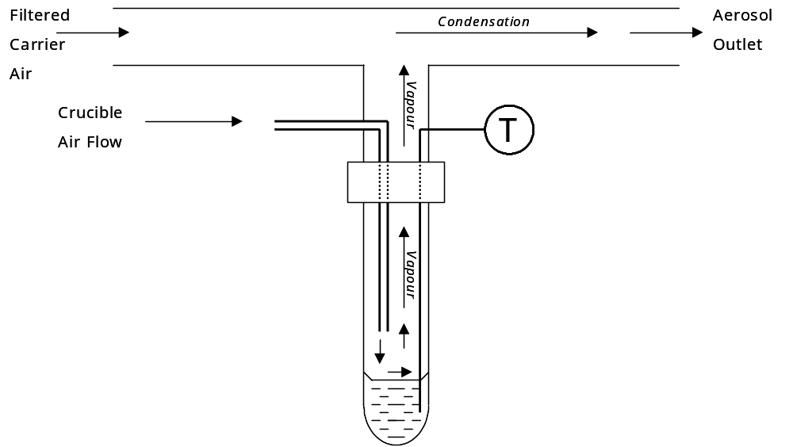

Figure 5b Condensation Aerosol Generator

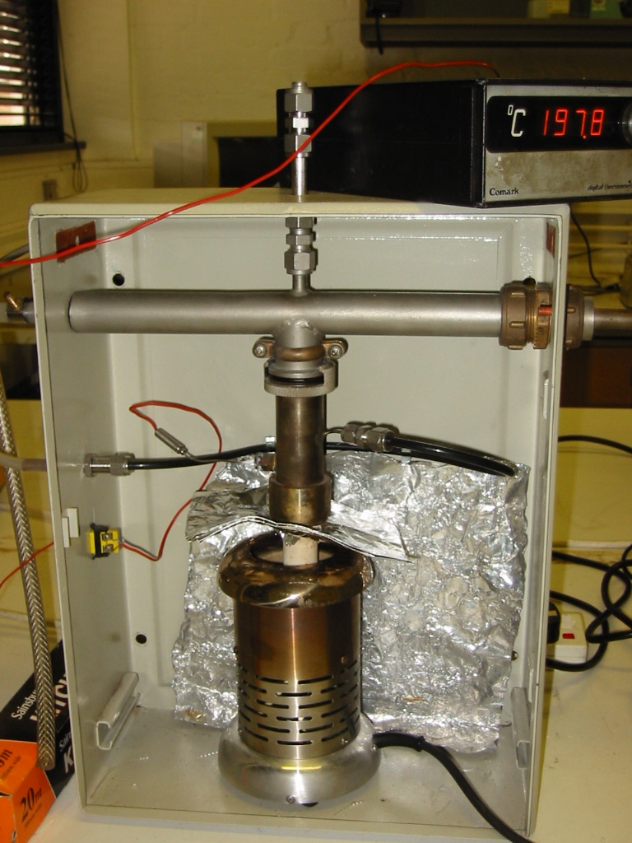
Filtered
Carrier Air
Aerosol
Out
Crucible
Air
Flow
Crucible
Heater

Figure 6 Typical Size Distribution of a Sodium Chloride Test Aerosol

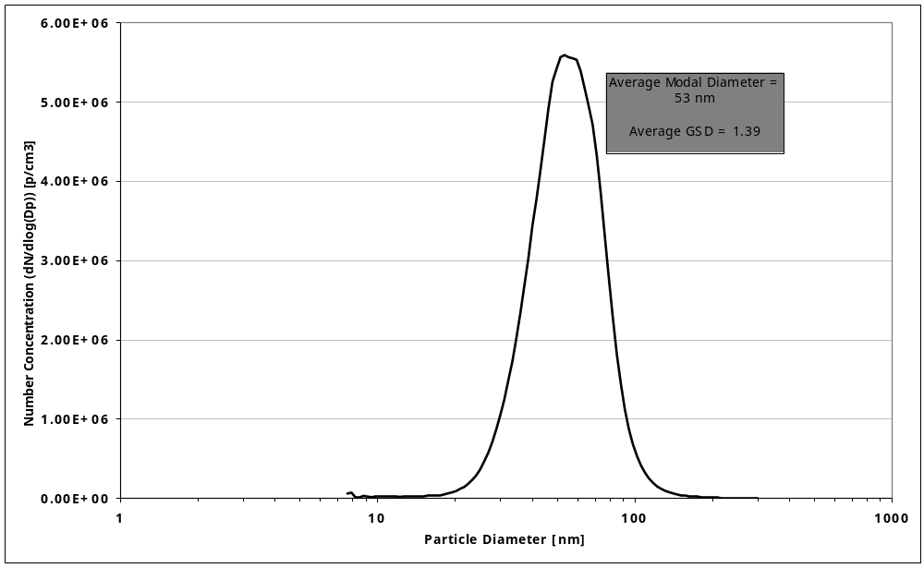
The electrostatic classifier was used to select monodisperse fractions of the polydisperse sodium chloride test aerosol and deliver concentrations in the range from zero to 10,000 particles cm⁻³ to the PNCs, while simultaneously logging the concentrations reported by both PNCs. The electrostatic classifier was simply used to vary the concentration of particles reaching the PNCs, in contrast to the primary method where the electrostatic classification delivers singly charged particles to allow measurement with the reference aerosol electrometer. The range of diameters delivered by the classifier depended upon the unclassified aerosol mode and monodispersity, and the voltages chosen. Care was taken to ensure that the voltages selected on the classifier were such that the particles delivered to the PNCs were significantly bigger than the lower size detection limit of either PNC. This was particularly important in this example as the PMP Golden PNC had been modified to provide lower size detection limits of 23 ± 3 and 37 ± 4 nm for 50 % detection efficiency (D₅₀) and 90 % detection efficiency (D₉₀) respectively. The reference PNC was unmodified having a D₅₀ of 9.5 ± 0.5 nm and D₉₀ of 13.5 ± 0.5 nm. Thus significant differences between the concentrations reported by both PNCs would be expected if the test particles were smaller than ~40 nm. Identical flow paths were used to deliver the test particles from the electrostatic classifier to both PNCs, thus ensuring any losses within the pipe work were the same for both units. The maximum diameter delivered to the PNCs was limited to 100 nm.

Note: This method provides a quick and easy demonstration that the PNC under validation responds in the same way as the reference PNC to a variety of particle diameters and concentrations. The range of available concentrations is dependant on the characteristics of the unclassified aerosol.

An example of the results of two such comparisons is shown in Figure 7.

An alternative approach can be adopted where the output from the classifier is held at a single voltage and therefore delivers a single particle diameter, but particle concentration is varied using a controllable diluter installed after the classifier but before the point at which the test aerosol is divided for delivery to each PNC. Investigation of the effect of particle diameter would have consequences for the aerosol generation method, which would have to be capable of generating the maximum required concentration at each of the diameters of interest for subsequent dilution. Monodispersity is not a requirement.
Figure 7 PMP Golden PNC Validation by the Secondary Method



