Volatile Particle Remover Calibration Procedure


Report to the Department for Transport

Restricted Commercial
ED47382004/VPR
Issue Number Draft Revision 3
July 2007

Title | Volatile Particle Remover Calibration Procedure

Customer | Department for Transport

Customer reference | Contract No. PRO 4/9/4

Confidentiality, copyright and reproduction | This report is the Copyright of Department of Transport and has been prepared by AEA Technology plc under contract to Department for Transport dated 7 August 2006. The contents of this report may not be reproduced in whole or in part, nor passed to any organisation or person without the specific prior written permission of Department for Transport. AEA Technology plc accepts no liability whatsoever to any third party for any loss or damage arising from any interpretation or use of the information contained in this report, or reliance on any views expressed therein

File reference | Willow\aug\emma\VPR Calibration Procedure – Draft Report Revised.doc

Reference number | ED47382004/VPR- DRAFT

AEA Energy & Environment
Building 551.11
Harwell International Business Centre
Didcot
OX11 0QJ

t: 0870 190 6566
f: 0870 190 6608

AEA Energy & Environment is a business name of
AEA Technology plc

AEA Energy & Environment is certificated to ISO9001
and ISO14001

Author | Name | Emma Sandbach

Approved by | Name | Ian Marshall

Signature

 | Date | 20 July 2007

Table of contents
1 Introduction 1
2 VPR Overview 2
2.1 Requirements 2
2.2 Recommended System 2
3 Calibration Methods 4
3.1 Calibration Criteria 4
3.2 Calibration Aerosol 6
3.3 Additional equipment requirements 6
4 Procedure 8
4.1 Gas calibration of the diluters 8
4.2 Calibration of the VPR for solid particle penetration efficiency 9
4.3 Calibration of the VPR for volatile particle removal efficiency 11
4.4 Calculation of the dilution factors 15
4.5 Calculation of penetration efficiency of solid particles 15
4.6 Calculation of removal efficiency of volatile particles 16
5 References 18
6 Annex 1 20
6.1 Solid and volatile particle calibration method: example 20
7 Annex 2 24
7.1 Analyses of gas calibration of diluters 24

Introduction

Appendix 5 of the ‘Proposal for draft supplement 7 to the 05 series of amendments to Regulation No.83’¹ describes a sampling pre-conditioning system to be used for particle number emissions measurements of exhaust emissions after a cold start for type approval testing.

The sampling pre-conditoning unit shall be capable of diluting the sample in one or more stages to achieve a particle number concentration below 10,000/cm³ and gas temperature below 35°C at the particle number counter. The major component of the sample pre-conditioning system is a Volatile Particle Remover (VPR), which is used to define the nature of the particles to be measured. The version of the VPR described in the recommended system provides heated dilution, thermal conditioning of the sample aerosol, further dilution of particle number concentration and cooling of the sample prior to entry into the particle number counter.

This document describes calibration procedures for the VPR.

VPR Overview

Requirements
The specific requirements for the sample preconditioning unit are described in Section 1.3.3 of ‘Proposal for draft supplement 7 to the 05 series of amendments to Regulation No.83’¹(this was further amended in Informal document No. GRPE-54-10⁴, and is included here).

1.3.3. The sample preconditioning unit shall

1.3.3.1. Be capable of diluting the sample in one or more stages to achieve a particle number concentration below 10,000/cm³ and gas temperature below 35 °C at the particle number counter.

1.3.3.2. Include an initial heated dilution stage which outputs a diluted sample at a temperature of ≥ 150 °C ≤ 400 °C.

1.3.3.3. Include elements which operate under conditions that achieve greater than 60, 70 and 80 per cent solid particle penetration respectively at 30, 50 and 100 nm particle diameters for the sample pre-conditioning unit as a whole.

1.3.3.4. Also achieve greater than 99 per cent reduction of an aerosol comprising ≥ 30 nm n-C40 alkane particles.

Recommended System
The following section describes the recommended practice for particle number measurement, taken from Section 1.4, Appendix 5 of the ‘Proposal for draft supplement 7 to the 05 series of amendments to Regulation No.83’¹. However, any sample preconditioning system meeting the requirements detailed in Section 2.1 may be used. The recommended system is illustrated in Figure 1.

The volatile particle remover (VPR) shall comprise one particle number diluter (PND₁), an evaporation tube and a second diluter (PND₂) in series. This dilution function (DFtot) is to reduce the number concentration of the sample entering the particle concentration measurement unit to less than 10,000 particles/cm³ and to suppress nucleation within the sample. DFtot is calculated as the product of the dilution factor in the first particle number diluter (PNDF₁) and the dilution factor in the second particle number diluter (PNDF₂).

The VPR shall operate under conditions that achieve greater than 99 per cent reduction of ≥ 30 nm C40 particles and greater than 60, 70, 80 per cent respectively solid particle penetration at 30, 50 and 100nm particle diameters.

1.4.4.1. First Particle Number Dilution Device (PND₁)
The first particle number dilution device shall be specifically designed to dilute particle number concentration and operate at a (wall) temperature of 150 °C - 400 °C. The wall temperature setpoint should not exceed the wall temperature of the ET (paragraph 1.4.4.2.). The diluter should be supplied with HEPA filtered dilution air and be capable of a dilution factor of 10 to 500 times.

1.4.4.2. Evaporation Tube
The entire length of the ET shall be controlled to a wall temperature greater than or equal to that of the first particle number dilution device and the wall temperature held at a fixed value between 300 °C and 400 °C and within a tolerance of ± 20 °C.

1.4.4.3. Second Particle Number Dilution Device (PND₂)
The second particle number dilution device shall be specifically designed to dilute particle number concentration. The diluter shall be supplied with HEPA filtered dilution air and be capable of maintaining a single dilution factor within a range of 10 to 30 times. The dilution factor of PND₂ shall be selected in the range between 10 and 15 such that particle number concentration downstream of the second diluter is < 10⁴ particles cm/ ³ and the gas temperature prior to entry to the PNC is < 35 °C.

Figure 1: Schematic diagram of particle number emissions measurement system
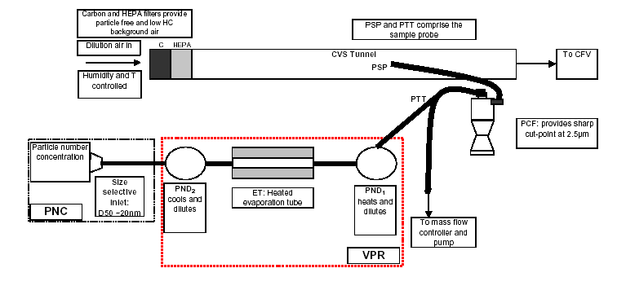

Calibration Methods

The following general points are brought to the attention of the reader:

- Principles of good calibration practice should be adopted when using any of the methods described below. In particular, users should ensure that any piece of ancillary equipment that is critical to the calibration is itself appropriately calibrated before use.

- The calibration methods may rely upon comparing the measurements from two pieces of aerosol measurement instrumentation. The user must ensure that the calibration aerosol pathway to each instrument is configured so that any particle deposition that may occur between particle source and instrument is comparable for both instruments. This is usually achieved by ensuring residence time is comparable in both pathways. It may also be necessary to take into account the pathway within each instrument from the inlet to the measurement volume, if there are significant differences between the instruments.

- Particle deposition can be minimised by utilizing conductive tubing.

- The term ‘upstream’ refers to the sampling location at the inlet of the VPR ie PND₁ inlet.

- The term ‘downstream’ refers to the sampling location at the outlet of the VPR ie after the second diluter PND₂.

Calibration Criteria

The VPR must be calibrated in terms of its total dilution factor, solid particle penetration efficiency and its volatile particle removal efficiency (or suppression of nucleation particles).

Calibration of the diluters

The Technical Service shall ensure the existence of a calibration certificate for the diluter demonstrating compliance with a traceable performance specification within a 6 month period prior to the emissions test.

Calibration shall be undertaken by measuring the concentration of the standard gas with a calibrated gas monitor at the inlet and outlet of each diluter. Calibration shall be undertaken at least 5 dilution factors spaced logarithmically across the dilution factor range from 10 to 500. Measured dilution factors shall be within ± 10 per cent of nominal dilution factor settings. If a diluter is to be used at a fixed dilution setting, then it shall be calibrated at the set-point.

It is recommended that Nitric Oxide (NO) be used as the standard gas and measured using a NOx analyser fitted with a NO₂ converter. The efficiency of the converter should not be less than 95 percent, and the analyser should be calibrated in accordance with Section 2 of Appendix 3 of the ‘Proposal for draft supplement 7 to the 05 series of amendments to Regulation No.83’¹.

Calibration of the VPR
The Technical Service shall ensure the existence of a calibration certificate for the volatile particle remover demonstrating effective penetration efficiency within a 6 month period prior to the emissions test. If the volatile particle remover incorporates temperature monitoring alarms a 12 months calibration interval shall be permissible.

The VPR shall be characterised for particle penetration efficiency with solid particles of diameters 30 nm, 50 nm and 100 nm and the overall particle penetration efficiency determined.

Solid particle penetration efficiency
The test aerosol for these measurements shall be solid particles of diameters 30, 50 and 100 nm and a minimum concentration of 5,000 particles/cm³ at the VPR inlet. It is recommended that the number concentration at the inlet of the VPR be as close to 10,000 particles/cm³ as possible without exceeding the particle count limit on the PNC.

Particle concentrations shall be measured upstream and downstream of the components. Minimum penetration efficiencies of 60, 70 and 80 per cent respectively shall be achieved at the three test particle diameters.

It is recommended that the penetration efficiency of the VPR is determined as a complete unit.

Calibration shall be conducted at the instrument manufacturer's recommended operating conditions.

Volatile particle removal efficiency
The Technical Service shall ensure the existence of a calibration certificate for the VPR demonstrating effective volatile particle removal efficiency within a 6 month period prior to the emissions test. The VPR shall demonstrate greater than 99 per cent reduction of monosdisperse ≥ 30 nm n-C40 alkane particles (GSD ≤ 1.2) at an upstream particle concentration of a minimum of 10,000/cm³ when operated at the following fixed conditions: evaporation tube temperatures 300°C, secondary dilution factor 10.

The volatile particle removal efficiency should be determined at dilution settings most commonly used for emissions testing of DPF vehicles.

Calibration Aerosol

Solid particles
There are a number of aerosol generation techniques that are capable of producing solid particles in the size range between 30 and 100nm diameter including condensation generators, combustion aerosol generators, nebulisation and hot wires. Any of these methods are suitable for producing calibration aerosols, but for the VPR calibration they must meet the following criteria:

- Capable of producing a stable aerosol at a minimum concentration of 5,000 particles/cm³ and a maximum concentration of 10,000 particles/cm³.
- Monodispersity: GSD ≤ 1.2

A common aerosol used for instrument calibration is sodium chloride. This is well characterised, inexpensive and relatively safe to use compared with other aerosols. Sodium chloride particles may be generated using a number of the techniques listed above.

Volatile particles
The requirement for volatile particles is more prescriptive than for solid particles, these are:
- Tetracontane (C₄₀) particles with a diameter of >30nm at concentrations >10,000 particles/cm³.
- Monodispersity: GSD ≤ 1.2

A condensation generator is a simple method to produce these particles. The monodispersity of the aerosol (for both and volatile particles) should be verified if it is not defined by the aerosol generator itself. A technique for producing solid and volatile particles is decribed in the example of Annex 1. Alternative methods that generate similarly sized particles and concentrations are equally appropriate.

Additional equipment requirements
The following table details the equipment, along with their purposes, that are additional to the components of the particle number measurement system and are recommended requirements for successful calibration of the volatile particle remover.

Table 1: Description of equipment required for calibration of the VPR
Required equipment | Purpose
1 calibrated flow meter | Measurement of particle counter flow
1 HEPA filter (at least 99.99% efficiency) | Zero checks on PNC and VPR
1 Aerosol generator | To generate solid and volatile particles for VPR performance checks
1 Neutraliser | Neutralisation of charges on aerosol for calibration
1 calibrated gas analyser (recommended NOx analyser with converter) | Calibration of the diluters
1 bottle of certified gas (recommended ≥ 5000pm NO) | Calibration of the diluters
1 calibrated flow meter/rotameter | To indicate inlet flow of gas supply to diluter to ensure ambient pressure at diluter inlet.
Optional
Calibrated Electrostatic Classifier/Scanning Mobility Particle Sizer | Production of monodisperse aerosols, other instruments may be used to produce monodisperse particles but an SMPS may be required to verify the GSD.
Additional calibrated PNC | For simultaneous measurements of upstream and downstream particle number concentration for VPR performance checks.
Calibrated flow meter and pump | To simulate downstream PNC flow from VPR whilst taking upstream measurements if calibrating the VPR with one PNC.

Procedure

The procedures for performing a VPR calibration are described below.

Gas calibration of the diluters
Calibration of the diluters should be performed at two temperature conditions:
- With the VPR not heated ie at room temperature
- With the VPR heated to the specifications detailed in Appendix 5 of the ‘Proposal for draft supplement 7 to the 05 series of amendments to Regulation No.83’¹.

The purpose of the room temperature calibration is to provide dilution factors that will later be used in calculating the volatile particle penetration efficiency (see Section 4.6).

For both temperature conditions the procedure is identical. It is recommended the room temperature calibration be performed first.

If certified gas is being used for the diluter calibration then upstream measurement of the raw gas concentration is not required. The only measurement that needs to be made is the gas concentration downstream of the VPR (ie PNC sampling position).

Diluter Calibration Procedure:

Prepare the particle number system for use but do not apply any heating to the diluters or evaporation tube.
- Where appropriate clean any dilution mechanisms within the VPR as advised by the manufacturer (eg for rotating disc diluters remove the disc and clean using an appropriate solvent).
- Perform any routine maintenance of the VPR as advised by the manufacturer (eg replacement of filters, tubing etc).
- Prepare the NOx analyser for use, following manufacturers guidance for stabilisation/warm up period.
- Zero and span the NOx analyser according to the manufacturers instructions.
- Connect the NOx analyser to the VPR outlet (PNC position), ensuring that flow rates in the VPR meet the manufacturers specifications.

Supply the VPR with NO gas ensuring that the system doesn’t become over pressurised. This can easily be done by using a flow meter at the inlet of the VPR with a flow splitter to provide gas at ambient pressure to the first diluter, allowing excess gas to be vented to an exhaust.
- Select the first dilution setting for calibration and begin recording data from the analyser. Allow the downstream measurement to stabilise and record data for at least 2 minutes. Once a stable measurement has been recorded select the next dilution measurement and allow to stabilise. Repeat this step until all 5 dilution settings have been measured.
- To verify system stability repeat the first dilution setting measurement, and check the performance is as expected.
- Any diluters that have a fixed dilution factor need only be calibrated at one dilution factor.
- If the VPR comprises more than one diluter, they must be calibrated separately.

Once calibration of the dilution factors is complete the analyser zero and span should be repeated to ensure analyser performance hasn’t drifted during the procedure. The calibration is considered acceptable is the difference between the two zero and span analyses is less than 2 percent.

The VPR should then be heated to the specifications detailed in Appendix 5 of the ‘Proposal for draft supplement 7 to the 05 series of amendments to Regulation No.83’¹ and the calibration procedure repeated at the same five dilution settings for each diluter within the VPR.

Calibration of the VPR for solid particle penetration efficiency
The solid particle penetration efficiency may be measured in two ways:

  - Using one particle counter. In this case the upstream and downstream particle number concentrations are recorded using the same PNC sampling at either position through equivalent sampling lines. Upstream and downstream sampling lines are simply exhanged and the number concentration allowed to stabilise before measurement commences. Finally, the upstream sampling line should be reconnected to the PNC to verify that the upstream concentation hasn’t drifted during the measurement.
  - Using two particle counters, one measuring upstream/at the VPR inlet and one measuring downstream/at the VPR outlet. If this option is selected then it is assumed that the correlation between the two PNCs (at the inlet and outlet of the VPR), has been confirmed before this procedure commences, using the secondary calibration method described in the ‘Condensation Particle Counter Calibration Procedures³’ document. If you are using two different models of PNCs please note their counting efficiency may differ, especially for small particle diameters, if the cut off efficiency curves are different for the two models of PNC the option of using one PNC must be adopted for calibration at small diameters.

Prepare the VPR and PNCs for use:
- Position all apparatus according to your manufacturers instructions, this will be generally similar to that described in the example, Annex 1, Figure 2.
- Where appropriate clean any dilution mechanisms within the VPR as advised by the manufacturer (eg for rotating disc diluters remove the disc and clean using an appropriate solvent).
- Perform any routine maintenance of the VPR as advised by the manufacturer (eg replacement of filters, tubing etc).
- Switch on the electrostatic classifier (or other source of monodisperse particles), PNCs and VPR.
- Fill the PNCs with working fluid and allow the saturator and condenser to reach their specified temperatures.
- Apply an external vacuum source to the PNCs if not fitted with an internal pump.
- Do not proceed unless all indicaters on the PNCs show correct instrument status (eg temperature, liquid level, flow and laser etc).
- Check the inlet flow rates of the PNCs with an appropriate calibrated flow meter (low pressure drop variety recommended, eg bubble flow meter). The flow into the particle counter shall report a measured value within 5 percent of the particle counter nominal flow rate.
- Check that zero concentration is reported when a HEPA filter of at least 99.99 percent efficiency is attached to the inlet of the PNCs. The PNC requires attention from the manufacturer if concentrations greater than 1 particles/cm³ are reported.
- If required, apply clean dry filtered air to the VPR at pressures specified by the manufacturer.
- Switch on heating to VPR and allow to reach specified temperatures.
- Connect the PNC to the VPR.
- When the VPR has reached its specified temperature settings connect a HEPA filter of at least 99.99 percent efficiency to the inlet and ensure a zero concentration is reported on the PNC. Do not proceed if particle concentrations of greater than 1 particles/cm³ are reported.
- If you are using one PNC for the solid particle calibration exchange the sampling line from the VPR outlet location (downstream) to the VPR inlet (upstream) and use a mass flow controller, or similar, to simulate the flow rate of the PNC from the VPR. If you are using two PNCs split the flow from the neutraliser between the upstream PNC and the inlet of the VPR.

Note: if an aerosol generator which produces monodisperse particles is used, the electrostatic classifier is not required and the VPR can be connected directly to the aerosol source via a neutraliser.

- Ensure that the particle residence time in the pipework from the neutraliser to both the upstream PNC and the inlet to the VPR are identical. Residence time must be adjusted by varying the length rather than the diameter of the pathway, as diffisional deposition is independent of tube diameter for a given volumetric flow rate.
- Set the electrostatic classifier flows such that the monodisperse aerosol flow leaving the classifier is sufficient for the total inlet flow of both the PNC and the VPR (provide additional particle-free flow after the classifier if necessary).

Make arrangements to log data from both the upstream (inlet) and downstream (outlet) PNCs simultaneously at the same sampling rate.

Generate the calibration aerosol and connect the electrostatic classifier to the source.
- Select a monodisperse diameter using the electrostatic classifier and allow the number concentration to stabilise upstream of the VPR. All monodisperse particles must enter the VPR at concentrations of greater than 5000 particles/cm³. Once stable record measurements for 10 minutes up and downstream of the VPR
- Once a stable measurement has been taken the next monodisperse diameter should be selected on the electrostatic classifier and allowed to stabilise. This should be repeated until all monodisperse diameters have been measured.
- If you are using one PNC each measurement must be stable and the upstream measurement must be verified after measuring the downstream concentration to ensure the inlet concentration has not drifted during the measurement, eg measure upstream concentration for 10 minutes, measure the downstream concentration for 10 minutes, then return to the upstream sampling arrangement and sample for 10 minutes to ensure the concentration is stable.

Once all required diameters have been measured the aerosol source should be disconnected from the VPR and a HEPA filter applied to the inlet to remove all particles from the system and to verify the zero concentration leaving the VPR (should be less than 1 particle/cm³). This ensures the VPR has not become contaminated from the calibration procedure.

Calibration of the VPR for volatile particle removal efficiency
The procedure for calibrating the VPR in terms of volatile particle removal efficiency is similar to that described for solid particle penetration efficiency. There are a two key differences described below:

- Only 1 monodisperse diameter is required, ≥ 30nm (tetracontane, C₄₀)
- The inlet concentration to the VPR must be >10,000 particles/cm³.

Additionally, there are two methods for measurement of volatile particle removal efficiency, both of which should be performed at the operating conditions most commonly used for DPF exhaust emissions measurements:

Method 1 - Measurement of up and downstream particle concentrations using a PNC
This can be the PNC supplied with the particle number measurement system. For the volatile particle removal efficiency calibration an upstream concentration of >10,000 particles/cm³ is required, however this concentration will result in coincidence errors to be introduced into the PNC measurement. An assumption can be made that any measurement by the PNC above this limit ensures the VPR is challenged with a minimum of 10,000 particles/cm³. The procedure for this method is as follows (this calibration can be performed with either one or two PNCs):

Prepare the VPR and PNCs for use:
- Position all apparatus according to your manufacturers instructions, this will be generally similar to that described in the example, Annex 1, Figure 2.
- Where appropriate clean any dilution mechanisms within the VPR as advised by the manufacturer (eg for rotating disc diluters remove the disc and clean using an appropriate solvent).
- Perform any routine maintenance of the VPR as advised by the manufacturer (eg replacement of filters, tubing etc).
- Switch on the electrostatic classsifer (or other source of monodisperse particles), PNCs and VPR.
- Fill the PNCs with working fluid and allow the saturator and condenser to reach their specified temperatures.
- Apply an external vacuum source to the PNCs if not fitted with an internal pump.
- Do not proceed unless all indicaters on the PNCs show correct instrument status (eg temperature, liquid level, flow and laser etc).
- Check the inlet flow rates of the PNCs with an appropriate calibrated flow meter (low pressure drop variety recommended, eg bubble flow meter). The flow into the particle counter shall report a measured value within 5 percent of the particle counter nominal flow rate.
- Check that zero concentration is reported when a HEPA filter of at least 99.99 percent efficiency is attached to the inlet of the PNCs. The PNC requires attention from the manufacturer if concentrations greater than 1 particles/cm³ are reported.
- If required, apply clean dry filtered air to the VPR at pressures specified by the manufacturer.
- Switch on heating to VPR and allow to reach specified temperatures.
- Connect the PNC to the VPR.
- When the VPR has reached its specified temperature settings connect a HEPA filter of at least 99.99 percent efficiency to the inlet and ensure a zero concentration is reported on the PNC. Do not proceed if particle concentrations of greater than 1 particles/cm³ are reported.
- If you are using one PNC for the volatile particle calibration exchange the sampling line from the VPR outlet location (downstream) to the VPR inlet (upstream) and use a mass flow controller, or similar, to simulate the flow rate of the PNC from the VPR. If you are using two PNCs split the flow from the neutraliser between the upstream PNC and the inlet of the VPR.

Note: if an aerosol generator which produces monodisperse particles is used, the electrostatic classifier is not required and the VPR can be connected directly to the aerosol source via a neutraliser.

- Ensure that the particle residence time in the pipework from the neutraliser to both the upstream PNC and the inlet to the VPR are identical. Residence time must be adjusted by varying the length rather than the diameter of the pathway, as diffusional deposition is independent of tube diameter for a given volumetric flow rate.
- Set the electrostatic classifier flows such that the monodisperse aerosol flow leaving the classifier is sufficient for the total inlet flow of both the PNC and the VPR (provide additional particle-free flow after the classifier if necessary).

Make arrangements to log data from both the upstream (inlet) and downstream (outlet) PNCs simultaneously at the same sampling rate.

Generate the calibration aerosol and connect the electrostatic classifier to the source.
- Select 30nm particles using the electrostatic classifier and allow the number concentration to stabilise upstream of the VPR.. Once stable record measurements for 10 minutes up and downstream of the VPR
- If you are using one PNC each measurement must be stable and the upstream measurement must be verified after measuring the downstream concentration to ensure the inlet concentration has not drifted during the measurement, eg measure upstream concentration for 10 minutes, measure the downstream concentration for 10 minutes, then return to the upstream sampling arrangement and sample for 10 minutes to ensure the concentration is stable.

Once complete the aerosol source should be disconnected from the VPR and a HEPA filter applied to the inlet to remove all particles from the system and to verify the zero concentration leaving the VPR (should be less than 1 particle/cm³). This ensures the VPR has not become contaminated from the calibration procedure.

Method 2 - one PNC measuring downstream of the VPR only.
The particle counter used for this method can be the PNC supplied with the particle number measurement system. The procedure for this method is as follows:

Prepare the VPR and PNCs for use:
- Position all apparatus according to your manufacturers instructions, this should be something similar to that described in the example, Annex 1, Figure 2.
- Where appropriate clean any dilution mechanisms within the VPR as advised by the manufacturer (eg for rotating disc diluters remove the disc and clean using an appropriate solvent).
- Perform any routine maintenance of the VPR as advised by the manufacturer (eg replacement of filters, tubing etc).
- Switch on the electrostatic classsifer (or other source of monodisperse particles), PNC and VPR.
- Fill the PNC with working fluid and allow the saturator and condenser to reach their specified temperatures.
- Apply an external vacuum source to the PNC if not fitted with an internal pump.
- Do not proceed unless all indicaters on the PNC show correct instrument status (eg temperature, liquid level, flow and laser etc).
- Check the inlet flow rates of the PNC with an appropriate calibrated flow meter (low pressure drop variety recommended, eg bubble flow meter). The flow into the particle counter shall report a measured value within 5 percent of the particle counter nominal flow rate.
- Check that zero concentration is reported when a HEPA filter of at least 99.99 percent efficiency is attached to the inlet of the PNC. The PNC requires attention from the manufacturer if concentrations greater than 1 particles/cm³ are reported.
- If required, apply clean dry filtered air to the VPR at pressures specified by the manufacturer.
- Connect the PNC to the VPR.
- Do not heat the VPR, leave it at room temperature.
- Connect a HEPA filter of at least 99.99 percent efficiency to the inlet and ensure a zero concentration is reported on the PNC. Do not proceed if particle concentrations of greater than 1 particles/cm³ are reported.

Note: if an aerosol generator which produces monodisperse particles is used, the electrostatic classifier is not required and the VPR can be connected directly to the aerosol source via a neutraliser.

- Set the electrostatic classifier flows such that the monodisperse aerosol flow leaving the classifier is sufficient for the inlet flow of the VPR (provide additional particle-free flow after the classifier if necessary).

Make arrangements to log data from the PNC.

Generate the calibration aerosol and connect the electrostatic classifier to the source.
- Select 30nm using the electrostatic classifier and allow to stabilise for at least 10 minutes. The monodisperse particles must enter the VPR at concentrations of greater than 10,000 particles/cm³. Once stable record measurements for 10 minutes downstream of the VPR
- Switch on heating to VPR and allow to reach specified temperatures. Identical nominal dilution factors should be used at both tempeture settings.
- Continue to supply 30nm tetracontane particles to the VPR and record the particle concentration from the PNC (at the downstream location).
- When a stable downstream concentration is achieved, and the VPR has reached its temperature settings, record the downstream number concentrations over a 10 minute period.

Once complete the aerosol source should be disconnected from the VPR and a HEPA filter applied to the inlet to remove all particles from the system and to verify the zero concentration leaving the VPR (should be less than 1 particle/cm³). This ensures the VPR has not become contaminated from the calibration procedure.

Calculation of the dilution factors
The dilution factors for the first diluter (PND₁ DF) and secondary diluter (PND₂ DF) should be calculated separately for each temperature condition.

The requirement for the calibration of the diluters is for measured dilution factors to be within ±10% of nominal dilution factor settings.

To assess the performance of the diluters, dilution factors should be calculated from the average downstream gas concentration measurements.

Dilution Factor = Certified gas concentration (ppm)
Average downstream gas concentration (ppm)

The dilution factor calculation should be performed for each dilution setting measured. This calculation is identical for both room temperature and heated measurements. These data can then be plotted to examine the performance of the diluter compared with the nominal dilution settings. An example of how this data can be analysed is show in Annex 2, Figure 5. The measured dilution factors should always be used for any particle number measurement calculations rather than manufacturers recommended factors.

Calculation of penetration efficiency of solid particles
The penetration efficiencies (PE) should be calculated using the following equation:

Downstream number concentration x 100% = PE
(Upstream number concentration at PND₁ inlet/PND₁ DF/PND₂ DF)

Note: Downstream number concentration is the number concentration at the outlet of the VPR ie the PNC sampling location,

Upstream number concentration is the number concentration at the inlet of the VPR ie the PND₁ inlet,

DF is dilution factor,

PND₁ DF is the dilution factor of the primary diluter and

PND₂ DF is the dilution factor of the secondary diluter.

The dilution factors used for this calculation should be those calculated from the gas calibration of the diluters using the heated VPR.

The number concentrations should be averaged over the 10 minute stable period.

100% penetration efficiency indicates zero particle losses in the system. The pass criteria is 60,70 and 80% penetration efficiency at 30,50 and 100nm particle diameters.

Calculation of removal efficiency of volatile particles
There are two methods to calculate the removal efficiency of volatile particle depending on which calibration method was adopted:

Method 1
The average number concentration of volatile particles at the inlet of the VPR should be calculated over the 10 minute stable period. The performance requirement of the VPR is that >99% of tetracontane particles are removed. Therefore the pass criteria for the suppression of nucleation particles is 1% of the inlet concentration.

The average number concentration at the outlet of the VPR should be calculated over the 10 minute stable period, and if this is less than 1% of the inlet concentration then the VPR performance is acceptable.

Dilution factors must be applied to the downstream number concentration measurements. These dilution factors should be those derived from the gas calibration of the diluters (for the heated VPR).

Volatile Particle Removal Efficiency Criteria =

Average Downstream Concentration ∙ PND₁ DF ∙ PND₂ DF ≤ Average Upstream Concentration
100
DF = dilution factor, determined from gas calibration

Method 2
The average number concentration of volatile particles downstream of the VPR should be calculated over the 10 minute stable period for both temperature conditions ie room temperature and heated.

Dilution factors must be applied to both sets of downstream number concentration measurements. These dilution factors should be those derived from the gas calibration of the diluters (separate factors should be used for the room temperature and for the heated VPR).

Volatile Particle Removal Efficiency Acceptance Criteria :
Average Downstream Concentration (HT) ∙ PND₁ DF (HT) ∙ PND₂ DF (HT) ≤
Average Downstream Concentration (RT) ∙ PND₁ DF (RT) ∙ PND₂ DF (RT)
100

DF = dilution factor, determined from gas calibration
RT = room temperature VPR
HT = heated VPR

References
¹ Amendments to UNECE Regulations, Regulation No. 83, Proposal for draft supplement 7 to the 05 series of amendments to Regulation No.83, ECE/TRANS/WP.29/GRPE/2007/8

²Andersson JD, Clark D UN-GRPE PMP Phase 3 Inter-laboratory Correlation Exercise: Framework and Laboratory Guide, A Document For The UK Department for Transport. RD 04/80801.5

³Marshall, IA Condensation Particle Counter Calibration Procedures, report to Department for Transport, netcen/ED44970001/Issue 2, September 2006.

⁴UK Proposal to amend document ECE/TRANS/WP.29/GRPE/2007/8, Informal document no. GRPE-54-10.

Annex 1

Solid and volatile particle calibration method: example
The following example describes one method for calibrating the VPR for solid particle penetration efficiency and volatile removal efficiency. The experimental set-up is illustrated in Figure 2.

Figure 2: Calibration of the VPR

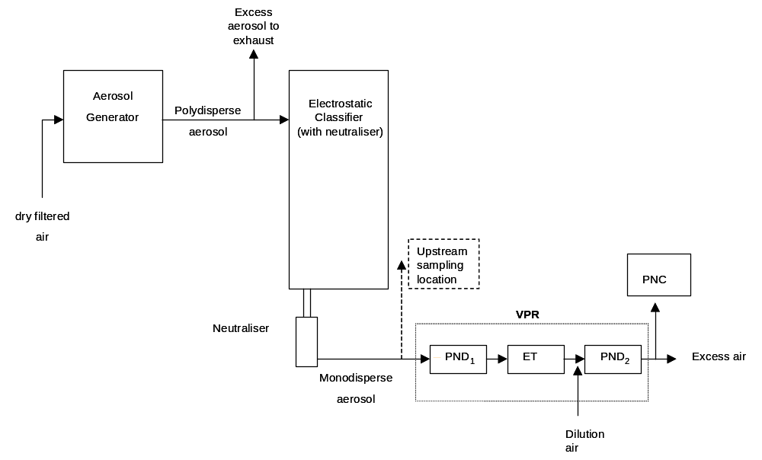
The aerosol generator consisted of a ceramic crucible heated via an electric Bunsen (Figure 3). The bulk material (sodium chloride for solid particle penetration efficiencies and tetracontane for volatile particle removal efficiencies) was placed in the ceramic crucible and heated to near its boiling point. A small flow was introduced into the crucible to displace vapour from the surface of the bulk material to a cooler region of the generator where condensation occurred. Particle diameters were varied by controlling the rate of vapour transport from the crucible (via the crucible air flow) and/or the subsequent cooling rate of the vapour (via the carrier air flow). A typical polydisperse size distribution (before selection of a monodisperse fraction) of a generated aerosol is presented in Figure 4.

Figure 3: Condensation Aerosol Generator
.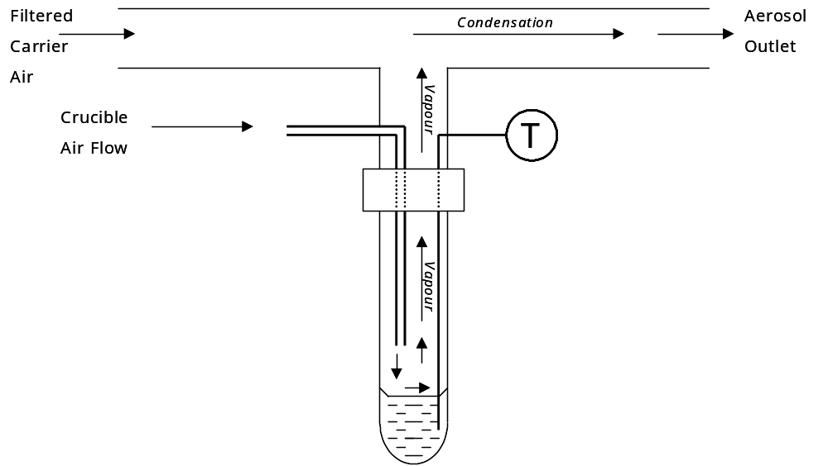

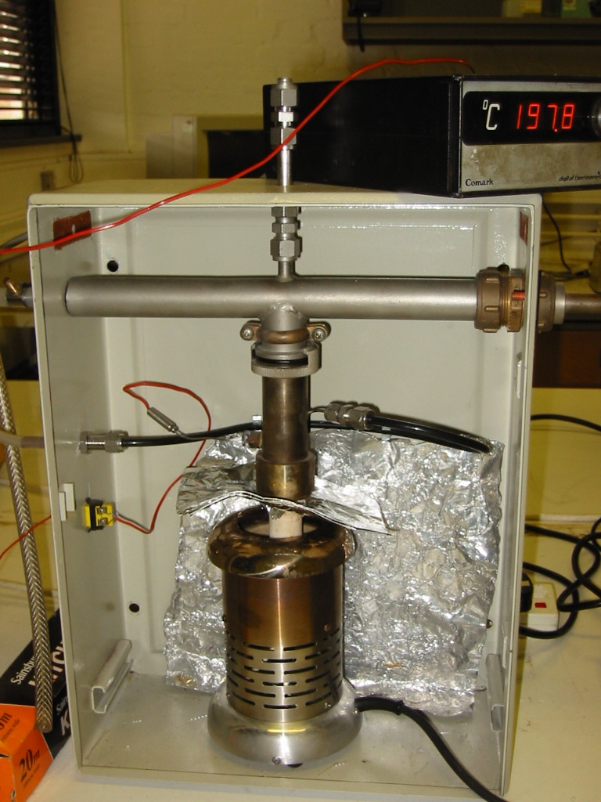
Filtered
Carrier Air
Aerosol
Out
Crucible
Air
Flow
Crucible
Heater

Figure 4 Typical size distribution of a polydisperse sodium chloride calibration aerosol
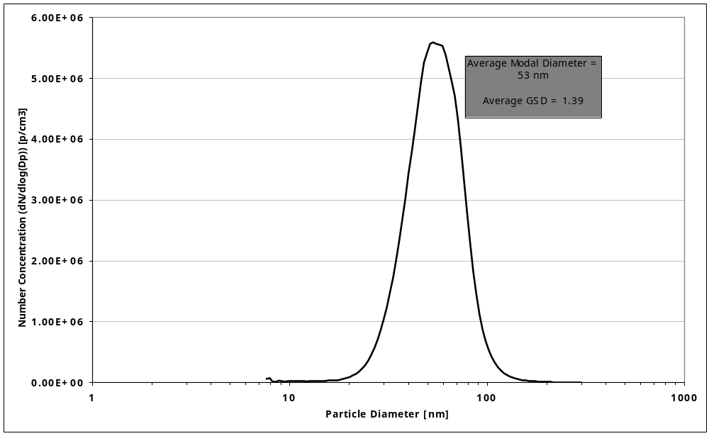

Note: This aerosol generation method is reported purely as an example. Alternative methods that generate similarly sized particles and concentrations are equally appropriate.

The electrostatic classifier was used to select monodisperse fractions of the polydisperse calibration aerosol and deliver the required number concentrations to the VPR (> 5000 particles cm⁻³ for sodium chloride and >10,000 particles cm⁻³ for tetracontane), reducing the GSD (geometric standard deviation) to around 1.2.

Two PNCs were used to simultaneously record the number concentrations upstream (at the inlet of PND₁) and downstream (at the outlet of the VPR).

Note: It is imperative that the response of these PNCs is verified before the VPR is calibrated; this is to ensure that the two PNCs are equivalent. The upstream and downstream concentrations are directly compared with each other to calculate the penetration efficiencies of the VPR; therefore the PNCs must be compared with each other. The secondary calibration method for PNC calibration is recommended, as detailed in the ‘Condensation Particle Counter Calibration Procedures³’. The linearity of response in terms of the R² coefficient must be greater than 0.97, else the PNCs do not respond linearly over the measured concentration range. If the two PNCs do not meet these requirements the upstream and downstream concentrations may not be directly compared to calculate the penetration efficiencies. The results from the PNCs would then need to be corrected to take into consideration any measurement differences between the two. This is unfavourable as this introduces additional measurement uncertainties into the calibration procedure of the VPR.

Additionally, care must be taken when comparing the results from two PNCs if they are not the same model, this was particularly important in this example as one PNC had been modified to provide lower size detection limits of 23±3 and 37±4 nm for 50 % detection efficiency (D₅₀) and 90 % detection efficiency (D₉₀) respectively than the standard model of TSI PNC 3010. The AEA PNC was unmodified having a D₅₀ of 9.5±0.5 nm and D₉₀ of 13.5±0.5 nm. Thus significant differences between the concentrations reported by both PNCs would be expected if the calibration particles were smaller than around 40 nm. For the VPR calibrations at 30nm the AEA PNC was used in both the upstream and downstream sampling positions through equivalent sampling lines. The downstream sampling line was exchanged for the upstream sampling line, the number concentration was allowed to stabilise and then the upstream sampling was reconnected to the PNC to verify that the inlet concentration had not drifted throughout the measurements.

Identical flow paths were used to deliver the calibration particles from the electrostatic classifier to the PNCs and the VPR inlet, thus ensuring any losses within the pipe work were the equivalent for all measurements.

For each monodisperse diameter the system was allowed to stabilise for at least 10 minutes before selecting the next diameter. When the measurements at each diameter had been made the results were analysed to calculate the penetration efficiency of solid particles and supression of nucleation particles.

Annex 2

Analyses of gas calibration of diluters

Figure 5 illustrates one method for analysing the measured dilution factors to assess if they meet the performance criteria. The data points are derived from the percentage difference between the measured dilution factors and the nominal dilution factors. The percentage difference is then plotted against the nominal dilution factors to show if the +/- 10% criteria is achieved (as indicated by the red boxed area). This method easily identifies any measurements not meeting the criteria as shown by the outlier in Figure 5 at the 95 dilution factor.

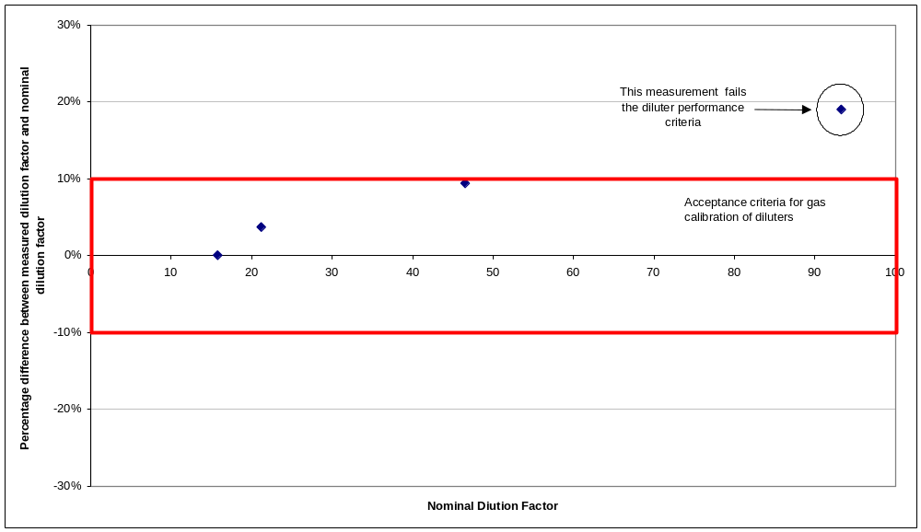
Figure 5: Example of how to analyse measurements of gas calibration of diluters.

