UNITED NATIONS |  | ST
 | Secretariat | Distr.  GENERAL  ST/SG/AC.10/C.3/2008/67  2 September 2008  Original: ENGLISH
COMMITTEE OF EXPERTS ON THE TRANSPORT OF
DANGEROUS GOODS AND ON THE GLOBALLY
HARMONIZED SYSTEM OF CLASSIFICATION
AND LABELLING OF CHEMICALS

Sub-Committee of Experts on the
Transport of Dangerous Goods

Thirty-fourth session

Geneva, 1-9 December 2008
Item 4 of the provisional agenda

LISTING, CLASSIFICATION AND PACKING

Special Provision for UN 1404 – Calcium hydride

Transmitted by the expert from the United Kingdom

1. Calcium hydride (UN1404) is a solid substance used as a reagent in testing kits that are used to measure the presence of water in oil. Water in lubricating or fuel oil can enter from many sources including condensation, leakage and malfunction of oil treatment systems. Water in oil will cause corrosion, cavitation and instability of additive packages and encourage the growth of microbes.

Testing for water in oil is essential to maintain and protect equipment, preventing damage in advance, and improving worker safety.

Test methods have been developed using very small quantities of UN 1404 in sealed sachets. The calcium hydride reacts with the water in the small, measured, quantity of oil sample and the small amount of gas given off is readily measured and enables the level of water in the oil to be determined.

These kits are transported to customers throughout the world, and at present have to be consigned as fully regulated packages solely due to the presence of a very small quantity of a packing group I substance (UN 1404). There are no limited quantity or exempted quantity provisions for this substance in the Model Regulations.

2. The quantity packaged in each sachet is typically not more than 0.5 grams per sachet and there are 50 sachets per kit. Were a single sachet filled to 0.5 grams fail to remain sealed and the contents totally react with water (such as that present in the air) the amount of highly flammable gas generated would be 0.53 litres.

3. Currently there are a number of Special Provisions and packing provisions which provide for various exemptions from the Model Regulations for similar products. These include:

SP 216 permitting flammable liquids of PGII or PGIII in sachets with a maximum of 10 ml to be exempted;
SP 335 permitting similar 10g/10ml exemptions for UN 3077 and 3082;
SP 342 permits an exemption for ethylene oxide (a toxic gas) (see ST/SG/AC.10/C.3/2008/3);
PP 83 in P403 relating to UN 2813.

4. The expert from the United Kingdom recognises that UN 1404 is a substance of Packing Group I which may be of more concern to Sub-Committee experts than the examples cited above. However, these kits provide an essential means of safely analysing products for industry and are robustly packaged, with each sachet sealed in a compatible plastics bag (see photographs at Annex A). It is the view of the expert from the United Kingdom that they pose little risk in transport. It is proposed, therefore, that a new Special Provision is assigned to this substance, as set out below.

Proposal

- Add a new Special Provision XXX to Chapter 3.3 to read as follows:

“XXX Sachets containing not more than 0.5 g of Calcium Hydride and with not more than 25 g per outer packaging may be transported in accordance with the provisions of Chapter 3.5 irrespective of the indication of E0 in column 7b of the Dangerous Goods List provided that in addition to the packaging required by 3.5.2 each sachet is sealed in a plastics bag compatible with the product.”.

- In the Dangerous Goods List in Chapter 3.2, for UN 1404 CALCIUM HYDRIDE add in Column (6) “XXX”
ANNEX

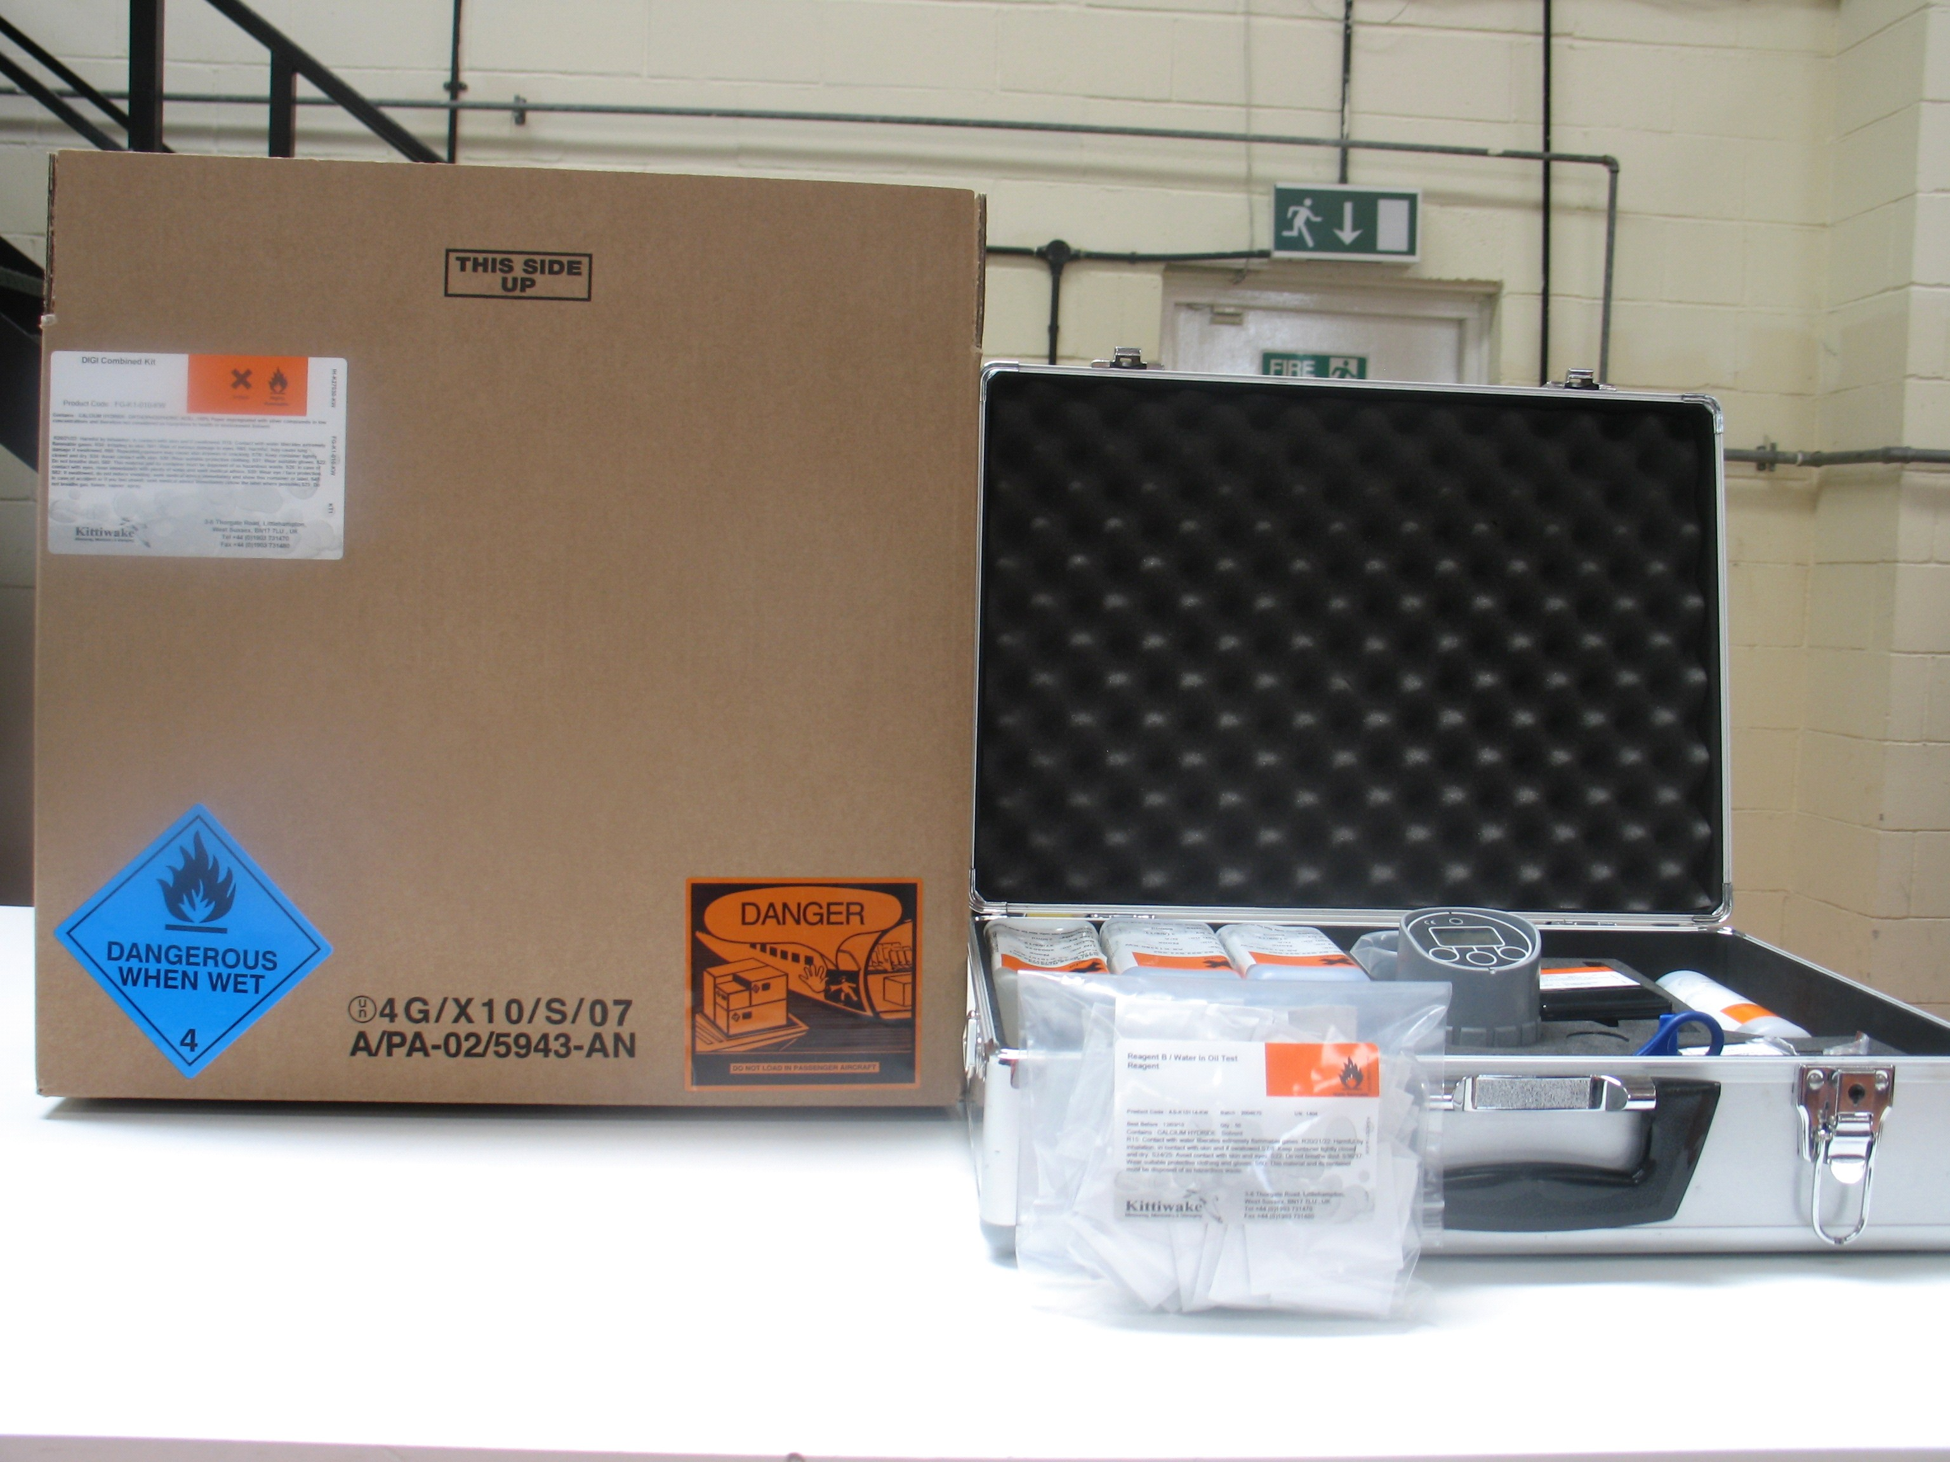

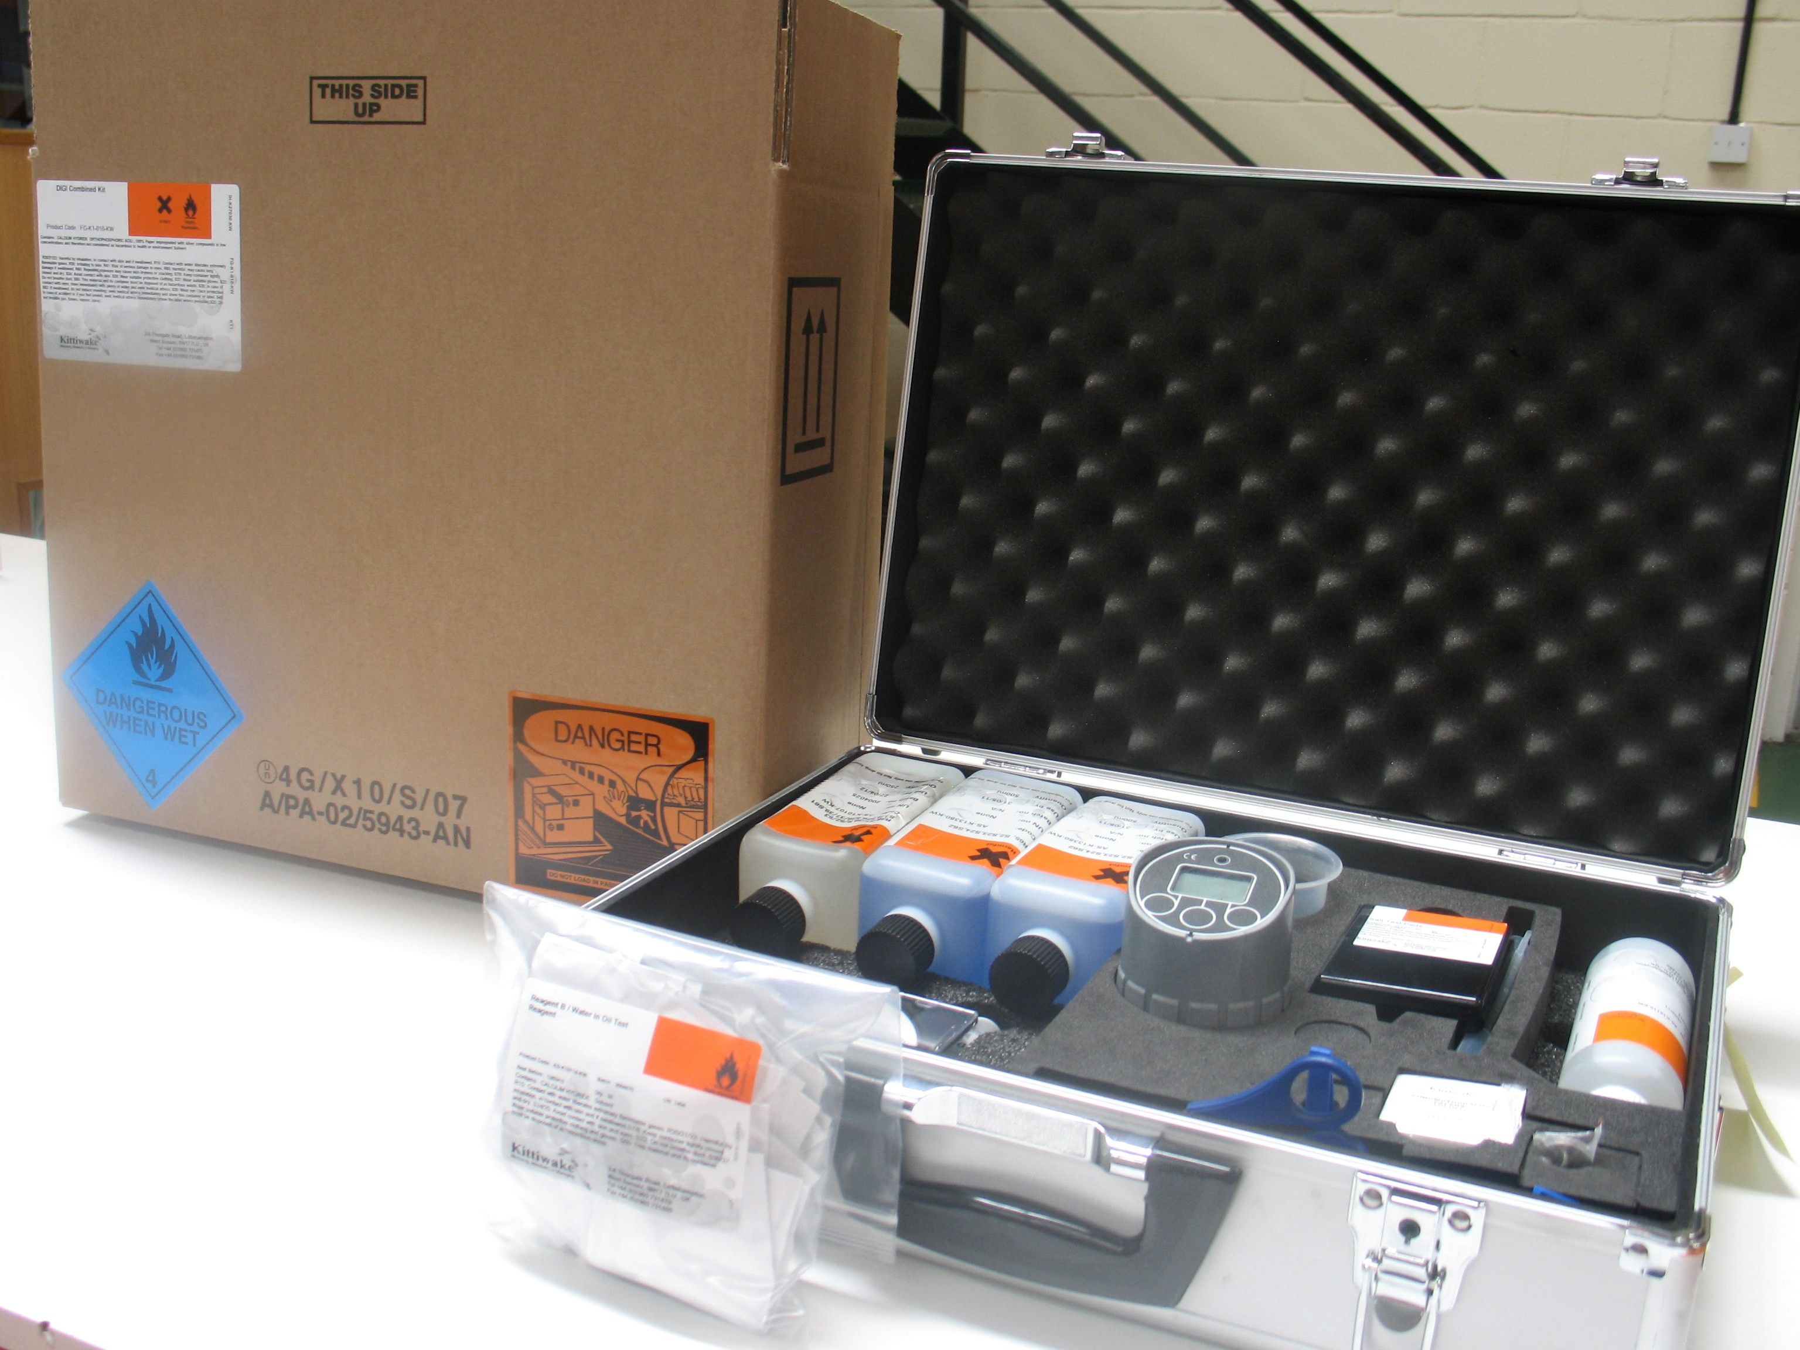

In accordance with the programme of work of the Sub-Committee for 2007-2008 approved by the Committee at its third session (refer to ST/SG/AC.10/C.3/60 para. 100 and ST/SG/AC.10/C.3/34, para. 14).

