REPLY TO QUESTIONS RAISED BY THE COMPLIANCE COMMITTEE OF THE AARHUS CONVENTION IN A DOCUMENT DATED 15 JANUARY 2010 CONCERNING SPAIN’S COMPLIANCE WITH THE PROVISIONS OF THE CONVENTION AS REGARDS THE ACCESS TO INFORMATION, PUBLIC PARTICIPATION IN DECISION-MAKING AND ACCESS TO JUSTICE IN THE AUTONOMOUS COMMUNITY OF EXTREMADURA (REF. ACCC/C/2009/36).

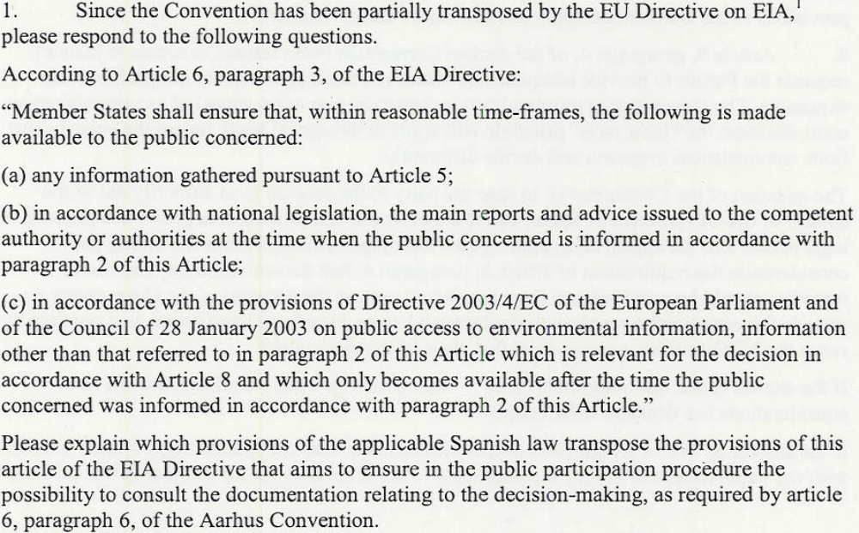

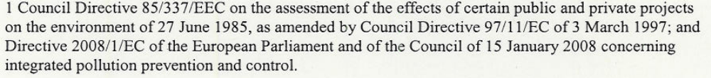

The transposing to Spanish law of provisions of article 6(3) of Council Directive 85/337/EEC of 27 June 1985 on the assessment of the effects of certain public and private projects on the environment, as amended (EU Directive on EIA), is made through article 9 of Royal Legislative Decree 1/2008, of 11 January 2008, approving the consolidated text of the Environmental Impact Assessment Act for projects (published in Official State Gazette - BOE - No 23, of 26 January 2008), the text of which is as follows:
“Article 9. Procedure for public information and consultation to public authorities and interested parties.
1. The substantive body shall subject the environmental impact study to that referred to in article 7, within the applicable procedure for the authorisation or completion of the project to which it corresponds, and jointly with the latter, to the procedure for public information and other reports laid forth therein. This procedure shall be implemented in those stages in which all options relating to the determination of the content, scope, and description of the project subject to authorisation to environmental impact assessment remain open, and it shall have a duration of no less that 30 days.
The public information procedure must also be implemented by the substantive body as regards the projects requiring Integrated Environmental Authorisation in pursuance of the Integrated Pollution Prevention and Control Act 16/2002, of 1 July 2002. 2. During implementation of the public information procedure, the substantive body shall inform the public of relevant aspects related to the project authorisation procedure and, namely, of the following:
a) Application for project authorisation.
b) The fact that the project is subject to an environmental impact assessment, and that, as appropriate, the provisions set forth in article 11 on cross-border consultations may apply.
c) Identification of the authority empowered to settle the procedure, of those who may retrieve relevant information, and of those to whom comments, allegations, and queries may be submitted, and the time frame available for such submission.
d) Nature of the decisions or, as appropriate, of the decision drafts to be adopted.
e) Specification of the availability of the information collected in accordance with article 7 and of the date on and place(s) at which such information shall be made available to the public.
f) Identification of participation channels.
3. Likewise, the substantive body shall consult the public authorities concerned which had previously been consulted as regards the definition of the scope and the level of detail of the environmental impact study and shall furnish them with following information, which, besides, shall be made available to the interested parties:
a) All information set forth in view of article 7.
b) All relevant documentation received by the substantive body prior to the implementatiuon of the public information procedure. The substantive body shall inform the interested parties and the public authorities concerned of the right to participate in the corresponding procedure and of the time at which they are entitled to exercise this right. This notification shall specify the competent authority to which comments and allegations confirming participation are to be submitted and the time frame in which they should be sent. The time frame shall not be less than 30 days.
4. Similarly, the substantive body shall make available to interested parties and public authorities the information other than that set down in clause 3, which may be retrieved only once the period of information to the public specified in clause 2 has expired and which is relevant for the purposes of the decision on the completion of the project.
5. The developer must consider the results of consultations and public information in the project and the substantive body must consider the same in the authorisation of the project."

As can be seen, article 9 contains certain aspects of article 7 of the same Royal Legislative Decree, which governs the environmental impact study and its content. Namely, it determines the following:
“Article 7. Environmental impact study.
1. The projects to be subject to environmental impact assessment should include an environmental impact study, the scope and level of detail of which shall be determined beforehand by the environmental body. The study shall contain at least the following information: a) Project overview including foreseeable future requirements regarding the use of land and of other natural resources. Estimate of types and quantities of waste discharged and emissions of resulting material or energy.
b) A preamble of the main alternatives examined and a rationale of the main reasons for the solution adopted, taking into account environmental effects. c) Assessment of foreseeable direct and indirect effects of the project on the population, flora, fauna, soil, air, water, climate factors, the landscape and tangible property, including historical, artistic and archaeological heritage. Further, the interaction between all of these factors shall be dealt with. d) Measures planned to reduce, eliminate or off-set significant environmental effects. e) Environmental monitoring programme. f) Study summary and conclusions in easily understandable terms. Where applicable, report of any hindrances of an information or technical nature encountered in the compilation of the study.
2. The authorities shall make available to the project holder the reports and any documentation in its possession if useful for completion of the environmental impact study. “

Royal Legislative Decree 1/2008, approving the consolidated text of the EIA law in Spain, does not specify in what format the environmental impact assessment application should be submitted by the developer or indeed the environmental impact study itself.
As regards the use of electronic forms, the EU Directive on EIA only sets down in article 6.2. that, “The public shall be informed, whether by public notices or other appropriate means such as electronic media where available, of the following matters early in the environmental decision-making procedures referred to in Article 2.2. and, at the latest, as soon as information can reasonably be provided….”.

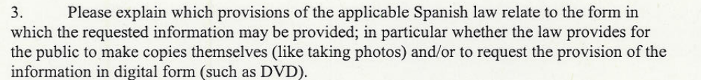

Act 27/2006, of 18 July 2006, which in Spain governs entitlement to access to information, public participation and access to justice on environmental matters (Official State Gazette - BOE - No 171, of 19 July 2006) lays down in article 3.1.e) the public's right to receive environmental information in the form or format chosen, under the terms set forth in article 11.
This rule of law determines the following:
“1. When the provision of environmental information is requested in a particular form or format, the public authority empowered to settle the procedure must meet the request except under any of the following circumstances:
a) The information has already been disclosed, in compliance with the provisions of Chapter I hereunder, in an alternative form or format that is easily accessible by the applicant. In this case, the competent public authority shall inform the applicant of where they may access the information or it shall send it to them in the format available.
b) The public authority considers it to be reasonable to make the information available to the applicant in an alternative form or format and fully explains the reason for doing so.
2. For these purposes public authorities shall seek to store the environmental information in its power, or in that of other subjects on its behalf, in forms or formats that are easily copied and accessed by way of computer telecommunications or by other electronic means.
Further, article 3.g) of the Act entitles the public to be apprised of the fees and price list that, where appropriate, are required in order to receive the information requested, and the circumstances under which payment may be claimed or waived. In the latter case, article 15 of the Act sets down that access to any public lists or records of environmental information that public authorities have in their power, and compiled and maintained as set down in article 5 clause 1(c) and clause 3(c), shall be free of charge. On-site viewing of the information requested shall also be free of charge whereas payment of the fee for the provision of copies of fewer than 20 pages in DIN A4 format is waived, pursuant to the objective exemptions laid down in additional provision one.
As regards the possibility of retrieving information in digital form, Act 11/2007, of 22 June 2007, on the public's electronic access to public services (Official State Gazette – BOE – No 150, of 23 June 2007), lays down the legal provisions. This rule recognises the public’s right to communicate with public authorities by electronic means and governs the basic aspects regarding the use of information technology in administrative activity; in dealings between public authorities; and in dealings with public authorities for the purpose of safeguarding the public’s rights, a single communication channel with the authorities, and valid and efficient administrative activity under conditions of legal guarantee. In any case, the availability, access, integrity, authenticity, confidentiality and storing of the data, information and services managed in the exercise of their competences shall be guaranteed.
Article 6 of the Act regarding the public's rights specifically set forth that of “…obtaining electronic copies of the electronic documents forming part of procedures in which they are interested”. In this regard it should be clarified that, pursuant to Spanish Act 27/2006 and that governing EIA procedures and Integrated Environmental Authorisation (IPPC), interested parties include, besides any to whom provisions of Act 30/1992 on the Legal Framework of Public Authorities and the Common Administrative Procedure apply, any non-profit legal entities that meet certain requisites (specified in article 23 of Act 27/2006).
In accordance with final provision three of the aforementioned electronic access act, in the scope of central government and public bodies attached thereto or dependent thereon, the rights set down in article 6 of the Act may be exercised in relation to the totality of the procedures and activities under its power starting from 31 December 2009.

Included in the rights pertaining to environmental matters that Act 27/2006 grants to the public, as regards access to information, is the right to be informed of the rights granted by the Act and to be advised as regards the proper exercise of such rights, and to receive assistance in information searches.
Additionally, in the process of governing the obligations of public authorities regarding environmental matters, article 5.1.a) of Act 27/2006, sets down the following: that of properly informing the public on the rights granted to them by the Act, and on the channels to exercise such rights; that of providing information for its proper exercise, and advice and guidance to the extent possible; that of ensuring that staff assist the public when they attempt to access environmental information; and that of encouraging the use of information technology and telecommunications to facilitate access to information.
The legal aid in the access to justice is stated in articles 20 to 23 inclusive of the Law 27/2006 and dealt in the answer to the question number 8.

A complaint may be lodged to the ombudsman when proceedings and decisions of public authorities fail to objectively serve general interests or fail to comply with the operating principles of such authorities (article 103.1. of the Spanish Constitution), in prejudice to the duly observe of the fundamental rights and responsibilities governed in Heading I of the Constitution.

According to article 54 of the Constitution, a framework law shall govern the institution of ombudsman, as high commissioner for parliament, appointed by the latter to protect the rights set forth in the foregoing Heading I, for the purpose of overseeing government activity, accountable to parliament.

Specifically, the ombudsman is governed by Framework Law 3/1981, of 6 April 1981 (Official State Gazette - BOE - of 7 May 1981). Article 15 of the foregoing law sets down that reasoned claims are to be submitted in writing and signed, with the full name and address of the interested party, within a time frame not exceeding one year as of the time of apprisal of the facts which are the object thereof.

The ombudsman’s procedures are non-executive and of a summarised, concise and informal nature, with the opportunity to provide recommendations and reminders to the authorities concerned, the processing thereof being accountable to parliament.

These aspects are fully governed under articles 30 and 31 of Framework Law 3/1981, which determine the following:

“Article 30.
One. During its investigations the ombudsman may put warnings, recommendations, reminders of legal responsibilities, and suggestions to authorities and officials in order that new measures may be adopted. At any event, authorities and officials shall be obliged to reply in writing within a period not exceeding one month.
Two. In the event that the ombudsman’s recommendations formulated within a reasonable time frame fail to lead to the adoption of the required measure by the administrative authority concerned, or if the authority fails to inform the ombudsman of the reasons for such failure to adopt such a measure, the former shall apprise the minister of the department concerned, or the maximum authority of the authority concerned, of the background to the issue and the recommendations proposed. If no suitable justification is received, the ombudsman shall record the issue in its annual or special report, naming the authorities or officials that have adopted such an attitude, among the cases in which a positive outcome has not arisen although the ombudsman considered this to be possible.
Article 31.
One. The ombudsman shall inform the interested party of the outcome of its investigations and management, in addition to any reply given by the authority or official concerned, except in the event that, by their nature, they are considered confidential or secret.
Three. The ombudsman shall report the positive or negative outcome of its investigations to the authority, official or government office subject to such investigation.

Other institutions performing similar functions in certain autonomous communities include Defensor del Pueblo Andaluz in Andalusia, Justicia de Aragón in Aragon, Diputado del Común in the Canary Islands, Procurador del Común in Castile-Leon, Sindic de Greuges in Catalonia, Síndico de Agravios in Valencia province, Valedor do Pobo in Galicia, Ararteko in the Basque Country and Comisión de Defensa del Ciudadano in Murcia.

Act 36/1985, of 6 November 1985, governs relations between the ombudsman institution and similar figures in the various autonomous communities.

The national focal point of the Aarhus Convention contacted the ombudsman on this matter and was apprised of, as a result of such correspondence, the fact that the ombudsman had no knowledge of the existence of the communication regarding the Plataforma contra la Contaminacion de Almendralejo ('Almendralejo Anti-Pollution Platform').

For this reason – and taking into account the information’s significance and the Compliance Committee’s interest on the matter – the communication procedure and the email address for communication enquires was officially announced on the UNECE website in January 2010 by the Ministry of the Environment and Rural and Marine Affairs.

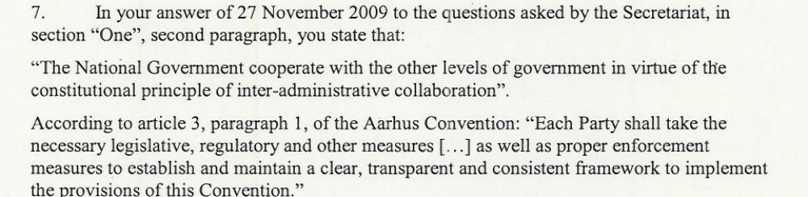

“It is clear that Spain has different levels of government. Could you please provide details on how the principle of inter-administrative cooperation applies in matters relating to the Aarhus Convention? What exactly is the action taken by the central government to ensure that the provisions of the Convention apply to all levels of the government?

The remit of the Ministry of the Environment and Rural and Marine Affairs includes, amongst others, tasks corresponding to the promotion and monitoring of cooperative relationships between State and regional authorities on environmental matters and of the activity of cooperation bodies such as the Sectorial Environment Conference. The national focal point of the Aarhus Convention, which is established in the aforementioned Department, exercises the same cooperation in the subjects of access to information, public participation and access to justice on environmental matters, as regards the remaining ministerial departments of central government and the agencies of autonomous communities and local authorities which may be affected in each case.
The legal framework in which this type of inter-administrative relationship is based is multiple.
Indeed, we must first consider Law 30/1992, of the Legal Framework of Public Administrations and the Common Administrative Procedure, article 4 thereof sets forth the following for administrative procedures in general:
“1. Public authorities act and work together in accordance with the principle of institutional loyalty and, consequently, shall:
- Respect the legitimate exercise by other authorities of their powers;
- Consider, in the exercise of their own powers, the entirety of the public interests involved and, specifically, those whose management is commissioned to other authorities;
- Furnish other authorities with the information they require on the activity undertaken in the exercise of their own powers;
- Provide the active cooperation and assistance that other authorities may request for the effective exercise of their powers.
2. For the purposes of the provisions set down in c) and d) of the preceding clause, public authorities may request as many data, documents, or evidential material at the disposal of the entity to which it addresses such request. Further, they may request assistance for the execution of their powers.”
Secondly, namely that concerning the special procedure legally provided for to ensure that rights regarding access to information, public participation and access to justice on environmental matters are safeguarded - set forth in Law 27/2006 – the principle of inter-administrative collaboration sets down, for its part, in article 4 thereof, that determines the following:

“Public authorities shall establish the most effective means for the efficient exercise of the rights acknowledged in this Law. For this purpose, they shall adapt their activities to the principles of mutual information, cooperation and collaboration.”
Pursuant to the foregoing, and as the Compliance Committee of the Aarhus Convention is well aware of, the national focal point of the Aarhus Convention in Spain has undertaken the proceedings required by the peripheral authorities involved in the issues hereunder (the case of the alcohol industry of Almendralejo Vinibasa, S.A. and of Refinería Balboa, S.A.), having been duly informed by the respective local and autonomic authorities of the queries raised by the Committee itself, to which a reply has been given, observing, at any event, the legitimate exercise by the above authorities of their powers, given that it is also legally recognised.

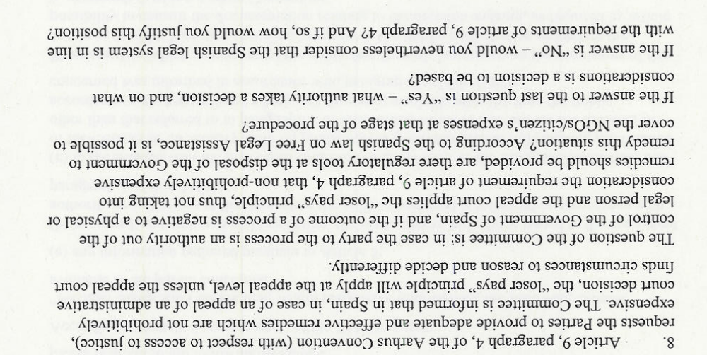

The reply to this question raised by the Committee needs to identify summarily the legal scheme of the situation addressed, which is governed by at least three different pieces of legislation. It is also important to stress the fact that, in the Spanish Legal system, there is no specific regime for purely “environmental litigation”. Environmental litigation consists usually of “administrative” litigation, because in most part of the cases there is a decision issued by an administrative agency (granting or denying a permit, imposing a penalty, etc), which is challenged by an interested party. Judicial control of administrative action is governed by a national Statute, the Act 29/1998, of 13 July 1998 (called Ley de la Jurisdicción Contencioso-Administrativa). Besides this general regulatory scheme, the Act 27/2006, of 18 July 2006, applies also as a “special” legislation in the domain of judicial control or bureaucracy in environmental matters. Finally, the Act 1/1996, of 10 January 1996, on free legal assistance (Ley de asistencia juridica gratuita) has a general application on any kind of legal proceedings.

The different elements included in the question need a clarification and some considerations:

1st.- The “loser pays” principle and its role in “environmental litigation”.

Concerning the expenses of any legal proceeding in Spain, (called “costas” in Spanish), it is important to clarify that this issue is governed by different statutes, depending on the “jurisdictional track” (orden jurisdiccional) that is involved in the proceedings. Since –as stated above- most “environmental litigation” usually implies challenging governmental decisions -at a local, regional and national level-, attention must be paid on how the issue of expenses in governed in the controlling statute: the Act 29/1998, of 13 July 1998 (Ley de la Jurisdicción Contencioso-Administrativa). This statute establishes a different regime for first instance proceedings (proceso en primera instancia) and for appeal proceedings (recursos contra sentencias y autos).

In the administrative, jurisdictional track, an appeal instance or “segunda instancia” implies that a lower administrative court has already adjudicated an appeal (recurso contencioso-administrativo) against an Agency decision. Thus, in first instance proceedings, the general rule is that each party must bear their own costs, but if the court finds that the lawsuit was filled by the claimant without any reasonable ground (something called “en temeridad”: with temerity or recklessly), then this party may be condemned by the court to pay for the costs of both parties (article 139.1 of the abovementioned statute). In the second instance (an appeal against the lower court decision), the rule changes (art. 139.2), since: in general the party that loses has to pay for the total costs of the appeal proceedings. This situation is identified in Question n. 8 as the “loser pays” principle. However, this rule is not rigid and absolute, for the court may decide otherwise…”if the court finds specific circumstances justifying that outcome”. One of those “specific circumstances” may be the fact that the appellant is an NGO.

In the light of this legal situation, the hypothesis advanced by this question (that “the loser pays principle” may go contrary to art. 9.4 of the Aarhus Convention) can not be supported in absolute terms. Thus, there is no automatic “violation” of art. 9.4.

2nd.- The possible contradiction between the “loser principle” and art. 9.4 of the Convention.

The question raised by the Committee seems to accept the assumption that there is such a contradiction, since it asks: “…are there regulatory tools at the disposal of the Government to remedy this situation?”. However, this assumption is at least arguable.
Art. 9.4 is fully respected by the Spanish legal scheme on judicial control of Administrative decisions, in the first instance. However, art. 9.4 can not extend to all different kinds of instances. Different reasons do support this conclusion:

- First: the Convention asks for “effective remedies which are not prohibitively expensive”, but does not impose “free” or no-costs remedies in all cases. Neither the text nor the “spirit” of the Convention requires that outcome.

- Second: art. 9.4 of the Convention is clearly a non “self-executing” provision, because it does not provide for actual or clear guidelines on what should be considered as “prohibitively” expensive or even an “expensive” cost.

- Third: The scope of art. 9.4 should be harmonised with the domestic public interest of maintaining a fair and workable judicial system, as well as deterring groundless, reckless or unreasonable litigation, in accordance with art. 3.8 of the Convention ( “This provision shall not affect the powers of national courts to award reasonable costs in judicial proceedings”).

3rd.- The likely or eventual impact of the “loser principle” on art.9.4 of Aarhus Convention is limited or neutralised by the Spanish legal scheme on free legal assistance.

The Spanish legal scheme on Free Legal Assistance is governed by Act 1/1996, of 10 January 1996, as explained supra.

Under this statute, any physical person lacking financial or monetary resources may be granted free legal assistance (asistencia juridical gratuita). In order to qualify for that free assistance, a person should belong to a family that does not earn in one year more that twice the minimum salary, which is determined annually by the Government. For 2010 this figure is 633 euros per month. All the salaries and wages of the different members of the family should be considered globally, and that sum is divided by the actual number of family members. For what concerns legal persons (like NGOs), Free Legal Assistance is granted if they have the legal nature of foundations or association of public interest. In this case the “threshold” for having free legal assistance is three times the minimum salary (articles 2 and 3 of the statute).

Free Legal assistance is granted on demand by Commissions on Free legal Assistance, acting in each province and in each autonomous community. There is also a National Commission. Different commissions with other territorial scope may be established if necessary. The members of the said commissions are: (a) a public prosecutor; (b) the dean of the bar association and of the solicitors association; (c) representatives of the different levels of government (articles 9 and 10 of the Statute).

The material scope of Free Legal Assistance is very large, and it covers, inter alia: (a) the wages of barristers and solicitors (obligatory in administrative justice); (b) the applicable announcements in public or official gazettes; (c) the costs of evidences and proofs, etc. It is important to state that, once the Free Legal assistance has been granted, this right also applies in second or appellate instances. (articles 6 and 7 of the statute). Accordingly, even if a Citizen/NGO benefiting from Free Legal Assistance loses an appellate legal proceeding in Administrative Justice, they will not pay for the costs of the lawsuit.

In the light of the precedent considerations, it is possible to establish the following conclusions:

- The fact that the “loser principle” rules exclusively in appellate proceedings in administrative justice does not infringe art. 9.4 of Aarhus convention.

- According to the Spanish Law on Free Legal Assistance, it is possible to cover the NGO/Citizen´s expenses at the appellate stage of legal proceedings.

- The Spanish system is in line with the requirements of art. 9.4 of Aarhus Convention.

