UNITED NATIONS ECONOMIC COMMISSION FOR EUROPE
Joint Task Force on Energy Efficiency Standards in Buildings

Mapping of Existing Technologies to Enhance Energy Efficiency in Buildings in the UNECE Region

Kankana Dubey, Andrey Dodonov
(draft as of 14.11.2018)
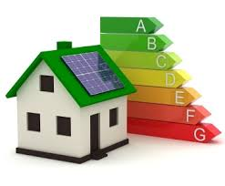

GENEVA, 2018

Table of Contents
List of Tables 3
List of Figures 3
Acronyms and Abbreviations 3
Executive Summary 3
Introduction 3
- Methodology and scope of study 3
- Energy efficiency technologies in buildings in the UNECE region 3
Building envelope: insulation and glazing 3
Space heating 3
Air conditioning, water heating and cooling 3
Appliances 3
Lighting 3
- Current deployment of energy efficient technologies – data analysis and review 3
Conclusions 4
Recommendations 4
Annexes 4
References 4

Executive Summary
One of the most important goals of public policy to stimulate the transition to a sustainable energy system is to improve energy efficiency, with consideration to flexibility and adaptability of UNECE member States, to accelerate progress towards achieving the objective of sustainable development. Indeed, according to (UNECE, 2017a, p. 10), “improving energy efficiency is one of the most cost-effective options for meeting growing energy demand in most countries. It contributes to energy security, a better environment, improved quality of life, and economic well-being”. While it is generally recognized that significant progress is being made, there is still substantial potential for improving energy efficiency worldwide. Nonetheless, regarding EU Country profiles and diversity, many adjustments in energy efficiency must take account of technological advancements that are being implemented in various private and/or public buildings. This topic is widely linked to national policies in the environmental sector, and especially to ecological transitions supported at a local level.
Across all countries in the United Nations Economic Commission for Europe (UNECE) region, buildings account for approximately one third of energy consumption, and 40 percent of CO₂ emissions (UNECE 2018). The buildings sector thus presents a unique opportunity to substantially improve energy efficiency – both via retrofitting existing buildings and requiring higher energy efficiencies on newly-constructed buildings. National public policies mechanisms which are meant to encourage increasing building energy efficiency through mandatory standards, cash and tax incentives, and consumer information programs.
In 2017 the UN Committee on Housing and Land Management (CHLM) and the Committee on Sustainable Energy (CSE) commissioned a comparative study on building standards in the UNECE region, entitled “Mapping of Existing Energy Efficiency Standards and Technologies in Buildings in the UNECE Region”. The current report follows up on this study by analyzing the actual prevalence of specific types of energy-efficient technologies in the buildings sector in the UNECE region, along with the levels and types of public policy interventions supporting their implementations. The study objectives are to evaluate the adaptation of these technologies by UNECE member States, identify implementation gaps and possible causal barriers, and recommend country-specific rectifying actions that take account of the ecological transition at all levels of building repairs and renovations, and new building programs. The data for this study has been gathered mainly through desktop research of both internet and print media, including official governmental communiques, NGO-published reports, academic publications, energy databases, and public news outlets. The data has been validated and the data sources further augmented through consultations with various subject-matter experts and organizations.

Gap Analysis
The analyzed UNECE member States have been categorized into five subregions named A, B, C, D, and E, and assessed on a 3-point scale (Low, Medium, High) for implementation of the building energy efficiency technologies listed in the Appendix. For tabulation and analysis, the technologies were aggregated into five high-level categories: “Building Envelope and Glazing”, “Heating of Domestic Hot Water Supply”, “Air Conditioning, Ventilation, and Cooling”, “Appliances” and “Lighting”. Where possible, relevant data was gathered separately for retrofitting existing buildings, and implementation in new construction; then further segregated the data into four types of buildings: single-family dwellings, multi-family dwellings, commercial buildings, and public buildings.
The data suggests that some aspects and types of energy efficiency technologies are very consistently required and implemented in the buildings sector across the UNECE member States. For example, efficient building envelope insulation (including windows) are used in all countries, and many member States have made good progress towards net-zero energy impact buildings – at least for those owned/occupied by the public sector. Another example of consistent application is public policy to phase out incandescent bulbs in favor of more efficient lighting technology. Several countries have gone further, encouraging implementation of more advanced sensor-based lighting control systems to reduce energy consumption. On the other hand, the analysis has found much wider disparities in the prevalence of energy efficient decentralized space heating technologies. For example, Denmark has extensively encouraged the installation of new electrical boilers for building heating during both renovations of existing buildings and construction of new buildings. In Finland, however, oil-burning boilers are more prevalent, though the Finnish Government has various measures in place to encourage switching from oil-heating systems to more efficient alternatives.

Introduction
According to the report “Energy for Sustainable Development in the UNECE Region” released in 2017 by the United Nations Economic Commission for Europe (UNECE, 2017a), one of the most important goals of public policy to stimulate the transition to a sustainable energy system is to improve energy efficiency expeditiously that raises awareness on the ecological transition for the 50 coming years. The report states, “Improving energy efficiency is one of the most cost-effective options for meeting growing energy demand in most countries. It contributes to energy security, a better environment, improved quality of life, and economic well-being” (UNECE, 2017a, p. 10). The UN’s Sustainable Development Goals target 7.3 (SDG7.3) is to “double the global rate of improvement in energy efficiency by 2030” (UNECE, 2017a, p. 1). There is significant potential worldwide for improving energy efficiency, and it is widely recognized that significant progress is indeed being made. According to the Enerdata Global Energy Statistical Yearbook 2016, global energy intensity improved by 1.8% in 2016 and 1.2% in 2017. However, there are still significant barriers hindering this progress, and these recent gains have not been enough to meet a Sustainable Energy for All (SDG7.3) target (UNECE, 2017b).
Out of all sectors of economic activity, the buildings sector has the largest potential for cost-effective improvement in energy efficiency and emissions reductions. Additionally, focusing on the buildings sector brings significant social co-benefits, such as:
- increasing energy security
- expanding entrepreneurial opportunities
- creating jobs
- reducing energy poverty
- increasing access to energy services
- improving air quality (both indoor & outdoor), with positive impact on residents’ health
- increasing comfort and health /
- increasing living standards thanks to mixed high-quality housing projects.
In short, highly efficient buildings are the foundation of healthy, prosperous, secure, and sustainable communities.
Consumption of carbon-emitting energy by buildings can be reduced in three different ways: reducing the demand for energy, increasing ‘technical’ energy efficiency, and integrating renewable sources of energy; the term ‘energy efficiency’ is used here to cover all three reduction methods. This report focuses on the existing technological opportunities and barriers against improving efficiency of energy used for heating, cooling, ventilation, and lighting in the built environment. In many reported cases, barriers are often linked to a specific approach of some lobbies in the energy sector which are not sufficiently prepared to make “green energies” available, because of powerful political, economic, and ideological forces
A variety of public policies designed to improve energy efficiency in the buildings sector have been implemented throughout the UNECE region, with varying degrees of success. Another benefit of focusing on energy efficiency in buildings is that the buildings sector is already quite regulated, which enhances dissemination of energy efficiency requirements, further driving progress. Another supporting factor is the role of the public sector. Public buildings often constitute a significant share of a country’s total building stock. Therefore, by choosing energy-efficient designs and materials for their own buildings, governments can exert a powerful influence on the buildings sector, as well as set an example. Many countries have set up official national energy efficiency laws or programmes with quantified energy efficiency targets. These programmes can have a substantial impact on the durability and effective coordination of public policy in favour of energy efficiency but require sufficient political consensus for practical implementation.
Policies, programmes, and technologies can be considered to address energy efficiency in buildings from three perspectives: systems, structure, and service. Examples of policies and programmes which support increased energy efficiency in the buildings sector include appliance standards and labels (Energy Star, et al.), building energy codes, utility demand-side management programmes and targets, public-sector energy leadership programmes, energy pricing measures and financial incentives, education and training initiatives, targeted awareness programmes, and the promotion of energy service companies (ESCOs) (UNDP, 2009). The level of success of each of these types of policies is dependent upon many factors and may be hindered by various barriers. In addition, the best approach to improving building energy efficiency in each country may depend upon the economic maturity of its building sector to accept adaptation to ecological transition...
In rapidly developing countries in which the built environment is largely immature, the buildings sector should prioritize improving energy efficiency and reducing future emissions in new construction. Policies and programs targeting existing building stock will likely have a lower magnitude impact on overall improvement in energy efficiency. This is one aspect in which the developing economies can have a disproportionately large impact on reaching global energy efficiency targets, as the marginal cost of increasing building energy efficiency is lowest at construction time. New construction represents a significant opportunity to integrate efficient materials, new technologies, and best practices from the start. During construction, the entire building system can be designed to optimize energy efficiency. Operational energy consumption is affected by location, orientation, structure, layout, construction materials, and included equipment – all design- and construction-time decisions. Some of these factors can be improved upon later during major renovations but are more capital intensive.
Conversely, in many OECD countries with developed economies and extensive building infrastructure already in place, retrofitting existing buildings to improve energy efficiency and reduce emissions should take priority over new buildings. Consider the built environment in the European Union, which is composed of approximately 35% of buildings 50+ years old: improving their energy efficiencies could reduce the region’s total energy consumption by more than 5% (UNECE, 2017a, p. 8).
Three major types of factors affect building energy efficiency during its use – condition and design of the building structure and envelope, performance of major equipment (boilers, AC units, lighting, etc.), and occupant behavior (temperature, timing and use of appliances and lights). Optimizing the energy efficiency of the components of these factors, with respect to occupant comfort and safety, requires complex building energy systems to monitor and control the buildings internal environment. However, a significant number of companies in the UNECE region don’t currently implement such standardized energy management systems (UNECE, 2017b, p. 27).
Multiple barriers make it difficult to transform the vast potential of energy savings in the buildings sector into a reality. Some of these barriers are general (that is, they apply to all energy efficiency projects in all sectors), while others are specific to the buildings sector.
General barriers to improving energy efficiency include:
- lack of technology
- limited financing
- insufficient awareness and expertise of financiers
- un-adapted or missing regulations
- high costs of reliable information
- greater weight given to upfront costs compared to recurring costs
- lack of knowledge by building owners and/or design teams
Effective lobbying capability to counteract the fossil fuel lobby is also a significant barrier; even renewable energy has an extensive lobby (UNDP, 2009). Similarly, most countries lack governmental agencies with a clear mandate and adequate capacity to design and implement policies in favour of building energy efficiency. One significant barrier specific to the buildings sector is structural complexity; a holistic systems perspective, which leads to more thorough optimization of design and operation and hence improved energy efficiency, requires more breadth and depth of expertise (UNDP, 2009).
In the European Union, much attention has been given over the past decade to energy efficiency in the buildings sector, with the following directives:
- directive of 16 December 2002 on the energy performance of buildings
- directive of 6 July 2005 establishing a framework for the setting of eco-design requirements for energy-using products
- directive of 5 April 2006 on energy end-use efficiency and energy services
- directive of 23 April 2009 on the promotion of the use of energy from renewable sources providing for the promotion of energy efficiency
- directive of 21 October 2009 establishing framework for setting of the Ecodesign requirements for energy-related products
- directive of 19 May 2010 on the indication of energy efficiency labelling and standard product information of the consumption of energy and other resources by energy-related products
- directive of 19 May 2010 on the energy performance of buildings
- directive of 25 October 2012 on energy efficiency amending directives 2009/125/EC and 2010/30/EU and repealing directives 2004/8/EC and 2006/32/EC
- directive of 30 May 2018 amending directive 2010/31/EU on energy performance of buildings and directive 2012/27/EU on energy efficiency

To help officials in EU countries implement the Energy Efficiency Directive, the European Commission has published several guidance notes; Article 5, 6, 7, 8, 9-11, 14, 15. Country-level implementation of these directives should induce important changes in energy efficiency in Europe, especially in the buildings sector. In the United States, the Energy Policy Act of 2005 covers almost every aspect of energy generation, distribution, and consumption, along with guidelines on energy efficiency. In 2012, 31 states, by adopting either ASHRAE 90.1.2007 or the ICC Energy Conservation 2000-2015, adopted model codes for residential and commercial buildings. Their provisions concerning energy efficiency in buildings include: energy consumption reduction targets for public buildings, integrating efficient equipment in public procurement, new standards for 14 large appliances, and tax incentives for energy efficiency improvements in homes, commercial buildings, and public buildings. However, some environmental organisations have criticized the act for bringing only limited progress on energy efficiency in buildings (IPCC, GABC).
Chapter 1 documents the objectives and scope of this study. The methodology used, as well as perceived limitations is also detailed. Chapter 2 focuses on the energy used in the building during its operational life, and relevant existing energy efficiency technologies in six broad categories: building envelope (insulation and glazing), space heating, air conditioning, water heating and cooling, appliances, and lighting. These technologies are mapped in relation to existing building standards. The review of the application and adaption of the relevant technologies, nation-level assessment, and the gap analysis is documented in Chapter 3. Gaps are identified and analyzed with respect to several perspectives, including: knowledge, technical, regulatory, institutional, and financial. This report ends with conclusions and recommendations, which are based on the mapping and gap analysis, focusing on priority actions countries in the UNECE region should take to increase the uptake of technologies to enhance energy efficiency in buildings. Recommendations include, but are not limited to, aspects surrounding policy and legislation, investments and financial incentives, technology adaptation, and capacity development.

CHAPTER 1 - Objective, Scope, Methodology, and Limitations
The objective of this study is to examine and analyze the current status of energy efficiency in buildings in the UNECE region; its broad focus is threefold: relevant technologies, building standards, and supporting public policies. Gap analysis between actual and ideal implementations is used to form a base from which to guide UNECE member states in their efforts to improve building energy efficiency, in support of SDG7.3. The UNECE Committee of Housing and Land Management (CHLM) and Committee on Sustainable Energy (CSE) published an initial report, entitled “Mapping of Existing Energy Efficiency Standards and Technologies in Buildings in the UNECE Region”, towards this goal (UNECE, 2018). This report documented building codes and energy efficiency requirements currently in place. The UNECE published an additional report, entitled “Overcoming Barriers to Investing in Energy Efficiency”, in support of the same goal (UNECE, 2017b). The authors of this report surveyed global energy efficiency experts and practitioners on the narrow topic of barriers which hinder improving building energy efficiency. To further strengthen the understanding of the UNECE member states on the technological impact of energy efficiency technologies in the buildings sector (UNDP, 2009), the current study was commissioned.
This study undertakes the mapping and clustering of existing technologies to enhance energy efficiency in buildings. It further identifies and analyses the gaps between existing energy efficient technologies in the buildings sector, and their application and adaptation in the UNECE region. The analysis complements the previous reports which were limited, respectively, to building codes and technical requirements, and various social, policy, and financial barriers (UNECE 2017b, UNECE 2018). Specifically, this study extends the initial assessments of energy efficiency technologies in buildings in relation to the existing standards and current barriers. The main method of this study is gap analysis, based on desktop research; the analysis focuses on the following topics relevant to energy efficiency for countries in the UNECE region:
- institutional and legal policy
- building codes and standards
- existing technologies
local capacity development
- existing availability of materials and equipment
- currently implemented financial and economic mechanisms
This report is based on the principles of Framework Guidelines for Energy Efficiency Standards in Buildings (UNECE 2017c), and thus transcends the incremental, components-based approach of existing building standards analyses. It is well-known that the largest saving potential in energy use occur when a systems perspective is used to implement energy efficiency improvements. This design perspective influences the gap analysis and subsequent recommendations. Furthermore, the identified gaps are analyzed by highlighting the difference in the use of technologies among countries of the UNECE region. The analysis includes evaluation of the correlation between the strictness and enforcement of existing standards, and the level of applied technologies.
The data collected to measure and analyse the trends and patterns of application of energy efficient technologies is based on the following assessment criteria. The implementation of each technology in each country was evaluated on an impact score as defined below.

Impact Score | Assessment Criteria
3(High) | The technology is strongly prevalent. There is governmental support and initiative to encourage promotion of the technology, and there are active measures being undertaken which include financial support and incentives. Application of this technology is mandatory, or in a transition phase to becoming mandatory. There could be fines for non-compliance. This technology might be made affordable and economically feasible through means of incentives and being widely implemented.
2 (Medium) | National legislation (laws, building energy codes etc.) does not require implementation of this technology. There are only some cases when implementation of this technology is supported on the regional level (e.g. in some climate zones etc., but not in the whole country). Some prescriptive recommendations may exist in the legislative documents. This technology is frequently implemented during new construction or retrofits; despite the lack of proper regulatory framework, it may be affordable and widely used. There is a moderate trend of implementation for the technology, but there are still some gap areas which exist. This could be improved with public-private partnerships, government support, push-pull marketing strategies, compliance standards, and financial incentives.
1 (Low) | Existing legislation does not require implementation of this technology. There are also no specific building energy codes that describe at least prescriptive requirements. This technology is only seldom implemented in some regions (including demo-projects, implemented by the international public organizations and co-financed by the various funds). The technology is likely economically inefficient. It is being implemented, but at a stage of infancy; market barriers exist which curtail adaptation. Much is mentioned about it in policies, but there is not substantial applicability and efforts are required to promote the technology.
0 (Non-applicable) | Implementation of this technology is not economically feasible and not mandatory. This technology is not applicable (only in some specific cases).
NI – No Information | No information, as of now, on the data point.

The validity of the conclusions and recommendations in this report is limited by the data which was publicly available through desktop research at the time of study development. Where appropriate in the remainder of the report, assumptions made have been have documented; all inferences are likewise dependent upon these assumptions. Finally, unlike the aforementioned report (UNECE 2017b), this study is not based on data elicited via a structured survey from subject matter experts. To the extent that said experts hold relevant information that is not publicly available, the conclusions and recommendations here may be biased.
This study was consulted, and results validated, by the stakeholders from the UNECE region, relevant national authorities, and members of the UNECE Joint Task Force on Energy Efficiency Standards in Buildings. The preliminary findings of the study were validated at the Third Meeting of the Joint Task Force Commission in Geneva, Switzerland on October 3rd, 2018, and the finalized study presented during the ninth International Forum on Energy for sustainable Development, on 12-15th November 2018 in Kiev, Ukraine.

CHAPTER 2 – Energy Efficient Technologies in Buildings in the UNECE Region
The buildings sector consumes significant amounts of energy to maintain comfortable living conditions, which requires: space heating and domestic hot water preparation, ventilation and air conditioning/cooling, and power supply for lighting and other household appliances. There are advanced technical solutions for buildings being integrated in modern architecture which reduce energy consumption, carbon emissions, and energy wastage, while providing maximum thermal comfort and safety of the occupants. In general, such technologies either reduce the energy demand, or increase the efficiency with which energy is used.
Modern building regulations define the requirements of building engineering systems and set building envelope thermal performance limits, which also determines the most optimal energy consumption, in terms of technical and financial and economic conditions.
Building codes provide guidelines for new construction and for retrofitting the existing building stock to create high-performance buildings by applying an integrated, holistic design process, which increases building life-span; reduces energy consumption; and contributes to a better, healthier, more comfortable environment for people to live and work. Several technological options exist which, along with providing energy efficient solutions, also support sustainability measures; reduce operating costs and environmental impacts; and increase building adaptability, durability, and resilience. This Chapter focuses on how and where energy is consumed in a building during its operational life, and on relevant existing energy efficiency technologies, which have been divided into six broad categories:
- building envelope and structure; insulation, glazing, airtightness and reduced thermal bridging;
- space heating;
- central air conditioning/cooling;
- water heating and cooling
- appliances and equipment; and
- lighting.
The following are some examples of energy efficient measures which can be adopted to make buildings efficient and productive.
Thermal protection for enhancing the building envelopes and structure:
- thermal insulation of building envelope;
- replacement of obsolete windows and doors with modern energy-efficient ones;
- increasing the airtightness of buildings; and
- improve design details to reduce thermal bridging in building envelopes.
Decrease heat losses in buildings
- restoration and sealing of inter-panel joints of the walls and ceilings, in case of panel building reconstruction;
- installation of additional entrance groups (tambours) with double doors;
- installation of automatic door closers; and
- installation of heat recovery units to limit heat loss by the ventilation system, and supply fresh and clean air.
Improvement and optimization of internal heat-supply systems, to decrease energy consumption
- thermal insulation of heating system pipelines, hot water risers, and heating system distribution mains;
- installation of automatic individual heat points for the heat supply system;
- installation of thermostats for the heating system radiators;
- installation of balancing valves on the heating system risers;
- installation of heat- and water-heating boilers (including biofuel) with weather-compensating controls;
- use of circulating pumps for heating systems, hot water supply with built-in or external frequency converter drives;
- installation of reflective insulation behind radiators; and
- hydro-pneumatic or chemical cleaning of heat supply systems, including basic equipment.
Reduction or optimization of electricity consumption
- replacement of lamps and bulbs in internal and external lighting systems;
- use of scheduling / occupant or daylight sensors for lighting controls;
- use of high-efficiency electric heating/cooling equipment (heat pump);
- optimization of energy consumption by elevators with installation of frequency converter drives;
- use of frequency converters in the engineering building systems to optimize the operation of fans, pumps, and other relevant equipment;
- installation of energy-efficient household appliances; and
- installation of photovoltaic heating and power-generating systems (solar panels).
Some of the basiq energy efficiency measures are described in the rest of this chapter, highlighting their impacts on energy consumption and applicability in the UNECE regions.

2.1. Building Envelope: Insulation and Glazing

2.1.а Insulation of building envelope, airtightness, thermal bridging.

The building envelope has the greatest impact on buildings performance; it is a prime focus area to consider when energy efficiency measures are planned for existing or new buildings. Considering the functions of the building envelope - security, comfort, shelter, privacy, aesthetics, ventilation etc. - it is imperative to optimize the design of the building envelope to meet the occupants’ requirements while reducing energy consumption and heat loss.
The importance of thermal insulation, airtightness and reducing a thermal bridging in buildings is equally relevant for countries in both hot and cold climates. Heat loss through leakage during cold months leads to increased use of heating energy, this is analogous to losing cool air from central air conditioning in summer months (both situations resulting in increased consumption and higher carbon emissions). Most building heat loss is through the walls, roofs, and floors and glazing, sealing joints, thermal bridges etc.
Airtightness as well as reduce of thermal bridging are the critical measures for improving thermal performance and comfort, but also to ensure long-term building durability.
Proper insulation can reduce the heat loss in cold climates and heat gain in hot climates. The type and amount of insulation varies according to climate, building type and usage. . There are many available energy efficiency technologies which address the building envelope that are predominantly applied to new buildings. Some may also be implemented during retrofit upgrades, as applicable.
Insulation layer thickness selection is based on the requirements of the construction and regulatory criteria, climate conditions, current thermal, and other necessary parameters. All of which should be considered in the architectural design stage. T. Some of thermal insulation materials primarily used in buildings to promote energy efficiency are shown in Figure 1.

The most popular and common technological solutions for building envelope insulation are the following:
- layering of insulating material between the exterior and interior walls;
- insulation on the building exterior with plastic covering; and
- insulation material between the ground floor or basement and the floors above.
The principles of some technical solutions for insulation are illustrated in Figure 1.
Some of technology for exterior wall insulation

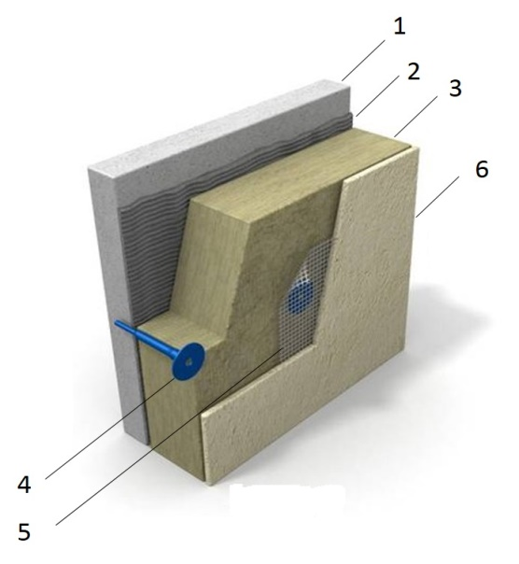 | Key elements of the proposed technology
- The existing concrete wall
- Adhesive composition
- Rigid mineral wool plate based on basalt
- Fixing plug
- Reinforcing fiberglass mesh is applied to the adhesive composition
- Outer protective and decorative coating with preliminary primer layer
Some ofd technology for insulation of attic slab

 | Key elements of the proposed technology
- The existing concrete slab
- Cement screed
- air barrier (vapor control layer in some assemblies)
- Rigid mineral wool plate based on basalt
- Hydroisolation
- Layer of reinforced cement-sand screed
Figure 1 - Technical solutions for insulation of attic slab for unheated attic space

 | Fiberglass | Rock wool | Slag wool | Expanded polystyrene (Frothed non-pressed) | Extruded polystyrene
VIEW | 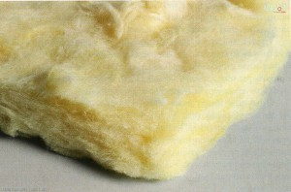 | 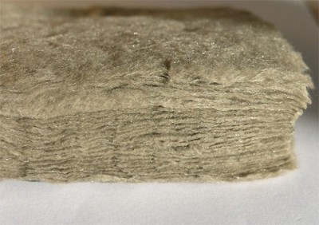 | 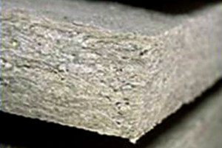 | 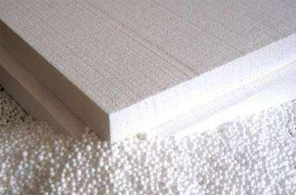
CHARACTERISTIC | Initial raw materials for production of fiberglass are: sand, soda, limestone, drill (or etibor), cullet. Heat conductivity - 0,038-0,046 W/m·K.  Max operational temperature - 450 °C.  Min. operational temperature -60 °C. | The main raw materials for production of stone (basalt) cotton wool are rocks. Heat conductivity - 0,035 — 0,042 W/m•K.  Max operational temperature – up to 1000 °C  (only in case of lack of deformation). | Initial material for production of slag cotton wool are domain slags. Heat conductivity - 0,04 - 0,07 W/m•K.  Max operational temperature - 300 °C. | Expanded polystyrene (or polyfoam) stands for the foam plastic which consists for 98% of air. Heat conductivity - 0,036 - 0,050 W/m•K  Max operational temperature - +70 °C.  Min operational temperature - 50 °C. | Extruded expanded polystyrene consists of the granules of polystyrene formed by an extrusion method. Heat conductivity - 0,028 -0,034W/m•K  Max operational temperature - +75 °C.  Min operational temperature - 50 °C.
ADVANTAGES | - Lightness  - Elasticity  - Good sound-proofing properties;  - Nonflammable  - High compression for easy transport | - Nonflammable  - High elasticity  - Immunity to mold and fungus  - Resistance to short-term influence of moisture – can be mounted during rain  - Fibers are noncaustic | - Low water absorption – is ideal for work under the open sky in any weather | - Low price  - Excellent flexibility  - High durability on compression at the low density  - Simplicity of installation | - High durability on compression at the low density  - Low water absorption  - Low vapor permeability  - Low coefficient of heat conductivity
DISADVANTAGES | - High fragility of fibers  - High water absorption | - Low compression of material; inconvenient for transport  - High cost | - High fragility of fibers  - Low indicators of heat conductivity | - FlammabilityHigh water absorption  - Repeated transition of temperature through 0ºС leads to destruction | - Group of combustibility G1-G4 (combustible)  - High cost
RESTRICTIONS | It is necessary to use the coveralls made of a dense material, gloves, respirator, and safety glasses during installation. | Requires careful transport and protection against mechanical influences. | Not recommended to use together with metallic facade elements. | Prohibited to use without covering – requires cement and sand or plaster protection from the open environment. | Prohibited to use without covering – requires cement and sand or plaster protection from the open environment.
Figure 2 – Some of thermal insulation materials applied in the UNECE region

2.1.b Installation of modern windows with higher thermal characteristics
Replacing of outdated windows with the latest window technology insulation is much more efficient than repairing them. Building standards in several countries required the installation of energy efficient windows with high thermal characteristics. These windows are made using multi chamber glazing profiles, which is a more complicated design than traditional old wooden-paneled windows. As well as having advanced thermal characteristics, multi chamber windows are stronger, resisting deformation, so can be expected to last longer. Windows with broad materials are available, some of the variations are seen in Figure 3.
Wooden profile | Aluminum profile | PVC profile
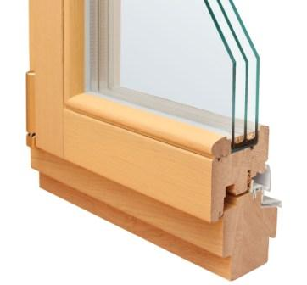 | 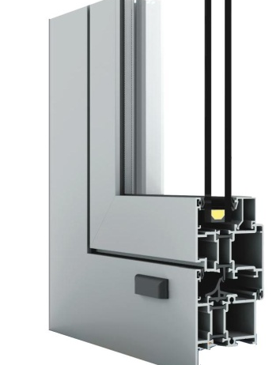 | 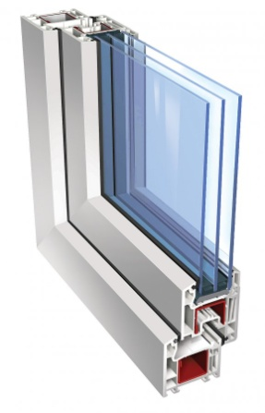
Wooden windows made of such breeds of a tree, such as oak, pine, ash, and larch.  Advantages:  - Attractiveness  - Good thermal insulation and frost resistance  - Sound insulation  - Possibility of change of color, either outside, or inside  Disadvantages:  - Combustibility and hygroscopicity  - Ongoing maintenance / finishing required | Aluminum windows are divided into two types: light and warm aluminum.  Windows made of light aluminum are suitable for buildings which do not require significant sound and heat isolation. Such windows are very light and small.  Warm aluminum windows consist of two parts: external – cold, and internal – warm. These parts are produced separately and later merged directly on the building.  Advantages:  - Lightness  - Durability  - Resistance to weather conditions  Possibility to customize the configuration and complexity of the window  Disadvantages:  - Susceptibility to electrochemical corrosion  - High heat conductivity of the aluminum – requires thermally broken frames to achieve high performance levels | These windows are made of polyvinylchloride (PVC); they are the cheapest type of windows.  Advantages:  - Good thermal insulation  - Excellent sound insulation  - Resistance to various atmospheric actions  - Simple operation and maintenance  Disadvantages:  - Mechanical damages at a plastic window can't be corrected
Figure 3 - Various energy efficient window profiles
The design of a double-glazed or triple-glazed window units consists of sheets of glass divided by a spacer which is hermetically sealed on each end. The glass panes are separated by a air, or filled with gas, to reduce heat transfer.
Depending on the thermal and technical requirements, window profiles can be specified in accordance with the building regulations or to meet requirements, for instance acoustic insulation. In many countries, windows have energy saving glazing, which has a glass panel coated with a thin layer of silver atoms; this can decrease the glazing emissivity significantly. This type of single-chamber double-glazed window is warmer than the simple double-chamber ones. At the same time, it weighs about 30% less, which contributes to a longer lifespan. Moreover, due to the silver ions, this type of double-glazed window exhibits the mirror effect. This enhanced reflectivity allows the windows to help a room stay cooler during the summer, and warmer in the winter.

2.2. Heating, domestic hot and cold water supply
Different approaches to the design of heat supply system depend largely on the availability of energy resources, price, infrastructure, technological development, and energy policy a specific country. Heat supply systems technology is in a transition phase, and there are significant technological advancements being made to include renewable energy as a source of heat supply. The following governmental support measures are important for the implementation of the renewable energy:
- legal framework and policy
- establishment of targets for promoting renewable energy sources for use in electricity or heating
- provision of financial / fiscal incentives for investment in renewables
- adoption of medium-term feed-in tariffs for the purchase of renewable energy
- imposition of an obligation on power companies to secure a certain percentage of their supplies from renewable sources
Thus, implementation of the renewable energy solutions can be applied both for centralized and decentralized heat supply systems.

2.2.a Improvement of decentralized heating supply system
The principle of decentralized heat supply is based on independently-produced heat energy for internal needs. Decentralized heating systems can rely on both non-renewable fuel (e.g. installation of boiler equipment) and renewable energy (installation of roof-top solar collector systems and heat pumps).
Installation of the boiler equipment
One of the most widespread measures within the modernization of the decentralized heat supply system is the replacement of the outdated boilers with the more efficient ones. The efficiency of the new boiler equipment can be determined by the efficiency in energy generation from fuel combusted. The coefficient that defines the efficiency of boilers is called efficiency coefficient. The higher coefficient of boiler efficiency means the input of fuel required is less for the heat generation or for hot water supply. The modernized boiler equipment has a higher efficiency coefficient from combusting similar amount of fuel type as compared to the traditional boilers.
Additionally, the technology allows the boiler to switch over to different fuel type with higher calorific values along with the additional feature, the automatic heat regulation systems coupled with weather compensated control.
There are different types of the boiler equipment, which operate using the various fuel types such as: natural gas-fired boilers, diesel, coal, electric and biomass (see Figure 5).
One of the most efficient boiler technologies is condensing boilers, which are more efficient than traditional boilers. The use of the condensation of the water vapor, formed as a result of the hydrocarbon combustion process, is considered as the most innovative boiler technology. Condensing boilers operate on this principle.
The European Union adopted the DIRECTIVE 2009/125/EC 21 October 2009 (establishing a framework for setting ecodesign requirements for energy-related products) forbidding the sale of non-condensing gas-fired boilers in the entire EU region, barring a few exceptions. The higher efficiency and environmental-friendliness of condensing boilers make them superior to traditional gas-fired boilers. Currently, all European manufacturers are obliged to produce only condensing gas-heating equipment for sale in the EU countries.

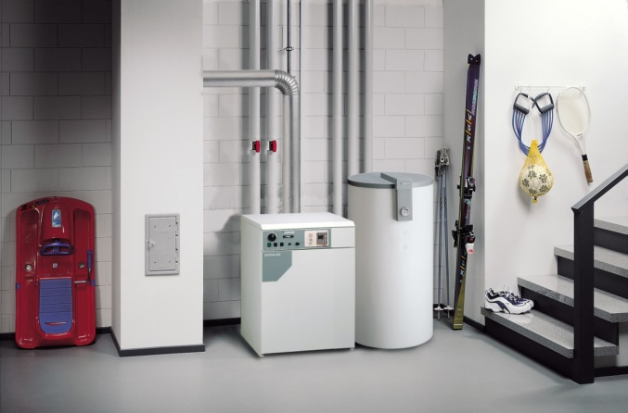 | 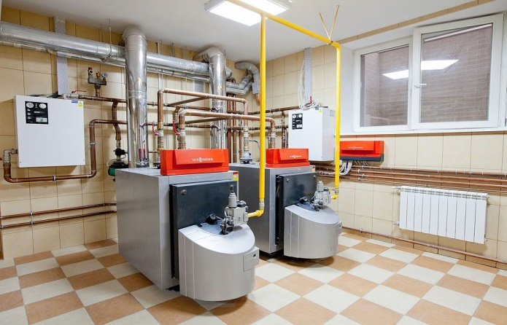
Figure 4 - Examples of modern gas-fired boilers

Solar collector solutions
Solar heating is one of the most widely-used technical solution using renewable energy in the buildings sector. Heat from solar radiation can be used for domestic hot water and internal heating in residential or public buildings. There are two types of solar collectors: flat and vacuum tube collectors. The typical solar collectors generate temperatures of 60-100°C.
Flat solar collectors | Vacuum tube collectors
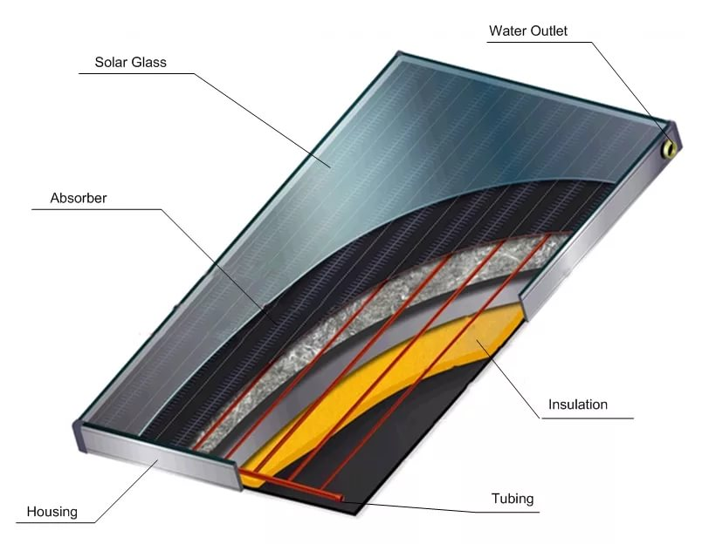 | 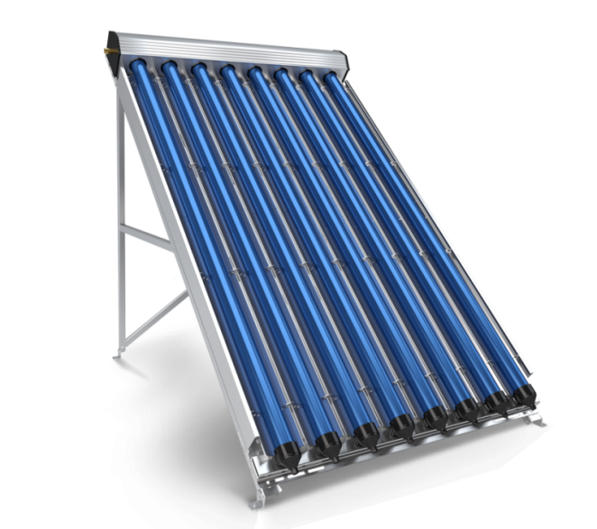
Advantages
- Low cost solution  - Easy to install and maintain  - Simple to operate and generally no other equipment required (such as pumps)  - Proven technology with significant lifetime (more than 25 years)  Ideal for intermittent loads (e.g. houses, restaurants, and small businesses)  - Transparent insulation can be equipped for flat collectors to achive a higher efficiency. It can be used to reach the higher target temperatures or applicable in cold climate to protect collector against the freeze. This variant also has overheating prevention at the collector level. | - Higher efficiency compared to flat collectors  - Ideal for high and constant loads (hotels, spa, swimming pools and gyms)  - Ideal for solar cooling and heating; temperatures can range from 50°C in winter to 120°C in summer  - Cover winter load, except in extreme conditions  - Not prone to damage from heavy snow or hail
Disadvantages
- Lower efficiency compared to vacuum tube collectors  - Temperature range not ideal for solar cooling; during extended winter periods, cannot accommodate the DHW (domestic hot water) load;  - Sensitive to damage from extreme snowfall or hail |  | - They are a relatively expensive solution  - Not ideal for small DHW loads (such as houses)  - Hot summer conditions may cause glycol pyrolysis if there is no constant consumption or water circulation (temperatures may rise above 130°C)  - Prone to being damaged if used for intermittent loads  - Low electricity consumption due to the need for forced recirculation, especially during summer
Figure 5 - Types of solar collectors
Solar systems can be divided into two key categories: passive and active (see Figure 6). The passive solar system is installed as one complete rooftop unit comprised of a solar collector and water tank. This system is relatively less expensive but at the same time it is not appropriate for use in the cold climates.
Active solar water heating and heat supply systems include a wide range of engineering equipment: solar collectors, controllers, circulation pump, broad tank, main storage container, and connecting pipes. Active systems are more expensive, but give more benefits, and can be used during the winter season. Electric heating provides for the necessary water temperature, especially during cloudy weather with lower levels of radiation. In general, these systems consume less electricity annually. Active systems can be used not only for water heating, but also for heat supply systems. Further, it is possible to adjust the capacity of active solar systems (within specified limits) by means of adding more solar collectors. For example, in case it is necessary to heat more water or to increase the heating area.
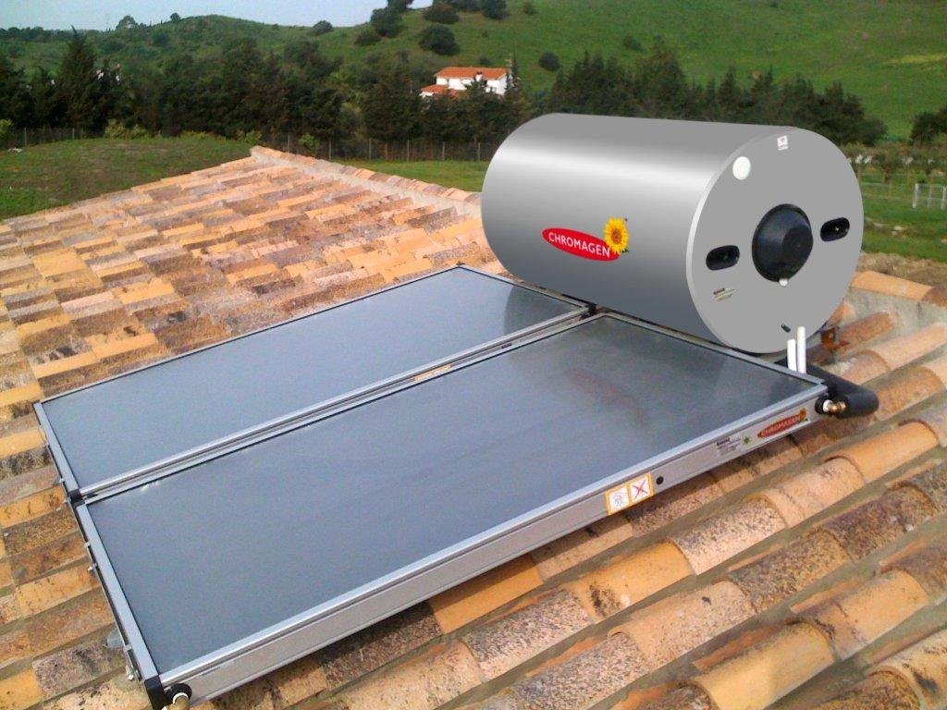 | 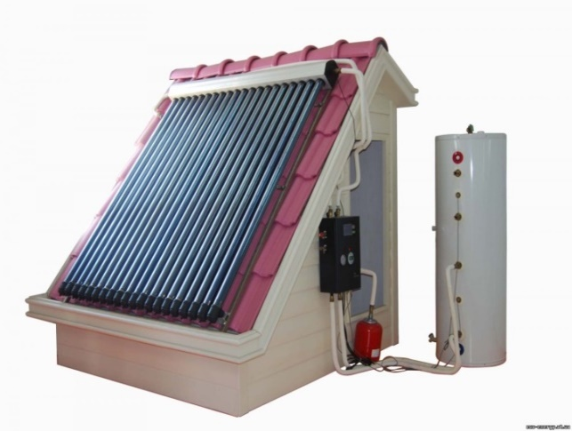
View of passive solar system with flat collectors | View of active solar system with vacuum tube collectors
Figure 6 - Examples of solar heating systems
Heat pumps

A heat pump operates on the principle of vapor-compression cooling. Heat power is carried by means of condensation and evaporation of a coolant (generally, Freon circulating within the closed contours). Heat pumps consume electricity to operate the coolant compressor and secondary circuit circulation pumps. There are several key points on installation of heat pumps in the buildings sector:

- Installation of heat pumps systems is economically feasible when installed at the time of construction, as it is easier to make provision for space. During a building retrofit, it may be possible to integrate a heat pump with the existing heat supply system, along with a heat collector.
- In cold climates and warm seasons, heat pumps using a water source can work more effectively than air-based heat pumps, or other air conditioning systems. Heat pumps are much more efficient than other electric heating systems and, depending on fuel prices, they can be also more economic than other heating systems.
- Heat pumps demonstrate outstanding efficiency when daytime temperatures fluctuate drastically.
- Heat pumps are economically feasible in countries where fossil fuel (e.g. natural gas) is relatively expensive compared to electricity, or not available. Heat pump systems have lower energy costs, while the electricity price (for kW) is in 3.5 times higher than the price of traditional fuel (for production of 1 kW).
- In areas where drilling is relatively cheaper, geothermal systems with a vertical soil heat exchanger are the most attractive. However, flat geothermal systems (low depth, wide area) can also work well if there are large areas on the property which can be used for this purpose.
Heat pumps may be classified according to the source of low-potential thermal power, as shown in Figure 7.

TYPE | SOIL - WATER |  | WATER – WATER |  | AIR - WATER
 | Horizontal | Vertical | Horizontal | Vertical
VIEW | 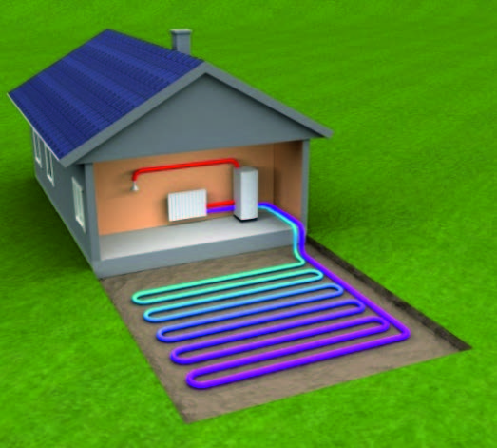 | 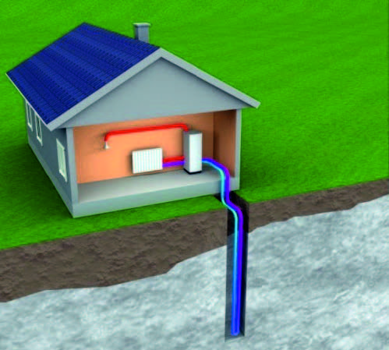 | 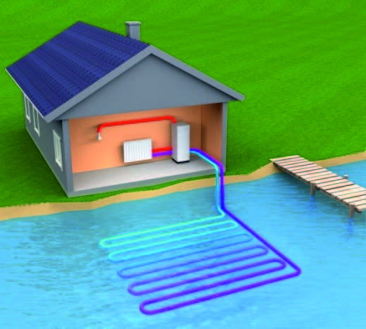 | 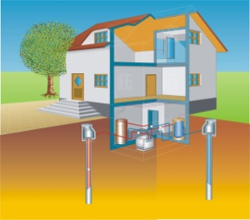 | 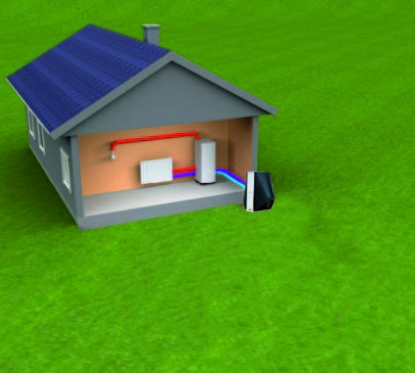
DESIGN | The collector is placed in the form of rings or twisting inside the horizontal trenches lower than the depth of frost penetration into the soil (usually at least 1.20m). | The collector is placed vertically in a well up to 200m in depth. | The collector is placed in the form of rings or twisting in a water reservoir (lake, pond, river) lower than the frost penetration depth. | The collector is placed vertically in a well, and the second well is located in downstream water in an underground layer of 15-20m. | The units consist either of two blocks, which are placed outside and inside the building, or of monoblock, connected with the external space by a flexible air duct.
PRINCIPLE OF OPERATION | Energy is gained by the heat exchanger, which is placed in a vault, and accumulated in the carrier. Afterwards, this carrier is continually supplied to the heat pump evaporator and returned for additional heat power. |  | The principle of operation is equal to the other pump systems. The only difference is that the heat exchanger is place in water. | The ground waters gained from the first well and are supplying to the evaporator of the heat pump, that gains the heat power from the water.  Water cooled down for 5 degrees returns to the second well. | The fans supply air into the heat pump evaporator and gains its heat power.
APPLICATION | This method is the most economically feasible for residential buildings, in case presence of own plot land for placing of horizontal collector | Is applied in cases when the land plot area does not allow to place the contour horizontally or there is the threat of landscape damage. | This is the cost effective solution, but this solution has a requirements to the water reservoir | Is applied in case of a sufficient amount of ground waters and the site size, which allows the placement of two wells. | This variant is applicable and not expensive. Although the capacity of these units is reduced, they are sustainable and operate at temperatures as low as -15°С. Then it is necessary to connect another heat energy source.
Figure 7- Types of heat pumps

2.2.b Improvement of centralized heating supply system
The centralized district heating supply consists of a heat energy source, distribution heating network, and an individual heat point of transformation of heat power, which has a connection to the consumer which are internal heating systems of building. Each of the previously listed items have an important role in reliable and quality heat supply of the buildings; please see Figure 8.
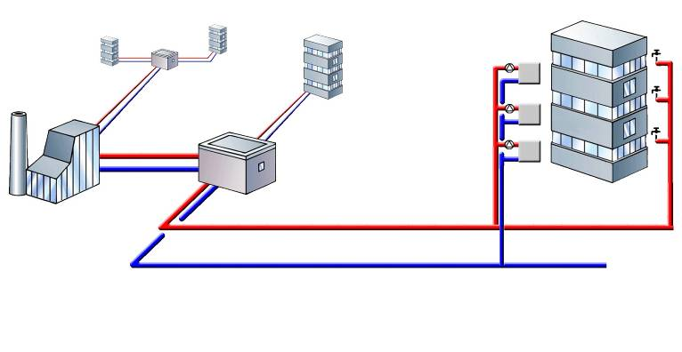
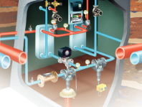
1
2
3
4

View of principal diagram of centralized district heating | Main elements
 | 1 | Central heating plant/central boiler
 | 2 | District heating network
 | 3 | Heat individual point
 | 4 | Internal heating system of building
Figure 8 - Diagram of centralized district heating system
Multi-family residential, public and commercial buildings are usually equipped with engineering systems which include heating, ventilation, and air conditioning (HVAC), and hot water supply. Regardless of the building purpose and size, all engineering systems should provide comfort conditions for occupants, safety, and reliability of supply whilst saving energy and reducing CO₂ emissions. The centralized heating system configuration is an intensive operating system; for instance, the load of heating and ventilation systems depend on the outdoor air temperature and heat release in the premises, as well as the work of the domestic hot water supply system.
The implementation of the district heating systems requires a complex automation system within the building heat supply systems, covering the heat points and heat consuming systems. In many countries, the centralized heat power supply system uses an automated control system, which is an obligatory measure in new buildings and for retrofits.

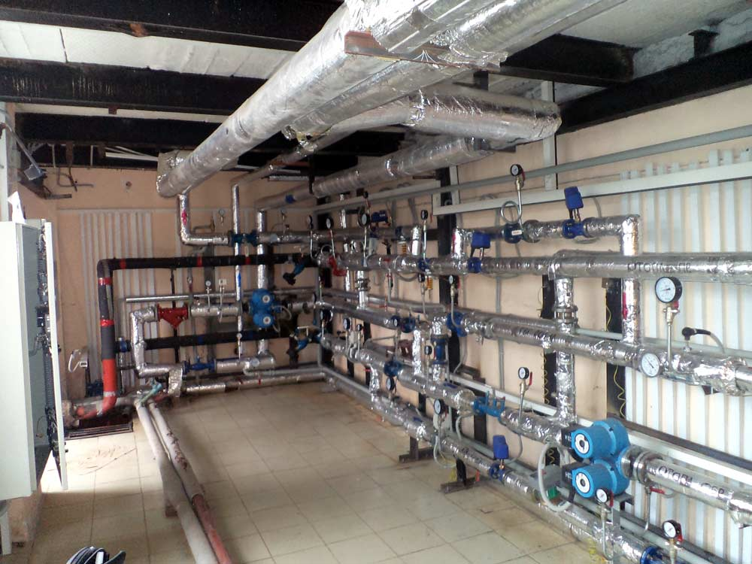 | 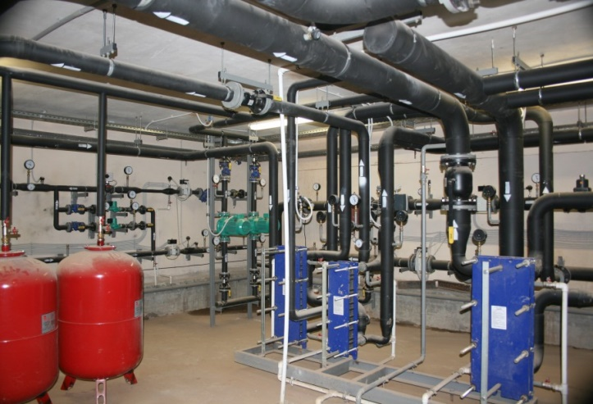
Figure 9 - View of individual automatic heat point with weather compensation control
The most significant energy saving impact from heat consumption systems can be achieved with the application of automatic heating individual point, which have the following basic functions:
- adjustment of the temperature of hot water supplied into the heating system, depending on the outdoor air temperature (weather compensation control);
- adjustment of the temperature of the hot water, which returns from the building’s internal heating system to the district heating network in line with the outdoor air temperature as per the set temperature schedule;
- accelerated warming-up of the building after energy saving mode (reduced heat consumption);
- correction of the heat consumption according to the indoor air temperature in the premises;
- hot water temperature constraint in the heating supply system pipelines;
- adjustment of the heat load in the hot water supply system;
- adjustment of the heat load by the ventilation units with the freezing protective function;
- adjustment of the heat consumption reduction within the set periods, in accordance with the outdoor air temperature; and
- adjustment of heat consumption, considering the orientation of the building and its ability to act as a heat sink.
In many countries, the hands-on experience in modernizing the heat points has proved the effectiveness of this measure

2.2.c System performance optimization measures
Insulation of pipes and equipment
Figure 10 shows the insulation of pipelines for both cold-and heat-power supply systems, which is a necessary measure in new constructions and building retrofits. Insulating pipelines by wrapping with insulation materials not only reduces the heat losses in the pipelines, but also provides the estimated heat carrier temperature at the same level. Insulated pipelines keep their temperatures better, leading to substantial energy savings.

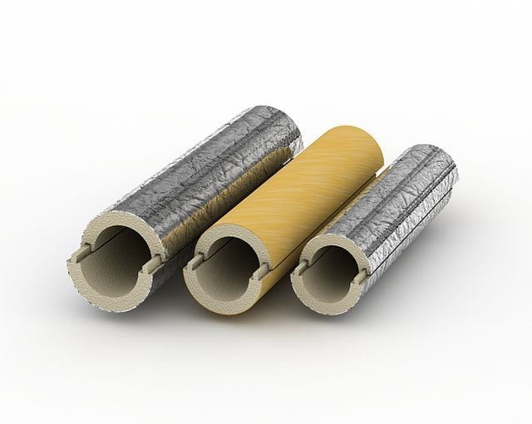 | 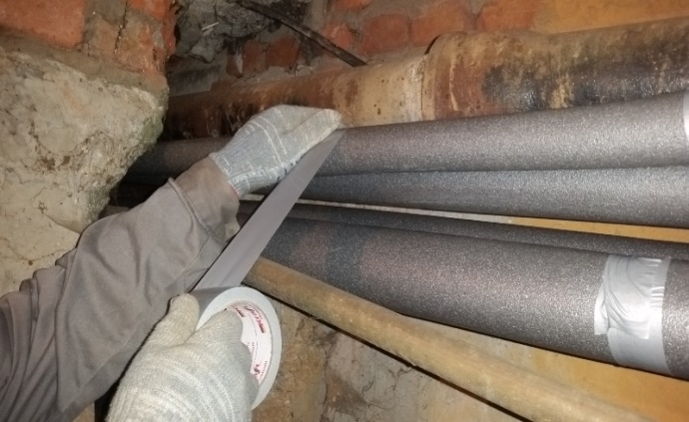
Figure 10 - View of pipe insulation and insulated distribution pipes of HVAC systems

There are several types of thermal insulation materials for pipelines available in the market. The application of thermal insulation for cold and heat power supply systems is an obligatory measure for new constructions and retrofits in many countries. In case of retrofits, the pipeline insulation should only be performed after pipelines are repaired and pressure-tested, which usually include the following activities:
• dismantling of any existing thermal insulation;
• cleaning of the pipeline surface;
• replacement of pipeline portions as necessary; and
• installation of the thermal insulation.
Installation of thermostatic regulators on radiators
Control of temperature in individual rooms is a fundamental for rational use of energy. In the common case of radiator heating, the significant heat saving can be achieved by installing the thermostatic valves on radiators. For other types of heat emission systems, such as floor heating or fan-coils in offices, the same logic applies.
. Thermostatic regulators consist of two parts: a valve and a thermostatic element, as shown in Figure 11.

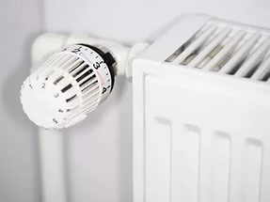 | 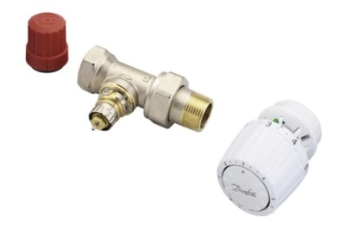
Figure 11 - View of thermostatic radiator control elements

Thermostatic valves are usually installed in the heating system before the radiator. These thermostats can be adjusted by the building occupants according to the desired indoor temperature. The key working element of a thermostat is the thermostatic element, which has a temperature-sensing element inside controlling, together with the valve, the water flow into the radiator.
By reducing/avoiding the excessive heat supply when the ambient temperature corresponds to occupants’ preferences, the thermostat prevents over-heating of the premises and maintains ambient comfort. By means of automated regulation of the air temperature, radiator thermostats allow, depending e.g. on user behavior, takes an energy savings to heating system of the building. In their absence, temperatures overshoot and occupants will remove excess heat by opening the windows.
Installation of thermostats on radiators is coupled with the replacement of outdated heating devices with higher energy efficient systems (higher thermal performance).
Installation of the balancing valves
Balancing valves are part of clearance pipe fittings, intended for the circulation of hydraulic balancing rings (risers, branches) of the cold and heat power supply systems. Optimization of system performance should be done for dynamically varying real life building operation conditions, providing stabilization of the dynamic regimes of its work. They can be seen in Figure 12.
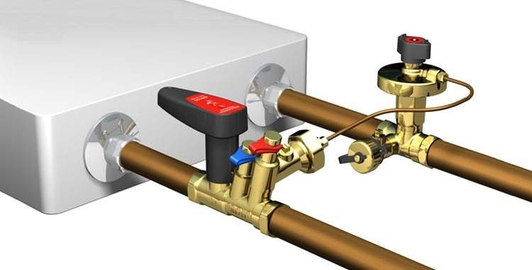 | 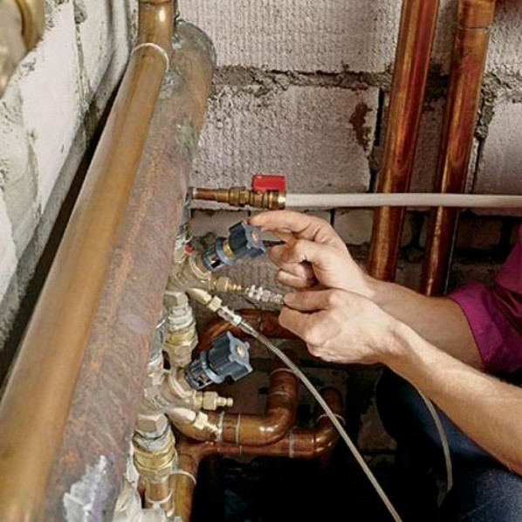
Figure 12- View of balancing valves for HVAC systems

The application of balancing valves, in particular dynamic balancing by differential pressure control, provides the following benefits for systems of cold and heat power supply:
- ensuring hydraulic stability and the optimal operational conditions of the system elements heat emitters and their controls, heat distribution system, heat generator;
- ensuring that the right amount of energy, at the right time, at the right place is available across the entire building – in particular dynamic balancing functionality;
- reduction of the noise level of the different elements operation, for instance radiator thermostats for heat supply system or regulating valves for the fan coils in the cold supply systems, by means of automatically maintained drop pressure at the same level;
- reduction of the noise level in pipelines and other elements by means of restricting the maximum heat carrier flow;
- stabilization of the heat, cold supply, and ventilation systems during periods of extended continuous operation by means of compensation which increases the resistance of hydraulic elements to corrosion and scum;
- simplification of the installation and maintenance of the systems by means of combining the functions of overlapping part, descent of the heat carrier and air, which gives the possibility of computer diagnosis of the heating and ventilation systems;
- possibility to divide the heat or cooling system of the building into temperature zones, i.e. into floor- or apartment-specific systems (one of the directions of energy saving);
- reduction of energy consumption by circulating pumps; and
- provision of an additional economic and hygiene benefit by preventing diversion of the heat carrier in the heating and ventilation systems.
The functionality of dynamic balancing is provided by automated balancing valves for risers or for each heat emitter. They are recommended to be installed with the default presets; where solutions for risers are chosen, they should be installed on each riser of the heating systems and only afterwards should their settings be tuned. The implementation of this measure should be done after the development of the design documentation, and after the heating system is flushed. By the reparation of heat and cold supply systems, it is reasonable to install balancing valves together with other measures. During installation of balancing valves, it is necessary to consider the commissioning works which should be performed by the specialized organization.
Energy Monitoring and Smart Metering System
Energy monitoring and smart metering system (EMSMS) is recommended to be guided by the essential requirements to the system of automated commercial energy resources accounting, regulation and control system. By type, the technical part of the EMSMS is divided into hardware and software components. The overall structure of the technical part can be represented as a three-level system. The lower (first) level of the system combines smart meters with digital telemetry and pulse outputs, pulse counting device, interface converters, transceivers, as well as all components of the infrastructure related to the construction of information communication channels with higher (second) level.
EMSMS includes three levels of components:
• Measuring components (smart meters) - control and measuring system which measures the parameters of resources consumption, forms and provides primary data (measurement results) on the quantity and quality of resources consumed, provides intermediate storage of all received (unmodified) information for each automation object (measurement, diagnosis, scheduling and other results), in accordance with the required periods of storage;
• Linking components - consist of devices intended for the reception of measuring data and signals of faulty measuring components and transferring them to be processed by the computing components.
• Computing components – a unified computer center for data processing, analysis, storage and distribution of information resources. At this level, the resulting data are generated based on the information obtained from measuring the components.

2.3 Air conditioning, Ventilation and Cooling

2.3a Application of Frequency converter Drives for the for electric motors of pumps and fans
Modern building engineering systems have a variable operating mode (ability to change parameters or characteristics during the operation of system), allowing for the reduction of design parameters of the fresh-air, heating, cooling, hot or cold water into building engineering systems. These parameters must be optimally set to maintain proper ambient climate conditions, and to more ensure efficient energy consumption. These changes are influenced by the fact that all of modern engineering systems have a dynamic mode of operation, which adjusts to account for constant changes of factors (outdoor climate conditions which influence the building, indoor heat gain from solar irradiation, equipment or people, occupancy changes, changes of the current level of energy, heat or cold-water consumption etc).
The use of frequency converter drives (FCD) for pump and fan electric motors of all engineering systems in buildings helps to optimize and adopt these systems’ operational parameters. As part of adapting the basic parameters of engineering systems, FCD reduce the spinning rate of electric motors, and hence reduce power consumption. This change is typically controlled by pressure, temperature, flow, and CO₂ sensors. FCD are very efficient and extensively applied in many countries. As an example, application of FCD for fans of outdoor condenser units of central cooling system can:
- reduce power consumed by compressors;
- significantly reduce energy consumption by fan electrical motors;
- increase fan resource;
- reduce noise; and
- support the floating condensing pressure function.
 | 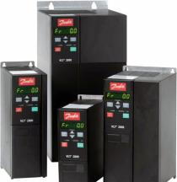
Example of circulation pump, with frequency converter | View of frequency converter
Figure 13 - Frequency converters

2.3.b Application of heat recovery for centralized mechanical inlet and outlet ventilation systems
Heat recovery is a process of extracting heat from air which is expelled from a building via outlet ventilation, and then injecting that heat back into the supply air coming in through inlet ventilation. This reduces energy consumption for space heating, due to the additional (intermediate) heating of air in the recuperator. A recuperator is a heat transfer device whereby cold air is heated by warmer exhaust. The heat transfer occurs across the plates of a heat exchanger, where the two volumes of air are not allowed to mix.
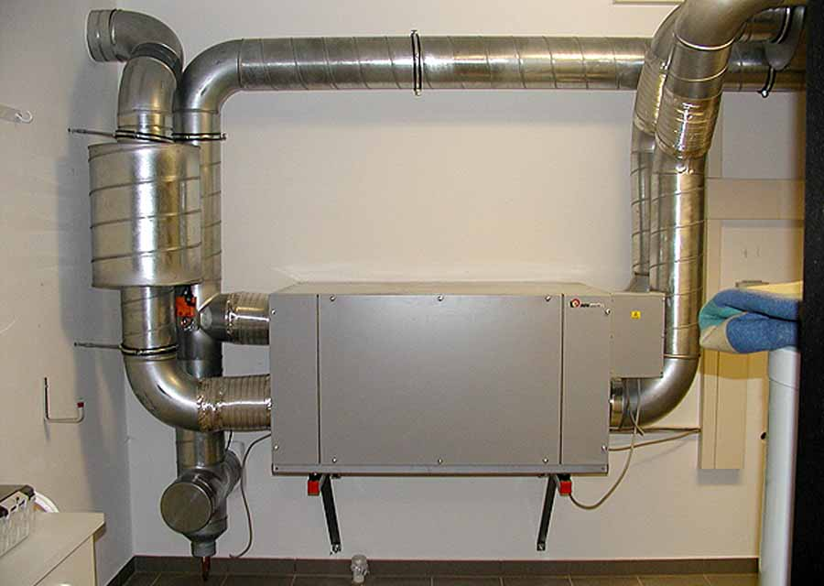 | 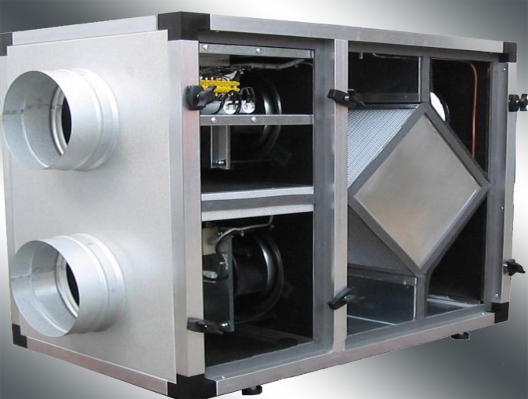
Figure 14 - Views of a heat recovery unit for mechanical inlet and outlet ventilation

2.3.c Application of cooling system with variable flow
Modern cooling systems with variable coolant consumption (ability of cooling system to change the cooling demand during the operation of system) are widely applied in public and governmental buildings, in which the operation of a centralized air conditioning system includes typical air handling units as well as fan coils and other appliances. The hydraulic system of a building cooling system is divided into the primary and secondary contour. The chiller (the cold energy source) is connected to the primary circuit, while the fan coils and air conditioning units are attached to the secondary contour. A group of circulation pumps and the shut off and balancing valves are also part of the hydraulic system. The traditional approach in design and operation of cooling systems is based on systems with a constant consumption of coolant. It means that the coolant is continuously supplied from the chiller through pipelines, which distribute it to the consuming devices. Such traditional approach is not efficient in terms of energy efficiency because it based on the constant consumption of electricity. The application of the new systems with a variable consumption of coolant allows to implement the technical solutions, aimed to reduce the amount of consumed cooling water depending on the needs of the end consumer. Therefore, the operational costs of coolant pumping significantly reduce in the system of cold supply with the subsequent possibility of change of the produced cold energy by the chiller. The use of circulation pumps with a variable consumption in a secondary hydraulic contour allows to decrease the energy consumption of pump groups.

2.4 Energy efficient appliances (EE labeling)
Application of energy efficient appliance labeling is one of the measures for reducing internal electrical consumption on the consumer level. Every type of building includes a large number of household or office equipment: copiers, printers, intercoms, kettles, refrigerators, freezers, washing machines, dishwashers, electric stoves etc. Home appliances consume a significant share of household electricity.
The use of household appliances with a A class of energy efficiency is an efficient way to reduce energy consumption, as well as contribute to the ecological footprint of buildings. In this regard electrical appliances can be certified according to the standards ISO 9001 and ISO 14001, which indicate that no hazardous substances harming nature have been used. The biggest part of large-size household appliances are obliged to be certified and properly labeled in accordance with the European energy efficiency class (from G to A+++). The class of energy efficiency should be reflected on a special label applied on the electrical appliance, such as that is shown in Figure 15.

Home appliances with higher classes of energy efficiency significantly consume less electricity. In fact, appliances with energy efficiency class A and more (the highest) can reduce energy consumption .Home appliances in many countries are now labeled.  Labels typically include the following information:  - Title, model, producer;  - Class of energy efficiency: color code with alphabetic reference (from А to G), which reflects the level of energy consumption;  - Level of energy consumption;  - Additional information regarding the type of the appliance, e.g. the internal volume of the refrigerator in liters, the maximum speed of rotation for washing machines etc.; and  - Noise level expressed in Decibels. |  | 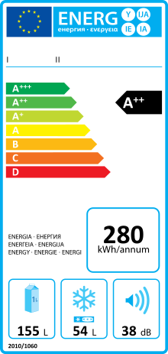
Figure 15 - Energy efficiency labeling

2.5 Modernization of existing lighting system of the building
Modernization of the existing lighting system in residential building is aimed at replacing incandescent lamps with energy efficient lamps or modules. Multifamily residential and municipal public buildings usually use either filament or fluorescent lamps and in some cases LEDs (see Figure 17). However, there are different opportunities to optimize the lighting systems for example, in the public areas (such as staircases, common laundries, cellars, attics, etc.) of buildings, e.g.:
- replacement outdated inefficient lamps;
- installation of lighting management systems with sensors; and
- accompanying actions.
Energy saving lamps can be characterized by their lower energy consumption and longer service life. At the same time these lamps do not require any additional operational cost or maintenance. Bulb replacement can be implemented both on the individual level (installation of the energy saving lighting appliances by inhabitants in their houses) and by the building owners (installation of energy saving lamps and modules in the public areas, such as stairs, entrance tambours, outdoor lighting systems).

There are many types of lighting appliances for internal building lighting systems with various ingress protection classes. The most efficient and at the same time simple and affordable solution is the replacement of the existing outdated lamps with the energy efficient ones. Nowadays the most widespread light-emitting diode (LED) or compact fluorescent lamp (CFL) lighting appliances, equipped with motion sensors. There are also different types of lighting appliances with built-in devices providing emergency lighting in case of a power outage.
Motion- and thermo-sensitive devices can detect the absence/presence of people and turn off/on the lights as appropriate. Ambient-light sensors can do the same, toggling lights in the presence or absence of sufficient ambient light. These kinds of controls can include automatic dimming as well as switch scheduling. The economic attractiveness of sensor-based lighting controls are building specific, depending on factors such as operational hours, occupant behavior, electricity prices, etc.
In order to enhance the energy efficiency benefit in buildings, it is reasonable to implement a lighting management system, which preferably automated or by installation of dimmers (reducing the lighting appliances luminescence). It is also possible to adjust the lighting system in accordance with the sunrise and sunset calendar.

In addition to providing better illumination, the following measures can also be implemented to improve the efficiency of energy consumption for building lighting:
- to maintain the purity of plafonds;
- not to curtain and not to block the front windows;
- to use pale wall colors (which better reflects the light); and
- to install the lighting modules on the ceiling only, but not on the walls, because this leads to the lighting losing its capacity.
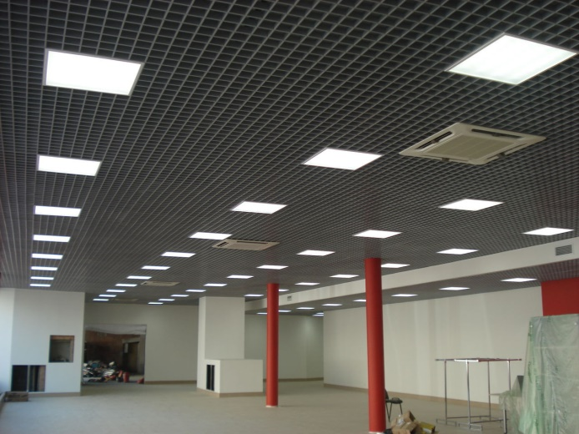 | 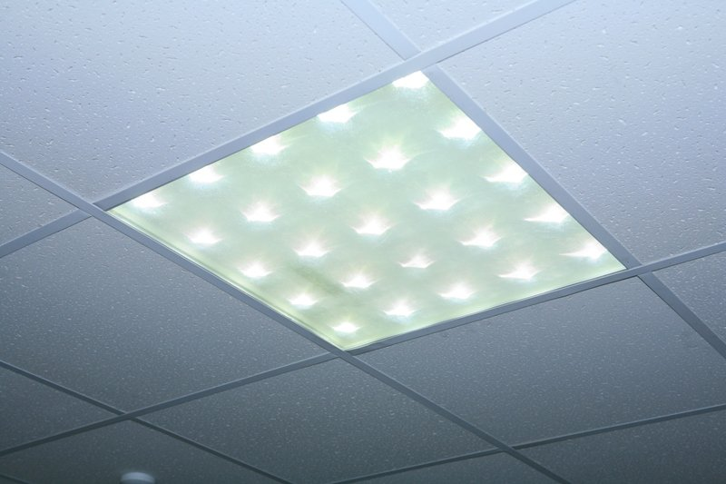
Figure 16 - View of new LED lamps

CHAPTER 3
Much progress has been made globally towards improving energy efficiency in the buildings sector, helped along primarily by three types of public policy tools: legal requirements (such as building standards), financial incentives (rebates, reduced-rate debt, tax deductions), and informational awareness programs. In the European Union the EU directives have played a vital role in promoting energy efficiency in the buildings sector, despite these efforts, energy efficiency in the building sector is improving only incrementally and in disjoint fragments.
In search of these gaps, data obtained from UNECE member States has been analyzed to identify instructive differences, lessons learned, and best practices in the buildings sector. The ultimate goal of this study is to understand and elucidate the current energy efficiency technology trends in the buildings sector in the UNECE region. This chapter documents the data analysis for the major classifications of energy efficiency technology.

Subregions A, B and D

Building envelope: insulation and glazing
Strict adherence to the EU directives of 30 May 2018 amending directive 2010/31/EU on energy performance of buildings and directive 2012/27/EU on promoting implementation of energy efficiency in buildings has significantly increased adaptation of energy efficiency technologies in the buildings sector. These directives have had far-reaching consequences, one of which is that most countries in subregions A and B are aggressively installing building insulation and windows with high energy efficiency ratings. In addition, energy performance certificates are generating real economic value for building owners. One study (CCC,2016) found that residences in the Netherlands with A, B, or C ratings generated a nearly 4% premium. In Ireland, A- and B-rated homes showed premiums of 9% and 5% over D-rated homes, respectively; the market assigned a discount of over 10% to homes with F and G ratings. Building owners are hence able to earn a profit on energy efficiency investments from both reduced energy consumption and increased economic rents.
The final major impact throughout the European Union is the requirement for new buildings to meet the NZEB standard. Nearly zero-energy buildings are designed to be highly efficient and use renewable sources to generate the low amounts of energy they consume. In subregion A, Belgium and Germany have taken the NZEB standard one step further and are implementing the Passivhaus standard for both new and existing buildings. This standard has more stringent requirements for space heating/cooling energy consumption, air tightness, and energy generation. The Passivhaus concept is being further extended by the Powerhouse Consortium in Norway, who is developing the Powerhouse design concept, in which a building is designed to be net positive for energy over its entire lifecycle – including construction and demolition.
In subregion B, almost all countries are achieving their building envelope energy efficiency targets for both retrofits and new construction, except for Bulgaria and Latvia; efforts are underway for both countries. Some countries, such as Romania, have implemented strong support measures by way of grants and tax incentives. Since 2010, thermal rehabilitation of residential buildings may be financed by bank loans that are guaranteed by the Romanian government (financing from state and local government and owners); this includes the building envelope and replacement of heating systems for low income households, along with effective audit practices. Still, renovation in existing buildings is lagging, apart from commercial buildings. Similarly, the data on Bulgaria and Cyprus show lower implementation of building envelope energy efficiency technologies for commercial and public buildings; Lithuania is relatively behind in implementing retrofitting measures for single-family residences. Other countries in subregion B, such as Croatia, Cyprus, Czech Republic, Estonia, Hungary, Malta, Poland, Romania, Slovakia, and Slovenia, have achieved a remarkably fast and strong penetration of NZEB within the existing national building stocks.
In the North American subregion D, both the United States and Canada have extensive building standards – at the federal, state, and local levels – which set minimum energy efficiency requirements for the building envelope. Many US states have codes regulating building renovations as well. An analysis of relevant building standards (PNNL,2016) in the US by Pacific Northwest National Laboratory suggested that residences and commercial buildings would save over $125B between 2012 and 2040, corresponding to 841 million tons of avoided CO₂ emissions. Similar in many ways to the NZEB standard in the European Union, the US Green Building Council introduced the LEED (Leadership in Energy and Environmental Design) building rating certification. LEED is now the most widely used green building rating system in the rest of the world; a LEED certification demonstrates that a building meets stringent energy consumption requirements.

Space heating, Air conditioning, Water heating and cooling
Figure 1 displays a visual representation of the mix of heating solutions for new construction for all countries in subregion A. For each country, the impact score has been averaged across all four building types (multi-family home, single-family home, commercial, public) for each type of technology. France has the most diverse mix of heating solutions in subregion A, followed by Spain and Ireland. Ireland is the only country in the region using coal in both new and existing buildings. With the exceptions of Greece, Italy, Luxembourg, and Portugal, all other countries in subregion A have shown improvements in developing centralized space heating solutions. Belgium, Finland, France, Ireland, Spain, and Switzerland have adopted various types of renewable energy for space heating (biomass, solar, and heat pumps). The UK, Norway, Italy, and Iceland have a higher market share in heat pumps and biomass-fired boilers. Germany is largely using solar energy in space heating. No evidence of substantial implementation of these technologies in Andorra was identified.
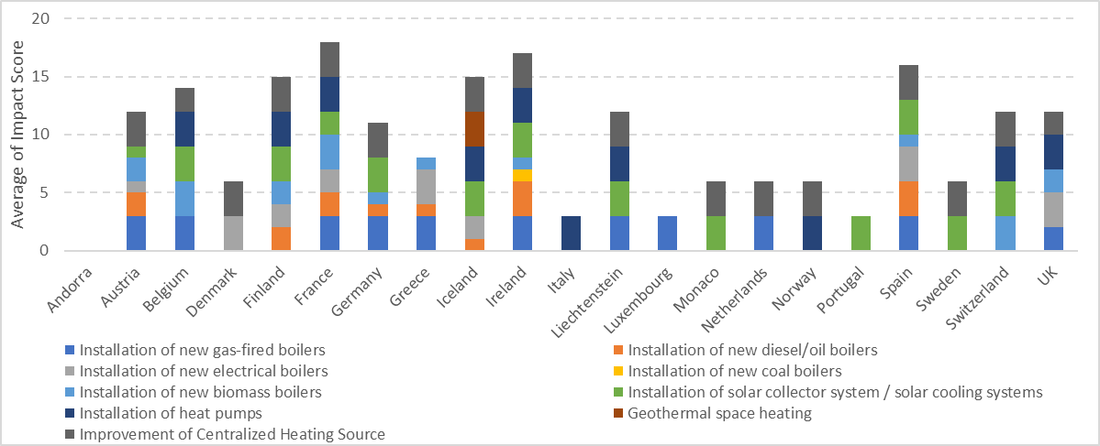
Figure 1 - New construction space heating technology mix in subregion A. Each bar in each stack represents the average impact score for that technology, across all building types, for that country.
The stacked bar chart in Figure 2 shows, visually, the mix of new construction heating solutions in subregion B. Slovenia is leading the adaptation of most energy efficient technologies in space heating, using biomass-fired boilers, solar, and heat pumps in its technology mix for new buildings and existing buildings – as are Cyprus, Malta, Poland, and Slovakia. Latvia and Hungary both have a large share of gas-fired boilers, though Hungary additionally supports adaptation of heat pumps for space heating.
Croatia and Malta have a diverse mix of space heating technologies and use diesel and oil boilers in new and existing buildings. The Czech Republic is the only country in the region to still have coal-fired boilers in new and existing buildings. Country data on Romania, Latvia, and Estonia show no market penetration of central heating systems in the buildings sector. Figure 2 summarizes this information in visual form for subregion B.
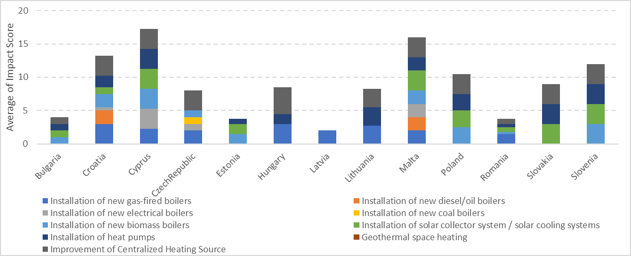
Figure 2 - New construction space heating technology mix in subregion B.
It is interesting to note that Canada in subregion D has the most diverse technologies used for space heating, including coal, with the lone exception that geo-thermal power is not used. Indeed, only Iceland in the UNECE region uses geo-thermal power for heating. The United States, on the other hand, tends to rely mostly on decentralized heating, and exhibits low adaptation of central heating systems.
After the building envelope, the second most productive area for improving energy efficiency in the buildings sector is the subsystems responsible for ventilation, space heating / cooling, and water heating / cooling. Acting to curb this energy demand and boost renewables and to reduce energy costs substantially and slash harmful carbon emissions, in 2016, the European Commission published its first plan (EC, 2016) to tackle the massive amount of energy used for heating and cooling in the buildings sector. A major strategy of the plan is to improve integration of the power grid with district heating and cooling systems, so utility-scale renewable power could replace fossil fuel generation for district heating / cooling.
There have been significant advances in the efficiency of space-conditioning equipment in recent years. A variety of fuels and technologies are used to heat residential buildings in the UNECE region. Natural gas is mainly used for heating, but the impressive gains in energy efficiency technologies in boilers, along with design improvements in vent dampers and HVAC systems, are encouraging increased diversity of technological solutions and contributing towards energy savings for residential and commercial buildings. Distribution systems and controls are frequently overlooked opportunities for improving the efficiency of space conditioning systems. For example, leaky air distribution ducts can result in significant energy losses, suggesting that greater attention to such simple parts is warranted. Existing building retrofits improve the efficiency of space heating systems already in place, and are usually limited to simple maintenance, such as replacing filters, oiling motors, and cleaning burners.
One strategy used in Sweden to improve the efficiency of space conditioning is to link district heating systems with industries. In some parts of Sweden (SSB, 2011), a significant proportion (up to 90%) of multi-family residential buildings rely upon district heating that uses waste heat from nearby industrial plants and waste incinerators. Not only does this reduce energy consumption for space heating, but it also reduces industrial waste heat. Finland is another useful example. It is one of the leading countries in the world in the utilization of combined heat-and-power generation. More than 30% of the country’s electricity is generated in connection with the production of district heat. Almost half of the population lives in residences warmed by district heating.

Appliances
Throughout the lifetime of a building, equipment such as appliances, lighting, and electronics is replaced and upgraded. Each time this occurs represents an opportunity to maximize efficiency improvements. Such upgrade opportunities are much more frequent than major retrofits — appliances are replaced several times over the life of a building; electronics and lighting even more often. Each replacement decision has less energy impact than a retrofit, but the aggregate impact is of nearly comparable importance. The primary tool used by policymakers to encourage improvement of energy efficiency in both household and office appliances has been through labeling, though some governments have implemented cash rebate programs. In the USA, the American Recovery and Reinvestment Act (DOE, 2015) has resulted in an unprecedented number of household appliances being replaced with energy efficient upgrades. Other countries with similar programs include Canada, Denmark, and Germany. EU member States are bound by the 2010 EU Energy Labeling Directive (2010/30/EU) and previously-mentioned Ecodesign Directive. These directives require many household appliances to meet minimum energy efficiency standards and to carry energy labels, categorizing the expected energy consumption (similar to the voluntary Energy Star program introduced by the US Environmental Protection Agency). However, obtaining the maximal impact of appliance labeling programs requires promotion on the part of EU member State governments; the case of Latvia is instructive of this point. Latvia, for example, has failed to realize the expected increased energy efficiency in appliances, as there has been insufficient promotion of labeled products.
A second issue with labeling is the stringency of the efficiency requirements – specifically when minimum requirements are equal, or very close, to the market averages. More stringent regulations that drive technological innovation are needed to induce market changes and improve energy efficiency. Overall, the low-hanging fruits of improved energy efficiency in appliances has probably already been picked; large appliances - such as refrigerators, freezers, and washers - are substantially more efficient than their 1990’s counterparts. Building lighting, however still has much to offer in the way of increased energy efficiency.

Lighting
The energy efficiency of building lighting can be improved by the application of three main types of technological solutions:
- application of daylighting architectural solutions
- installation of interior & exterior lighting sensors and controls
- installation of newer light bulbs (CF & LED)
Policymakers predominantly use legal constraints, such as building codes and technological standards, and informational programs to drive improvements in lighting energy efficiency. Many countries have phased out inefficient lighting technologies by tightening efficiency standards. Building codes also place requirements on lighting fixtures and control systems to encourage efficiency. While enhanced standards have a big effect, they mostly impact new construction (and buildings undergoing deep retrofits, to a lesser degree). For example, daylighting architectural solutions, which involve designing a building to make maximal use of sunlight for internal lighting, can obviously mostly be applied to new construction. Policymakers from Finland, Denmark, Monaco, and Norway (subregion A) have been effective in encouraging the use of this technology in both new and existing buildings. It is moderately prevalent in Austria, but only for public buildings. In subregion B, only Estonia and Cyprus make much use of daylighting, with Estonia also focusing on public and commercial buildings. In addition to reducing energy consumption, there are documented social benefits to using natural lighting.
Lighting sensors and controls are technologies that can have a tremendous impact on energy consumption for lighting – both interior and exterior - by ensuring that lights are only used when required. Motion- and thermo-sensitive devices can detect the absence/presence of people and turn off/on the lights as appropriate. Ambient-light sensors can do the same, toggling lights in the presence or absence of sufficient ambient light. These kinds of controls can include automatic dimming as well as switch scheduling. The economic attractiveness of sensor-based lighting controls are building specific, depending on factors such as operational hours, occupant behavior, electricity prices, etc. It is nearly inconceivable, except perhaps in degenerate cases, that the appropriate application of lighting sensors and control technology could not reduce energy consumption and pay for itself.
Furthermore, sensor-based control technologies are predominantly used in public and commercial buildings. Despite the disproportionately large impact on reducing building energy consumption, sensor-based lighting controls are not widely used. Only Cyprus and Estonia, in subregion B, make moderate-to-heavy use of the technology. The technology is significantly prevalent in less than half of the subregion A countries. Hence, it is clear that public policy and awareness campaigns are necessary to encourage adoption. In 2013, energy saving initiative undertaken by then the Environment Minister, Delphine Batho for all non-residential buildings in France must turn off the lights at night to reduce both light pollution and energy consumption. Indoor lighting which can be seen outside must be switched off at 1 AM or one hour after closing time (whichever is earlier) and can only be switched-on after 7 AM or one hour before opening (whichever is earlier). Outdoor lighting of building facades (shops, monuments, schools, city halls etc.) can only be on between sunset and 1 AM. Needless to say, sensor-based automated control systems are implemented in buildings to meet these lighting regulations.
The simplest, furthest reaching, and most prevalent technology for decreasing lighting energy consumption is energy efficient light bulbs. Compact fluorescent (CF) bulbs and light-emitting diodes (LED) are far superior to both incandescent and halogen bulbs. New energy efficient light bulbs can be used in both new and existing buildings, residences, public buildings, and commercial buildings.
The United States began phasing out incandescent bulbs in 2007, and the Canadian government began banning them in 2014. The European Union voted in 2009 to ban them, with the ban taking full effect September of 2018. In the EU, the incandescent ban is expected to reduce annual energy consumption by 9.4 TWh - equivalent to Portugal’s electricity consumption over 5 years. These savings correspond to a reduction of 3.4 million tonnes of CO₂ emissions every year, as well as a significant reduction in waste. However, simply banning incandescent bulbs is not enough, as has been seen by some of the earliest adopters.
The UN member States which implemented relevant policy earliest – such as Denmark and the United Kingdom – have seen sharp reductions in sales of incandescent bulbs, as expected. However, much of this market share has inadvertently been shifted to halogen bulbs. Halogen bulbs are only slightly more efficient, so the full potential energy savings that could be achieved through switching to CF bulbs or LEDs has not been realized; there is little sign of LEDs having significantly penetrated the domestic lighting markets yet.
In subregion A, most countries are relying solely on energy-efficient lamp replacements to drive reductions in energy consumption for lighting – countries like Germany, Spain, and Switzerland. A few countries are much more diversified, investing in efforts to use all three types of technological solutions. Denmark, Monaco, and Norway exemplify this strategy of diversification. In subregion B, Estonia is diversifying efforts for new construction, with Cyprus focusing on retrofits.

Smart systems and solutions
There are several types of energy efficient technologies that have the potential to impact multiple building subsystems. A good example of technology that enables increased energy efficiency in several different building subsystems is smart metering and smart building systems. In fact, one of the primary objectives of EU energy efficiency directives is to encourage the use of information and communication technology and smart technologies to ensure buildings operate efficiently. The governments of Denmark, Italy, Switzerland, and the United Kingdom in subregion A, and Estonia, Lithuania, and Malta in subregion B have implemented energy efficiency policies promoting the application of such smart systems. In fact, nearly 100% of buildings in Finland, Italy and Sweden are already equipped with smart meters
The UK Government, for example, is committed to ensure that every home and small business in the country is offered a smart meter by the end of 2020. Their Smart Metering Programme (DBEIS, 2018) aims to roll-out over 50 million smart meters (gas and electricity) to all domestic properties and smart / advanced meters to smaller non-domestic sites in Great Britain - impacting approximately 30 million premises. The Smart Metering Programme is currently in the main installation phase, and there are now over 11 million smart and advanced meters operating across British homes and businesses.
In the United States, cloud-based energy management and control systems are extensively used as they obviate the need for on-site staff with expertise in maintaining the building energy systems. Using a third-party firm to monitor the building, for instance checking HVAC equipment or setting lighting schedules, can be a cost-effective way to reduce energy consumption. However, for a multi-tenant office building, split incentives may discourage a building owner from purchasing a cloud-based control system when tenants are responsible for their energy consumption. However, for office buildings in which the owner is responsible for paying the energy bill and maintaining the building’s primary energy consuming systems, there is more economic incentive to invest in such technology. This suggests that the highest barrier in implementing smart metering and control systems technologies in buildings is the requisite capital expenditure - which most countries believe is the key issue.

Subregions C, E and F

Building envelope: insulation and glazing
Countries of subregion C has common situation with post-Soviet type of building construction. Existing housing and public buildings stock have sufficient potential for energy efficient improvements of insulation and glazing, as it was designed and constructed 30-40 years ago in average. Policies and norms of 70-s and 80-s were much strict in terms of materials quality and margin of safety, with less emphasis on increased efficiency of insulation and glazing, because of limited abilities of materials of that time. This situation resulted in stronger demand for activities, that should be focused on mandatory regulated improvement of insulation during retrofits of all categories of buildings. Figures presented in current research shows that most of the countries in subregion C implemented updated regulatory normative, with higher requirements for insulation and glazing. In most cases it resulted in modification of procurement procedures including some mandatory requirements for implementation of modern-type insulation materials and gazing.
There is a common approach along almost all countries of subregion С, to include “typical” EE measures, including modern insulation and glazing, for retrofits and new construction for multi-family residential and public buildings. This requirement reflected in country specific Law on Energy Efficiency (or equivalent). In most cases proper insulation and glazing considered to be a measure with long-term payback period, especially taking into account lower energy prices in subregion C, compared to others regions of the study. Despite this fact countries have strong technical understanding of critical role of proper insulation and glazing, for sustainable functioning of all internal and external building engineering systems. This situation is resolved differently for various buildings types. For multi-family residential and public buildings there are stimulation mechanisms initiated from the governmental side to illuminate this financial gap (subsidized loans, tax incentives, specialized EE funds, having insulation and glazing as a priority and others). Usually public buildings financed from the state/regional or municipal budgets have a special internal policy or normative, which includes mandatory implementation of EE insulation and glazing fro both new construction and retrofits. In Kazakhstan, Armenia, Ukraine, Russian Federation and other countries in subregion C same as in subregion E and F, there are pre-defined values of annual levels of insulation and glazing level increase for public and multi-family residential buildings, included in budget financing of relevant Department (or Municipality).
Private sector buildings also have less specified mandatory requirements for insulation and glazing, prescribed by various regulations and normative across all countries of subregions C, E and F. In most cases it a market driven process supported by desire of business owners. In 2018 for all three subregions it is obvious to have this issue properly fixed in order to cut energy and financial losses. Sure, this statement is more relevant for companies of medium and big-size, but there is strong trend of developing of this idea in small size individual companies. Especially it is relevant for countries of subregion E with higher energy prices and countries of subregions C and F with cold climate.
Single family residences still have lower level of EE insulation and glazing implementation but starting from 2012 there was a shift in common understanding of savings potential by individual home owners and by 2018 we can see number of specialised solutions for this type of users. Specialised micro-finance tools were developed and implemented by Asian Credit Fund in Kazakhstan and Kirgizstan, to support citizens of rural areas to improve quality of their houses. In Uzbekistan there is governmentally supported program for mew construction of standardized individual houses, with a strongly subsidized price and mortgage schemes. Same approach used in Armenia.

Space heating, Air conditioning, Water heating and cooling
Modern technologies in space heating / domestic hot water / cold water supply show varying levels of implementation across countries in subregion C, E and F for each technology, due to broad energy and fuel mix used in different countries. Some countries like Kazakhstan are still actively increasing use of coal and other fossil fuels due to certain economic growth and this trend supposed to be there for coming years. Countries of subregion E and F (Serbia, Albania, Montenegro, less in Turkey) are facing another problem of required decrease of external fuel resources consumption in order to become more sustainable and self-sufficient. Sometimes this projects, especially renewables and bio-mass ones, are not fully financially attractive and have operations scheme subsidised by Government or International Donors.

Improvement of decentralized heating source
Subregion C includes several coal manufacturing and coal consuming countries, where decentralised heat supply and power generation are predominantly based on coal. Modern energy effective coal-burning technologies are in mid or low levels of use. Starting form 2016 there was matched strong ground interest among coal consuming countries for new EE technologies of coal burning. Pilot implementation of highly efficient boilers and pyrolysis type turbine energy generators in Russian federation and Kazakhstan shows high technical and financial potential for cleaner energy generation.
Implementation of biomass-fired boilers is still in a development stage for most countries of subregion, with slightly better implementation in countries with limited local energy resources, such as Ukraine and Moldova form subregion C, Serbia, Bosnia and Herzegovina and other sub-region E countries.
Installation of new gas-fired boilers are mandatory in Turkmenistan and Uzbekistan for all building’s categories. Other countries show better implementation levels for building retrofits and new construction of multi-family and public buildings, with lower levels of implementation for other building types. It is fair to conclude availability and pretty good level of penetration of modern gas fired heat and energy generators produced by modern worldwide companies across countries of subregions C, E and F. The limitation barrier is level of professionalism and competence of a specific maintenance specialist on place and real stock availability of spare parts in case of repair is needed. Commercial buildings in most of countries of subregions C, E and F have a strong attitude to use modern EE generation equipment used in shopping malls, hotels, office buildings.
Nevertheless, there are countries, which have adopted advanced mandatory requirements for implementation of heat pumps (Albania and Ukraine), and solar collector hot water systems (Uzbekistan and Kirgizstan).
More than half of the countries use electrical boilers across various building types of subregions C, E and F. In most cases, because of lack of other fuel sources available for heating and domestic hot water preparation. In this region there were no identified countries with governmentally supported mandatory requirements for installation of EE electrical boilers. This is a serious gap that should eliminated in nearest future, due to absence, most cases, of reasonable rapid alternative switch of the fuel.

Improvement of centralized heating system
Subregions C, E and F have a long-term history of traditional implementation centralised heat supply system, as a most sustainable model of urban development process. Systems that are currently in operation in countries of subregion C were principally designed and constructed in since 1960-s – 1970s, and currently are they became a subject of a huge renovation campaign powered by number of country level policies and regulations and well as regional specific incentives and financial tools. Improvement of centralized heating system is a highly important issue for most of the big cities in countries of sub-region C and E.
Analysis shows most popular technical solution used in each country of the subregion C, E and F, is installation of individual heat points with weather compensation control.
There are some countries, such as the Russian Federation, Kazakhstan, Turkey, and Ukraine with mandatory requirements for implementation of this measure for retrofits and new construction of all types of buildings except single-family buildings. Other countries with existing centralised district hot water supply systems are in the process of adoption or implementation of this technology. Others which don't have such a case are not focused on support of this activity are Albania, Bosnia and Herzegovina, Macedonia, Montenegro, Belarus, and Uzbekistan.
Common measures are widely implemented across all countries of subregion C, E and F. Insulation of pipes and other equipment solutions are mandatory in Ukraine, Moldova, Turkmenistan, and Belarus. Despite the importance of pipe insulation, several countries have very low levels of implementation: Kyrgyzstan, Armenia, Turkey, Georgia, Montenegro, and Serbia.
Some countries of subregions C, E and F (the Russian Federation, Turkey, Moldova, Ukraine, Turkmenistan, Belarus) have already put installation of balancing valves, thermostats, efficient pumps, heat exchangers, and other relevant engineering equipment into the mandatory country policies and design norms. There was no specific reason identified for the observed varying levels of implementation for such comprehensive measures, but additional support is required for countries with a low level of implementation.
Other technologies from the list of common measures, e.g. EE water pumps, water supply sensors, and waste water heat recuperation, are still implemented at low levels for most countries in subregions C, E, and F; exceptions are the Russian Federation, Belarus, Kyrgyzstan, Uzbekistan, and Turkey.

Ventilation, Air conditioning and Cooling
Research for this study identified a trend across most of the countries to focus heavily on ventilation and air conditioning for most building types. From a technical point of view, there are some limitations in VAC equipment installation and modernisation during retrofitting residences. Implementation is higher, however, for retrofitting other building types, and for new construction.
Installation of air recuperation units and modern FCD solutions for fans and pumps are common for installation in new constructing of commercial and public buildings. This trend could be seen in Ukraine, Moldova, and the Russian Federation, for which countries these technologies are mandatory, and show high implementation levels.
Implementation of variable flow cooling systems across countries in subregion C is a relatively new trend which shows high potential for increased energy efficiency in the buildings sector. The technology is mostly used in retrofits and new construction of commercial and public buildings in Turkey, Georgia, Moldova, and Montenegro. Variable flow cooling systems are implemented less frequently in multi-family residences in all countries.
High efficiency factor VAC equipment is more thoroughly implemented across subregions C and E and F. Implementation of modern absorption-type cooling units and effective individual air conditioners is supported by a number of international and national stakeholders operating in countries of the subregions C, E and F For the Russian Federation, Uzbekistan, Turkey, and Ukraine, the technology is either mandatory or currently at a high level of implementation for both retrofits and new construction of building types except commercial buildings. For the remaining countries of subregion C, implementation of energy efficient VAC equipment is still in the development stage.
Insulation of distribution pipes for cooling networks is widely implemented in almost half of the subregion C and F countries (Turkey, Uzbekistan, the Russian Federation, Azerbaijan, Moldova, Ukraine, and Belarus). Support of this measure has increased during the last 5-6 years as the cooling equipment market has evolved, with the active presence of suppliers of modern energy efficiency solutions. In order to ensure proper functioning of new equipment, more attention has been focused on increased quality of insulation.

Appliances
Promotion and implementation of EE appliances is a relatively new trend for countries of subregion C. Several research studies and building energy load profile analyses have demonstrated that implementation of modern EE appliances (domestic and especially commercial) could bring big energy savings to the overall energy consumption pattern of a typical building. Number of countries have promoted implementation of EE appliances with support of international donors and various national support programs, which covered both public- and private-sector representatives.
Across subregion C there is certain level of understanding from end-users’ side and existing market demand for highly efficient domestic appliances for multifamily residential, and single-family buildings. Major number of appliances suppliers in the regions tries their best to take out a marketing advantage on better promotion of more EE equipment rather than really focus on reduced energy consumption. For public and commercial buildings implementation of modern efficient equipment became a common norm since last 5-6 years. Most of the subregion C, E and F countries adjusted their public procurement procedures for both new construction and retrofit process, with strong requirement to purchase only high efficiency class equipotent.
Countries of subregions E and F are following general European approach to mandatory implementation of EE appliances for all building types. Only a few countries, such as Turkmenistan (in subregion C) and Bosnia and Herzegovina (in subregion E), still have not made EE appliance implementation mandatory, but are making progress.

Lighting
A big worldwide trend of modern EE lights system implementation in full scale reflected across all countries of subregion C, E and F. Implementation of EE lighting systems has been strongly promoted. The national governments together with various international donors have provided massive support for improving capacity of local producers, with a focus on developing, in most cases, modern LED technologies.
This study identified no cases of mandatory implementation of LED lamps on the policy level in subregions C, E and F; nevertheless, there is certainly a high trend of installation for all countries there. The highest levels of penetration are for capital repairs and new construction of all building types except single-family residences. In addition, there are some countries focused on further promotion of occupancy / daylight sensors, exterior lightt control, and “day light” architectural solutions. Now, almost all countries still have low levels of implementation of these technologies.

Smart systems and solutions
Main objective of smart solution measure and metering systems, in terms of implementation of EE technologies on buildings, implementation is to really track and verify achieved level of energy saving and/or changes of the building load profile. Without established metering and officially approved controlling methodology it is hard to conduct fair estimation of achieved energy savings and conduct a forecast on estimated EE potential in future.
One of the biggest gaps in terms of implementation of smart meters in countries of subregions C, E and F is lack of legislative acts, which are focused on regulation of analytical methodologies for analysis of EE results and potential. It means, that just massive implementation of smart data collection system would be helpless without a unified analytical methodology, accepted on a relevant Ministerial level.
This type of administrative and analytical approached shows good results in Serbia and Bosnia and Herzegovina (subregion E), Ukraine, Kazakhstan, Armenia, the Russian Federation (subregion C) and Turkey (subregion F). Governmentally supported implementation of municipal level energy management systems, in these countries, both for multi-apartment residential and public buildings resulted in strong quality increase of energy action plans for municipalities, which implemented such an approach.
In 2015 Serbia started national level energy management program with massive connection of public buildings to centralized database, served specifically for municipalities and country level budget financing planning and energy consumption forecast. This experience is now being transferred across subregion E to Bosnia and Herzegovina, Albania. In subregion C the Russian Federation and Kazakhstan are among the leaders in energy management smart systems implementation. Since 2012 Russian Energy Agency operates State Energy Information System, which incorporates all energy consumption data from multi-apartment, commercial and public buildings. Originally it was developed for manual data input, but during last 2-3 years it is significantly improving towards digitalization and smart data collection od energy data.
In 2012 Kazakhstan, first country in non-European region, inserted a strict mandatory requirement for nomination of a responsible municipal level energy managers with relevant smart data collection system implementation for objects with annual consumption more than 1500 tons of fuel equivalent. This system was well functioning till 2016, when this mandatory energy managers presence requirement was excluded from the Law and position stopped to be financed by state budget.

CONCLUSIONS
Across all countries in the United Nations Economic Commission for Europe region, buildings account for approximately one third of energy consumption, and 40 percent of CO₂ emissions. The buildings sector thus presents a unique opportunity to substantially improve energy efficiency. Throughout the UNECE subregions analysed, overall positive trends in energy efficiency in the buildings sector can be observed in the gathered data. Three types of public policy tools have driven these improvements: legal requirements (such as building standards), financial incentives (rebates, reduced-rate debt, tax deductions), and information awareness programmes. For example, the European Union’s Ecodesign Directive (2009/125/EC) created a framework by which energy consumption requirements could be set for appliances. In the United States of America, the Internal Revenue Service allows certain types of energy efficiency investments to partially offset federal income tax liabilities; some state governments have similar tax reduction programs. The Canadian government’s online directory of energy efficiency informational and awareness programs lists dozens of entries.
In addition to the myriad environmental benefits associated with decreased energy consumption and increased generation of renewable electricity, many of the technologies discussed in this report bestow social benefits not related to energy (health, quality of life, monetary, etc.). This was seen during research and data analysis, and has factored heavily into the recommendations. Despite the many efforts and concerted focus, energy efficiency in the building sector is improving only incrementally and in disjoint fragments.
This is particularly surprising, given that recent advances in technology design have yielded remarkable advancements in efficiency and this trend is expected to continue. Even the global trend towards digitalization and smart technologies has a positive impact on energy efficiency. Improved technologies are commercially available yet are inconsistently used – despite generally attractive payback periods. The substantial gaps between what is available on the market and what is used makes it clear that political will to effectively drive adaptation, rather than just technical advancement, is key to increasing energy efficiency. Analysis of the data demonstrates this for several types of technologies.
Consider building space conditioning as the largest source of fuel consumption in EU countries, the initiatives taken in subregions A, B, and D are witnessing a paradigm shift in adoption of technologies for heating and cooling. The analysis of EU countries shows increased adoption of high energy efficiency boilers, along with shifts to cleaner fuel sources. The trend is predominantly moving towards efficient gas-fired boilers, electric boilers, solar collector systems, and heat pumps. This is likely due to the market reacting to relevant EU directives. There are several countries in the UNECE region in which coal is still prevalent as a decentralized building heating fuel. Since coal is cheaply and easily available in these countries, modern energy efficient coal-fired boilers are being adopted in both new construction and building retrofits. While energy efficiency is improved, strong concerns remain regarding the health risks of using coal for residential space heating.
The efficiency of residential space heating has improved at a rate of more than 2% annually in the EU zone since 2000. This is primarily due to construction of more energy efficient buildings with better heating systems, as well as renovations of existing buildings. Since 2000, the energy consumed by residential space heating in the EU has decreased, as a percentage of total household consumption, by at least 4%. There is an associated socioeconomic benefit to this progress as well. European companies have developed and produced more than 90% of the efficient and renewable boilers used in the EU.
Energy efficiency advances have also been made in appliances. With the implementation of labelling and eco-design regulations, the uptake for energy efficient appliances is on an upward trend. Appliances, while small, can have a disproportionate impact on improving energy efficiency, because they are generally replaced many times throughout a building’s lifetime – more frequently than major retrofits are performed. While energy efficient appliances may be associated with positive energy rebound, this may be offset by social benefits including improved quality of life and higher living standards. Experience has shown, though, that effective promotion and awareness campaigns are essential to encourage consumers to purchase appliances labelled with high energy efficiency ratings.
One of the EU Member States, for example, has failed to realize the expected increased energy efficiency in appliances, as there has been insufficient promotion of labelled products. In addition, some appliance labelling schemes have minimum requirements which are equal, or very close, to the market averages. More stringent regulations would improve the efficiency gains while driving technical innovations needed to induce market changes.
Progress has been made in increasing energy efficiency in building lighting. Most countries in the UNECE region are phasing out, or have banned, incandescent light bulbs in favour of compact fluorescent and light-emitting diode technologies. Energy efficient light fixtures can be used in all types of buildings, and for both new and existing buildings. In addition to increased energy efficiency, better lighting brings several social benefits, such as decreased waste. However, care must be taken to ensure incandescent bulbs are not replaced with halogen bulbs, which are less efficient than both CFL and LED solutions. Sensor-based control technologies for lighting are predominantly used in public and commercial buildings. These technologies can be installed in new buildings as well as retrofit into existing buildings. Despite the disproportionately large impact on reducing building energy consumption, sensor-based lighting controls are not widely used. Only two countries in subregion B, for example, make moderate or better use of these technologies. Hence, it is clear that public policy and awareness campaigns are necessary to encourage adoption. In subregion A, a French regulation requires the use of sensor-based lighting controls to turn off lights in non-residential buildings at night. This regulation applies to both exterior and interior lighting (if externally visible). In addition to reducing energy consumption, this regulation reduces light pollution.
A good example of technology that enables increased energy efficiency in buildings is smart meters. In addition to facilitating decreased energy consumption, the use of smart metering systems for electricity consumption can bring a variety of social benefits. Among these, they allow: more accurate consumption monitoring, enhanced consumer awareness, and flexible socially-responsible pricing. These benefits can be even further compounded if the smart metering system is integrated throughout the building, so individual circuits are metered. Yet, smart meters are only being extensively used in a few UNECE countries. In some locations where they are installed in residences, consumers have responded negatively. In addition, there is currently no international standard for smart meter technology, limiting interoperability.
While not a technical solution per se, energy performance certificates are also helping drive increased energy efficiency while bestowing economic benefits. Buildings throughout the European Union can be rated and certified for their efficient use of energy. LEED, based in the United States, is quite similar. In several EU countries, EPCs have been documented to generate real economic value for building owners. Residences with higher ratings tend to earn substantially higher premiums. Building owners are hence able to earn a profit on energy efficiency investments from both reduced energy consumption and increased economic rents.

RECOMMENDATIONS

Role of public and private sector
Government plays a central role in supporting economic growth. It needs to provide good policy, strong institutions, and efficient public services to ensure the private sector can thrive. Governments must also commit to develop and sustain the institutions that implement, oversee, and regulate those policies. This is the enabling environment that encourages the private sector to invest. The private sector is critical to economic growth, but it cannot and does not act alone, a balanced strategy is required; for example, the “Technology push and Market pull strategy”.
Governmental research and development programs should be designed to advance technologies which are too risky for the private sector. This will require transparent collaboration between government, industry, and energy program administration. Some of these innovations will eventually mature to a point that the private sector can develop them into marketable products. This strategy has been successfully implemented for several decades by NASA and DARPA in the United States.
New market opportunities
Some countries, such as Andorra, Germany, Norway, and the USA, have undertaken initiatives locally to raise the bar for developing energy efficient technologies in buildings. Examples include occupancy sensors and the Passivhaus and Powerhouse standards, discussed earlier in this report. These technological developments boost economic growth, develop a local competitive market, increase employment, promote implementation of cheaper and accessible energy efficient technologies, and can develop international markets. To demonstrate this final point: new technologies, such as fuel cell cogeneration and geothermal heating / cooling, are being developed by European companies. They have no competitors for their innovations, and have found international markets including China, South Korea, and the middle east.

Connecting building energy efficiency with INDC targets
Increasing energy efficiency in the buildings sector will result in a clear reduction in CO₂ emissions from electricity generation, which is related to the Intended Nationally Determined Contributions (NDC) as part of the UNFCCC negotiations. Countries can simultaneously promote energy efficiency in the buildings sector and progress toward climate change reduction goals by connecting building energy efficiency measures with INDC targets.
Synergistic integration with other sectors
The European Commission plan to tackle the massive amount of energy used for heating and cooling in the buildings sector included a strategy to improve integration of the power grid with district heating and cooling systems. The focus of this strategy is for utility-scale renewable power to replace fossil fuel generation for district heating / cooling, hence reducing CO₂ emissions. For countries that have substantial exothermic (coal, nuclear) baseload electricity generation capacity, this plan could be extended to further integrate the systems to use the baseload generation waste heat for district heating / cooling.
As mentioned in Chapter 3, a significant proportion of multi-family residences in some parts of Sweden rely upon district heating that uses waste heat from nearby industrial plants and waste incinerators. Not only does this reduce energy consumption for space heating, but it also reduces industrial waste heat. Governments and industry in other countries should aggressively pursue this as a means of increasing energy efficiency in the buildings sector.

Technological adaptation
Building simulation software tools can effectively assess the performance of energy efficiency technology from a holistic, performance-based criteria perspective. Such systems can even use localized climate data, utility tariffs, and fuel costs. The information generated by using such models could produce dynamic energy production and consumption simulations to find the optimal energy efficiency solution for each property.
The use of smart metering systems for electricity consumption can bring a variety of social benefits. Among these, they allow: more accurate consumption monitoring, enhanced consumer awareness, and flexible socially-responsible pricing. These benefits can be even further compounded if the smart metering system is integrated throughout the building, so individual circuits are metered. Yet, smart meters are only being extensively used in a few UNECE countries. In some locations where they are installed in residences, consumers have responded negatively. In addition, there is currently no international standard for smart meter technology, limiting interoperability. Smart meter technology should be standardized internationally, governments should update building codes and regulations to mandate installation of smart metering systems, and social awareness campaigns promoting the social benefits of smart meters need to be undertaken.

Policy and legislation
The UNECE region countries should consider going beyond the EU directives and promote energy efficiency policies that are more locally-nuanced. Energy efficiency policies should be made while considering the local perspectives and challenges.

Investment and finance
Substantial financial barriers to households taking advantage of energy efficiency opportunities remain. To help overcome the complexity of investments and lack of capacity at the individual and suppliers’ level, Energy Service Companies (ESCO) should be more heavily promoted by Governments.
Reduced rate financing should be made available by banks, local authorities, and private financiers to support adoption of energy efficiency measures by individuals. Perhaps the public cost of these subsidies could be offset by reducing targeted interest rates. In addition to increasing energy efficiency in the buildings sector, this should facilitate further growth of competitive markets for energy efficiency technology.

Capacity development
Energy efficiency and renovations are essential elements of lifecycle management, a discipline that has so far been largely neglected in education, in favour of focusing on new development. Education is needed for both young people and mature students, and for both new recruits and professionals.

Curate and publish data regarding monetary benefits
One type of barrier that comes up frequently in discussing gaps in energy efficiency technology implementation is insufficient information regarding associated monetary benefits. Governments should promote and sponsor creation of datasets and tools demonstrating potential cost savings that may be realized from various energy efficient technologies, covering both residential and commercial buildings. Experience from public buildings could be a source for these datasets, but government-sponsored pilot building programs for residence and commercial buildings would be indispensable. Availability of real data will empower the industries and local manufacturers to drive the uptake of energy efficient technologies and develop markets.

Multiple benefit of energy efficiency
The major benefits of energy performance certificates are potentially twofold: building owners can earn a profit on energy efficiency investments from both reduced energy consumption and increased economic rents. This has been documented in multiple countries. Local governments can promote increased energy efficiency in buildings associated with EPCs by collecting and publishing data – preferably at the city level – demonstrating both decreased energy costs and higher income form building rentals / sales.
Informational awareness for simple retrofit opportunities
Distribution systems are frequently overlooked opportunities for improving the energy efficiency of buildings. For example, leaky air distribution ducts can result in significant energy losses, suggesting that greater attention to such simple parts is warranted. A similar claim could likely be made for the losses due to uninsulated water pipes. Governments should implement social awareness and training programs targeted at contractors, building inspectors, and residential ‘do-it-yourselves’ to encourage proper sealing and insulating of air ducts and water pipes.
Energy imports / exports
Analysis supporting the adoption of governmental promotions, incentives, and policies to increase energy efficiency needs to explicitly consider the international energy market. Reduced domestic demand for energy can translate directly into increased exports (for exporting countries), or decreased imports (for importing countries). The associated ancillary benefits – increased revenue for the former, decreased import dependency for the latter, for example – can further strengthen the case for energy efficiency.
Key focus on building retrofits
Much of the effort to increase energy efficiency in the buildings sector seems to be focused on new construction. By focusing more on renovation of existing buildings, countries can obtain varied social benefits; one of which is increased jobs in small- and medium-sized enterprises. For example, the EU renovation market is expected to reach around 100 Billion euros by 2030. Additionally, the existing building stock, if inefficient, will continue to use energy inefficiently, leading to an increased burden on utilities in future years.
Coordination between regional and national governmental levels
In some countries, governance structure is such that building codes are made at the federal level, while regional governments choose whether to adopt these codes. This situation hinders the federal government from driving action. Federal and regional governments need to coordinate and colaborate to design policies and building codes that will be adopted regionally.

Performance vs. prescriptive codes
Countries should focus on implementing performance-based building codes rather than prescriptive building codes. Performance-based codes, with appropriate minimum energy efficiency standards, give building contractors and owners flexibility to choose the best technological solutions to reduce energy consumption.
Reduce fossil fuel use in space heating
Countries in which coal is still prevalent as a decentralized building heating technology should consider shifting to alternative fuel technologies. Installation of increased efficiency coal-fired boilers should be encouraged only in the short term as a stop-gap measure. In some countries where coal is cheaply available, price subsidies for other fuels or technologies may be necessary to encourage this shift. In addition to the environmental impact of burning coal, the WHO has published evidence of severe health impacts from burning coal to heat residences. Building standards and regulations need to be updated to phase out the installation of new coal-fired heating systems, in preference for safer, more energy efficient technologies. Governments also need to implement social awareness campaigns to inform their populations about the risks and dangers of burning coal for heat.

References

Due to insufficient data, San Marino was excluded from this study.
Subregion A = Andorra, Austria, Belgium, Denmark, Finland, France, Germany, Greece, Iceland, Ireland, Italy, Liechtenstein, Luxembourg, Monaco, Netherlands, Norway, Portugal, San Marino, Spain, Sweden, Switzerland, UK Subregion B = Bulgaria, Croatia, Cyprus, Czech Republic, Estonia, Hungary, Latvia, Lithuania, Malta, Poland, Romania, Slovakia, Slovenia Subregion C = Eastern Europe, Caucasus, Central Asia and Russian Federation Subregion D = Canada, United States of America Subregion E =South East Europe
Energy intensity is defined as total energy consumption divided by gross world product
ASHRAE 90.1-2007 is the primary document for establishing the BASELINE BUILDING PERFORMANCE standard for the whole building energy simulation. The baseline building performance is the annual energy cost for a building design intended for use as a baseline for rating above standard design.
The International Energy Conservation Code 2015 (IECC 2015) is a model code produced by the International Code Council (ICC). This document provides the foundation for many state and city codes.

