UNITED  NATIONS | E

 | Economic and Social  Council | Distr.  GENERAL  TRANS/WP.29/805  3 August 2001  ENGLISH  Original: ENGLISH  and FRENCH

ECONOMIC COMMISSION FOR EUROPE

INLAND TRANSPORT COMMITTEE

World Forum for Harmonization of Vehicle Regulations (WP.29)

DRAFT SUPPLEMENT 2 TO THE 05 SERIES OF AMENDMENTS
TO REGULATION No. 83

(Emissions of M₁ and N₁ categories of vehicles)

Note: The text reproduced below was adopted by the Administrative Committee (AC.1) of the amended 1958 Agreement at its eighteenth session, following the recommendation by WP.29 at its one-hundred-and-twenty-fourth session. It is based on document TRANS/WP.29/2001/30, not amended (TRANS/WP.29/792, para. 144).

____________

GE.01-

Insert new paragraph 2.20., to read:

"2.20. "Periodically regenerating system" means an anti-pollution device (e.g. catalytic converter, particulate trap) that requires a periodical regeneration process in less than 4,000 km of normal vehicle operation. During cycles where regeneration occurs, emission standards can be exceeded. If a regeneration of an anti-pollution device occurs at least once per Type I test and that has already regenerated at least once during vehicle preparation cycle, it will be considered as a continuously regenerating system which does not require a special test procedure. Annex 13 does not apply to continuously regenerating systems.

At the request of the manufacturer, the test procedure specific to periodically regenerating systems will not apply to a regenerative device if the manufacturer provides data to the type approval authority that, during cycles where regeneration occurs, emissions remain below the standards given in paragraph 5.3.1.4. applied for the concerned vehicle category after agreement of the technical service."
Paragraph 5.3.1.4. amend to read (table not modified):
"5.3.1.4. Subject to the requirements of paragraph 5.3.1.5., the test shall be repeated three times. The results are multiplied by the appropriate deterioration factors obtained from paragraph 5.3.6. and, in the case of periodically regenerating systems as defined in paragraph 2.20., also must be multiplied by the factors K_{i} obtained from annex 13. The resulting masses of gaseous emissions and, in the case of vehicles equipped with compression-ignition engines, the mass of particulates obtained in each test shall be less than the limits shown in the table below:
....."
Insert new paragraph 8.2.3.1.1.1., to read:
"8.2.3.1.1.1. In the case of periodically regenerating systems as defined in paragraph 2.20., the results shall be multiplied by the factors K_{i} obtained by the procedure specified in annex 13 at the time when type approval was granted.
At the request of the manufacturer, testing may be carried out immediately after a regeneration has been completed."
Appendix 3,
Insert new paragraph 3.8., to read:
"3.8. In the case of vehicles equipped with periodically regenerating systems as defined in paragraph 2.20., it shall be established that the vehicle is not approaching a regeneration period. (The manufacturer must be given the opportunity to confirm this).

3.8.1. If this is the case, the vehicle must be driven until the end of the regeneration. If a regeneration occurs during emissions measurement, then a further test must be carried out to ensure that regeneration has been completed. A complete new test shall then be performed, and the first and second test results not taken into account.

3.8.2. As an alternative to paragraph 3.8.1., if the vehicle is approaching a regeneration the manufacturer may request that a specific conditioning cycle is used to ensure that regeneration (e.g. this may involve high speed, high load driving).

The manufacturer may request that testing may be carried out immediately after regeneration or after the conditioning cycle specified by the manufacturer and normal test preconditioning."

Insert a new paragraph 5.3., to read:

"5.3. In the case of periodically regenerating systems as defined in paragraph 2.20., the results shall be multiplied by the factors K_{i} obtained at the time when type approval was granted."

Annex 1,

The title, amend to read:

"Annex 1

ENGINE AND VEHICLE CHARACTERISTICS AND INFORMATION
CONCERNING THE CONDUCT OF TESTS"

Insert new items 4.2.11.2.1.10. to 4.2.11.2.1.10.4., to read:

"4.2.11.2.1.10. Regeneration systems/method of exhaust after-treatment systems, description:

            - The number of Type I operating cycles, or equivalent engine test bench cycles, between two cycles where regenerative phases occur under the conditions equivalent to Type I test (Distance ‘D’ in figure 1 in annex 13): ....................
............................................................

4.2.11.2.1.10.2. Description of method employed to determine the number of cycles between two cycles where regenerative phases occur:......................................................
4.2.11.2.1.10.3. Parameters to determine the level of loading required before regeneration occurs (i.e. temperature, pressure etc.): ............................................................
4.2.11.2.1.10.4. Description of method used to load system in the test procedure described in paragraph 3.1., annex 13: ..........................................................."
Items 4.2.11.2.1.10. to 4.2.11.2.10.2. (former), renumber as items 4.2.11.2.1.11. to 4.2.11.2.2.11.2.

Insert new items 4.2.11.2.5.4.1. to 4.2.11.2.5.4.4., to read:

"4.2.11.2.5.4.1. The number of Type I operating cycles, or equivalent engine test bench cycle, between two cycles where regeneration phases occur under the conditions equivalent to Type I test (Distance 'D' in figure 1 in annex 13): ....................
............................................................

4.2.11.2.5.4.2. Description of method employed to determine the number of cycles between two cycles where regenerative phases occur: ............................................................

4.2.11.2.5.4.3. Parameters to determine the level of loading required before regeneration occurs (i.e. temperature, pressure, etc.): ............................................................

4.2.11.2.5.4.4. Description of method used to load system in the test procedure described in paragraph 3.1., annex 13: ..........................................................."

Annex 2,

Item 16.1., amend to read:

"16.1. Test Type I:

Pollutant in g/km | CO | HC  (3) | No_{x} | HC + NO_{x}  (1) | Particulates  (1)
Measured
With factor K_{i} (2)
With deterioration factor

(1) For compression-ignition engined vehicles only.

(2) For vehicles equipped with periodically regenerating systems as defined in paragraph 2.20. of this Regulation, the measured values must be multiplied by the factors K_{i} obtained from annex 13.

(3) For positive-ignition engined vehicles only."

Annex 4,

Paragraph 1., amend to read:

"... shall apply additionally.
When the vehicle is equipped with a periodically regenerating system as defined in paragraph 2.20., the provisions of annex 13 shall apply."

Paragraph 3.2., amend to read:

"... shall be used for testing.
Fuel quality (sulphur content, etc.) shall be considered if required by new technologies during regeneration measurements. It may be negotiated for each test case in agreement with the Technical Services, within the specifications of the applicable test reference fuel defined in annex 10."

Annex 9,

Paragraph 6., amend to read:

"... those laid down in paragraph 5.3.1.4. of this Regulation.

In the case of vehicles equipped with periodically regenerating systems as defined in paragraph 2.20. of this Regulation, it shall be checked that the vehicle is not approaching a regeneration period. If this is the case, the vehicle must be driven until the end of the regeneration. If a regeneration occurs during the emissions measurement, a new test (including preconditioning) shall be performed, and the first result not taken into account.

All exhaust emissions results shall be plotted ....”

Annex 11,

Paragraph 3.2.1.2., amend to read:

..... misdiagnosis would occur under such conditions.
It is not necessary to illuminate the malfunction indicator (MI) if the OBD thresholds are exceeded during a regeneration provided no defect is present."

Add a new annex 13, to read:

"Annex 13

EMISSIONS TEST PROCEDURE FOR A VEHICLE EQUIPPED WITH
A PERIODICALLY REGENERATING SYSTEM

1. INTRODUCTION

This annex defines the specific provisions regarding type-approval of a vehicle equipped with a periodically regenerating system as defined in paragraph 2.20. of this Regulation.

2. SCOPE AND EXTENSION OF THE TYPE APPROVAL

2.1. Vehicle family groups equipped with periodically regenerating system

The procedure applies to vehicles equipped with a periodically regenerating system as defined in paragraph 2.20. of this Regulation. For the purpose of this annex vehicle family groups may be established. Accordingly, those vehicle types with regenerative systems, whose parameters described below are identical, or within the stated tolerances, shall be considered to belong to the same family with respect to measurements specific to the defined periodically regenerating systems.

2.1.1. Identical parameters are:

Engine:

(a) Combustion process.
Periodically regenerating system (i.e. catalyst, particulate trap):

(a) Construction (i.e. type of enclosure, type of precious metal, type of substrate, cell density),
(b) Type and working principle,
(c) Dosage and additive system,
(d) Volume ±10 per cent,
(e) Location (temperature ±50 °C at 120 km/h or 5 per cent difference of max. temperature / pressure).

2.2. Vehicle types of different reference masses

The K_{i} factors developed by the procedures in this annex for type approval of a vehicle type with a periodically regenerating system as defined in paragraph 2.20. of this Regulation, may be extended to other vehicles in the family group with a reference mass within the next two higher equivalent inertia classes or any lower equivalent inertia.

3. TEST PROCEDURE

The vehicle may be equipped with a switch capable of preventing or permitting the regeneration process provided that this operation has no effect on original engine calibration. This switch shall be permitted only for the purpose of preventing regeneration during loading of the regeneration system and during the pre-conditioning cycles. However, it shall not be used during the measurement of emissions during the regeneration phase; rather the emission test shall be carried out with the unchanged Original Equipment Manufacturer's (OEM) control unit.

3.1. Exhaust emission measurement between two cycles where regenerative phases occur

Average emissions between regeneration phases and during loading of the regenerative device shall be determined from the arithmetic mean of several approximately equidistant (if more than 2) Type I operating cycles or equivalent engine test bench cycles. As an alternative the manufacturer may provide data to show that the emissions remain constant (+15 per cent) between regeneration phases. In this case, the emissions measured during the regular Type I test may be used. In any other case emissions measurement for at least two Type I operating cycles or equivalent engine test bench cycles must be completed: one immediately after regeneration (before new loading) and one as close as possible prior to a regeneration phase. All emissions measurements and calculations shall be carried out according to annex 4, paragraphs 5., 6., 7. and 8.

3.1.2. The loading process and K_{i} determination shall be made during the Type I operating cycle, on a chassis dynamometer or on an engine test bench using an equivalent test cycle. These cycles may be run continuously (i.e. without the need to switch the engine off between cycles). After any number of completed cycles, the vehicle may be removed from the chassis dynamometer, and the test continued at a later time.

3.1.3. The number of cycles (D) between two cycles where regeneration phases occur, the number of cycles over which emissions measurements are made (n), and each emissions measurement (M’_{sij}) shall be reported in annex 1, items 4.2.11.2.1.10.1. to 4.2.11.2.1.10.4. or 4.2.11.2.5.4.1. to 4.2.11.2.5.4.4. as applicable.

3.2. Measurement of emissions during regeneration

3.2.1. Preparation of the vehicle, if required, for the emissions test during a regeneration phase, may be completed using the preparation cycles in paragraph 5.3. of annex 4 or equivalent engine test bench cycles, depending on the loading procedure chosen in paragraph 3.1.2. above.

3.2.2. The test and vehicle conditions for the Type 1 test described in annex 4 apply before the first valid emission test is carried out.

3.2.3. Regeneration must not occur during the preparation of the vehicle. This may be ensured by one of the following methods:

3.2.3.1. A "dummy" regenerating system or partial system may be fitted for the pre-conditioning cycles.

3.2.3.2. Any other method agreed between the manufacturer and the type approval authority.

3.2.4. A cold-start exhaust emission test including a regeneration process shall be performed according to the Type I operating cycle, or equivalent engine test bench cycle. If the emissions tests between two cycles where regeneration phases occur are carried out on an engine test bench, the emissions test including a regeneration phase shall also be carried out on an engine test bench.
3.2.5. If the regeneration process requires more than one operating cycle, subsequent test cycle(s) shall be driven immediately, without switching the engine off, until complete regeneration has been achieved (each cycle shall be completed). The time necessary to set up a new test should be as short as possible (e.g. particular matter filter change). The engine must be switched off during this period.

3.2.6. The emission values during regeneration (M_{ri}) shall be calculated according to annex 4, paragraph 8. The number of operating cycles (d) measured for complete regeneration shall be recorded.

3.3. Calculation of the combined exhaust emissions

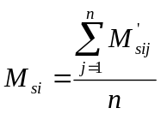 n ≥ 2 ; 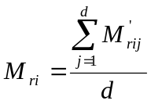

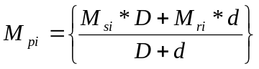

where for each pollutant (i) considered:

M’_{sij} = mass emissions of pollutant (i) in g/km over one Type I operating cycle (or equivalent engine test bench cycle) without regeneration
M’_{rij} = mass emissions of pollutant (i) in g/km over one Type I operating cycle (or equivalent engine test bench cycle) during regeneration. (when n>1, the first Type I test is run cold, and subsequent cycles are hot)
M_{si} = mean mass emission of pollutant (i) in g/km without regeneration
M_{ri} = mean mass emission of pollutant (i) in g/km during regeneration
M_{pi} = mean mass emission of pollutant (i) in g/km
n = number of test points at which emissions measurements (Type I operating cycles or equivalent engine test bench cycles) are made between two cycles where regenerative phases occur, ≥ 2
d = number of operating cycles required for regeneration
D = number of operating cycles between two cycles where regenerative phases occur

For exemplary illustration of measurement parameters see figure 8/1.

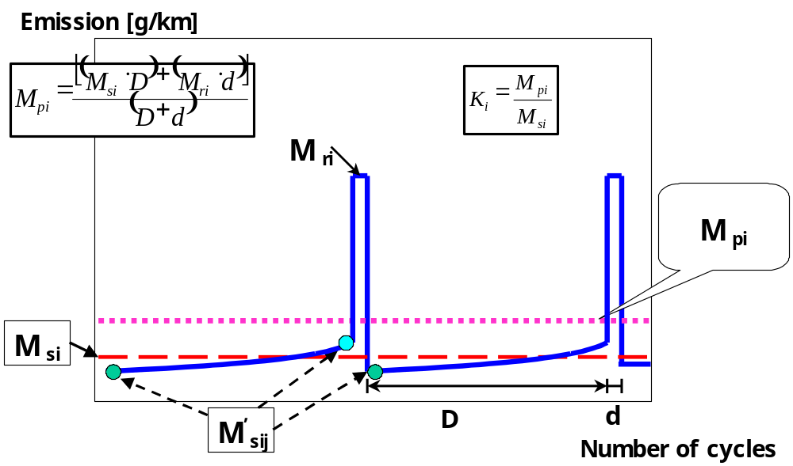

Figure 8/1: Parameters measured during emissions test during and between cycles where regeneration occurs (schematic example, the emissions during ‘D’ may increase or decrease)

3.4. Calculation of the regeneration factor K for each pollutant (i) considered

K_{i} = M_{pi} / M_{si}

M_{si}, M_{pi} and K_{i} results shall be recorded in the test report delivered by the technical service.

K_{i} may be determined following the completion of a single sequence."

_____________

