|  |  |  |  |
| --- | --- | --- | --- |
|  | United Nations | ECE/TRANS/WP.29/GRE/81 | |
| Description: _unlogo | **Economic and Social Council** | | Distr.: General  11 June 2019  Original: English |

**Economic Commission for Europe**

Inland Transport Committee

**World Forum for Harmonization of Vehicle Regulations**

**Working Party on Lighting and Light-Signalling**

**Eighty-first session**

Geneva, 15–18 April 2019

Report of the Working Party on Lighting and Light-Signalling on its eighty-first session

Contents

*Paragraphs Page*

I. Attendance 1 3

II. Adoption of the agenda (agenda item 1) 2–4 3

III. 1998 Agreement – UN Global Technical Regulations: Development (agenda item 2) 5 3

IV. 1997 Agreement – Rules: Development (agenda item 3) 6 3

V. Simplification of lighting and light-signalling UN Regulations (agenda item 4) 7–12 4

VI. UN Regulations Nos. 37 (Filament lamps), 99 (Gas discharge light sources),   
128 (Light emitting diodes light sources) and the Consolidated Resolution

on the common specifications of light source categories (agenda item 5) 13–15 5

VII. UN Regulation No. 48 (Installation of lighting and light-signalling devices)   
(agenda item 6) 16–18 5

A. Proposals for amendments to the 05 and 06 series of amendments 16-17 5

B. Other proposals for amendments to UN Regulation No. 48 18 6

VIII. Other UN Regulations (agenda item 7) 19–22 6

A. UN Regulation No. 53 (Installation of lighting and light-signalling devices

for L3 vehicles) 19–20 6

B. UN Regulation No. 65 (Special warning lamps) 21 7

C. UN Regulation No. 74 (Installation of lighting and light-signalling devices

for mopeds) 22 7

IX. Other business (agenda item 8) 23–26 7

A. Amendments to the Convention on Road Traffic (Vienna, 1968) 23 7

B. Decade of action for road safety 2011–2020 24 7

C. Development of the International Whole Vehicle Type Approval 25 7

D. International events in automotive lighting 26 8

X. New business and late submissions (agenda item 9) 27–28 8

XI. Direction of future work of GRE (agenda item 10) 29–30 8

XII. Provisional agenda for the next session (agenda item 11) 31 8

Annexes

I. List of informal documents considered during the session 9

II. Adopted amendments to ECE/TRANS/WP.29/GRE/2019/3 10

III[.](#_Toc369772241) Adopted amendments to ECE/TRANS/WP.29/GRE/2018/40 11

IV[.](#_Toc369772241) Adopted amendments to ECE/TRANS/WP.29/GRE/2019/2 12

V[.](#_Toc369772241) GRE informal groups 13

I. Attendance

1. The Working Party on Lighting and Light-Signalling (GRE) held its eighty-first session from 15 to 18 April 2019 in Geneva, under the chairmanship of Mr. M. Loccufier (Belgium). Experts from the following countries participated in the work according to Rule 1 (a) of the Rules of Procedure of the World Forum for Harmonization of Vehicle Regulations (WP.29) (TRANS/WP.29/690, ECE/TRANS/WP.29/690/Amends. 1 and 2): Belgium, China, Czechia, Cyprus, Finland, France, Germany, Hungary, India, Italy, Japan, Latvia, Luxembourg, Netherlands, Norway, Poland, Republic of Korea, Serbia, Spain, Switzerland, United Kingdom of Great Britain and Northern Ireland. An expert from the European Commission (EC) participated. Experts from the following non‑governmental organizations also took part in the session: European Association of Automotive Suppliers (CLEPA), International Automobile Federation (FIA), International Automotive Lighting and Light Signalling Expert Group (GTB), International Electrotechnical Commission (IEC), International Motorcycle Manufacturers Association (IMMA), International Organization of Motor Vehicle Manufacturers (OICA), Society of Automotive Engineers (SAE).

II. Adoption of the agenda (agenda item 1)

*Documentation*: ECE/TRANS/WP.29/GRE/2019/1, Informal documents GRE-81-01, GRE-81-11 and GRE-81-15

2. GRE considered and adopted the agenda (ECE/TRANS/WP.29/GRE/2019/1), as reproduced in GRE-81-01 together with the informal documents distributed during the session and subject to the addition of a new agenda item 8 (d) "Other business: International events in automotive lighting". GRE also noted the running order proposed by the Chair (GRE-81-11).

3. The list of informal documents is contained in Annex I to this report. The list of GRE informal groups is reproduced in Annex V to this report.

4. GRE took note of the highlights of the November 2018 and March 2019 sessions of WP.29 and the official document submission deadline of 29 July 2019 for the October 2019 session of GRE (GRE-81-15).

III. 1998 Agreement [–](https://en.wikipedia.org/wiki/En_dash) UN Global Technical Regulations: Development (agenda item 2)

5. GRE had an exchange of views on whether a new UN Global Technical Regulation (UN GTR) could be developed under stage two of the simplification of the lighting and light-signalling UN Regulations (SLR) or as a result of consideration of light-signalling functions of automated/autonomous vehicles (see para. 29 below).

IV. 1997 Agreement – Rules: Development (agenda item 3)

*Documentation*: Informal document PTI-10-03

6. The expert from OICA informed GRE that the Informal Working Group on Periodical Technical Inspection (IWG PTI), in one of its documents (PTI-10-03), had indicated the need to ensure the readability of an approval number for the rear fog lamps (UN Regulation No. 38) in an installed state. The Chair requested the secretariat to clarify this issue with IWG PTI.

V. Simplification of lighting and light-signalling UN Regulations (agenda item 4)

*Documentation*: ECE/TRANS/WP.29/GRE/2019/3, ECE/TRANS/WP.29/GRE/2019/6, ECE/TRANS/WP.29/GRE/2019/7, Informal documents GRE-81-13, GRE-81-16, GRE-81-17, GRE-81-19, GRE-81-20, GRE-81-21, GRE-81-22

7. GRE took note that the SLR package of amendment proposals, including the three new simplified UN Regulations on Light-Signalling Devices (LSD), Road Illumination Devices (RID) and Retro-Reflective Devices (RRD), had been adopted in March 2019, instead of November 2018. In view of the expected entry into force of the SLR package in October 2019, the second group of draft amendments that had originally been intended for submission to the June 2019 session of WP.29 had been postponed to November 2019.

8. The expert from the Informal Working Group "Simplification of the Lighting and Light-Signalling Regulations" (IWG SLR) reported on their progress and requested guidance from GRE (GRE-81-19). The expert from Poland commented on the IWG SLR request (GRE-81-22). GRE agreed that:

• The headlamp provisions should continue to be expressed in terms of the luminous intensities equivalent to the illuminance measured on a screen at a distance of 25 m.

• All technologies should be allowed for all SLR functions. Requirements should be common for all technologies; test requirements could be technology-specific.

• Combination of different light source technologies should be possible for all SLR functions.

9. The expert from IWG SLR requested advice on various options of how to use the Unique Identifier (UI) for the new simplified UN Regulations (GRE-81-20). GRE mandated the secretariat to send GRE-81-20 to IWG on Database for the Exchange of Type Approval documentation (DETA) for comments, and requested IWG SLR to consider delegating one of its experts to participate in IWG DETA sessions. Finally, GRE decided to revert to this issue at the next session.

10. The expert from IWG SLR presented a proposal for a new 07 series of amendments to UN Regulation No. 48 (ECE/TRANS/WP.29/GRE/2019/3). The expert from Poland commented on the proposal (GRE-81-13 and GRE-81-16). GRE focused its discussion on the aiming diagram in paragraph 6.2.6.1.2. Following an in-depth consideration, GRE agreed on a modified diagram (GRE-81-21 and Annex II) and requested IWG SLR to prepare, on the basis of the new diagram, a revised proposal for consideration at the next session. The experts from Germany and Poland made study reservations. The expert from Germany also pointed out that, at the next session, he would present the outcome of a research project on the issue.

11. The experts from France and Germany proposed introducing conditions for the use of logos inside the illuminating surface of a signalling lamp in the UN LSD Regulation and UN Regulation No. 48 (ECE/TRANS/WP.29/GRE/2019/6). Various experts commented and posed questions on the proposal. GRE noted that a clear definition of "logo" would be needed and that technological neutrality should be ensured. The expert from EC was of the view that the underlying issue did not have bearing on road safety and, thus, should not be discussed by GRE. The proponents agreed to revise the proposal in accordance with the comments received. The expert of OICA offered its assistance.

12. The expert from Germany presented a draft Supplement to the UN LSD Regulation which introduced requirements for testing the sun load impact (ECE/TRANS/WP.29/GRE/2019/7). The proposal received comments from the experts of France, Japan (GRE-81-17), Netherlands, United Kingdom of Great Britain and Northern Ireland, CLEPA, OICA and SAE. The expert from IMMA made a study reservation. The Chair invited the expert from Germany to update the proposal, based on the comments received, for consideration at the next session.

VI. UN Regulation Nos. 37 (Filament lamps), 99 (Gas discharge light sources), 28 (Light emitting diodes light sources) and the Consolidated Resolution on the common specification of light source categories (agenda item 5)

*Documentation*: ECE/TRANS/WP.29/GRE/2019/9, ECE/TRANS/WP.29/GRE/2019/10, Informal documents GRE-81-03, GRE-81-04, GRE-81-06, GRE-81-07 and GRE-81-14-Rev.1

13. The expert of GTB presented an amendment proposal to the Consolidated Resolution on the common specification of light source categories (R.E.5) that introduced new light emitting diode (LED) substitute light source categories C5W/LEDK and R5W/LED (ECE/TRANS/WP.29/GRE/2019/9 and GRE-81-03). The expert of GTB also tabled another proposal that introduced new LED substitute light source categories W5W/LEDK and WY5W/LED (ECE/TRANS/WP.29/GRE/2019/10 and GRE-81-04). The expert from IEC highlighted the interlock solutions for the new categories (GRE-81-07). GRE adopted both proposals and requested the secretariat to submit them to WP.29 and the Administrative Committee (AC.1) for consideration at their November 2019 sessions as draft amendment 4 to R.E.5.

14. The expert from the Task Force on Substitutes and Retrofits (TF SR) proposed editorial corrections and further modifications to ECE/TRANS/WP.29/GRE/2018/40, which had been adopted at the previous session of GRE and in which the information for the 24V version was missing (GRE-81-06). GRE adopted the proposal, as contained in Annex III, and requested the secretariat to submit it to WP.29 and AC.1 for consideration at their November 2019 sessions as part of the draft amendment to R.E.5 mentioned in paragraph 13 above.

15. The expert from TF SR presented a progress report of the Task Force (GRE-81-14-Rev.1). GRE noted that the next step (1B) of TF SR would be preparing documents on LED substitutes for road illumination for the next session of GRE. A time schedule for step 2 would be decided upon at the next session of GRE.

VII. UN Regulation No. 48 (Installation of lighting and light-signalling devices) (agenda item 6)

A. Proposals for amendments to the 05 and 06 series of amendments

*Documentation:* ECE/TRANS/WP.29/GRE/2019/5, ECE/TRANS/WP.29/GRE/2019/8

16. The expert from Czechia proposed to clarify the requirements for headlamps and DRL (ECE/TRANS/WP.29/GRE/2019/5). GRE adopted the proposals and requested the secretariat to submit them to WP.29 and AC.1 for consideration at their November 2019 sessions as draft Supplement 13 to the 06 series of amendments to UN Regulation No. 48.

17. The expert from Germany proposed to allow (a) the manual switch-off of all lighting devices in vehicles used by special forces and (b) the activation of hazard warning lights when opening a door in vehicles not equipped with a door assistance and warning system (ECE/TRANS/WP.29/GRE/2019/8). The experts from France, Japan and United Kingdom of Great Britain and Northern Ireland were not in a position to support the derogation (a) and indicated that such exceptions should be done in the national or regional legislation, rather than in a UN Regulation. For proposal (b), the expert from EC pointed out that it constitutes a new requirement and, thus, should be introduced by a new series of amendments. The experts from Czechia, Netherlands, United Kingdom of Great Britain and Northern Ireland and OICA were of the view that proposal (b) goes beyond the scope of GRE and should be addressed by the Working Party on General Safety Provisions (GRSG). The Chair requested the secretariat to bring the issue to the attention of GRSG.

B. Other proposals for amendments to UN Regulation No. 48

*Documentation:* ECE/TRANS/WP.29/GRE/2019/4, ECE/TRANS/WP.29/GRE/2019/11, Informal documents GRE-80-17, GRE-81-09, GRE-81-10 and GRE-81-24

18. The expert from the GRE special interest group introduced a consolidated proposal for a new 07 series of amendments (ECE/TRANS/WP.29/GRE/2019/11, GRE-81-09 and GRE-81-10). The expert from France proposed an additional modification (ECE/TRANS/WP.29/GRE/2019/4). Following in-depth discussion, GRE agreed that, given the complexity of the proposal, further work should be pursued by means of a task force. The experts from the Netherlands and Finland volunteered to act as Chair and Co-Chair, respectively, while the expert from OICA agreed to become secretary. GRE noted that the next session of the special interest group/task force would be convened on 16 and 17 May 2019 at the OICA office in Paris (GRE-81-24). The expert from SAE invited the task force to also address the earlier proposal of SAE on side retro-reflectors (GRE-80-17). Finally, GRE agreed to continue consideration of proposals for a new 07 series of amendments at the next session.

VIII. Other UN Regulations (agenda item 7)

A. UN Regulation No. 53 (Installation of lighting and light-signalling devices for L3 vehicles)

*Documentation:* ECE/TRANS/WP.29/GRE/2019/12, ECE/TRANS/WP.29/GRE/2018/50, Informal document GRE-81-18

19. The expert from IMMA recalled the draft 03 series of amendments to UN Regulation No. 53 adopted at the previous session of GRE (ECE/TRANS/WP.29/GRE/2018/50 and ECE/TRANS/WP.29/GRE/80, para. 28) and proposed to restore the original automatic headlamp requirement for vehicles not equipped with daytime running lamps (DRL) (ECE/TRANS/WP.29/GRE/2019/12). GRE adopted the proposal and requested the secretariat to submit it to WP.29 and AC.1 for consideration at their November 2019 sessions as part of the draft 03 series of amendments to UN Regulation No. 53. The expert from EC was not in a position to support the proposal.

20. The expert from India requested a postponement of consideration of his proposal to make the fitment of front position lamps optional, due to the introduction of automatic headlamp switching and DRL provisions (GRE-81-18).

B. UN Regulation No. 65 (Special warning lamps)

*Documentation:* Informal document GRE-81-05

21. The expert from GTB proposed editorial corrections to UN Regulation No. 65 (GRE-81-05). The expert from Cyprus commented on the proposal. The Chair invited GTB to prepare an official document for consideration at the next session.

C. UN Regulation No. 74 (Installation of lighting and light-signalling devices for mopeds)

*Documentation:* ECE/TRANS/WP.29/GRE/2019/2, Informal document GRE-81-02-Rev.1

22. The expert from the Netherlands tabled a revised proposal that requires mandatory installation of direction indicators on mopeds (ECE/TRANS/WP.29/GRE/2019/2 and GRE-81-02-Rev.1). GRE adopted the proposal, as laid down in Annex IV, and requested the secretariat to submit it to WP.29 and AC.1 for consideration at their November 2019 sessions as draft 02 series of amendments to UN Regulation No. 74.

IX. Other business (agenda item 8)

A. Amendments to the Convention on Road Traffic (Vienna, 1968)

23. GRE noted that the Global Forum for Road Traffic Safety (WP.1), at its recent session in March 2019, had continued discussing ECE/TRANS/WP.1/2017/1/Rev.1 (France, Italy and Laser Europe) as well as Informal document No. 8 submitted by the Government of Germany. After discussion, WP.1 decided to resume, at the next session, by first addressing points (i), (j), (r), (t), 34, 35 and 36 in ECE/TRANS/WP.1/2017/1/Rev.1 while taking into account Informal document No. 8. GRE invited its experts to review these documents.

B. Decade of action for road safety 2011[–](https://en.wikipedia.org/wiki/En_dash)2020

24. GRE was briefed on the recent developments in the field of road safety at the United Nations.

C. Development of the International Whole Vehicle Type Approval

Documentation: Informal document WP.29-176-21

25. GRE reviewed a candidate UN Regulation No. 27 (Advance warning triangle) that was proposed to be added in Annex 4 to UN Regulation No. 0 under Phase 2 of the International Whole Vehicle Type Approval (IWVTA) (WP.29-176-21) and decided that this was not necessary. At the same time, GRE highlighted the need to include in IWVTA, with high priority, the three new simplified UN Regulations on LSD, RID and RRD.

D. International events in automotive lighting

26. No information was reported under this agenda item.

X. New business and late submissions (agenda item 9)

*Documentation:* GRE-80-06

27. GRE noted that Mr. G. Draper (President, GTB) would no longer attend GRE sessions on a regular basis, due to a redistribution of tasks in GTB. GRE thanked him for his long participation and extensive contributions and wished him success in the future.

28. Due to lack of time, GRE decided to consider GRE-80-06 at the next session.

XI. Direction of future work of GRE (agenda item 10)

*Documentation:* Informal documents GRE-81-08-Rev.1, GRE-81-12-Rev.1 and GRE-81-23

29. GRE was briefed on the progress of the task force on the signalling requirements for automated/autonomous vehicles (TF AVSR) (GRE-81-08-Rev.1 and GRE-81-12-Rev.1). GRE noted that TF had not been able to reply to the main question on whether or not there should be a safety requirement for automated/autonomous vehicles to provide specific signals. GRE was not in a position to reach a consensus on this question either. While some experts felt that such signals were necessary for safety reasons, some others held a different view. The expert of SAE pointed out that his organization was developing lamps for automated/autonomous vehicles. GRE decided to request WP.29 for guidance on this matter. The Chair invited GRE experts to provide him with arguments for the request to WP.29 at its session in June 2019.

30. The expert from GTB presented their activity report and mentioned several ongoing studies which were scheduled to be completed by July 2019 (GRE-81-23). GRE looked forward to receiving the results of the studies.

XII. Provisional agenda for the next session (agenda item 11)

31. GRE agreed to keep the same structure of the provisional agenda.

Annex I

List of informal documents considered during the session

Informal documents GRE-81-…

| *No.* | *(Author) Title* | *Follow-up* |
| --- | --- | --- |
| 1 | (secretariat) - Updated provisional agenda for the eighty-first session of GRE | b |
| 2-Rev.1 | (Netherlands) - Proposal for the 02 series of amendments to UN Regulation No. 74 | b |
| 3 | (GTB) - Substitute light sources: equivalence reports for C5W and R5W | a |
| 4 | (GTB) - Substitute light sources: equivalence reports for W5W and WY5W | a |
| 5 | (GTB) - Proposal for corrections to UN Regulation No. 65 | c |
| 6 | (TF SR) - Modifications to ECE/TRANS/WP.29/GRE/2018/40 | b |
| 7 | (IEC) - Substitute interlock solutions | f |
| 8-Rev.1 | (TF AVSR) - Outcome of the discussion on autonomous vehicle signalling requirements | d |
| 9 | (Special Interest Group) - Support document for ECE/TRANS/WP.29/GRE/2019/11 | e |
| 10 | (Special Interest Group) - Revised proposal for a new series of amendments to UN Regulation No. 48 | e |
| 11 | (Chair) - Running order | f |
| 12-Rev.1 | (TF AVSR) - Progress report | f |
| 13 | (Poland) - Proposal for improvement of ECE/TRANS/WP.29/GRE/2019/3 | f |
| 14-Rev.1 | (TF SR) - Status report | f |
| 15 | (Secretariat) - General information and WP.29 highlights | f |
| 16 | (Poland) - Box justification in GRE-81-13 | f |
| 17 | (Japan) - Comments on ECE/TRANS/WP.29/GRE/2019/7 | e |
| 18 | (India) - Clarification on ECE/TRANS/WP.29/GRE/2018/47 | g |
| 19 | (IWG SLR) - Status report | f |
| 20 | (IWG SLR) - Unique Identifier for the new simplified UN Regulations | d |
| 21 | (Secretariat) - Updated diagram in ECE/TRANS/WP.29/GRE/2019/3 | e |
| 22 | (Poland) - Response to the IWG SLR request for guidance | d |
| 23 | (GTB) - Activity report | f |
| 24 | (OICA) - Invitation to the fifth session of the Special Interest Group | f |

*Notes:*

(a) Endorsed or adopted without amendment;

(b) Endorsed or adopted with amendments;

(c) Resume consideration on the basis of a document with an official symbol;

(d) Kept as a reference document/continue consideration;

(e) Revised proposal for the next session;

(f) Consideration completed or to be superseded;

(g) Withdrawn.

Annex II

Adopted amendments to ECE/TRANS/WP.29/GRE/2019/3

*Paragraph 6.2.6.1.2.,* replace the blue figure by the figure in red:

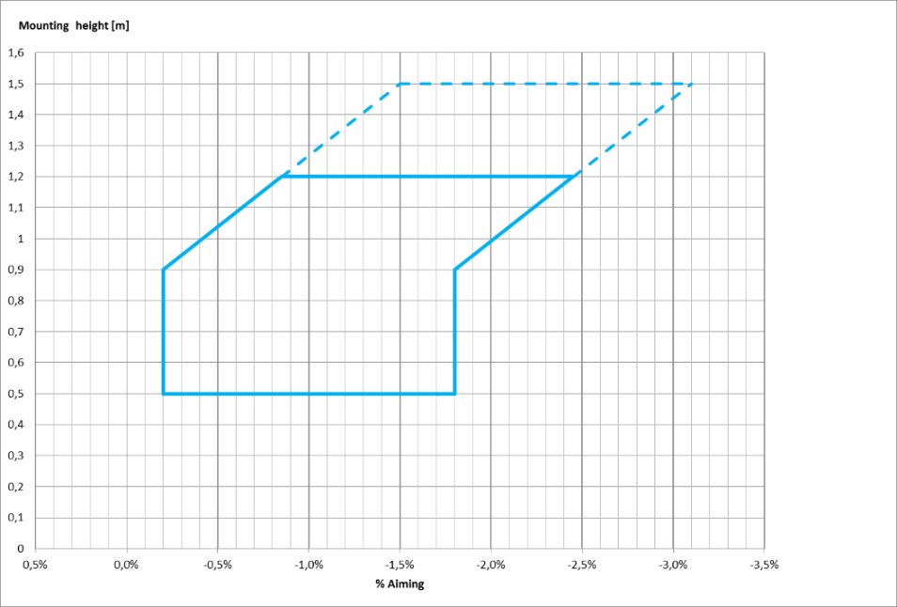

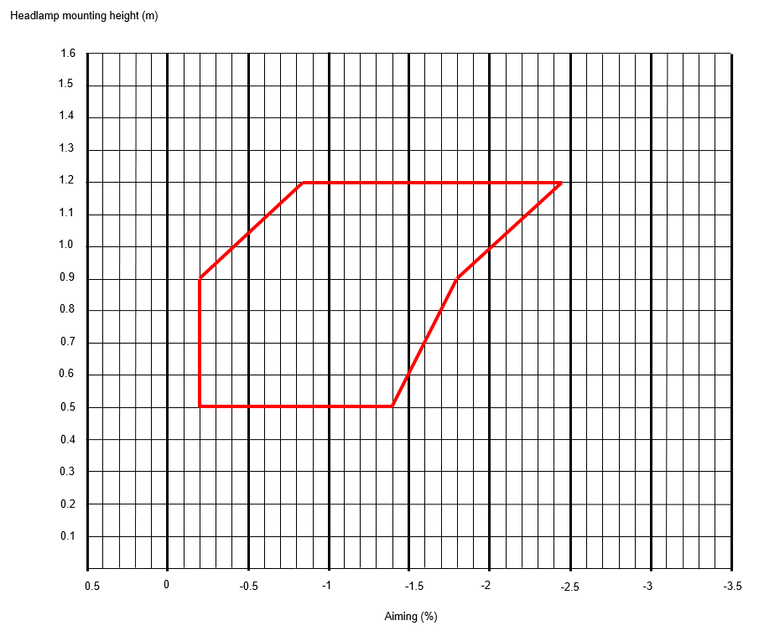

Annex III

Adopted amendments to ECE/TRANS/WP.29/GRE/2018/40

*Sheet PY21W/LED/1, table 1,* amend to read:

"Table 1

**Essential electrical and photometric characteristics of LED light sources**

| *Dimensions in mm* | | *LED light sources of normal production* | | | | | | *Standard LED light source* | |
| --- | --- | --- | --- | --- | --- | --- | --- | --- | --- |
|  | *nom.* | | |  | | *nom.* | |
| e 2/ | |  | 31.8 | | |  | | 31.8 | |
| h 2/ | |  | 9.0 | | |  | | 9.0 | |
| β 2/ | |  | 90° | | |  | | 90° | |
| Cap BAU15s-3(110°) in accordance with IEC Publication 60061 (sheet 7004-19A-1) | | | | | | | | |
| *Electrical and photometric characteristics* | | *5/* | | | *6/* | | | *5/* |
| Rated values | Volts | 12 | | | 24 | | | 12 | |
| Watts 3/ | 7 | | | | | | 7 | |
| Test voltage | Volts | 13.5 | | | 28.0 | | | 13.5 | |
| Objective values | Watts 3/ | 9 max. | | | 10 max. | | | 9 max. | |
| Electrical current (in mA) 3/ | (at 9–16V DC)  150 min.  750 max. | | (at 16–32V DC)  75 min.  375 max. | | | (at 9–16V DC)  150 min.  750 max. | | |
| Luminous flux3/, 4/ (in lm) | 280 ± 20 % | | | 280 ± 20 % | | | 280 ± 10 % | |
| Luminous flux3/ (in lm) | (at 9 V DC)  56 min. | | | (at 16 V DC)  30 min. | | | (at 9 V DC)  56 min. | |

1 The light emitted from the LED light source shall be amber.

2 To be checked by means of a "Box-System"; sheet PY21W/LED/2.

3 Operated in flashing mode for 30 minutes (frequency = 1.5 Hz, duty cycle 50 per cent ON, 50 per cent OFF) and measured in the ON-state of flashing mode after 30 minutes of operation.

4The value measured at elevated ambient temperature of 80°C shall be at least 65 per cent of this value.

5 In case of a failure of any of the light emitting elements, the LED light source shall either still comply to the requirements concerning luminous flux and luminous intensity distribution or stop emitting light whereby/in the latter case the electrical current draw, when operated between 12 V and 14 V, shall be less than 50 mA.

6 In case of a failure of any of the light emitting elements, the LED light source shall either still comply to the requirements concerning luminous flux and luminous intensity distribution or stop emitting light whereby/in the latter case the electrical current draw, when operated between 24 V and 28 V, shall be less than 25 mA."

Annex IV

Adopted amendments to ECE/TRANS/WP.29/GRE/2019/2

*New paragraphs 12.4. to 12.9.,* amend to read:

**"12.4. As from the official date of entry into force of the 02 series of amendments, no Contracting Party applying this UN Regulation shall refuse to grant or refuse to accept UN type approvals under this UN Regulation as amended by the 02 series of amendments.**

**12.5. As from 1 September 2023, Contracting Parties applying this UN Regulation shall not be obliged to accept UN type approvals to the preceding series of amendments, if first issued after 1 September 2023.**

**12.6. Notwithstanding the transitional provisions above, Contracting Parties who start to apply this UN Regulation after the date of entry into force of the most recent series of amendments are not obliged to accept UN type approvals which were granted in accordance with any of the preceding series of amendments to this UN Regulation.**

**12.7. Notwithstanding paragraph 12.5., Contracting Parties applying 02 series of amendments to this UN Regulation shall continue to accept UN type-approvals to the preceding series of amendments to this UN Regulation, if first issued after 1 September 2023 and any extension thereof, for the vehicles which are not affected by the changes introduced by the 02 series of amendments.**

**12.8. Contracting Parties applying the 02 series of amendments of this Regulation shall continue to accept, until 1 September 2028, type approvals granted according to the series preceding the 02 series of amendments to this Regulation if first issued before 1 September 2023.**

**12.9. Contracting Parties applying this UN Regulation shall not refuse to grant UN type approvals according to any preceding series of amendments to this UN Regulation or extensions thereof."**

Annex V

**GRE informal groups**

|  |  |  |
| --- | --- | --- |
| *Informal group* | *Chair(s)* | *Secretary* |
| Simplification of the Lighting and Light-Signalling UN Regulations (SLR) | Mr. Michel Loccufier (Belgium)  Phone: +32 474 989 023  Email: michel.loccufier@mobilit.fgov.be | Mr. Davide Puglisi (GTB)  Phone: +39 011 562 11 49  Fax: +39 011 53 21 43  Email: secretary@gtb-lighting.org |