Proposal for Supplement 3 to the 03 series of amendments to UN Regulation No. 129
Agenda Item 19
Submitted by the expert from the European Association of Automotive Suppliers*
The text reproduced below was prepared by the expert from the European Association of Automotive Suppliers (CLEPA), to introduce editorial changes in formal document ECE/TRANS/WP.29/GRSP/2019/12.
I. Proposal
Amend paragraph 4.8.3 2.3.4 to read/
"2.3.4.
"Universal booster cushion" (Non-Integral Universal Enhanced Child Restraint System without a backrest) is a category of Enhanced Child Restraint System without a backrest primarily designed for use in all i-Size and all Universal seating positions. If fitted, ISOFIX attachments are stowable. "

Amend paragraph 4.8.3. to read:
"4.8.3.
………
Universal booster cushion

i-Size compatible
Universal

Amend paragraph 6.1.3.6., to read:
"6.1.3.6
…..
Figure 2
Ruler of measurement device
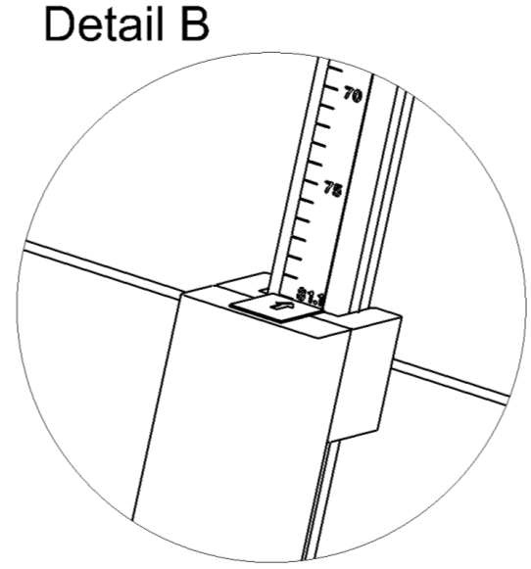

75

70
Ruler showing sitting height of child
…..

Annex 2, amend to read:
"Annex 2
1. Arrangements of the approval mark
….
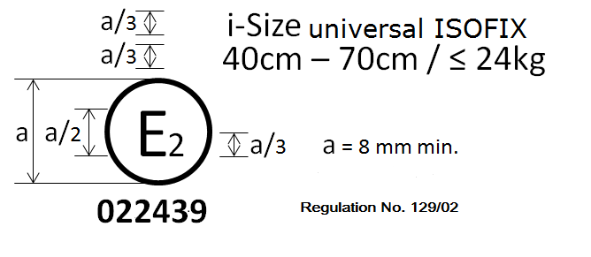
UN Regulation No. 129/03
032450
Specific vehicle booster cushion
125 cm–150 cm
…"

Annex 26 , amend to read :
Annex 26
Lower torso body block test
Figure 1
Manikin block (based on truncated P10)
Material: Expanded polystyrene (EPS) (40 to 45 g/l) or alternative non deformable material

II. Justification
1. Editorial corrections Correction to paragraphs 2.3.4, 4.8.3 and to diagram in Figure 2 paragraph 6.1.3.6 and to the label in Annex 2, in ECE/TRANS/WP.29/GRSP/2019/12.

* In accordance with the programme of work of the Inland Transport Committee for 2018–2019 (ECE/TRANS/274, para. 123 and ECE/TRANS/2018/21/Add.1, Cluster 3.1), the World Forum will develop, harmonize and update UN regulations to enhance the performance of vehicles. The present document is submitted in conformity with that mandate.

