Proposal for Supplement 13 to the 04 series of amendments to Regulation No. 44 (Child Restraint Systems)

Submitted by the expert from the Netherlands[1]*

The text reproduced below was prepared by the expert from the Netherlands, to exclude diverging interpretations of child restraint systems in UN Regulation No. 44. It is based on documents ECE/TRANS/WP.29/GRSP/2016/14 and ECE/TRANS/WP.29/2016/18 distributed during, respectively, the fifty-ninth and sixtieth session of GRSP. The modifications to the current text of the UN Regulation are marked in bold for new or strikethrough for deleted characters.

I. Proposal

*Paragraph 6.1.8*., amend to read:

"6.1.8. **Integral** child restraint systems of the "universal" category, except ISOFIX universal child restraint systems, shall have a main load-bearing contact point, between the child restraint and **the webbing of** the adult safety-belt. This point shall not be less than 150mm from the Cr axis when measured with the child restraint on the dynamic test bench installed in accordance with Annex 21 to this Regulation without a dummy.

**Non-integral child restraint systems of the “universal” category, shall have a main load-bearing contact point, between the child restraint and the webbing of the adult safety-belt. This point shall not be less than 65 mm vertically above the test bench cushion and not be less than 150mm from the Cr axis when measured with the child restraint on the dynamic test bench installed in accordance with Annex 21 to this Regulation without a dummy.**

**~~In each case, this shall be measured in a longitudinal plane making use of the Standard seat belt configuration for the fitting session described in figure 1C of Annex 13.~~** ~~This shall apply to all adjustment configurations~~.

Additional alternative belt routes are allowed. Where an alternative belt route exists, the manufacturer shall make specific reference to the alternative route in the user instructions, as required in paragraph 15. When tested, using such alternative belt route(s), the restraint shall comply with all the requirements of the Regulation. ~~with the exception of this paragraph.~~"

*Paragraph 6.2.2*., amend to read:

"6.2.2. ~~For groups I, II and III,~~ All restraint devices utilizing a "lap strap" shall positively guide the "lap strap" **on both sides** to ensure that the loads transmitted by the "lap strap" are transmitted through the pelvis. The assembly shall not subject weak parts of the child's body (abdomen, crotch, etc.) to excessive stresses. "

**In the case of booster cushions and booster seats , the lap portion of the adult seat belt shall be positively guided on both sides to ensure that the loads are transmitted by the adult lap belt are transmitted through the pelvis. The positive guidance of loads over the pelvis shall be realised from the moment that the child is installed; the lap belt shall pass over the ~~proximal of the~~ top of the thigh, just touching the fold with the pelvis. The angles α and β between the tangent line in which the belt touches the thighs and the horizontal shall be greater than 10°.**"

# **Figures of Strapped child**

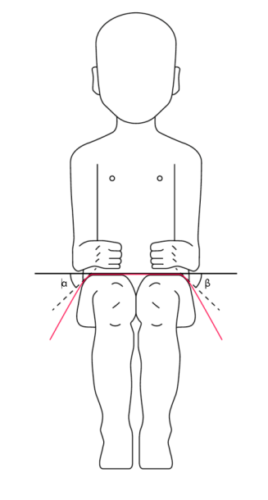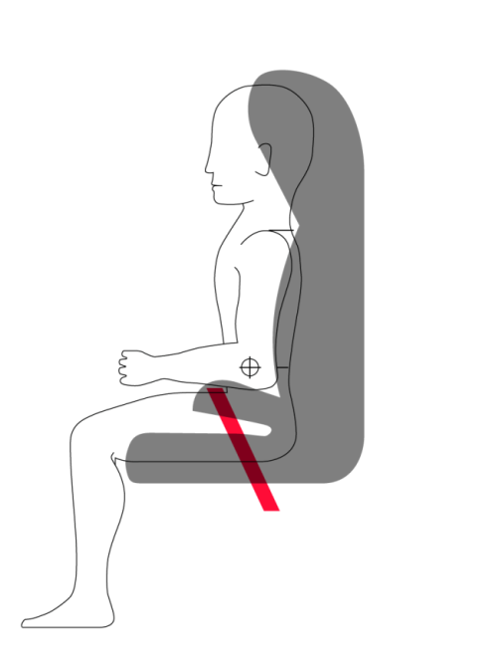

*Paragraph 7.2.1.1*., amend to read:

"7.2.1.1. The buckle shall be so designed as to preclude any possibility of incorrect manipulation. This means, inter/alia, that it shall not be possible for the buckle to be left in a partially closed position; it shall not be possible to exchange the buckle parts inadvertently when the buckle is being locked; the buckle shall only lock when all parts are engaged. Wherever the buckle **and /or the tongue are** ~~is~~ in contact with the child, it shall not be narrower than the minimum width of strap as specified in paragraph 7.2.4.1.1. below. This paragraph is not applicable to belt assemblies already approved according to ~~ECE~~ Regulation No. 16 or any equivalent standard in force. In the case of a "Special Needs Restraint" only the buckle on the primary means of restraint need comply with the requirements of this paragraph 7.2.1.1. to paragraph 7.2.1.9. inclusive."

*~~Annex 13,~~*

*~~Figure 1B~~*~~, amend to read:~~

~~"Figure 1B~~**~~Three-point retracting belt dynamic test~~**

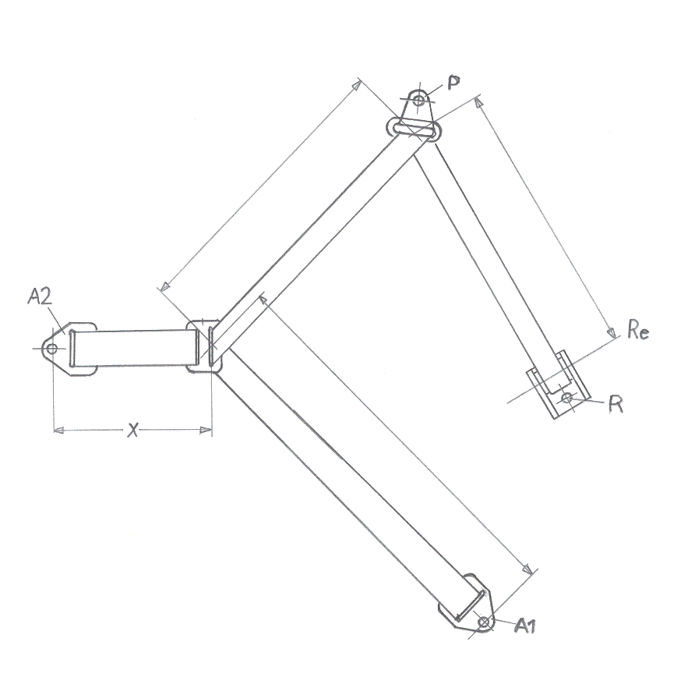"

*~~Insert new Figure 1C~~*~~, to read:~~

**~~Figure 1C  
Standard seat belt configuration, for fitting session of par.6.2.12.~~**

# 

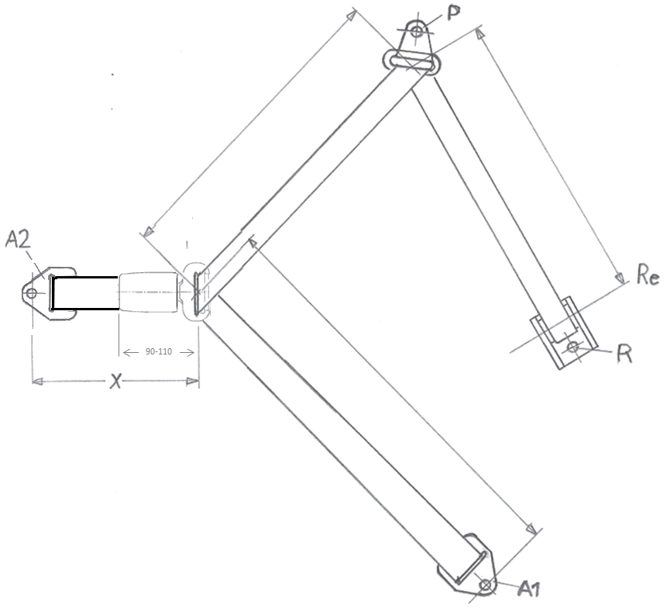

Buckle dimensions

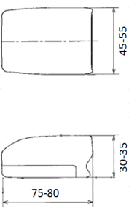

"

II. Justification

**On par. 6.1.8., the item concerning the main load-bearing contact point:**

Related to paragraph 6.1.8. in Reg.44 exists a complementary set of paragraphs in Reg.16 (Annex 17, Appendix 1 - Provisions concerning the installation of “universal” category child restraint systems installed with the safety-belt equipment of the vehicle). The intention of both is to guarantee compatibility. Firstly, Reg.16 allows car manufacturers a certain zone where their buckle and tongue may protrude; a “fixture” often called gabarit is used to check this.

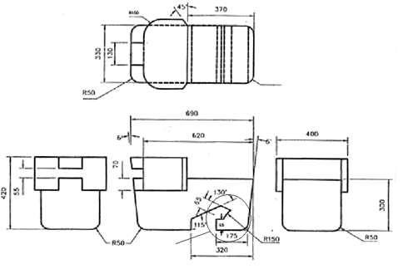

Detail W

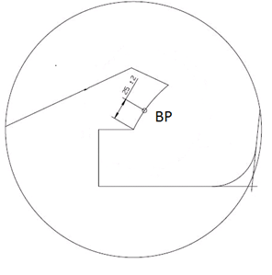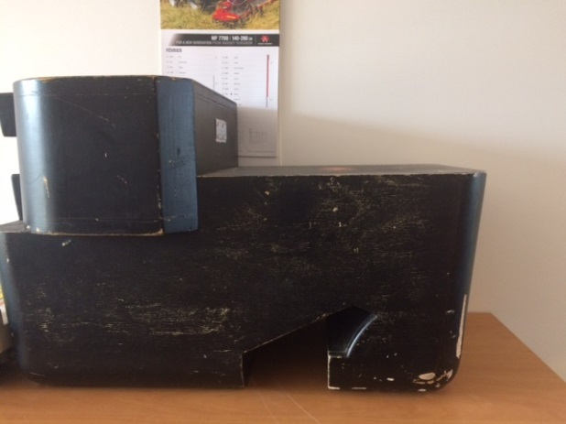

Below are showed two kinds of incompatibility (from an instruction manual Euro NCAP)

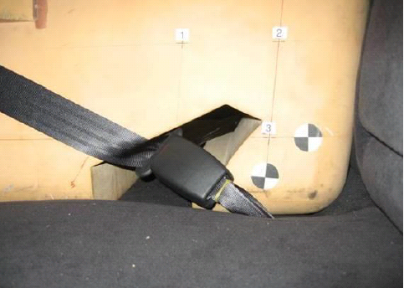 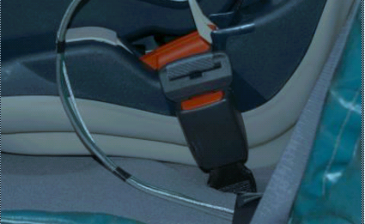

RDW has been confronted with the following incompatibility. Here the belt may be on a distance of 150 mm, but within the zone of 150 mm is the red webbing guide of the CRS and this CRS part can touch the car buckle-tongue combination in such a way to hinder proper restraining and cause also detrimental effects by hard-hard contact.

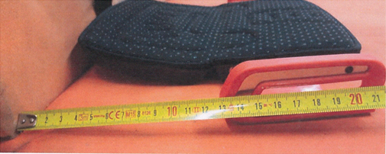

The new proposal for par. 6.1.8. brings the CRS requirements closer to the complementary car requirements and should prevent misinterpretations.

**On par. 6.2.2., the item concerning loads of the lap belt transmitted through the pelvis**

The lap belt, part of a car restraint, is type approved with a 50th % Male, but designed such that it will also function in favour of the 5th% Female. From UMTRI-83-53-1 (Schneider e.a.) with measurements of subjects sitting in the UMTRI contoured seat, are known: an abdominal depth (maximum) of 21 cm (page H-57) and thigh measures (circumference and breadth) that when calculated give an indication for a thigh thickness of 14 cm. Having in mind the crucial dimensions of the fixture (= the radius of 150 mm, the point BP and the 65 mm height), a belt+tongue that would be a border case with the Reg.16 fixture test, should fulfil its restraining function of a 5th % Female immediately after installation.

However children have less abdominal depth and less thigh thickness. One should be cautious in the process of getting loads transmitted by the "lap strap" through the pelvis.

Besides trying to fulfil the 150 mm not via “boosting” but purely forward (see above), there are other cases of transmitting loads raised by ANEC (IWG on CRS CRS-56-05).

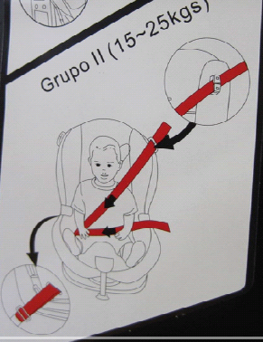 

On the buckle side it is OK, but on the other side the load by the lap belt will not be transmitted through the pelvis.

A child of stature 125 cm has an abdominal depth 14,3 -20,2 cm (Reg.129) and a child with an age of 6 (Q6) and 10.5 (Q10) years have an average thigh thickness (sitting) of respectively 9,2 and 11,4 cm (CANDAT). The child, hosted in a shell, should not be subject to extra slack.

As for adults, it is crucial that after installation the lap belt shall pass rearward on the thighs (flat), just touching the fold with the pelvis (the pelvis does not protrude very high above the thigh (not even a strap width!), so no lap belt up against the pelvis). From this point on the thighs the lap belt on both sides must have a routing downwards and preferable also rearwards just as is indicated in the figures to start its restraining process as soon as possible.

The new proposal for paragraph 6.2.2. stresses crucial points from above

**~~On par. 6.2.12. and 7.2.1.1., items concerning respectively the fixed buckle + tongue shall not permit a lie of belt completely different from that of the test-trolley, and twisted buckles + tongues~~**

~~Paragraph 6.2.12. requires to check the lie of belts in a situation with buckle (and tongue), however a procedure to check this is not prescribed. Similarly par. 7.2.1.1. requires “…wherever the buckle is in contact with the child, it shall not be narrower than the minimum width of strap …”; also here is no procedure prescribed and one has not mentioned the tongue which could also cause high local pressures!~~

~~By adding the tongue and proposing a procedure with a standard safety belt for a fitting session, test houses will be guided to do a real check and do it in a way that will be the same; this procedure is to be used in three paragraphs, namely 6.1.8., 6.2.12. and 7.2.1.1.~~

1. * In accordance with the programme of work of the Inland Transport Committee for 2016–2017 (ECE/TRANS/254, para. 159 and ECE/TRANS/2016/28/Add.1, cluster 3.1), the World Forum will develop, harmonize and update Regulations in order to enhance the performance of vehicles. The present document is submitted in conformity with that mandate.