UN/SCETDG/INF.7
Committee of Experts on the Transport of Dangerous Goods
and on the Globally Harmonized System of Classification
and Labelling of Chemicals
Sub-Committee of Experts on the Transport of Dangerous Goods 18 April 2024
Sixty-fourth session
Geneva, 24 June-3 July 2024
Item 3 of the provisional agenda
Listing, classification and packing

Transport provisions for small quantities of environmentally hazardous paints, printing inks, and related materials – Annexes to document ST/SG/AC.10/C.3/2024/31

Transmitted by the World Coatings Council (WCC)

Annexes to document ST/SG/AC.10/C.3/2024/31
1. This informal document contains three annexes that provide supporting information for WCC’s document to the sixty-fourth session of the TDG Sub-Committee (see document ST/SG/AC.10/C.3/2024/31)
2. Annex A provides additional information on the classification of mixtures as environmentally hazardous substances.
3. Annex B explains the differences in safety measures followed by the paint industry before and after the reclassification of certain paints from not regulated for transport to Class 9 environmentally hazardous mixtures.
4. Annex C illustrates the situations before-and-after reclassification due to the additional measures that needed to be taken to comply with Class 9 environmentally hazardous mixture requirements.

Annex A

Environmentally Hazardous Classification, including
M-Factors

I. Introduction
1. In 2009-2010, the term "environmentally hazardous (aquatic environment)" was implemented in the UN Model Recommendations for the Transport of Dangerous Goods. The criteria from GHS is used in the UN Model Regulations for TDG to identify environmentally hazardous chemicals, particularly those hazardous to the aquatic environment, and to define the applicable transport conditions to avoid or minimize their release into the environment (e.g., packing requirements).
2. There are two options to classify the environmental hazard in Class 9 for substances and mixtures in PG III:
- UN3077 ENVIRONMENTALLY HAZARDOUS SUBSTANCE, SOLID, N.O.S.; or
- UN3082 ENVIRONMENTALLY HAZARDOUS SUBSTANCE, LIQUID, N.O.S.

II. Criteria basics
3. The basic elements for classification of environmentally hazardous substances are:
- Acute aquatic toxicity
- Chronic aquatic toxicity
- Potential for or actual bioaccumulation
- Degradation for organic chemicals
4. The categories implemented for transport are Acute Category 1, Chronic Category 1, and Chronic Category 2. If one of these categories apply and the substance/mixture has not been assigned to hazard Classes 1-8, then it is classified as UN 3077 or UN 3082 environmentally hazardous in PG III.
5. If it meets the criteria for Classes 1-8 and another PG applies based on these hazards, then this PG takes precedence, and the environmentally hazardous substance adds to the existing classification.
6. The criteria for acute and chronic categories for substances is as follows:

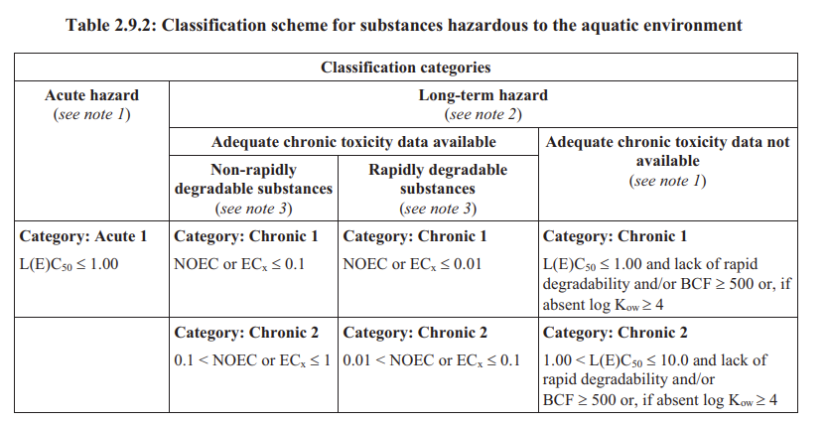

III. Mixture classification
7. Mixture classifications can be based on test results, bridging principles, or the summation method.
8. Mixtures can only be tested on the aquatic toxicity data for fish, crustacea, and algae/plants. Degradability and bioaccumulation data are not possible for mixtures (or it is too difficult to interpret the results). As such, degradability and bioaccumulation data are only suitable for substances.
9. The summation method is used to determine the classification for mixtures (from the 2023 revision of the UN Model Regulations for the Transportation of Dangerous Goods):
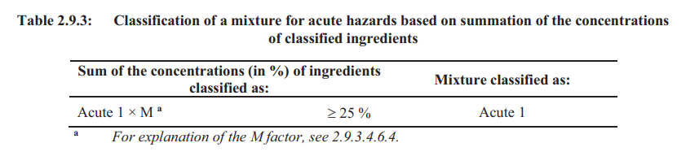
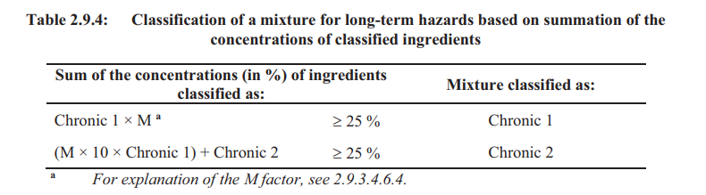

10. The M-factor is used for substances that are highly toxic to the environment. It is based on harmonized classification or the self-classification of substances (based on manufacturer/supplier ecotoxicity information). The purpose of applying the M-factor is to give an increased weight to highly toxic substances when classifying a mixture.
11. The M-factor applies to Acute and Chronic Category 1 and its eco-toxicity value:
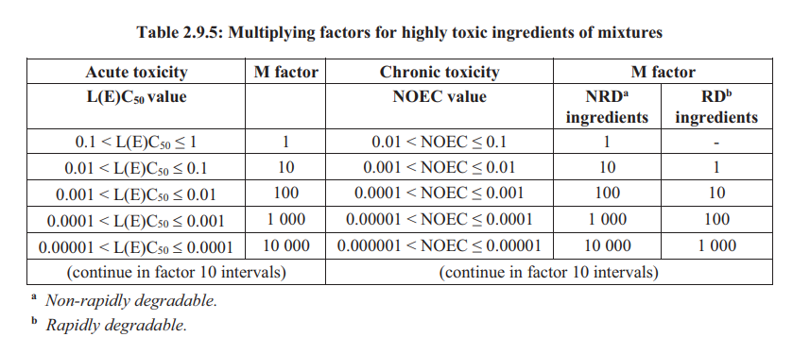

12. This means that a substance with a high M-factor leads to a Class 9 environmentally hazardous classification even at very low concentrations of highly toxic substances in mixtures.
13. Due to the conservative approach taken by the summation method, including use of M-factors, it has been suggested that paint manufacturers may wish to complete toxicity tests on their mixtures for classification purposes. However, there are a large number of different paint and ink formulations. As such, it is not considered feasible to test the mixtures, especially when considering the need to limit tests on animals.
14. WCC acknowledges that these substances are the most toxic to the environment and that any relaxation of the regulations must not lead to an increase in the risk from transporting such substances. However, the highly toxic ingredients that give rise to the classification of water-borne paints and inks as environmentally hazardous substances are present in the paints and inks at very low levels. The paints are classified as environmentally hazardous if it contains 0.025% or more of the substance with an M-factor Acute of 1000 or an M-factor Chronic of 100. Currently, mixtures containing only a small concentration of these substances are treated in the same way as the neat substance. However, due to the quantity of the substance in the mixture, the risk to the environment from a spill is lower due to the lower concentration of the substance in the mixture. Rather than set a limit to the M-factor, this proposal instead sets an upper concentration limit for the sum of highly toxic ingredients, as well as a limit for the packaging size to ensure that the risk is managed.

IV. Examples for the application of the formula presented above
15. Example 1: A liquid paint mixture contains one environmentally hazardous substance in a concentration of 0.03% assigned to Acute aquatic hazard category 1, M factor is 100.
Calculation for UN 3082:
Sum of the concentration of ingredients classified as: | Mixture is classified as: | Result:
Acute 1 x M ≥ 25% | Acute 1 | 0.03 x 100 = 3 = Not classified

This mixture is not acute aquatic toxic. Therefore, is not environmentally hazardous.
16. Example 2: A liquid paint mixture contains one environmentally hazardous substance in a concentration of 0.03% assigned to Chronic hazard category 1, M factor is 100.
Calculation for UN 3082:
Sum of the concentration of ingredients classified as: | Mixture is classified as: | Result:
Chronic 1 x M ≥ 25% | Chronic 1 | 0.03 x 100 = 3 = Not classified
(M x 10 x Chronic 1) + Chronic 2 ≥ 25 % | Chronic 2 | (100 x 10 x 0.03) + 0 = 30 =  Classified Chronic 2 (result ≥ 25)

This mixture is chronic aquatic toxic 2. Therefore, it is environmentally hazardous (UN3082).
17. Example 3: A liquid paint mixture contains one environmentally hazardous substance in a concentration of 0.03% assigned to both Acute and Chronic hazard category 1, M factor is 100 (acute) and 100 (chronic). Note: The preservative substance OIT – 2-octyl-2H-isothiazol-3-one (updated in 15th ATP of CLP) – is one of the substances with this aquatic toxic classification.
Calculation for UN 3082:
Sum of the concentration of ingredients classified as: | Mixture is classified as: | Result:
Acute 1 x M ≥ 25% | Acute 1 | 0.03 x 100 = 3 = Not classified

Sum of the concentration of ingredients classified as: | Mixture is classified as: | Result:
Chronic 1 x M ≥ 25% | Chronic 1 | 0.03 x 100 = 3 = Not classified
(M x 10 x Chronic 1) + Chronic 2 ≥ 25 % | Chronic 2 | (100 x 10 x 0.03) + 0 = 30 =  Classified Chronic 2 (result ≥ 25).

This mixture is chronic aquatic toxic 2. Therefore, it is environmentally hazardous (UN3082).
18. Example 4: A liquid paint mixture contains a mixture of environmentally hazardous substances in:
- A concentration of 0.01% assigned to both Acute and Chronic hazard category 1, M factor is 100 (acute) and 100 (chronic), and
- A concentration of 0.02% assigned to Chronic hazard category 1, M factor is 1000.
Calculation for UN 3082:
Sum of the concentration of ingredients classified as: | Mixture is classified as: | Result:
Acute 1 x M ≥ 25% | Acute 1 | 0.01 x 100 = 1 = Not classified

Sum of the concentration of ingredients classified as: | Mixture is classified as: | Result:
Chronic 1 x M ≥ 25% | Chronic 1 | Sub1(0.01 x 100) + Sub2(0.02x1000) = 21 =  not classified
(M x 10 x Chronic 1) + Chronic 2 ≥ 25 % | Chronic 2 | Sub1(100 x 10 x 0.01) + Sub2(1000x10x0.02) = 210 =  Classified

This mixture is chronic aquatic toxic 2. Therefore, it is environmentally hazardous (UN 3082).
19. Example 5: A liquid paint mixture contains a mixture of environmentally hazardous substances in:
(a) A concentration of 0.3% assigned to both Acute and Chronic hazard category 1, M factor is 10 (acute) and 10 (chronic), and
(b) A concentration of 0.8% assigned to both Acute and Chronic hazard category 1, M factor is 10 (acute) and 10 (chronic).

Calculation for UN 3082:
Sum of the concentration of ingredients classified as: | Mixture is classified as: | Result
Acute 1 x M ≥ 25% | Acute 1 | Sub1(0.3 x 10) + Sub2(0.8 x 10) = 11 =  Not classified

Sum of the concentration of ingredients classified as: | Mixture is classified as: | Result
Chronic 1 x M ≥ 25% | Chronic 1 | Sub1(0.3 x 10) + Sub2(0.8x10) = 11 =  Not classified
(M x 10 x Chronic 1) + Chronic 2 ≥ 25 % | Chronic 2 | Sub1(10 x 10 x 0.3) + Sub2(10x10x0.8) = 110 =  Classified Chronic 2 (result ≥ 25).

This mixture is chronic aquatic toxic 2. Therefore, it is environmentally hazardous (UN 3082).

V. Conclusion
20. WCC’s proposal is to exempt mixtures classified as UN 3082 that contain < 1% of highly toxic substances to the environment (with an M-factor > 1) from UN-approved packaging requirements in pack sizes up to and including 30 liters. This criteria is based on an upper concentration limit of the sum of highly toxic substances being less then 1% instead of a limit to the M-factor to make the calculation easier on mixture level; to exclude higher concentrations of highly toxic substance from the packaging exemption; and to align with the former 1% limit for severe marine pollutant (PP) from the IMDG Code.

Example | Contain < 1% (sum of conc.) | UN approved packaging under our proposal
Example 2  UN 3082 | 0.03% Chronic cat. 1, M = 100 | No (0.03% < 1% high toxic to environment substance)
Example 3  UN 3082 | 0.03% Acute cat. 1 (M = 100); Chronic cat. 1 (M = 100) | No (0.03% < 1% high toxic to environment substance)
Example 4  UN 3082 | Substance 1: 0.01% Acute cat. 1 (M = 100); Chronic cat. 1 (M = 100)  Substance 2: 0.02% Chronic cat. 1 (M = 1000) | No (0.01 + 0.02%) = 0.03% <1% high toxic to environment substance)
Example 5  UN 3082 | Substance 1: 0.3% Acute cat. 1 (M = 10); Chronic cat. 1 (M = 10)  Substance 2: 0.8% Acute cat. 1 (M = 10); Chronic cat. 1 (M = 10) | Yes (0.3 + 0.8 = 1.1% which is above sum of concentration limit)

VI. Additional considerations
21. Limited data was available on substances when Class 9 environmentally hazardous classification was introduced in 2009 (as well as information on M-factors). This has increased over the years due to the proliferation of high M-factors.
22. High M-factors have led to the environmentally hazardous classification for a mixture at disproportionately low levels (e.g. 0.025%) when compared to mixture classification for corrosive (5%) or toxic (oral at 33.3%; dermal at 30%; and inhalation at 5%). UN 3077 and UN 3082 only exist in PG III (less danger), whereas corrosive and toxic have the full range of PGs (PG I for severe danger; PG II for medium danger; and PG III for less danger). The environmentally hazardous classification does not take precedence over Classes 1-8 and is an additional hazard, whereas corrosive and toxic are not. Consequently, this classification has inadvertently become “over-prioritized” through the link between GHS & transport regulations, primarily due to M-Factors.
23. In transport classification for health hazards, only acute toxic classification is taken into account and not chronic toxic classification. In contrast, for environmentally hazardous classification, both acute and chronic (1 and 2) are seen as dangerous in transport.

Annex B

Impact of GHS/CLP classification changes on documentation and transportation, with pictorial examples in Annex C
1. The following table shows the safety measures that need to be taken to transport paint, paint related material, and printing ink before and after the regulation for reclassification to Class 9 takes place.
2. The table shows that many safety measures were already in place before 15th ATP, which adhered to existing dangerous goods regulations and were already implemented by industry. Additional measures were also introduced after implementation of 15th ATP in accordance with Class 9 environmentally hazardous mixture requirements (and in line with the transitional measures in ADR/RID 2023).
3. Annex C illustrates the situations before-and-after due to the additional measures that needed to be taken.

Safety measures to be taken to transport paint, paint related material and printing inks | Measures in place before implementation of 15th ATP | Additional measures to put into place after implementation of 15th ATP and classification as UN 3082 | Adherence (bold italics indicates the additional new safety measures implemented due to UN 3082 Class 9 Environmentally Hazardous classification)
Posting of CLP/GHS Labeling on packaging | In place | Addition: Env. Haz- Pict. and additional H- and P-Phrases | Full adherence
Sections 2 and 14 of the SDS | No mentioning of environmental hazard in section 2;  no dangerous goods specifications in section 14 (see figures IV & V in Annex C) | Additional information on environmental hazard in section 2; dangerous goods specifications in section 14 (see figures VI & VII in Annex C) | Full adherence
Use of packaging of good quality | In place à Currently used packaging is in full accordance with 4.1.1.1 of the dangerous goods regulations | Packaging needs to be UN-approved | Adherence not possible due to non-existing UN-packaging
Use of Transport Labels and Marks on outer/single packaging | Not applicable (see figure I in Annex C) | Class 9 Label + UN-Number + Env. Haz. Mark + mode of transport specific marking (see figures II & III in Annex C) | Full adherence
Building of safe and stable loading units | Adherence with international, EU, and national regulations already in place. Examples of industry common practices are:  Shrink wrapping with high-tensile wrapping foil.  Strapping with high-tensile strapping-cord  Use of high-tensile adhesive tape  (see figures III & IV in Annex C) | No additional measures to be taken | Full adherence
Load securing | Adherence with international, EU, and national regulations already in place (examples):  CTU-Code  EN 12195  VDI 2700 (Germany)  49 CFR, Part 177, Subpart B (USA) | No additional measures to be taken | Full adherence
Safety measures to be taken to transport paint, paint related material and printing inks | Measures in place before implementation of 15th ATP | Additional measures to put into place after implementation of 15th ATP and classification as UN 3082 | Adherence (Bold text shows the additional new safety measures implemented due to UN 3082 Class 9 Environmentally Hazardous classification)
Placarding and marking of CTU’s | Not applicable | Full compliance with Placarding and Marking requirements/provisions | Full adherence
DG-qualification of drivers | Not applicable | Full DG-qualification required | Full adherence
Vehicle emergency response equipment | Not applicable | Full DG-equipment required | Full adherence
Construction and registration of vehicles | Not applicable | Full compliance with DG regulations required | Full adherence
Transport documentation | Not applicable (except for standard transport documents such as delivery note or CMR etc.) | Full DG-documentation needed, in addition to standard transport documentation | Full adherence

Annex C

Pictures illustrating the current situation for transporting paints
1. Annex C contains pictorial examples that are referenced in the table in Annex B. Please consider Annex B when reviewing these pictures.

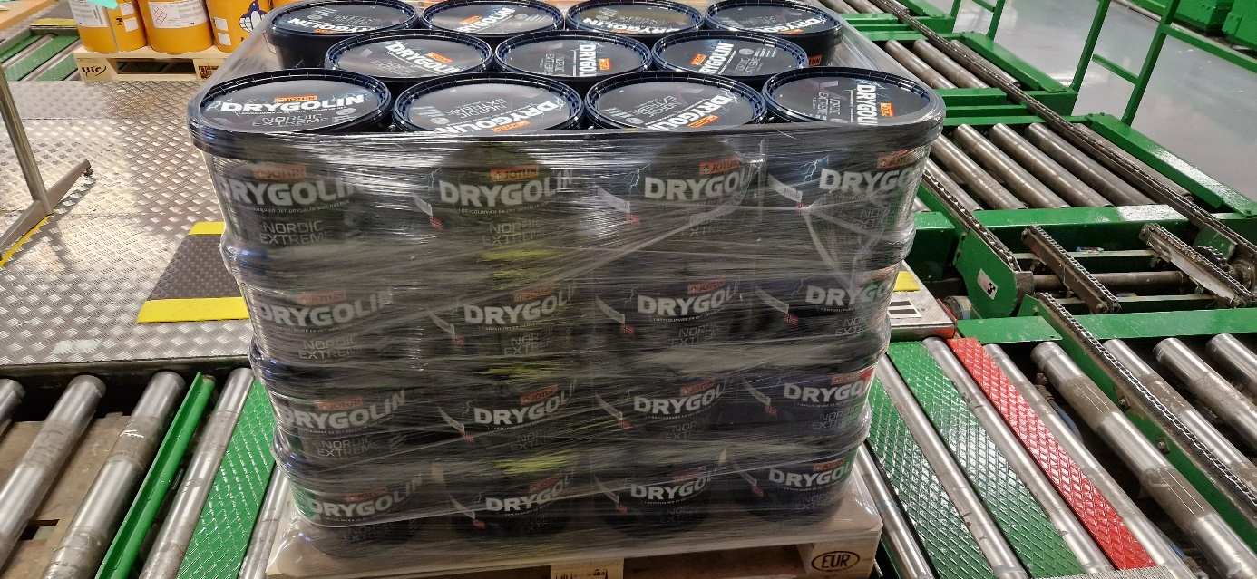
Figure I
Unmarked and unlabeled shipment before classification change.

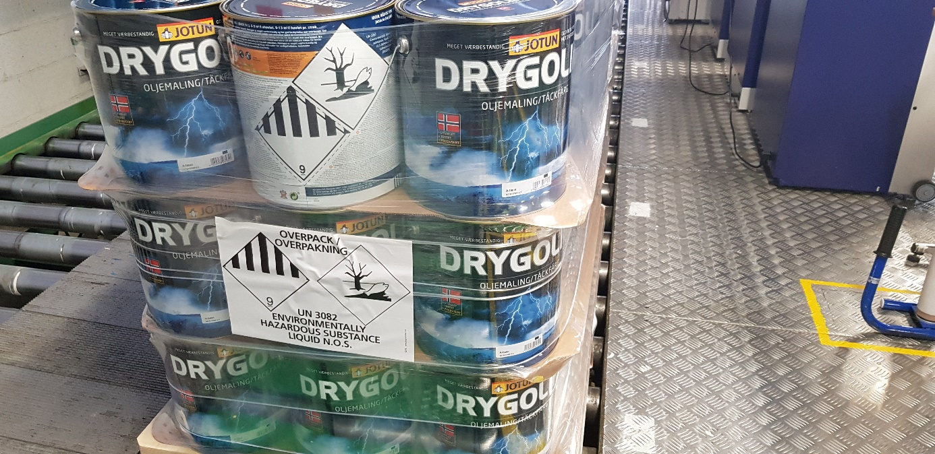
Figure II
Shipment of nonflammable solvent-borne exterior paint with full transport marking and labeling after classification change.

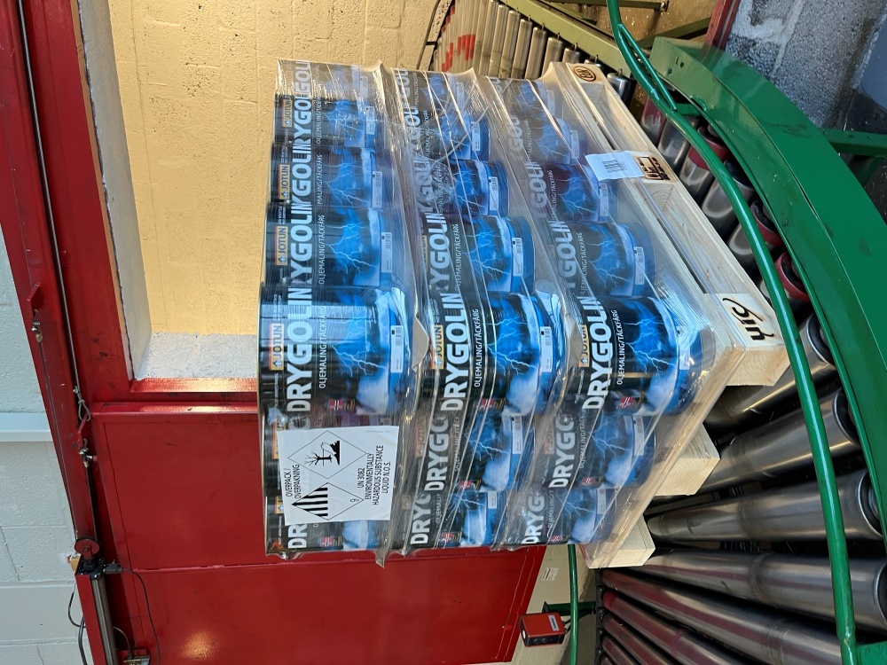
Figure III
Example of a stable shrink-wrapped loading unit.

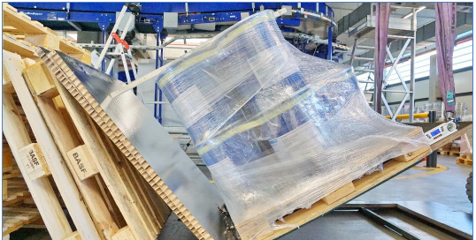
Figure IV
Example of the proven stability of a shrink-wrapped load via the tilting test.
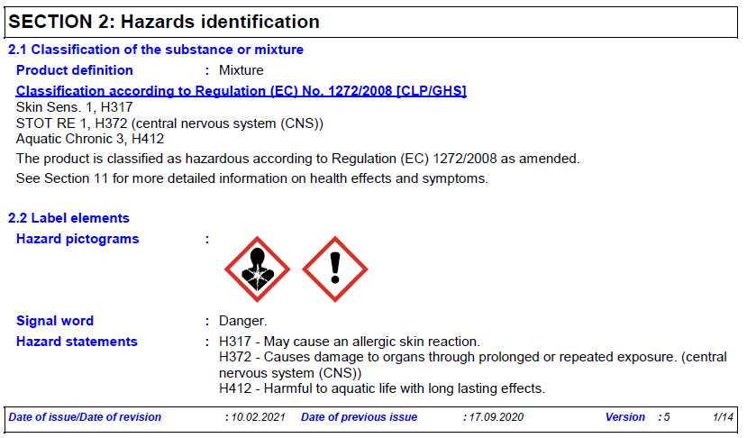
Figure V
Example of a portion of Section 2 of an SDS before ATP 15 without environmentally hazardous information.

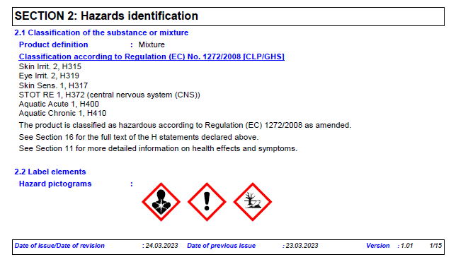
Figure VI
Example of a portion of Section 2 of an SDS after ATP 15, which includes the environmentally hazardous information.

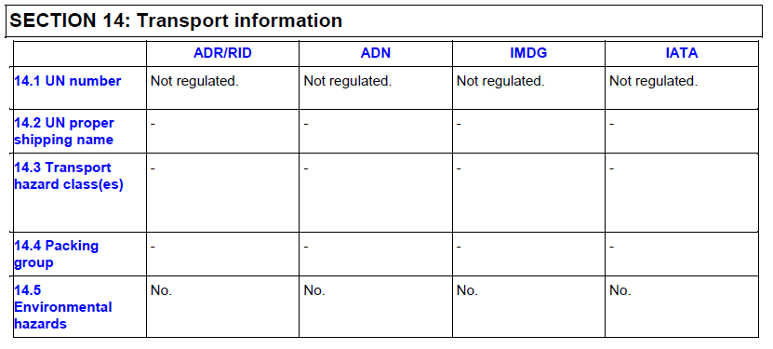
Figure VII
Example of Section 14 of an SDS before ATP 15 without transport classification.

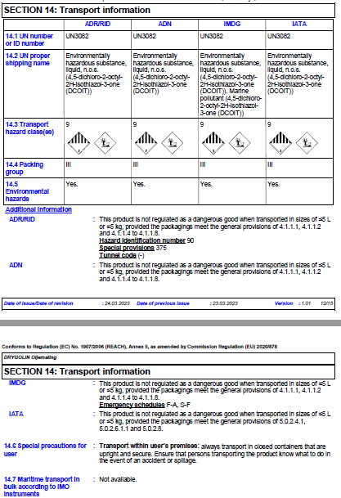
Figure VIII
Example of Section 14 of an SDS after ATP 15, which includes the required transport classification information
________________________

WCC members provided authorization to use the materials contained in this document for the purpose of the discussion at the Sixty-Fourth Session of the Sub-Committee of Experts on the Transport of Dangerous Goods. For reproduction permission and all other issues, please contact Rhett Cash at rcash@paint.org.

