Editorial improvements to GRE/2023/27-Rev.1
The modifications are highlighted in red in comparison to GRE/2023/27-Rev.1

- Proposal
Paragraph 1.3., amend to read:
"1.3. It covers:
(a) Requirements regarding the immunity to radiated and conducted disturbances for functions related to direct control of the vehicle, related to driver, passenger and other road users' protection, related to disturbances, which would cause confusion to the driver or other road users, related to vehicle data bus functionality, related to disturbances, which would affect vehicle statutory data;
(b) Requirements regarding the control of unwanted radiated and conducted emissions to protect the intended use of electrical or electronic equipment at own or adjacent vehicles or nearby, and the control of disturbances from accessories that may be retrofitted to the vehicle;
(c) Additional requirements for vehicles and ESAs providing coupling systems for charging the REESS regarding the control of emissions and immunity from this connection between vehicle and power grid.
Note: The immunity levels stated in this regulation ensure robustness of vehicle systems in the electromagnetic environment and therefore addresses one of the external environments to be considered for functional safety (e.g. in ISO 26262)."
Paragraph 2.12., amend to read:
"2.12. "Immunity related functions" are the following functions; this list is not exhaustive and shall be adapted to the technical evolution of vehicle/technology:
(a) Functions related to the direct control of the vehicle:
(i) By degradation or change in: e.g. engine, gear, brake, suspension, active steering, speed limitation devices;
(ii) By affecting drivers position: e.g. seat or steering wheel positioning;
(iii) By affecting driver's visibility: e.g. dipped beam, windscreen wiper, indirect vision systems, blind spot systems.
(b) Functions related to driver, passenger and other road user protection:
(i) E.g. airbag and safety restraint systems, emergency calling systems (e-call, AECS, ERA GLONASS, …);
(c) Functions which, when disturbed, cause confusion to the driver or other road users:
(i) Optical disturbances: incorrect operation of e.g. direction indicators, stop lamps, end outline marker lamps, rear position lamp, light bars for emergency system, wrong information from warning indicators, lamps or displays related to functions in subparagraphs (a) or (b) which might be observed in the direct view of the driver;
(ii) Acoustical disturbances: incorrect operation of e.g. anti-theft alarm, horn.
(d) Functions related to vehicle data bus functionality:
(i) By blocking data transmission on vehicle data bus-systems, which are used to transmit data, required to ensure the correct functioning of other immunity related functions.
(e) Functions which when disturbed affect vehicle statutory data: e.g. tachograph, odometer;
(f) Functions related to charging mode when coupled to the power grid:
(i) For vehicle test: by leading to unexpected vehicle motion;
(ii) For ESA test: by leading to an incorrect charging condition (e.g. over-current, over-voltage)."
Paragraph 2.28., amend to read:
"2.28. “Failure situations” involve those in which the ADS or another vehicle system experiences a fault or failure that removes or reduces the ADS’s ability to perform the DDTT, such as sensor or computer failure or a failed propulsion system."
Paragraph 2.30., amend to read:
"2.30. “Non-residential environment” refers to clause 3.1.12 of IEC 61000-6-4: 2018.
Location characterized by a separate power network, supplied from a high- or medium-voltage transformer, dedicated for the supply of the installation.
Note 1 to entry: Industrial locations can generally be described by the existence of an installation with one or more of the following characteristics:
• items of equipment installed and connected together and working simultaneously;
• significant amount of electrical power generated, transmitted and/or consumed;
• frequent switching of heavy inductive or capacitive loads;
• high currents and associated magnetic fields;
• presence of industrial, high power scientific and medical (ISM) equipment (for example, welding machines).
The electromagnetic environment at an industrial location is predominantly produced by the equipment and installation present at the location. There are types of industrial locations where some of the electromagnetic phenomena appear in a more severe degree than in other installations.
Example locations include metalworking, pulp and paper, chemical plants, car production, farm building, high voltage areas of airports."

Paragraph 3.2.8 amend to read:
"3.2.8. ESA which are brought to the market as spare replacement parts need no type approval if they are obviously marked as a spare replacement part by an identification number and if they are identical and from the same manufacturer as the corresponding Original Equipment"
Paragraph 6.8.2.1., amend to read:
"6.8.2.1. If tests are made using the methods described in Annex 9, the immunity test levels shall be 60 volts/m root-mean-square (rms) for the 150 mm stripline testing method, 15 volts/m rms for the 800 mm stripline testing method, 75 volts/m rms for the Transverse Electromagnetic Mode (TEM) cell testing method, 60 mA rms for the bulk current injection (BCI) testing method and 30 volts/m rms for the free field testing method in over 90 per cent of the 20 to 2,000 MHz frequency band, and to a minimum of 50 volts/m rms for the 150 mm stripline testing method, 12.5 volts/m rms for the 800 mm stripline testing method, 62.5 volts/m rms, for the TEM cell testing method, 50 mA rms for the bulk current injection (BCI) testing method and 25 volts/m rms for the free field testing method over the whole 20 to 2,000 MHz frequency band.
The immunity to electromagnetic radiation of ESA representative of its type shall be tested by the method(s) as described in Annex 9.:
Test severity in over 90 per cent of the 20 to 6,000 MHz frequency band are given in Table 2a.
Test severity for the minimum test Level over the whole 20 to 6,000 MHz frequency band given in Table 2b.
Table 2a
 | Test Level in over 90 per cent of the 20 to 6,000 MHz frequency band
Frequency range | Stripline | TEM cell | BCI | ALSE | Reverberation chamber
20 to 2,000 MHz | 60 V/m | 75 V/m | 60 mA | 30 V/m | 21 V/m
2,000 to 6,000 MHz | Not applicable | Not applicable | Not applicable | 10 V/m | 7 V/m

Table 2b
 | Minimum Test Level over the whole 20 to 6,000 MHz frequency band
Frequency range | Stripline | TEM cell | BCI | ALSE | Reverberation chamber
20 to 2,000 MHz | 50 V/m | 62,5 V/m | 50 mA | 25 V/m | 18 V/m
2,000 to 6,000 MHz | Not applicable | Not applicable | Not applicable | 8 V/m | 6 V/m
"
Paragraph 6.9.1., amend to read:
"6.9.1. Method of testing
The immunity of ESA representative of this type shall be tested by the method(s) according to ISO 7637-2:2004 for pulse 4 and ISO 7637-2:2011 for pulses 1, 2a, 2b, 3a and 3b, as described in Annex 10, with the test levels given in Tables 23a and 3b. Pulse 4 shall be tested according to the functional status as defined in ISO 7637-2:2004. Functional Performance Status Classification (FPSC) as in ISO 7637-1 shall be applied for pulses 1, 2a, 2b, 3a and 3b.

Immunity of ESA

Table 23a
Test pulse number | Immunity test level | Functional status for systemESA:
 |  | Related to immunity related functions | Not related to immunity related functions
1 | III | C | D
2a | III | B | D
2b | III | C | D
3a/3b | III | A | D
4 | III | B  (for ESA which shall be operational during engine start phases)  C  (for other ESA) | D

Table 3b
Test pulse number | Immunity test level |  | Test duration /  number of pulses | FPSC for systemESA:
 | 12V system | 24V system |  | Related to immunity related functions | Not related to immunity related functions
1 | -75 V | -450 V | 500 pulses | III | III
2a | +37 V | +37 V | 500 pulses | I | III
2b | +10 V | + 20 V | 10 pulses | II | III
3a | -112 V | -150 V | 1 h | I | III
3b | + 75 V | +150 V | 1 h | I | III
Pulse 4 is only applicable to ESAs that could be installed in vehicles with internal combustion engines which are started with a 12V/24V starter motor. "
Paragraph 7.3.2.1., amend to read:
"7.3.2.1. If measurements are made using the method described in Annex 11, the limits for input current ≤ 16 A per phase are those defined in IEC 61000-3-2 and given in Table 34.

Table 34
Maximum allowed harmonics (input current ≤ 16 A per phase)
Harmonic number  n | Maximum authorized harmonic current  A
Odd harmonics
3 | 2.3
5 | 1.14
7 | 0.77
9 | 0.40
11 | 0.33
13 | 0.21
15 ≤ n ≤ 39 | 0.15x15/n
Even harmonics
2 | 1.08
4 | 0.43
6 | 0.30
8 ≤ n ≤ 40 | 0.23x8/n
NOTE: For the application of limits given in Table 4, refer to IEC 61000-3-2, paragraph 6.3.3.4."

Insert new paragraphs 7.5.3. to 7.5.3.4., to read:
"7.5.3 Vehicle type approval limit for vehicles charged in other non-residential environment.
7.5.3.1. For specific vehicles which are charged only with charging stations located in area characterized by a separate power network, supplied from a high or medium voltage transformer, dedicated for the supply of the installation (buses, heavy duty trucks, etc..), limits from IEC 61000-6-4 shall be applied.
7.5.3.2. In this case, the manufacturer shall provide a statement that the vehicle can be used in "REESS charging mode coupled to the power grid" only in area characterized by a separate power network, supplied from a high or medium voltage transformer, dedicated for the supply of the installation. The manufacturer shall provide a statement that the vehicle shall be charged in non-residential environment only. This information shall be made publicly available following the type-approval.
7.5.3.3 If measurements are made using the method described in Annex 13, the limits on AC power lines are those defined in IEC 61000-6-4 and given in Table 10.
- Table 10
- Maximum allowed radiofrequency conducted disturbances on AC power lines
Frequency (MHz) | Limits and detector
0.15 to 0.5 | 79 dBµV (quasi-peak) 66 dBµV (average)
0.5 to 30 | 73 dBµV (quasi-peak) 60 dBµV (average)
7.5.3.4. If measurements are made using the method described in Annex 13, the limits on DC power lines are those defined in IEC 61000-6-4
and given in Table 11.
- Table 11
- Maximum allowed radiofrequency conducted disturbances on DC power lines
Frequency (MHz) | Limits and detector
0.15 to 0.5 | 89 dBµV (quasi-peak)  76 dBµV (average)
0.5 to 30 | 83 dBµV (quasi-peak)  70 dBµV (average)
"
Paragraph 7.9.2.1., amend to read:
"7.9.2.1. If tests are made using the methods described in Annex 16, the immunity test levels shall be:
(a) For AC power lines: ±2 kV test voltage in open circuit between line and earth and ±1 kV between lines (pulse 1.2 µs / 50 µs), with a rise time (Tr) of 1.2 µs, and a hold time (Th) of 50 µs. Each surge shall be applied five times with a maximum delay of 1 minute between each pulse. This has to shall be applied for the following phases: 0, 90, 180 and 270°,
(b) For DC power lines: ±0.5 kV test voltage in open circuit between line and earth and ±0.5 kV between lines (pulse 1.2 µs / 50 µs) with a rise time (Tr) of 1.2 µs, and a hold time (Th) of 50 µs. Each surge shall be applied five times with a maximum delay of 1 minute."
Paragraph 7.11.2.1., amend to read:
"7.11.2.1. If measurements are made using the method described in Annex 17, the limits for input current ≤ 16 A per phase are those defined in IEC 61000-3-2 and given in Table 120.

Table 120

Maximum allowed harmonics (input current ≤ 16 A per phase)
Harmonic number  n | Maximum authorized harmonic current  A
Odd harmonics
3 | 2.3
5 | 1.14
7 | 0.77
9 | 0.40
11 | 0.33
13 | 0.21
15 ≤ n ≤ 39 | 0.15x15/n
Even harmonics
2 | 1.08
4 | 0.43
6 | 0.30
8 ≤ n ≤ 40 | 0.23x8/n
NOTE: For the application of limits given in Table 12, refer to IEC 61000-3-2, Paragraph 6.3.3.4."
Appendix 1, amend to read:
“9. IEC 61000-3-2 "Electromagnetic Compatibility (EMC) - Part 3-2 - Limits for harmonic current emissions (equipment input current ≤ 16 A per phase)", edition 3.2 - 2005 + A1: 2008 + A2: 2009. 5.2 – 2018+AMD1:2020+AMD2:2024.”
Annex4, Paragraph 2.2., amend to read:
"2.2. Vehicle in configuration "REESS charging mode coupled to the power grid".
The vehicle shall be tested in the charging mode configuration (if available on vehicle) as defined in flowchart of figure 1
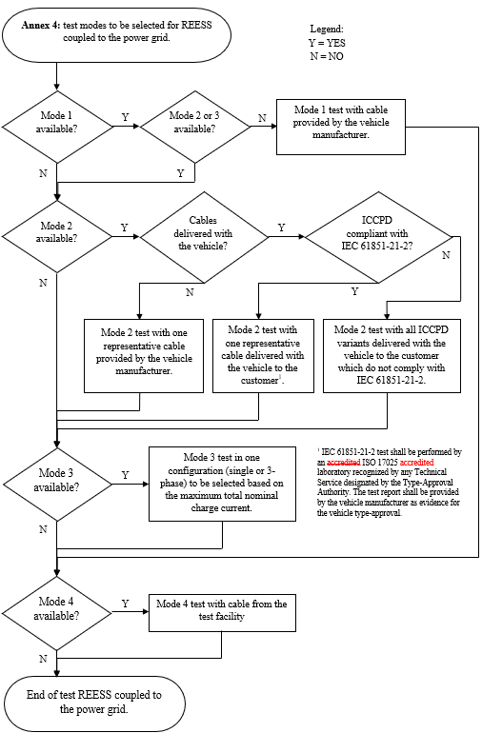
Figure 1
Charging mode configuration for Annex 4
The state of charge (SOC) of the traction battery shall be kept between 20 per cent and 80 per cent of the maximum SOC during the whole frequency range measurement (this may lead to splitting the measurement into different sub-bands with the need to discharge the vehicle's traction battery before starting the next sub-bands).
If the current consumption can be adjusted, then the current shall be set to at least 80 per cent of its nominal maximum rated charging/input current value for AC charging.
If the current consumption can be adjusted, then the current shall be set to at least 80 20 per cent of its nominal value or to a minimum of 16 A (if the 20 per cent of its nominal value cannot be achieved in the test facility) for DC charging unless another value is agreed with the type approval authorities.
In case of multiple batteries the average state of charge must be considered.
The vehicle shall be immobilized, the engine(s) (ICE and / or electrical engine) shall be OFF and in charging mode. All other equipment which can be switched ON by the driver or passengers shall be OFF.
The test set-up for the connection of the vehicle in configuration "REESS charging mode coupled to the power grid" is shown in Figures 3a to 3h (depending of AC or DC power charging mode, location of charging plug and charging with or without communication) of Appendix 1 to this Aannex."
Annex 6, paragraphs 1.1. to 1.3., amend to read:
"1.1. The test method described in this Aannex shall only be applied to vehicles. This method concerns both configurations of vehicle:
(a) Other than "REESS charging mode coupled to the power grid";
(b) "REESS charging mode coupled to the power grid".
A vehicle is considered to be a “large vehicle”, if it is longer than 12 m and/or wider than 2.60 m and/or higher than 4.00 m.
…"
Insert a new paragraph 1.4., to read:
"1.4 Applicability of test methods:
Figure 1
Type approval procedures for testing the immunity of vehicles to electromagnetic radiation
Alternative
No
Yes
Regular or alternative test method
One of the following test methods shall be used
Vehicle longer than 12.00 m and/or wider than 2.60 m and/or higher than 4.00 m

Regular
Regular
Alternatives
Alternatives
Vehicle test according to ISO 11451-4 BCI (20MHz – 2 GHz)
+ according to ISO 11451-2 in ALSE or OTS (additional antenna positions for ESA with immunity related functions) (2 – 6 GHz)

Vehicle test according to ISO 11451-2 in ALSE
Vehicle test according to ISO 11451-2 in OTS
Vehicle test according to ISO 11451-4 BCI (20MHz – 2 GHz)
+ Component test according to R10 Annex 9 (2 – 6 GHz)

Vehicle test according to ISO 11451-2 in ALSE or OTS (20MHz – 6 GHz)
+ Component test according to R10 Annex 9 (20 MHz – 6 GHz) for each ESA with immunity related functions outside antenna beamwidth
Vehicle test according to ISO 11451-2 in ALSE (additional antenna positions for ESA with immunity related functions)
Vehicle test according to ISO 11451-2 in OTS (additional antenna positions for ESA with immunity related functions)

"
Paragraph 2.1.1.2., amend to read:
"2.1.1.2. Basic vehicle conditions
The paragraph defines minimum test conditions (as far as applicable) and failure criteria for vehicle immunity tests. Other vehicle systems, which can affect immunity related functions, shall be tested in a way to be agreed between manufacturer and Technical Service.
"50 km/h mode" vehicle test conditions | Failure criteria
Vehicle speed 50 km/h (respectively 25 km/h for L₁, L₂ vehicles) ±20 per cent (vehicle driving the rollers). If the vehicle is equipped with a cruise control system, it shall be used to maintain the required constant vehicle speed and maintained without any deactivation. | Speed variation greater than ±10 per cent of the nominal speed. In case of automatic gearbox: change of gear ratio inducing a speed variation greater than ±10 per cent of the nominal speed.
Dipped beams ON (manual mode) | Lighting OFF (front light and rear light)
Specific warning (e.g Rotating/flashing light, signaling bar, siren…) ON | Specific warning OFF
Cluster operate in normal mode | Unexpected warning  Inconsistent variation of the odometer
Rear view system | Unexpected movement of rear view mirror  Loss or freezing of the display (CMS)
Front wiper ON (manual mode) maximum speed | Complete stop of front wiper
Direction indicator on driver's side ON | Frequency change (lower than 0.75 Hz or greater than 2.25 Hz). Duty cycle change (lower than 25 per cent or greater than 75 per cent).
Adjustable suspension in normal position | Unexpected significant variation
Driver's seat and steering wheel in medium position | Unexpected variation greater than 10 per cent of total range
Alarm unset | Unexpected activation of alarm
Horn OFF | Unexpected activation of horn
Airbag and safety restraint systems operational with inhibited passenger airbag if this function exists | Unexpected activation
Automatic doors closed | Unexpected opening
Adjustable endurance brake lever in normal position | Unexpected activation
Brake pedal not depressed | Unexpected activation of brake and unexpected activation of stop lights
ADS shall be operational ⁽¹⁾ | ADS does not remain in a failure safe mode or expected failure operational mode
⁽¹⁾: ADS are turned on by the driver but some or all ADS functions may revert to a mode where system is monitoring sensors but is not actively ‘driving’ the vehicle due to plausibility issues caused by the EMC laboratory environment.
"Brake mode" vehicle test conditions | Failure criteria
Vehicle in a state that allows the braking system to operate normally, parking brake released, vehicle speed 0 km/h.  Brake pedal depressed to activate the brake function and the stop lights without any dynamic cycle. | Stop lights inactivated during mode  Brake warning light ON with loss of brake function.
Day running light (DRL) ON | DRL inactivated during mode
ADS shall be operational ⁽¹⁾ | ADS does not remain in a failure safe mode or expected failure operational mode
⁽¹⁾: ADS are turned on by the driver but some or all ADS functions may revert to a mode where system is monitoring sensors but is not actively ‘driving’ the vehicle due to plausibility issues caused by the EMC laboratory environment.

AECS vehicle test conditions before and after immunity test | Failure criteria
A manual emergency call shall be triggered according to the vehicle manufacturer’s instructions, both before and after conducting the 50km/h or brake mode test. | An emergency call is not established.
Once the MSD has been received the emergency call is established, voice communication shall be evaluated, but only if voice communications are available in the AECS system. | The voice originating inside the vehicle cannot be heard clearly by the remote listener with satisfactory intelligibility.  The speech of the remote speaker cannot be heard clearly in the vehicle with satisfactory intelligibility.
After the evaluation of the voice call, the emergency call shall be terminated. Subsequently, the transmitted Minimum Set of Data (MSD) shall be evaluated. | Vehicle location data is NOT transmitted, or position error is greater than 150m.  Time stamp is not transmitted, or time error is greater than 60 seconds.  Vehicle identification number is not transmitted correctly.

AECSs vehicle test conditions during immunity test | Failure criteria
During the 50km/h or brake test mode, the warning signal device (also known as the tell-tale, which provides a failure indication), and all other displays used for indicating AECS faults, shall be monitored. There is no requirement for a cellular network or satellite navigation signals during these tests. | Emergency calling systems does not operate as intended as indicated by:  Failure indication of AECS warning signal device or other vehicle displays.  Upon completion of the test, diagnostic trouble code, which is related to emergency calling systems failure indication, is stored in the device memory.

AVAS test conditions | Failure criteria
Vehicle is tested in an operating state where the  AVAS Function/sound is active (if applicable) ⁽¹⁾ | Loss of AVAS function (loss of sound or system error indicator)
(1) This test may be incorporated into Brake or 50 km/h mode if AVAS system is active in these modes. If AVAS system is not operational during these two modes, the operating conditions (e.g. vehicle speed) shall be agreed between the Technical Service and the Vehicle Manufacturer.
"
Insert a new paragraph 2.1.1.6., to read:
"2.1.1.6. If the vehicle is equipped with an Accident Emergency Call Systems (AECS) according to UN R-144, it shall be tested over the air for the transmission of Minimum Set of Data (MSD) and voice call via a real Public Land Mobile Network (PLMN) or via a network simulator before and after 50 km/h or brake mode and using a private safety answering point (PSAP).
In case of a voice call via a real PLMN, emergency call number should be changed to dedicated PSAP number in order to avoid false calls to the emergency services. Only one specific cellular configuration, including one frequency band and one channel, within a single cellular technology (e.g. 2G, 3G, 4G, 5G.) shall be tested.
Vehicle manufacturer and Technical Service shall review the AECS warning signal strategy if it will detect AECS system faults even when there is no network coverage. If it is not possible to distinguish between lack of network coverage and a system fault, alternative arrangements shall be made to enable this. "
Paragraph 2.2.1.2., amend to read:
"2.2.1.2. Basic vehicle conditions
The paragraph defines minimum test conditions (as far as applicable) and failures criteria for vehicle immunity tests. Other vehicle systems, which can affect immunity related functions, shall be tested in a way to be agreed between manufacturer and Technical Service.
"REESS charging mode" vehicle test conditions | Failure criteria
The REESS shall be in charging mode. The REESS State of charge (SOC) shall be kept between 20 per cent and 80 per cent of the maximum SOC during the whole frequency range measurement (this may lead to split the measurement in different sub-bands with the need to discharge the vehicle's traction battery before starting the next sub-bands). If the current consumption can be adjusted, then the current shall be set to at least 20 per cent of its nominal maximum rated charging/input current value for AC charging.  If the current consumption can be adjusted, then the current shall be set to at least 20 per cent of its maximum nominal value or to a minimum of 16 A (if the 20 per cent of its maximum nominal value cannot be achieved in the test facility) for DC charging unless another value is agreed with the Type-Approval Authorities.  In case of multiple batteries the average state of charge must be considered. | Vehicle sets in motion.  Unexpected release of the parking brake.  Loss of Parking position for automatic transmission.
"

Annex 11,
Paragraph 2.1., amend to read:
"2.1. The vehicle shall be in configuration "REESS charging mode coupled to the power grid".
For two-wheeled vehicles, a non-conductive insulating support with a thickness of 5 – 20mm shall be used between stand and ground plane.
The vehicle shall be tested in the charging mode configuration (if available on vehicle) as defined in flowchart of figure 1
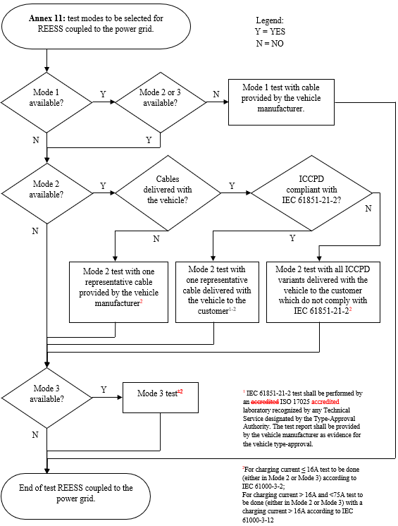
Figure 1
Charging mode configuration for Annex 11
The state of charge (SOC) of the traction battery shall be kept between 20 per cent and 80 per cent of the maximum SOC during the whole time duration of the measurement (this may lead to the measurement being splitting into different time slots with the need to discharge the vehicle’s traction battery before starting the next time slot). If the current consumption can be adjusted, then the current shall be set to at least 80 per cent of its nominal maximum rated charging/input current value for AC charging.

In case of multiple batteries the average state of charge must be considered.
The vehicle shall be immobilized, the engine(s) (ICE and / or electrical engine) shall be OFF and in charging mode.
All other equipment which can be switched ON by the driver or passengers shall be OFF."
Annex 12,
Paragraph 2.1., amend to read:
"2.1. The vehicle shall be in configuration "REESS charging mode coupled to the power grid".
For two-wheeled vehicles, a non-conductive insulating support with a thickness of 5 – 20mm shall be used between stand and ground plane.
The vehicle shall be tested in the charging mode configuration (if available on vehicle) as defined in flowchart of figure 1
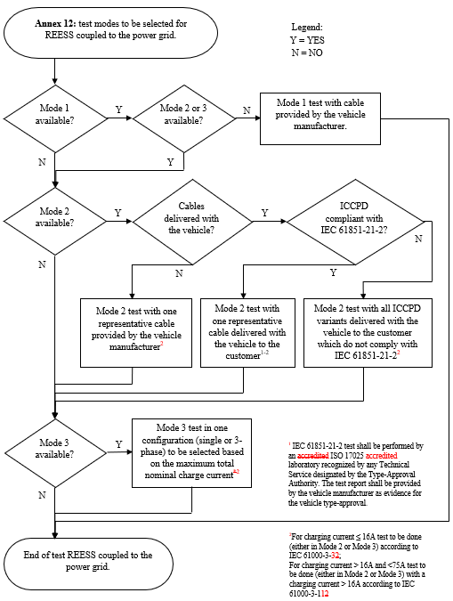
Figure 1
Charging mode configuration for Annex 12
The state of charge (SOC) of the traction battery shall be kept between 20 per cent and 80 per cent of the maximum SOC during the whole time duration of the measurement (this may lead to the measurement being splitting into different time slots with the need to discharge the vehicle’s traction battery before starting the next time slot). If the current consumption can be adjusted, then the current shall be set to at least 80 per cent of its nominal maximum rated charging/input current value for AC charging.
In case of multiple batteries the average state of charge must be considered.
The vehicle shall be immobilized, the engine(s) (ICE and / or electrical engine) shall be OFF and in charging mode.
All other equipment which can be switched ON by the driver or passengers shall be OFF."
Annex 13,
Paragraph 2.1., amend to read:
"2.1. The vehicle shall be in configuration "REESS charging mode coupled to the power grid".
For two-wheeled vehicles, a non-conductive insulating support with a thickness of 5 – 20mm shall be used between stand and ground plane.
The vehicle shall be tested in the charging mode configuration (if available on vehicle) as defined in flowchart of figure 1
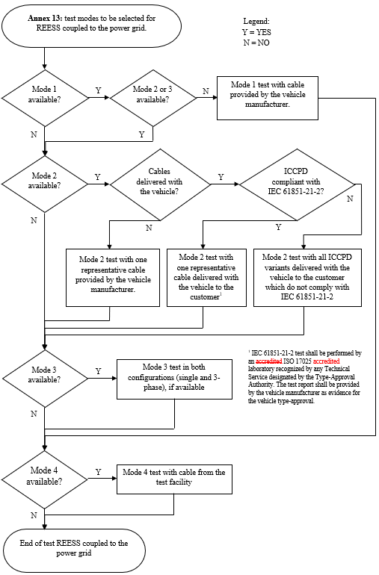
Figure 1: Charging mode configuration for Annex 13
The state of charge (SOC) of the traction battery shall be kept between 20 per cent and 80 per cent of the maximum SOC during the whole frequency range measurement (this may lead to splitting the measurement in different sub-bands with the need to discharge the vehicle's traction battery before starting the next sub-bands).
If the current consumption can be adjusted, then the current shall be set to at least 80 per cent of its nominal maximum rated charging/input current value for AC charging.
If the current consumption can be adjusted, then the current shall be set to at least 80 20 per cent of its nominal value or to a minimum of 16 A (if the 20 per cent of its nominal value cannot be achieved in the test facility) for DC charging unless another value is agreed with the Type-Approval Authorities.
In case of multiple batteries the average state of charge must be considered.
The vehicle shall be immobilized, the engine(s) (ICE and / or electrical engine) shall be OFF and in charging mode.
All other equipment which can be switched ON by the driver or passengers shall be OFF."
Annex 15,
Paragraph 2., amend to read:
"2. Vehicle state during tests in configuration "REESS in charging mode coupled to the power grid"
The vehicle shall be tested in the charging mode configuration (if available on vehicle) as defined in flowchart of figure 1
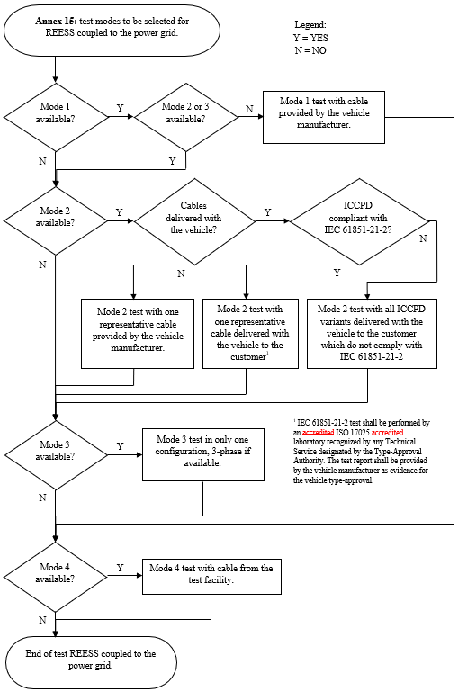
Figure 1
Charging mode configuration for Annex 15"
Annex 16,
Paragraph 2., amend to read:
"2. Vehicle state during tests in configuration "REESS in charging mode coupled to the power grid"
The vehicle shall be tested in the charging mode configuration (if available on vehicle) as defined in flowchart of figure 1
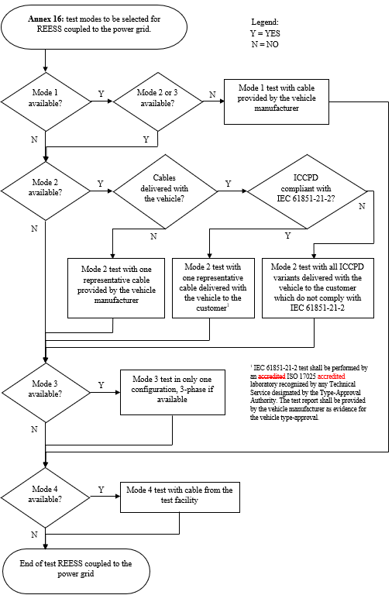
Figure 1
Charging mode configuration for Annex 16"

- Justification
Some editorial changes and clarifications are added in red as well as for the item 29. of the Justification in GRE/2027/27-Rev.1.

29. In Annex 4:
  - For two-wheeled vehicles, a non-conductive insulating support with a thickness of 5 – 20 mm shall be used between the stand and ground plane. This is necessary because the vehicle is normally not electrically grounded when it is parked on a public road. The only ground connection then is the charging interface.
  - New requirement to ensure all traction motors or auxiliary battery charging engines are activated during the measurements.
  - Introduction of a flow chart for clarification of the charging mode configurations to be tested:
- If a vehicle is equipped with charging mode 2 or 3, this will also cover mode 1. The test cable for mode 1 must be provided by the vehicle manufacturer for the EMC measurements.
- It is very common that the vehicles offer the possibility to be charged in mode 2 via an In Cord – Control and Protection Device (ICCPD). The only difference to mode 3 is the portability of mode 2 cables. But the electronics inside the ICCPD is comparable to a common wall box (see also IEC 61851-1). They are interchangeable and an extensive range of products are commercially available on the market. It is not possible to type approve all vehicle and ICCPD cables combinations. Flowcharts have been introduced in order to find a suitable way to ensure vehicles comply with the emission limits in all charge modes. Flowcharts offer three paths to ensure at least one test is carried out in mode 2:
- If charging mode 2 is available and the cable is not delivered with the vehicle to the customer, then the test shall be carried out with one representative cable provided by the vehicle manufacturer.
- The 06 series of amendments does not offer any test setup for ICCPD cables because the international standards CISPR 25 (component emission) and ISO 11452 series (component immunity) do not provide test setups for ICCPD cables. The relevant product standard for ICCPD cables is IEC 61851-21-2. If the emission and immunity was tested according to the IEC standard before one representative cable shall be used for the vehicle test in order to type approve the vehicle mode 2 interface.
- If the cables do not comply with IEC 61851-21-2 then the flow chart offers the possibility to test the vehicle with ICCPD(s) representing the types sold with the vehicle.
- Footnote 1 in Flowcharts:
- The IEC 61851-21-21 test shall be performed by an ISO 17025 accredited laboratory recognized by any technical service designated by the Type-Approval Authority. The vehicle manufacturer will submit the test report as evidence for vehicle type approval. This paragraph is included in the UN Regulations in many places.
- This means that any technical service designated by the Type-Approval Authority can accept any ISO 17025 laboratory accredited for IEC 61851-21-12 that it trusts.
- The importance of including this phrase is a matter of responsibility of the technical service, and therefore of the Type-Approval Authority, and on the other hand, of trust in its accredited laboratory.
- The group proposes to include charging cables in the approval without testing them according to the regulations, accepting test reports external to the vehicle approval supervision process, and this responsibility is the responsibility of the Type-Approval Authority and the technical services designated and recognized by this Authority.
- For mode 3 it is sufficient to perform tests with at least 80 per cent of the maximum total nominal charge current to cover the main influence of AC current level.
- Normally mode 4 cables are not delivered to the customer with the vehicle because they are part of the DC charging station. Therefore, the test facility should provide the charging infrastructure including the cable.
  - Reduction of the charging current to at least 20 per cent for DC charging; Results of multiple measurement confirmed that the major contribution to the electromagnetic emission comes from the communication between charging station and vehicle and not from the DC current. At the same time, EMC test laboratories face practical issue around delivering ever increasing DC fast charge currents with existing infrastructure. Expensive investments would have been necessary for high power DC charging stations which are suitable for the EMC environment. It was therefore agreed that if the 20 per cent of its nominal value cannot be achieved in the test facility, it would be sufficient to charge with 16A.
  - The requirements for test setups with longer charging cables were updated for consistency with ISO (e.g. first edition of ISO 11451-5) and CISPR standards.
  - Introduction of Fast Fourier Transform (FFT) based measuring instruments, because they are state of the art and have been verified to produce the same outcome as legacy measurement methods.
  - Introduction of an alternative approach where the vehicle manufacturer provides measurement data for each charging mode and the technical service confirms by a spot check.
  - Clarification of the total vehicle length.
  - Figure 2b for two-wheeled vehicles to be deleted because it provides no additional information. Furthermore, the location of the mid-point of the engine is not correct. According to paragraph 4.6 the antenna shall be aligned with the middle of the total vehicle (in many cases the length of two-wheeled vehicles is smaller than the 3 dB beamwidth of the antenna).
  - Updates of figures 3a to 3h for consistency with ISO (e.g. first edition of ISO 11451-5) and CISPR standards.

