|  |  |  |  |
| --- | --- | --- | --- |
|  | United Nations | ECE/TRANS/WP.15/AC.1/2019/9 | |
| _unlogo | **Economic and Social Council** | | Distr.: General  27 December 2018  English  Original: French |

**Economic Commission for Europe**

Inland Transport Committee

**Working Party on the Transport of Dangerous Goods**

**Joint Meeting of the RID Committee of Experts and the  
Working Party on the Transport of Dangerous Goods**

Bern, 18–22 March 2019

Item 5 (b) of the provisional agenda

**Proposals for amendments to RID/ADR/ADN: new proposals**

Amendment to additional provision CW36/CV36 of 7.5.11

Transmitted by the Government of Switzerland[[1]](#footnote-1)\*, [[2]](#footnote-2)\*\*

|  |
| --- |
| *Summary* |
| **Executive summary:** Apply to the carriage of gases for which additional provision CW36/CV36 of 7.5.11 is assigned safety measures similar to those provided for in 5.5.3.3.3 for substances presenting a risk of asphyxiation. |
| **Action to be taken:** Amend the wording of additional provision CW36/CV36 of 7.5.11. |
| **Related documents:** ECE/TRANS/WP.15/2017/13, ECE/TRANS/WP.15/239, informal document INF.21 of the March 2018 session, ECE/TRANS/WP.15/AC.1/150. |
|  |

Introduction

1. During the meeting of the Working Party on the Transport of Dangerous Goods (WP.15) in November 2017, a discussion on the scope of provision CV36 took place on the basis of document ECE/TRANS/WP.15/2017/13 of Switzerland. The discussion led to bringing the French terminology into line with the English (proposal 2). The same amendment was adopted for CW36 by the RID Committee of Experts’ standing working group in November 2017.

2. In addition, proposal 1 by Switzerland, reproduced below, received the support of most of the delegations that took the floor. The WP.15 working group agreed that the proposal was multimodal in scope and should be discussed in the RID/ADR/ADN Joint Meeting.

3. Following the discussion of informal document INF.21 by the Joint Meeting in March 2018, the representatives of EIGA and Liquid Gas Europe expressed their willingness to consult their members in order to contribute to the preparation of a revised version (para. 47 of report).

4. These associations subsequently confirmed to us that they have no objections to the proposal contained in informal document INF.21 and that it corresponds to the guidelines published in many of their publications. They are willing to discuss them in detail and describe the practices they recommend.

5. There are road vehicles that may be closed vehicles in which the load compartment is not separate from the passengers’ and driver’s compartment (see first image in annex). Passenger wagons may also have a load compartment for cargo. In this case, it is necessary to provide ventilation not only when opening the doors but also during the transport of gases to which CW36/CV36 is assigned.

6. In RID/ADR 2017, provisions have been introduced in 5.5.3.3.3 to ensure the safety of the driver when carrying substances presenting a risk of asphyxiation. They prescribe a separation of the accessible compartments during the carriage of load compartments when the latter are not ventilated.

7. The same safety issues arise when carrying gases to which CW36/CV36 is assigned. It would therefore be useful to adopt provisions similar to those of 5.5.3.3.3 for this purpose.

Proposal

8. Amend additional provision CW36/CV36 of 7.5.11 as follows (new text underlined in bold):

“CW36/CV36 Packages shall preferably be loaded in open or ventilated wagons/vehicles or open or ventilated containers. If this is not feasible and packages are carried in other closed wagons/vehicles or containers, **gas exchange between the load compartment and accessible compartments during carriage/the driver’s cab shall be prevented** and the cargo doors of the wagons/vehicles or containers shall be marked with the following in letters not less than 25 mm high:

‘WARNING

CLOSED MEANS OF CONTAINMENT

OPEN WITH CAUTION’

This shall be in a language considered appropriate by the consignor. For UN Nos. 2211 and 3314 this mark is not required when the wagon/vehicle or container is already marked according to special provision 965 of the IMDG Code.[[3]](#footnote-3)3”

Annex

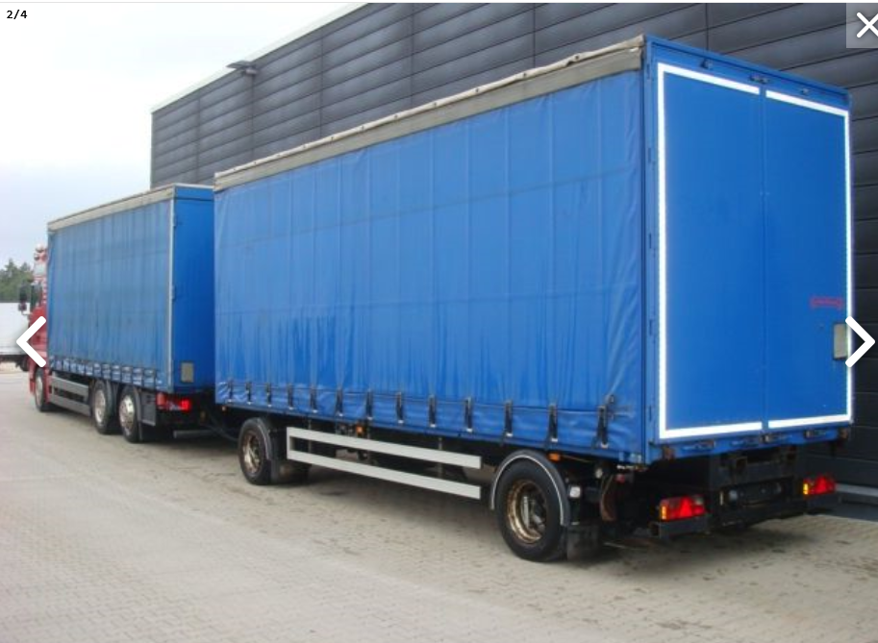

1. \* In accordance with the programme of work of the Inland Transport Committee for 2018–2019 (ECE/TRANS/WP.15/237, annex V (9.2)). [↑](#footnote-ref-1)
2. \*\* Circulated by the Intergovernmental Organisation for International Carriage by Rail (OTIF) under the symbol OTIF/RID/RC/2019/9. [↑](#footnote-ref-2)
3. 3 Warning mark including the words “CAUTION – MAY CONTAIN FLAMMABLE VAPOUR” with lettering not less than 25 mm high, affixed at each access point in a location where it will be easily seen by persons prior to opening or entering the vehicle or container. [↑](#footnote-ref-3)