UNITED

NATIONS
STSTE

Distr.
Secretariat

GENERAL

ST/SG/AC.10/C.4/2004/3
28 April 2004

Original: ENGLISH

COMMITTEE OF EXPERTS ON THE TRANSPORT OF

DANGEROUS GOODS AND ON THE GLOBALLY

HARMONIZED SYSTEM OF CLASSIFICATION

AND LABELLING OF CHEMICALS

Sub-Committee of Experts on the Globally Harmonized System

of Classification and Labelling of Chemicals

Seventh session, 14-16 July 2004
Item 2 (a) of the provisional agenda

UPDATING OF THE GLOBALLY HARMONIZED SYSTEM OF CLASSIFICATION AND LABELLING OF CHEMICALS (GHS)

Physical hazards

A new label for organic peroxides, Division 5.2 of the Model Regulations
and Chapter 2.15 of the GHS

Transmitted by the expert from Norway

1. Background

During the twenty-fourth session of the Sub-Committee of Experts on the Transport of Dangerous Goods (TDG Sub-Committee), the expert from Norway presented in ST/SG/AC.10/C.3/2003/33 a proposal for a new label for Division 5.2. After discussions, it was decided that the expert from Norway would present a revised document at the twenty-fifth session of the TDG Sub-Committee (ST/SG/AC.10/C.3/2004/21).

The document ST/SG/AC.10/C.3/2003/33 was also discussed in the sixth session of the Sub-Committee of Experts on the Globally Harmonized System of Classification and Labelling of Chemicals (GHS Sub-Committee) even though Norway had not sent this document, or a parallel one, also to the GHS Sub-Committee. After a fruitful discussion in the GHS Sub-Committee, it was decided that when the expert from Norway would send the revised document to the twenty-fifth session of the TDG Sub-Committee, he would also send a parallel document to the sixth session of the GHS Sub-Committee. The following is therefore the fulfillment of the above-mentioned decision taken in the GHS Sub-Committee. The two parallel documents are quite similar, differing mainly with respect to consequential amendments, which by necessity are different in the UN Model Regulations and the Globally Harmonized System of Classification and Labelling of Chemicals (GHS).
The main issue of the Norwegian proposal in ST/SG/AC.10/C.3/2003/33 was that the labels in Division 5.1 and Division 5.2 are identical (apart from the division number printed on the label), while substances in the two divisions present different potentials for danger in a fire.

As was mentioned in the Norwegian proposal, in a fire, substances belonging to Division 5.1 contribute oxygen, but normally not combustible material. For these substances to contribute to the fire, as a rule, combustible material must be added, e.g. combustible material transported together with the 5.1 substances, or in the form of contamination with reducing agents, e.g. metal powders.

Substances belonging to Division 5.2, on the other hand, contain both oxygen and combustible material. They may therefore themselves burn, e.g. if they are ignited by an existing fire, or if they reach a sufficiently high temperature as to undergo an exothermic decomposition, to which they are liable (cf. para. 2.5.3.1.1 of the Model Regulations).

From the above, it should be self evident that substances of Division 5.2 represent a far greater risk and danger for emergency responders than substances of Division 5.1. It would be favorable if this greater danger involved with Division 5.2 substances is communicated to the emergency responders quickly and efficiently i.e. through the ensuing label or placard.

In short, paper ST/SG/AC.10/C.3/2003/33 called for different labels for these two divisions to reflect differences between divisions as regards intrinsic properties of substances. The overall aim is to increase safety through a clear, unambiguous hazard communication through different labels, especially for emergency responders in an emergency situation. With today’s situation, it might not be easy for the emergency responders to differentiate between these to labels, especially since they must often, due to safety considerations, make observations as well as tactical and strategic planning from a distance.

Following the Norwegian presentation at the twenty-fourth session of the TDG Sub-Committee, there was a very fruitful discussion, and the Norwegian proposal was supported by several experts. It is important to note that the proposal was supported by a number of experts who had already presented the proposed label to organizations of emergency responders (e.g. fire fighters, police forces), and who reported unanimous support for the Norwegian proposal from these organizations. Especially interesting is the support from CTIF, both during the twenty-fourth session, and in later discussions of a more informal character.

During these discussions, the expert from Norway demonstrated that the proposed new label also enhances risk communication in bad light conditions. As is well known, colour vision deteriorates with decreasing light intensity. The uniqueness of the new proposed label is nevertheless upheld, with good contrast, as red in bad light conditions evolves into black, and yellow into white. Hence, the new label also represent an improvement over the old one for persons with reduced vision or lacking colour vision.

The expert from Norway would like to use this opportunity to thank the expert from the United States of America for supplying results from an empirical distance visibility test. This test shows that a label corresponding to Norway’s proposed label, relative to a number of proposed alternatives, shows better contrast, and hence a better relative visibility, with increasing distance, a factor of the utmost importance for emergency responders.

Some members of the TDG Sub-Committee suggested that there was a need for a transition period during which the existing version of the label for Division 5.2 might still be used. This would allow industry to get time to prepare themselves, and to adjust. The expert from Norway supports this view, and is thankful for this suggestion as an improvement to the original proposal.

2. Proposal

The expert from Norway is still of the opinion that substances of Division 5.1 and substances of Division 5.2 should be labelled in a sufficiently different way, so as to make sure that this difference is being relatively easily observed also at a distance. It is therefore proposed to substitute the existing label No. 5.2 with a modified label with the upper half of the label in red colour as shown in Figure 1.
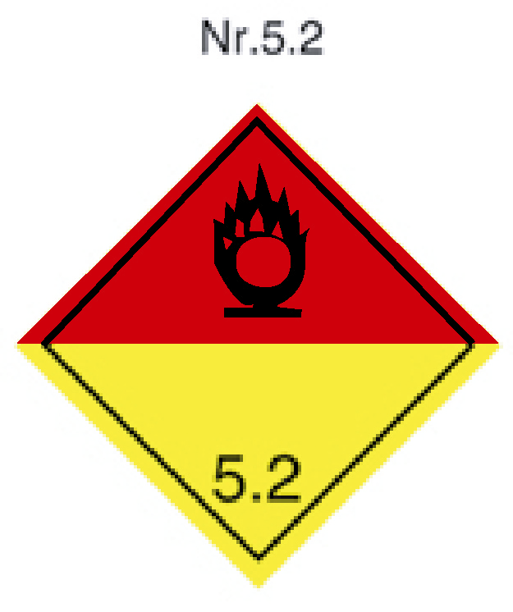
Figure 1.

(background upper half: red;
background lower half: yellow)

To implement the possibility of a transition period, as requested by some delegations, the expert from Norway proposes that the existing label No. 5.2 be used until 1 January 2011, and proposes below two alternative ways in which this can be written into the Model Regulations.

3. Justification

The justification for a new label was presented in ST/SG/AC.10/C.3/2003/33, and is repeated below.

Firstly, and most important, a clear difference is achieved between the two labels in Class 5. This in itself, as indicated above, decreases ambiguity and thereby increases safety of the emergency response. In fact, the whole idea of changing the label No. 5.2 is based on safety concerns expressed by a large number of Norwegian fire fighters, as regards to having two so similar labels. A common remark is that the ambiguity much reduces the information content, and that this in turn could lead to doubts, stress, and to unnecessary information seeking processes taking valuable time. Experience from training and educating approximately 4000 emergency responders in Norway was unanimous: presented with a prototype of the label shown in fig. 1, they all felt that such a change in label No. 5.2 would be a major improvement in hazard communication.

Secondly, having two labels for Class 5 is in line with the rest of the labelling system, where each different class/division is labelled with its own label.

Thirdly, adding red colour to the new label symbolizes, as is the case with the red colour on other labels, the existence of combustible material.

And, fourthly, the lower part of the label retains the yellow colour, symbolizing the oxygen content of the substance.

In addition, the proposed new label is kept within the general appearance of the “old” label as far as the icon is concerned. In addition, no totally new colours are introduced; the same colours are used for indicating the inherent properties of the substances as in the overall labeling system. Therefore the new proposed labels fits into the overall system of labelling, whose unity is preserved.

4. Implementation

The change of the existing label No. 5.2 calls for no major amendment in existing legislations. Apart from introducing a note, alternatively a new special provision, in the label itself, only a minor change in colour is involved; no new icons or numberings are introduced. As was mentioned in ST/SG/AC.10/C.3/2003/33, in training and education, having two different labels will simplify things both pedagogically and epistemologically, i.e. create an easier situation for both teacher (pedagogically) and student (epistemologically). This since fewer words are necessary to convey the difference in information content between two different labels, than between, in practice, two nearly identical ones. As the old saying goes: a picture tells more than a thousand words.

5. Consequential amendments

Paragraph 1.4.10.4.2.2 of the GHS states: “For transport, the pictograms (commonly referred to as labels in transport regulations) prescribed by the UN Model Regulations on the Transport of Dangerous Goods should be used”. In line with this, the only consequential amendment in the GHS, if the Norwegian proposal is adopted, is

  - Amendment in Annex 1

- For organic peroxides (p. 242),

(a) change Note 2 to read:

“(2) UN Model Regulations pictogram colours:

Organic peroxide pictogram:
Symbol and figure: flame over circle: black.
Background: upper half: red; lower half: yellow.
Explosives pictogram:
Symbol and figure: exploding bomb: black
Background: orange.”

(b) add new Note 3:

“(3) The label conforming to the colouring scheme in the table for oxidizing liquids may be used until 7 January 2011.”

In addition, it is suggested that the asterisks in the explosives pictogram shown under category are deleted; this since the explosive property is the subsidiary risk.

- For explosives (p. 233),

As a consequential amendment to modifying the table on page 242, the opportunity should also be taken to make the necessary correction in the table for explosives (p. 233), explaining the use of asterisks. It is therefore suggested to add a new Note 3 for explosives:

“(3) ** Place for division – to be left blank if explosive is the subsidiary risk.
* Place for compatibility group – to be left blank if explosive is the subsidiary risk”.
_____________

Note by the secretariat: An equivalent proposal has also been submitted to the Sub-Committee of Experts on the Transport of Dangerous Goods as document ST/SG/AC.10/C.3/2004/21. Comments have been made by experts from the TDG Sub-Committee, and issued as documents ST/SG/AC.10/C.3/2004/66 (United States of America) and ST/SG/AC.10/C.3/2004/71 (Russian Federation).

