Trade Facilitation Implementation Guide (TFIG)  and Global Supply Chains Regional Training Workshop | Language  of the workshop: Spanish - English  Venue: Santiago de Chile – Chile  from: 23/09/2013  to: 26/09/2013 | 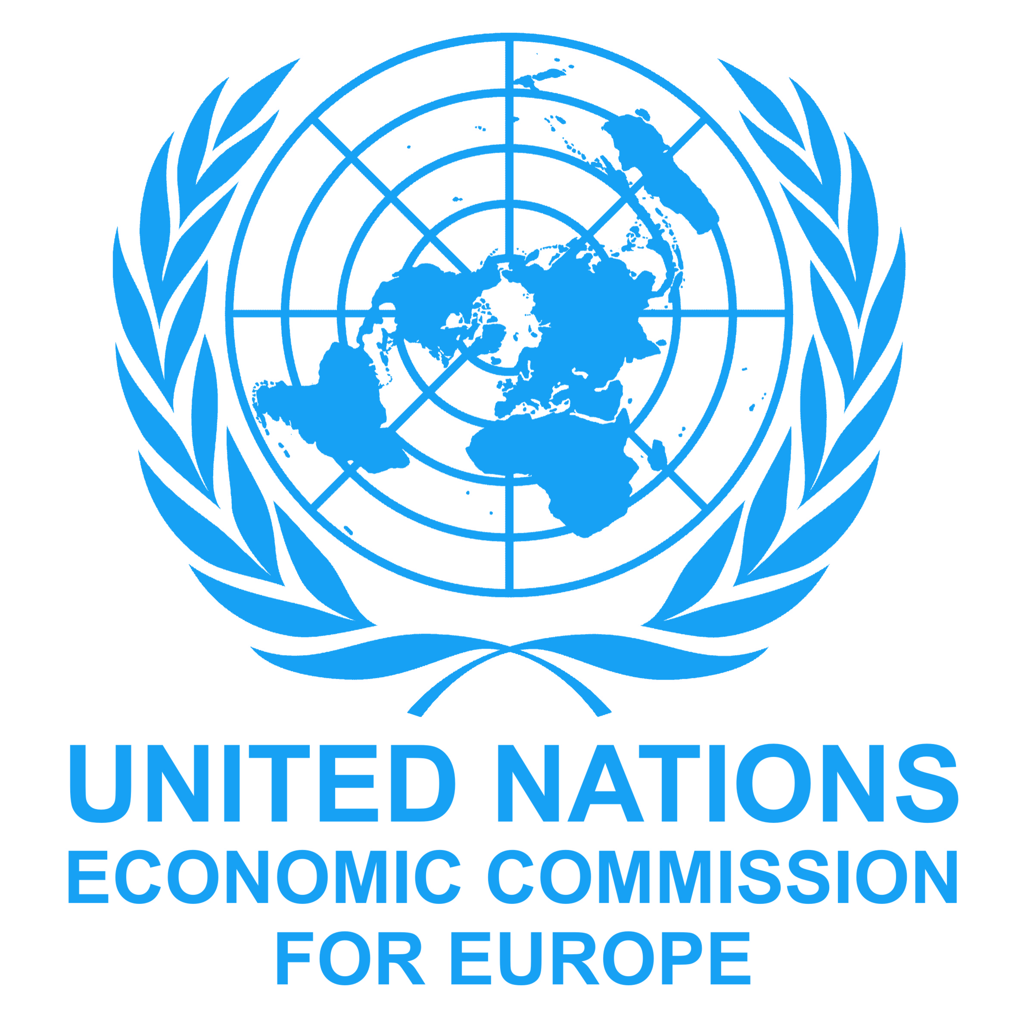 | 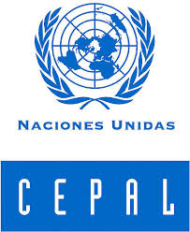
Activity Manager: Maria Cecarelli - Activity Assistant: Subashini Narasimhan
Time |  | Monday  23.09.2013 | Tuesday  24.09.2013 |  | Wednesday  25.09.2013 |  | Thursday  26.09.2013
9:00 - 10:30 | 1 | Welcome & Opening  Structure of the workshop  About the Guide  Needs and expectations  Jose Carlos Mattos (UNECLAC)  Maria Ceccarelli (UNECE) | 5 | Reducing Delays at Border Crossing  Dietmar Jost (Consultant) | 9 | WTO Negotiations on TF  Why is the WTO discussing TF?  What are the proposed measures?  B. Viohl (Consultant) | 13 | Information exchange in regional supply chains (GSC)  (Regional Consultant)
11:00 - 12:30 | 2 | Introduction to Trade Facilitation (TF)  -  Principles and Benefits  The Generic Approach to TF  Dietmar Jost (Consultant)  Birgit Viohl (Consultant) | 6 | Rationalize Trade Documents  & Info Requirements  Dietmar Jost (Consultant) | 10 | Global supply chains in the world economy  -  A model to identify regulatory, procedural and business requirements  Serguei Kouzmine (UNECE) | 14 | Information exchange in regional supply chains (GSC)  -  Continued  (Regional Consultant)
Lunch Break
13:30 – 15:00 | 3 | TF Domains  TF Instruments & Organizations  -  Dietmar Jost (Consultant)  Birgit Viohl (Consultant) | 7 | Single Window Implementation  Maria Ceccarelli (UNECE) | 11 | Global supply chains in the world economy  Country Presentations on information requirements and obstacles | 15 | TF Country Reforms and Capacity Building Plans  B. Viohl (Consultant)
15:30 – 17:00 | 4 | Creating a Trusted Partnership for TF  Birgit Viohl (Consultant) | 8 | Single Window Implementation  Country Presentations | 12 | Information exchange in global supply chains (GSC)  -  The roadmap for helping policy makers to overcome identified bottlenecks  Serguei Kouzmine (UNECE) | 16 | Workshop Evaluation & Closure  Jose Carlos Mattos (UNECLAC)  Maria Ceccarelli (UNECE)

